**Name : Hiral Mashru**

**SECTION A**

CREATE TABLE test4.Customer (

`ID` INT AUTO_INCREMENT PRIMARY KEY,

`FIRST_NAME` varchar(50) NOT NULL,

`LAST_NAME` varchar(50) NOT NULL,

`GENDER` varchar(20),

`BIRTHDATE` date,

`isVIP` bool,

`CREATED_DATE` date NOT NULL,

`UPDATED_DATE` date

);

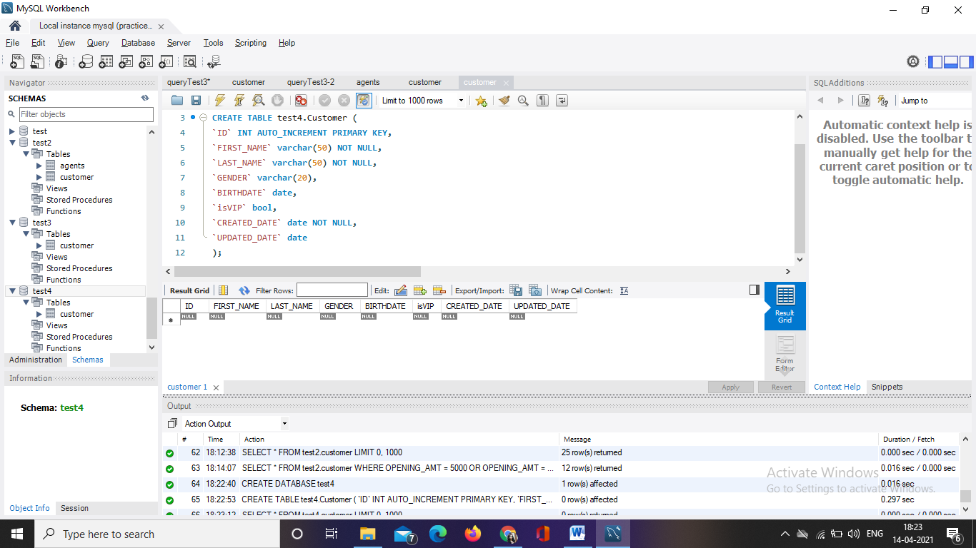

1. INSERT INTO test4.customer(FIRST_NAME,LAST_NAME,GENDER,CREATED_DATE,isVIP) VALUES ('Hiral','Mashru','Female','2021-04-14',1);

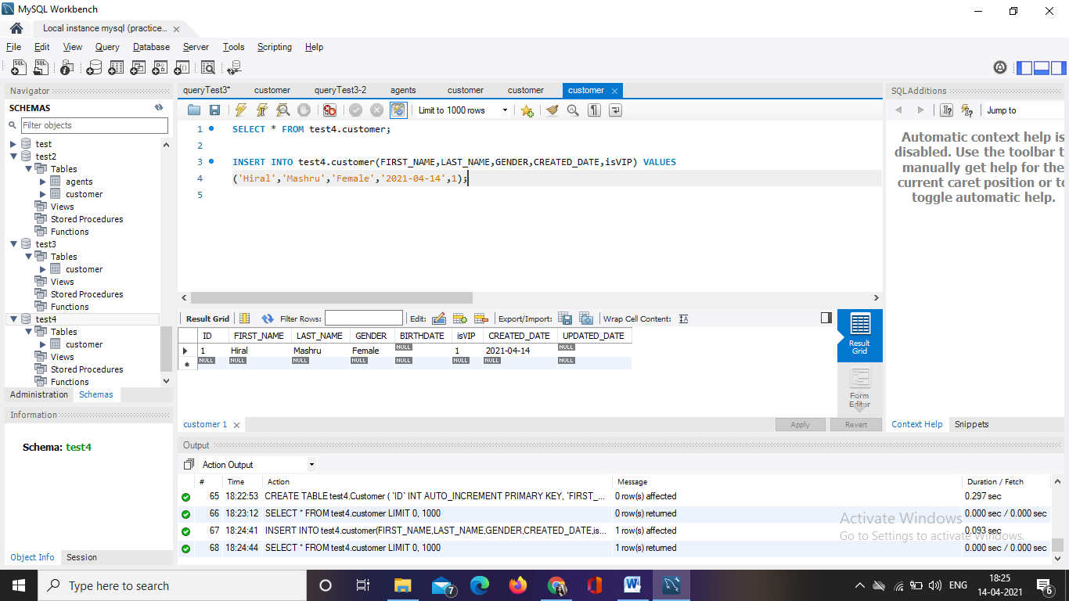

1. INSERT INTO test4.customer(FIRST_NAME,LAST_NAME,GENDER,CREATED_DATE,isVIP) VALUES ('Harsh','Mashru','Male','2021-04-14',0);

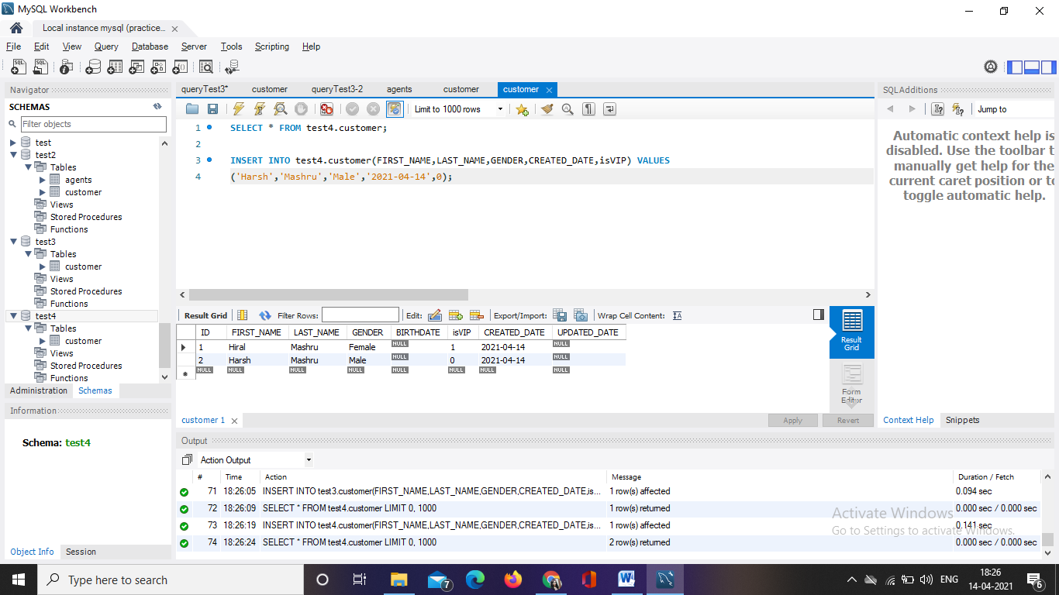

1. INSERT INTO test4.customer(FIRST_NAME,LAST_NAME,GENDER,CREATED_DATE) VALUES ('Heer','Mashru','Female','2021-04-14');

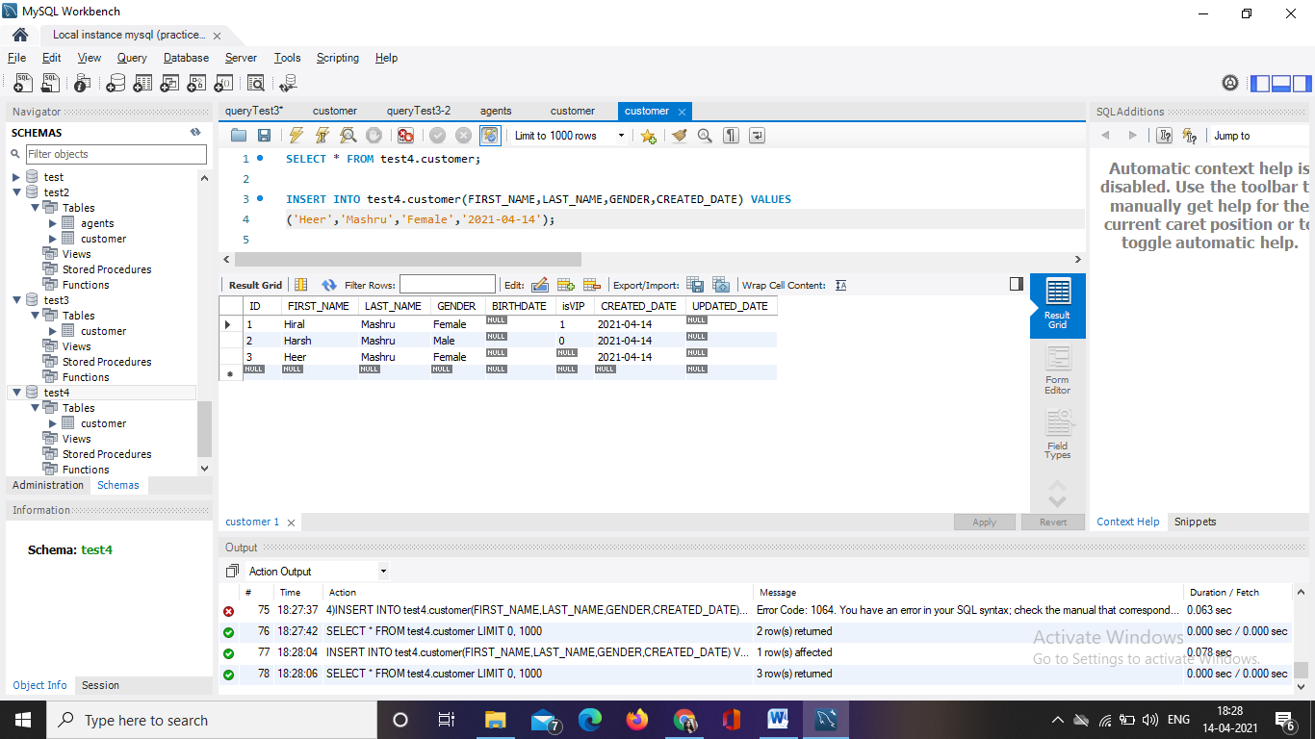

1. SELECT * FROM test4.customer WHERE isVIP = 1;

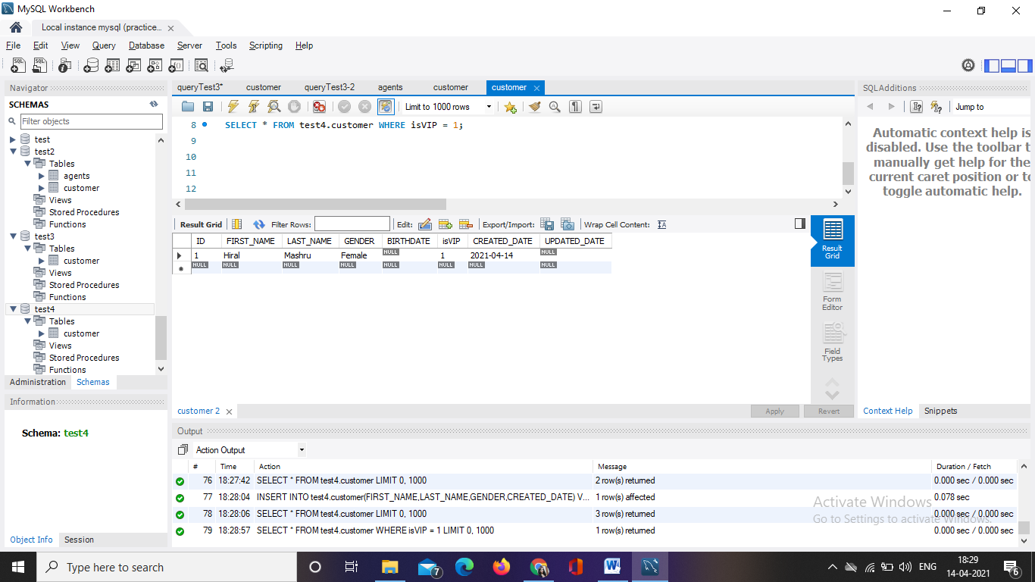

1. SELECT * FROM test4.customer WHERE isVIP = 0;

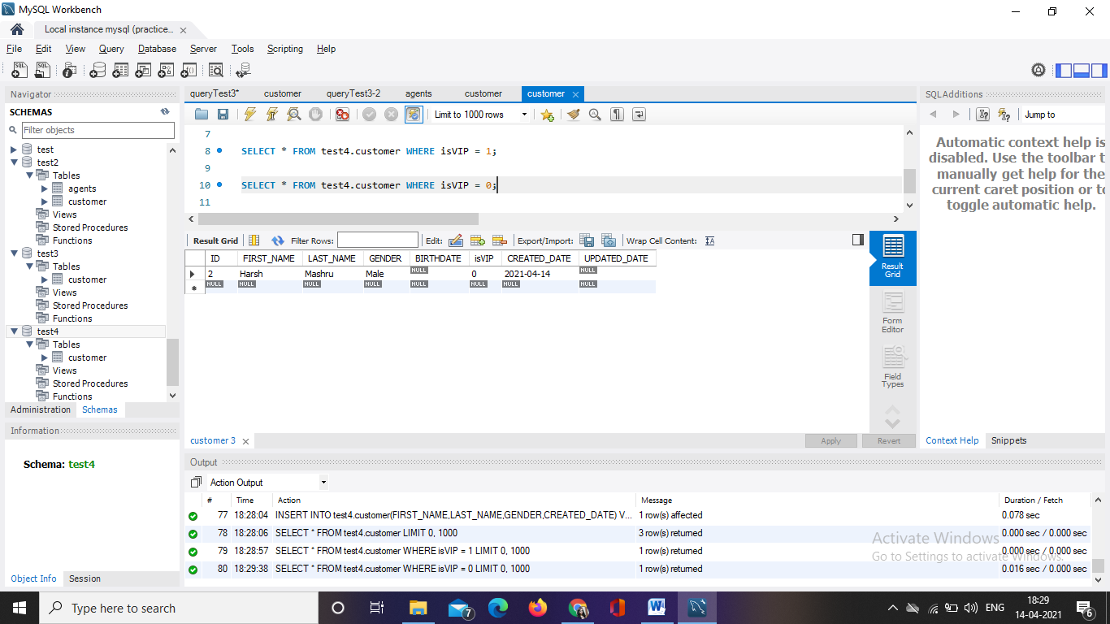

**SECTION – B**

1. SELECT SUM(COMMISSION) AS `Total Commission` FROM test2.agents;

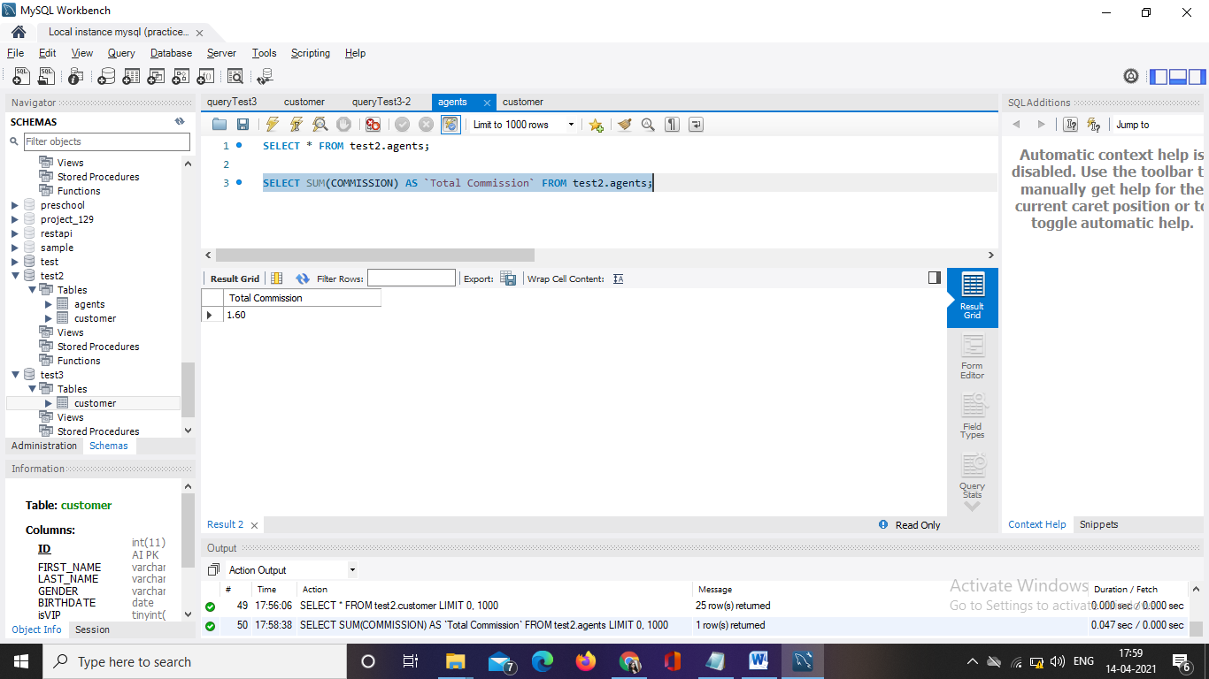

1. SELECT * FROM test2.agents WHERE `PHONE_NO` LIKE '077%';

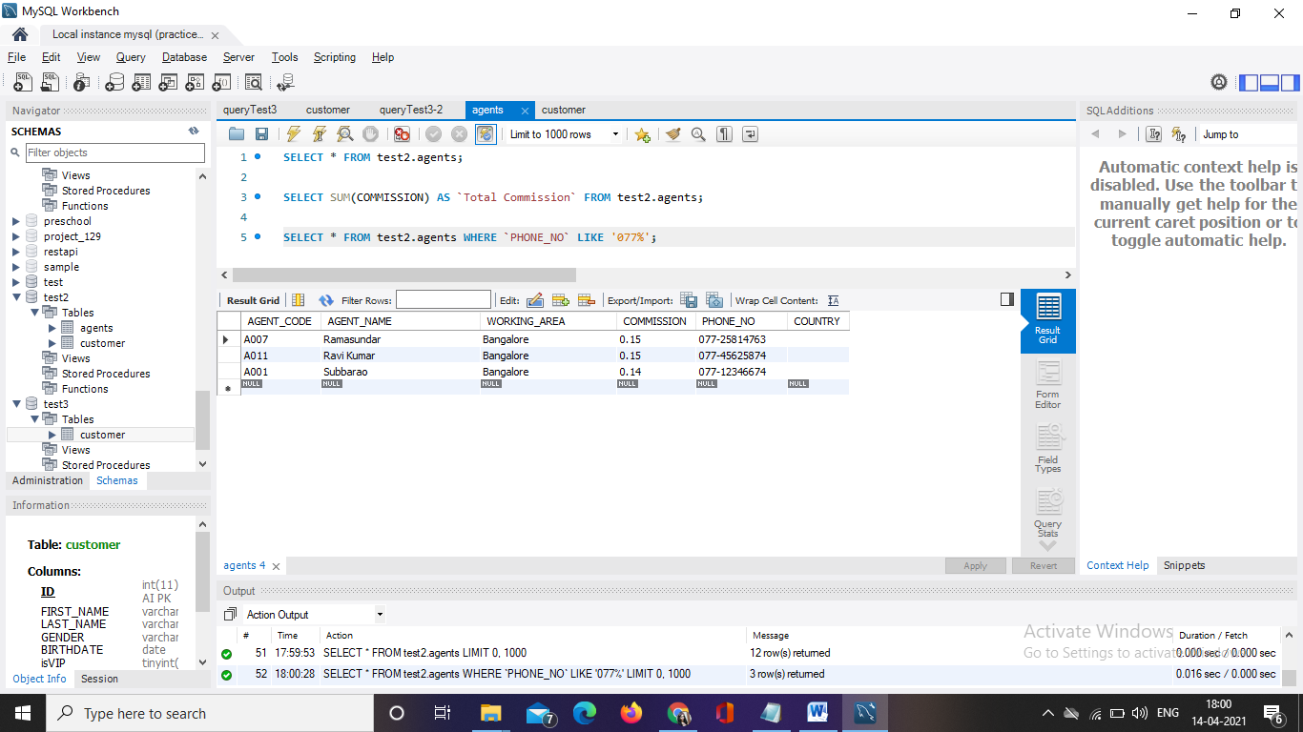

1. SELECT * FROM test2.customer ORDER BY `CUST_NAME`;

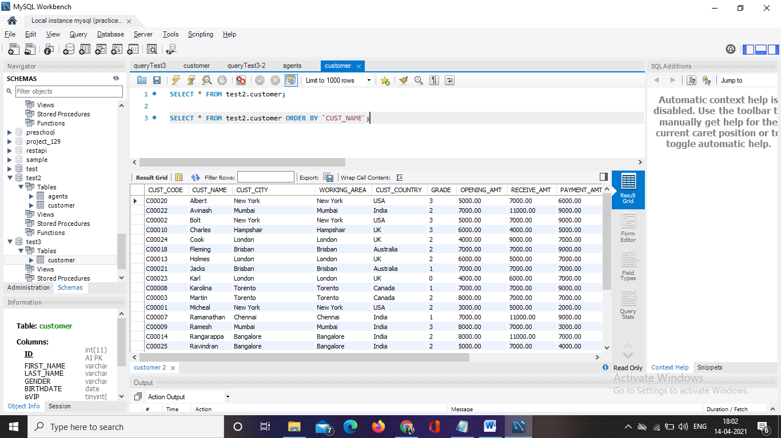

1. SELECT c.* FROM test2.customer AS c JOIN test2.agents AS a ON c.AGENT_CODE = a.AGENT_CODE WHERE a.AGENT_NAME = 'Alex';

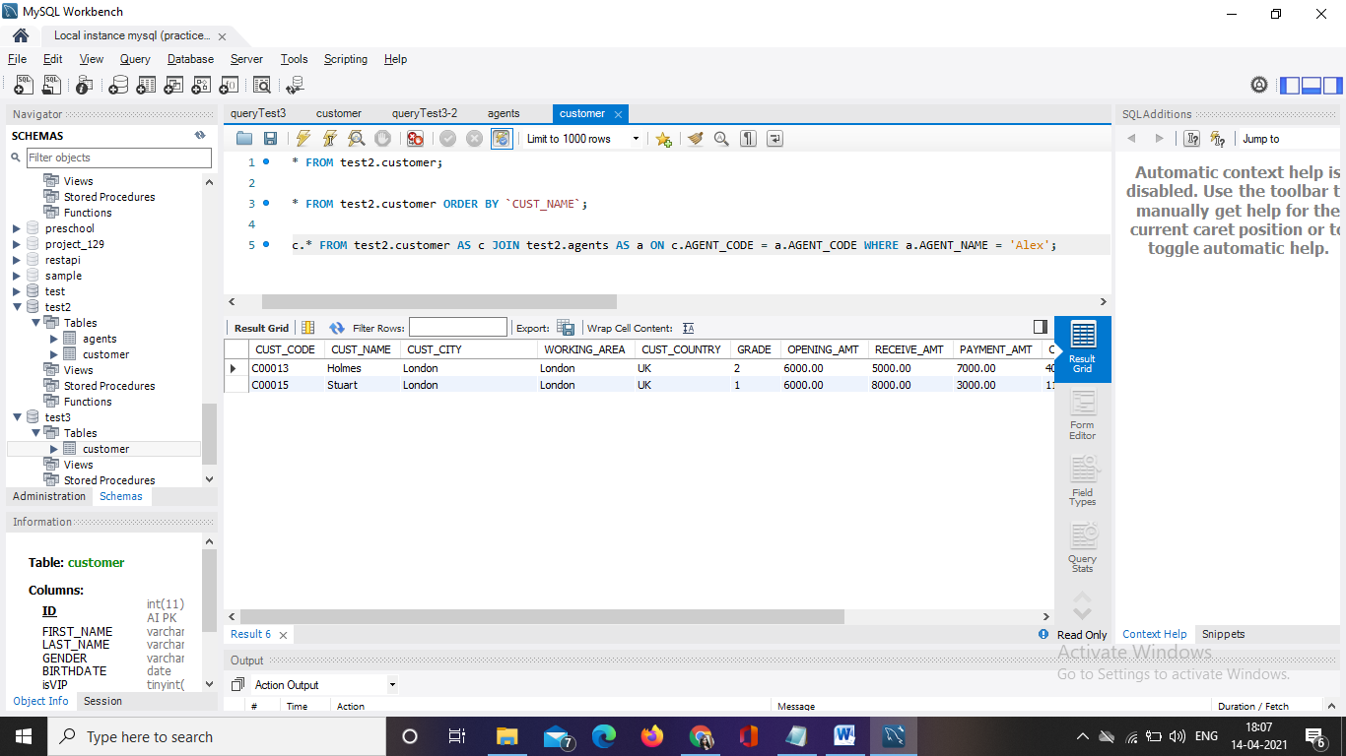

1. SELECT c.* FROM test2.customer AS c LEFT JOIN test2.agents AS a ON c.AGENT_CODE = a.AGENT_CODE WHERE a.AGENT_CODE IS NULL;

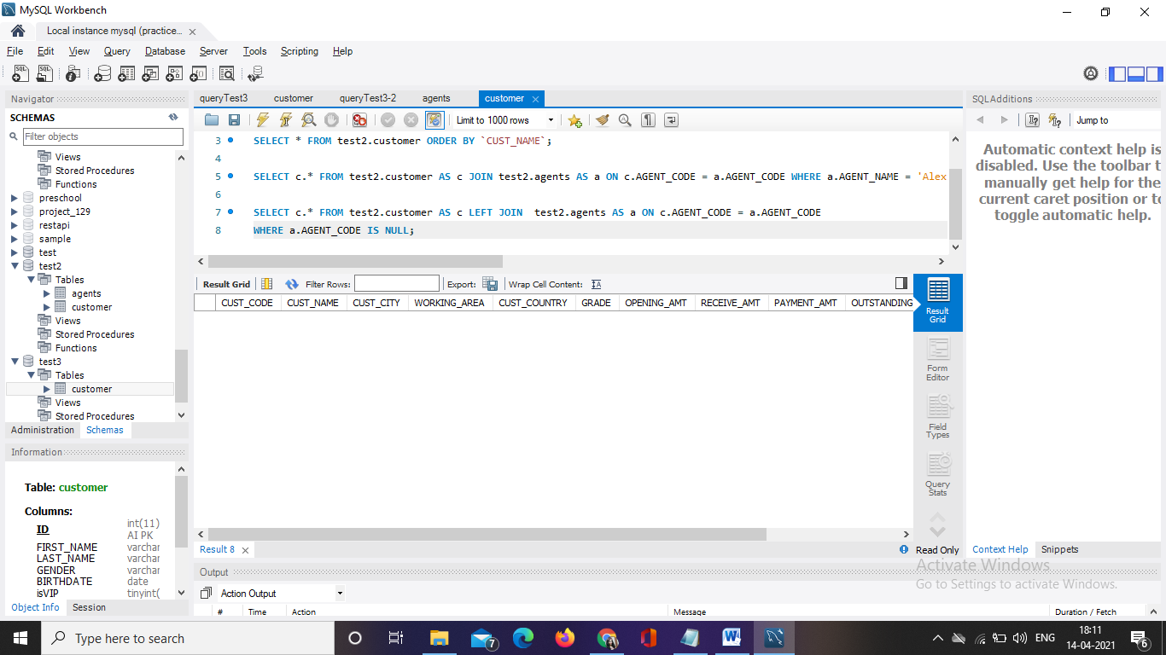

1. SELECT * FROM test2.customer WHERE OPENING_AMT = 5000 OR OPENING_AMT = 7000;

