CST2355 – Database Systems
Individual Lab Assignment 4

Hand-in:
- This template should be used to submit your lab assignment. That means you should save a copy of these instructions and then add your screenshots and other notes to that copy. Then submit the updated version to Brightspace.
- Make sure you have enough screenshots to completely document that you have completed all the steps.

Task 1: Viewing Existing Indexes (SSMS GUI)
1. Open SQL Server Management Studio (SSMS).
2. Navigate to AdventureWorks2022 database Production schema.
3. Expand the following tables:
- Production.Product
- Production.ProductCostHistory
4. Expand the "Indexes" folder under each table and review the existing indexes.
5. Provide screenshots of the indexes for both tables.
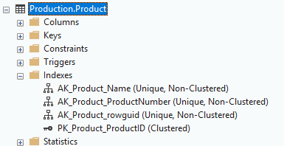

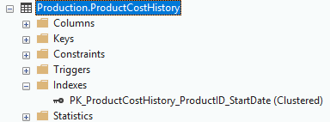

Task 2: Creating New Indexes
1. Create a non-clustered index on the 'Name' column of Production.Product.
2. Create a non-clustered index on the 'EndDate' column of Production.ProductCostHistory.
3. Provide screenshots of:
- The SQL statements you wrote.
- The successful creation confirmation in SSMS.
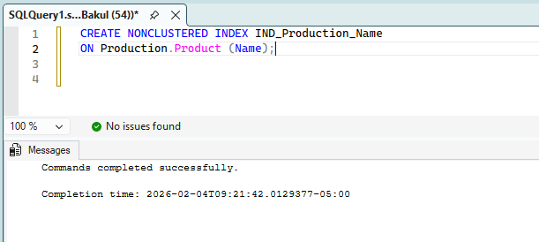

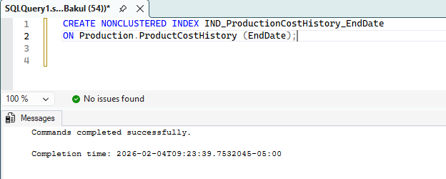

Task 3: Execution Plan Analysis (Using a Table Without Indexes)

Objective: To analyze and compare SQL Server execution plans by first querying a table with no indexes and then re-running the same query after creating a clustered index, using execution plan comparison.
Step 1: Create a Copy of Sales.SalesOrderHeader Without Indexes
Create a copy of the Sales.SalesOrderHeader table so that the new table has no indexes. (Table name / index names are your choice)
SQL> SELECT * INTO Sales.SalesOrderHeader_NoIndex FROM Sales.SalesOrderHeader;
Note: Above statement creates a copy of table with data but without any integrity constraints and indexes.
Verify that the new table has no indexes using Object Explorer or the following query:
SQL> SELECT name, type_desc FROM sys.indexes
WHERE object_id = OBJECT_ID('Sales.SalesOrderHeader_NoIndex');
Provide a screenshot showing that no indexes exist.
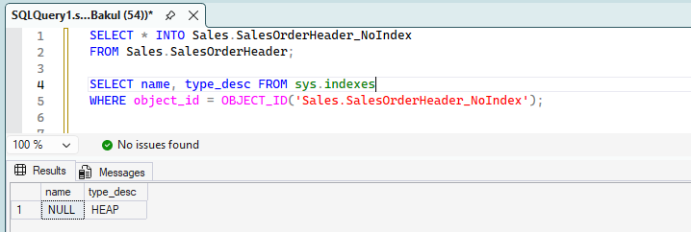

Step 2: Capture Execution Plan Without Index
Enable Actual Execution Plan: Click Include Actual Execution Plan in the toolbar or press Ctrl + M.
Execute the following query:
SQL> SELECT SalesOrderID, OrderDate, CustomerID FROM Sales.SalesOrderHeader_NoIndex
WHERE CustomerID = 29825;
In the Results pane: Click the Execution Plan tab, Right-click on the execution plan, Save the plan as EP1
Provide a screenshot of the execution plan showing the operator(s) used.
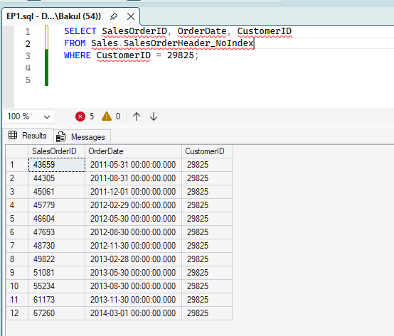

Step 3: Create a Clustered Index on the Table
Using SQL code, create a clustered index on the CustomerID column of the copied table i.e. step 1.
Step 4: Capture Execution Plan with Clustered Index i.e. repeat Step 2.
Ensure Actual Execution Plan is still enabled (Ctrl + M). Re-run the same query from step 2:

SQL> SELECT SalesOrderID, OrderDate, CustomerID FROM Sales.SalesOrderHeader_NoIndex
WHERE CustomerID = 29825;
In the Execution Plan tab, Right-click the new execution plan, Select Compare Show Plan, when prompted, choose EP1 (the execution plan saved earlier)
Step 5: Execution Plan Comparison
Provide a screenshot of the execution plan comparison, clearly showing:
- Operator changes (e.g., Table Scan vs. Index Seek)
- Relative cost differences
- Any improvement in estimated or actual cost
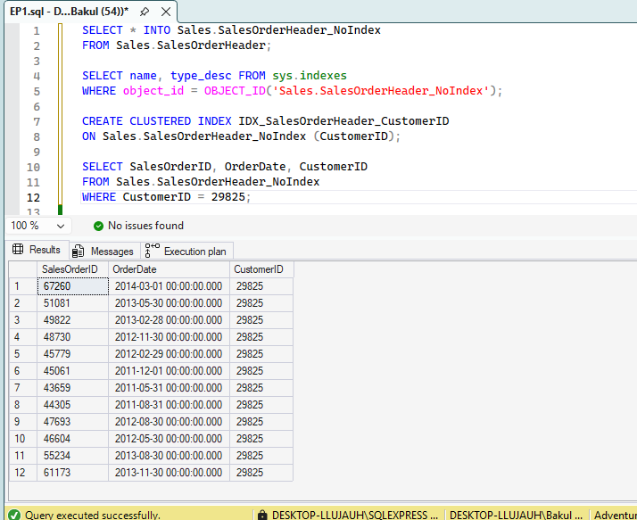

Step 6: Write a short note of your understanding of Execution Plans from the above comparison
As a comparison, I understand that indexes enhance the query performance. SQL Server implemented a table scan, which checks each row in the table without using the index. Following the creation of a clustered index, SQL Server uses a clustered index seek to locate and find the necessary data.

Task 4: Top-N Analysis – Provide screenshots of SQL code & top of the output for the below questions.
1. Find the top 5 most expensive products from Production.Product using TOP.
2. Using ROW_NUMBER(), Write a query to find the 10th most expensive product in the Production.Product.
Provide the screenshots clearly show your code and the top of the output.
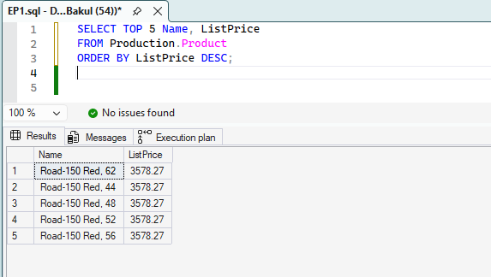

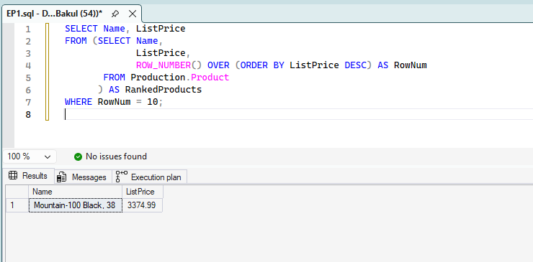

Make sure you have included all your screen shots to document your work and submit the file in Brightspace and you’re done!

