Course: CST8284
Lab 05
Hiralben Prajapati
25th March, 2026

This lab demonstrates the concept of polymorphism using a payment system for various categories of millers at Stoneware Corporation.
UML Diagram:

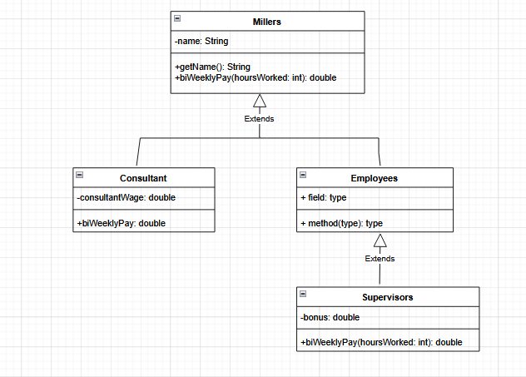

Screenshot: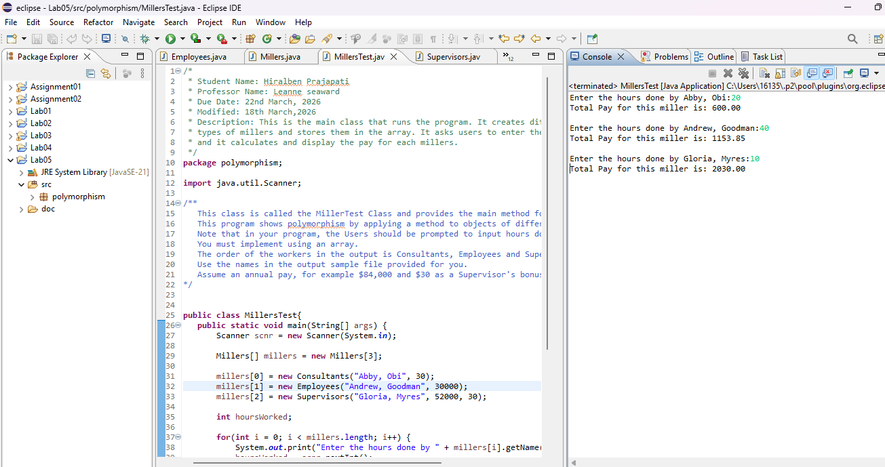

JavaDoc Screenshot.