CST2355 – Database Systems
Individual Lab Assignment 3

Hand-in:
- This template should be used to submit your lab assignment. That means you should save a copy of these instructions and then add your screenshots and other notes to that copy. Then submit the updated version to Brightspace.
- Make sure you have enough screenshots to completely document that you have completed all the steps.

Activities (Steps):
PART A: Sample Database Download & Restore
- AdventureWorks sample databases – Download
Use these links to download AdventureWorks.bak sample database:
https://learn.microsoft.com/en-us/sql/samples/adventureworks-install-configure?view=sql-server-ver17&tabs=ssms
- Restore to SQL Server
Move the AdventureWorks2022.bak or higher file to your SQL Server backup location. This location may vary depending on your installation location:
C:\Program Files\Microsoft SQL Server\MSSQL16.MSSQLSERVER\MSSQL\Backup
Now, Open SSMS and connect to your SQL Server instance.
  - Right-click Databases in Object Explorer and then select Restore Database... to start the Restore Database wizard.
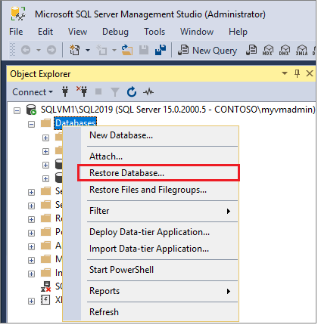

  - Select Device, and then select the ellipsis (...) to choose a device.
  - Select Add, and then choose the .bak file you recently moved to the backup location. If you move your file to this location but you don't see it in the wizard, SQL Server or the user signed into SQL Server doesn't have permission to this file in this folder.
  - Select OK to confirm your database backup selection and close the Select backup devices window.
  - Check the Files tab to confirm that the Restore as location and file names match your intended location and file names in the Restore Database wizard.
  - Select OK to restore your database.
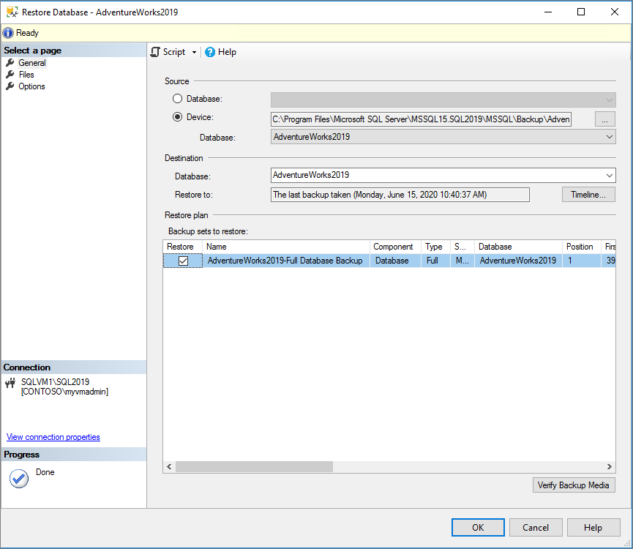
Using SSMS Object Explorer Check that AdventureWorks2022 database is restored to your server. Below is my server screenshot.
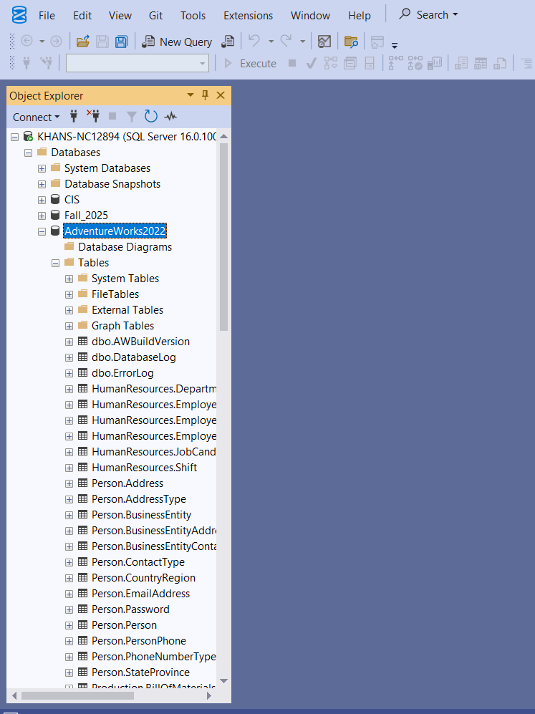
Examine the ERD of AdventureWorks2022 database:
https://www.dbdiagrams.com/online-diagrams/adventureworks/

2.7 PASTE YOUR SERVER’s SCREENSHOT SHOWING ADVENTUREWORK2022 DATABASE:
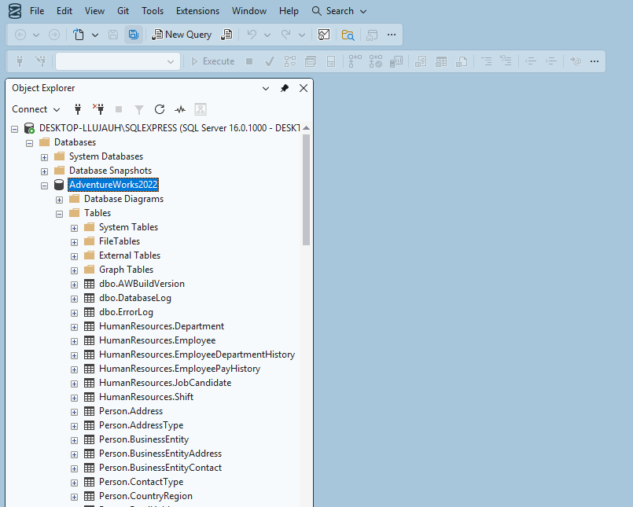

PART B: Advance SQL Queries
Provide screenshots & SQL code in txt file for each of the following questions. The screenshot should clearly show your Server Name, SQL Code & Output (Top). All sql code should be copied into notepad and upload along with this word template.
- Questions Using AdventureWork2022 database:

  - Using Production.Product table, write a query to display ProductID, Name, ListPrice. Using IIF condition of select, show all products as “Expensive” for ListPrice > 1000, otherwise “Affordable”.
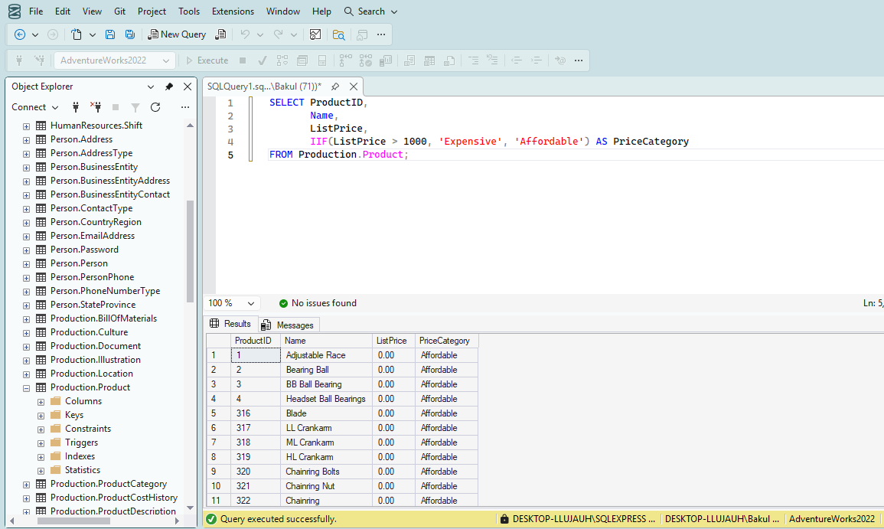

  - Using Sales.SalesOrderHeader, write a query to display SalesOrderID, OrderDate, TotalDue, and a column OrderValueCategory that classifies the order as:
'High Value' if TotalDue > 10000
'Medium Value' if TotalDue is between 5000 and 10000
'Low Value' otherwise.
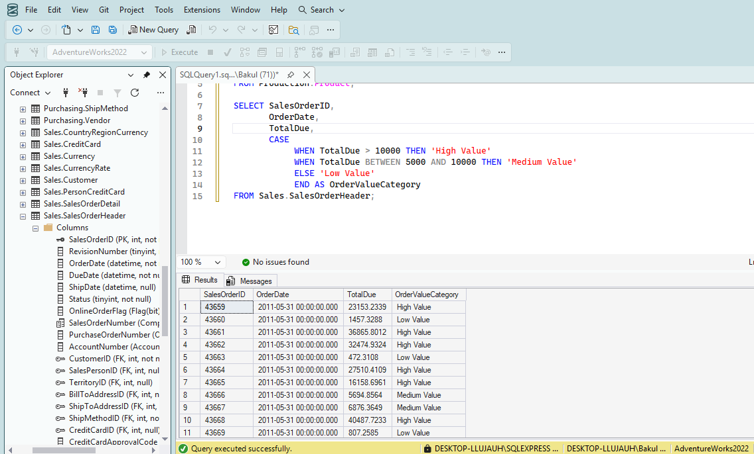
  - Find all customers (CustomerID, AccountNumber) from Sales.Customer who have placed at least one order in Sales.SalesOrderHeader. Use EXISTS in your query
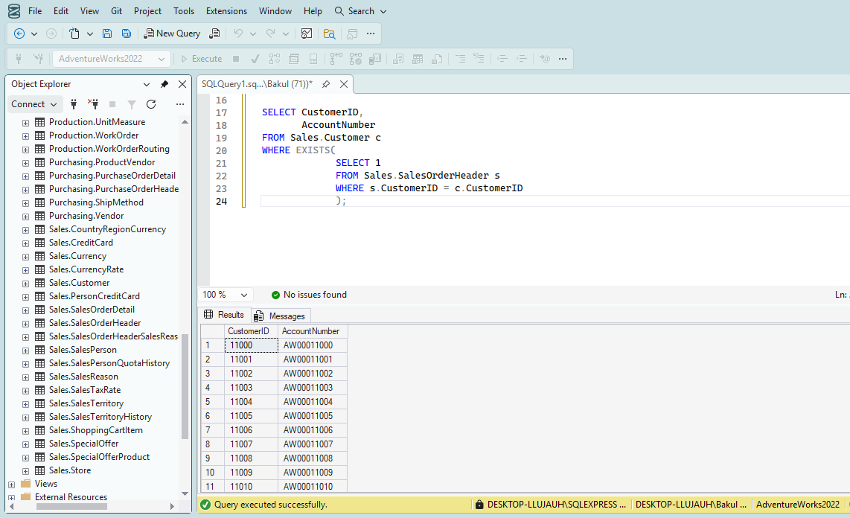
  - write a query on the HumanResources.Employee table to display the number of employees grouped by their JobTitle and Gender. The output should include: JobTitle, Gender, No_of_Emp (Alias for count of employee). Results ordered by JobTitle and Gender.
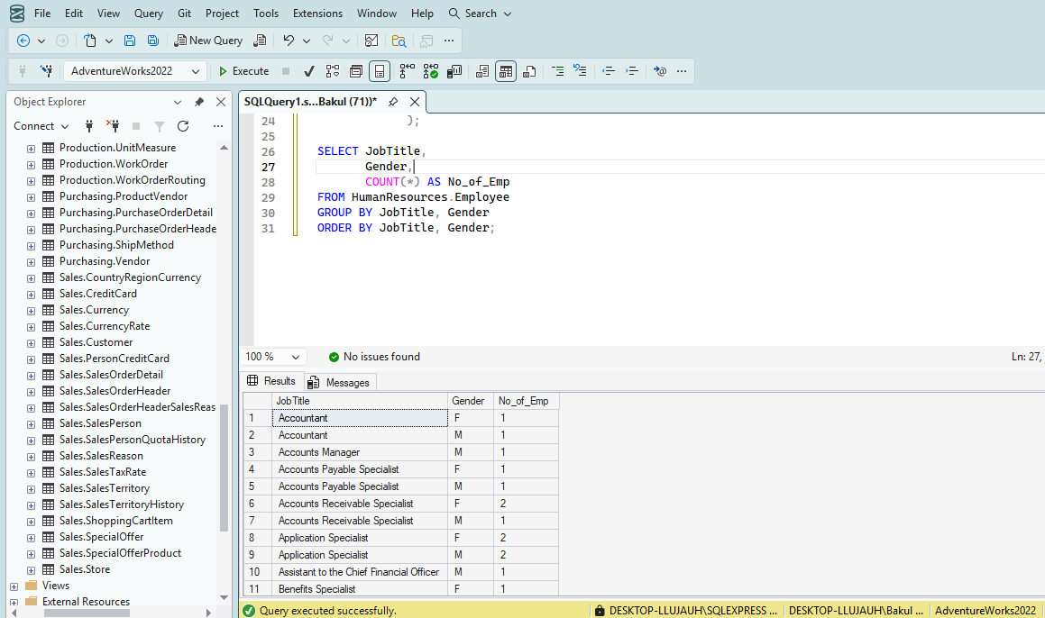
  - Now, Add ROLLUP to 3.4 code and compare the output.
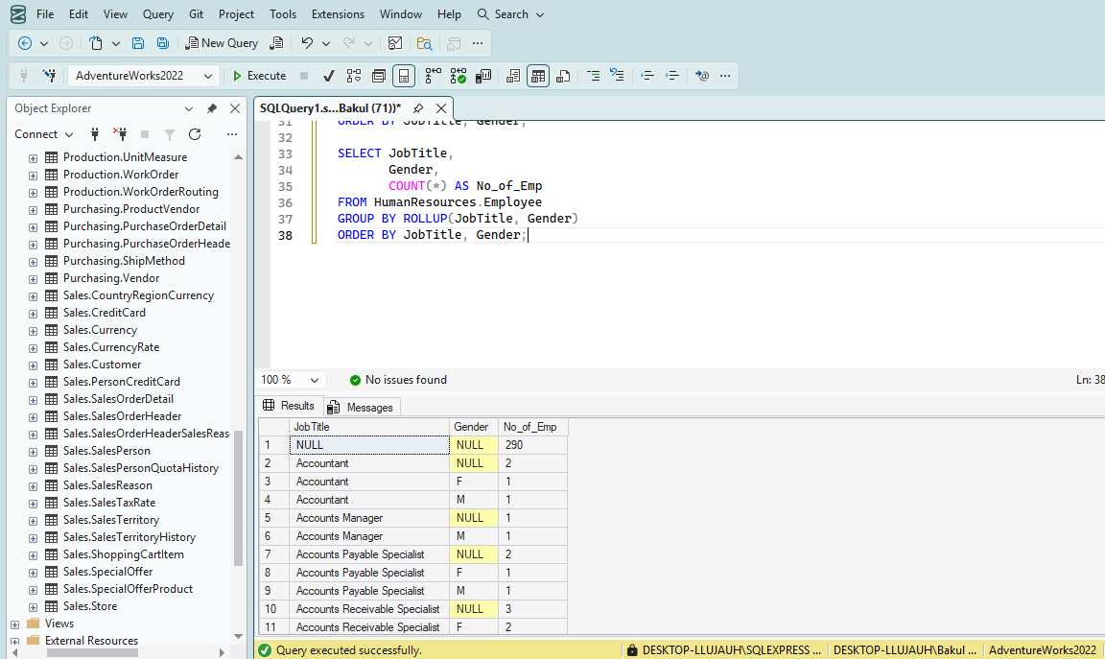
3.5. Add CUBE to 3.4 code and analyze the output.
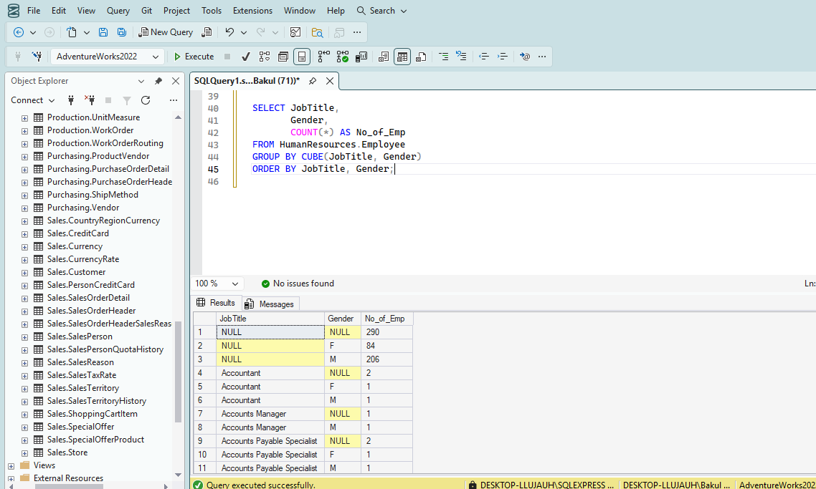
  - Using Sub Queries, find the products (ProductID, Name, ListPrice) from the Production.Product table whose ListPrice is greater than the average ListPrice of all products.
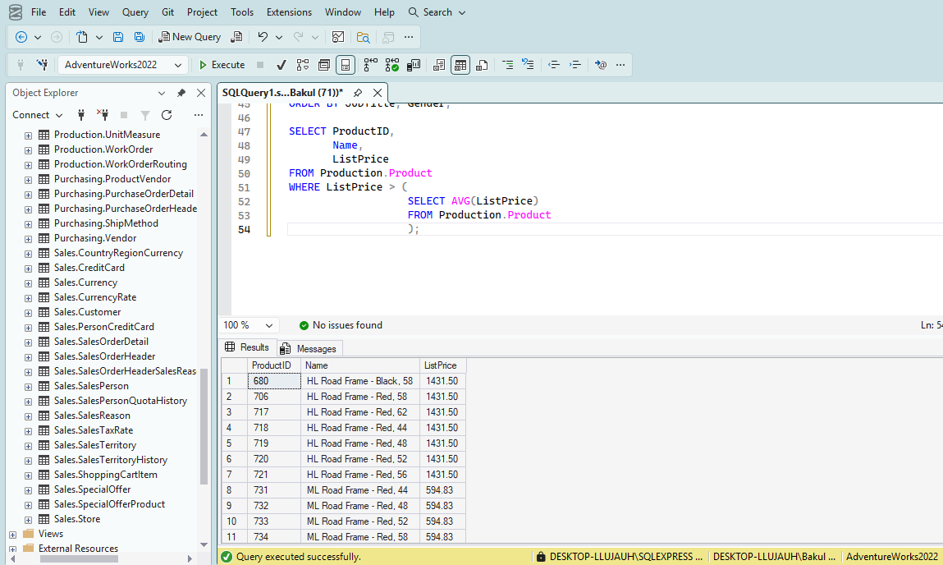
3.7 List the ProductID, Name, ProductSubcategoryID, and ListPrice of products whose ListPrice is greater than the average ListPrice of products in the same ProductSubcategory. HINT: Co-Related Sub Query.
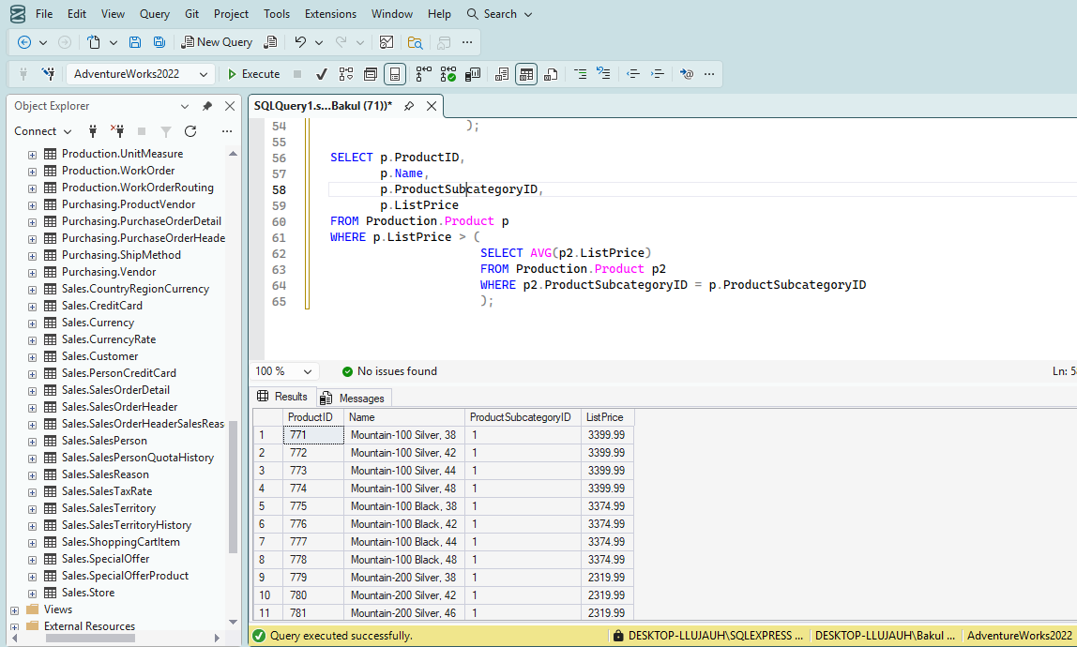

Make sure you have included all of your screen shots to document your work and submit the file in Brightspace and you’re done!

