CST2355 – Database Systems Individual Lab Assignment 2

Student Name: ___Hiralben Prajapati___
Student ID: ___041219844________
Student email: ___praj0083@algonquinlive.com__

Hand-in:

- This template should be used to submit your lab assignment. That means you should save a copy of these instructions and then add your screenshots and other notes to that copy. Then submit the updated version to Brightspace. This will thoroughly document your work and make it much easier to review before the midterm test.
- Make sure you have enough screenshots to completely document that you have completed all the steps.

Activities (Steps):

- In this lab you will be using the Microsoft SQL Server 2022 (or latest available) database management system, and the MS SQL Server Management Studio (Version 19). The first step is to get the software installed.
  - Follow the instructions below to install MS SQL Server 2022 (Developer Edition) and the SQL Server Management Studio 20
    - Navigate to: https://www.microsoft.com/en-ca/sql-server/sql-server-downloads
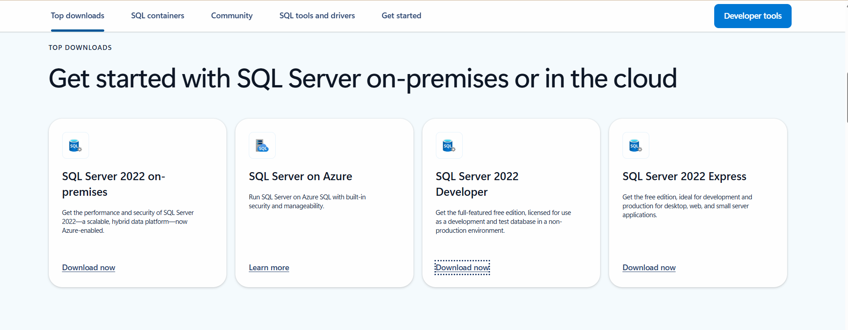
    - NOTE: Make sure you take a screenshot of the confirmation screen that shows all of the configuration folders, when you download and install the Developer edition – Basic Install. (Use the “Basic” installation configuration).
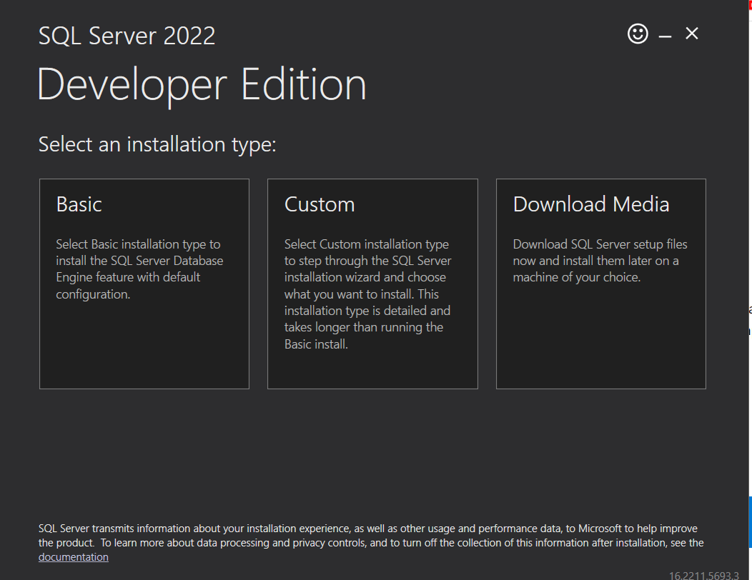
End of Installation. Continue to “Install SSMS”
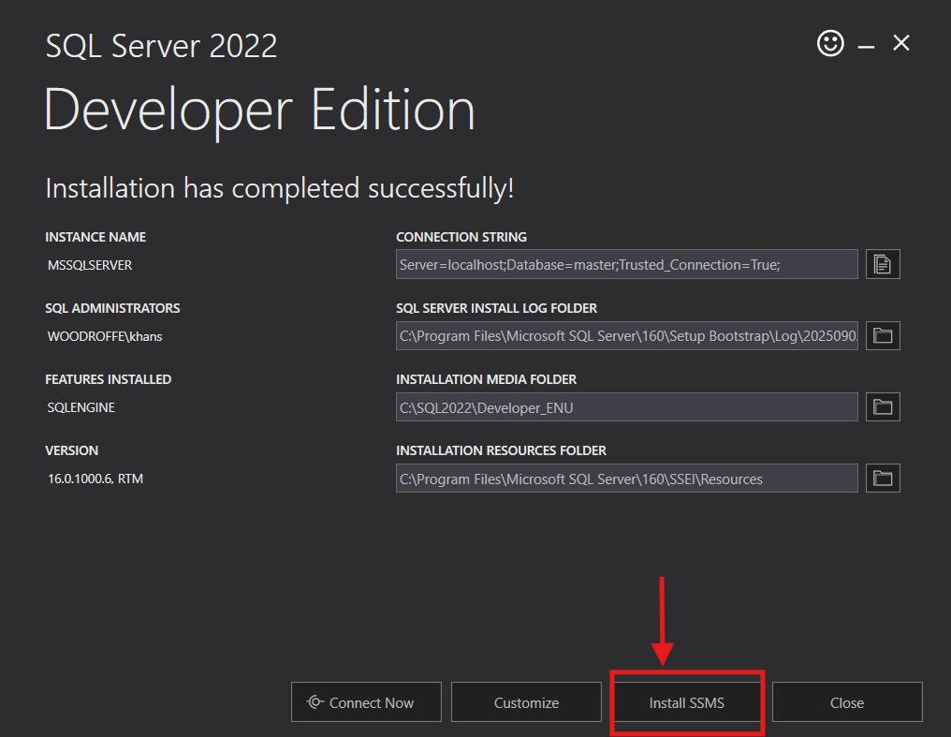
If you missed this step, here is the link to install SSMS: https://learn.microsoft.com/en-us/ssms/install/install?redirectedfrom=MSDN
    - Paste YOUR SQL Server installation confirmation screen here:
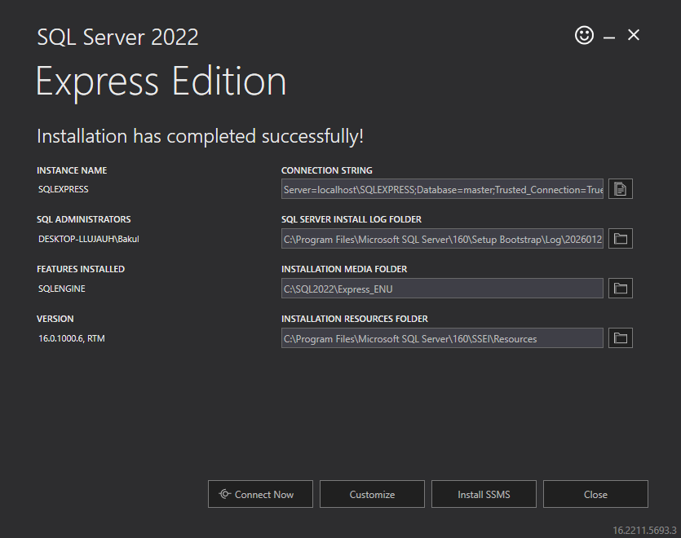

  - Paste your SSMS login screen here – Below is my login screen sample:
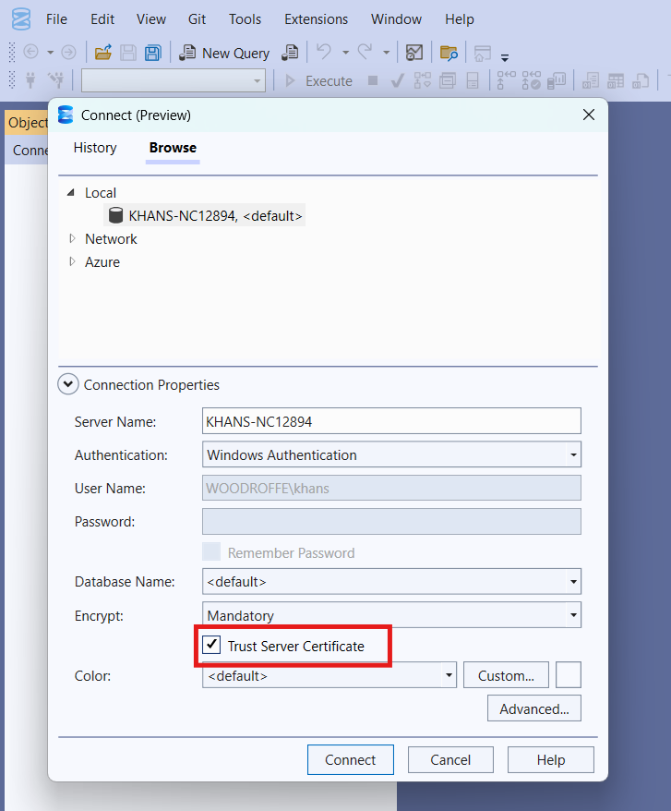
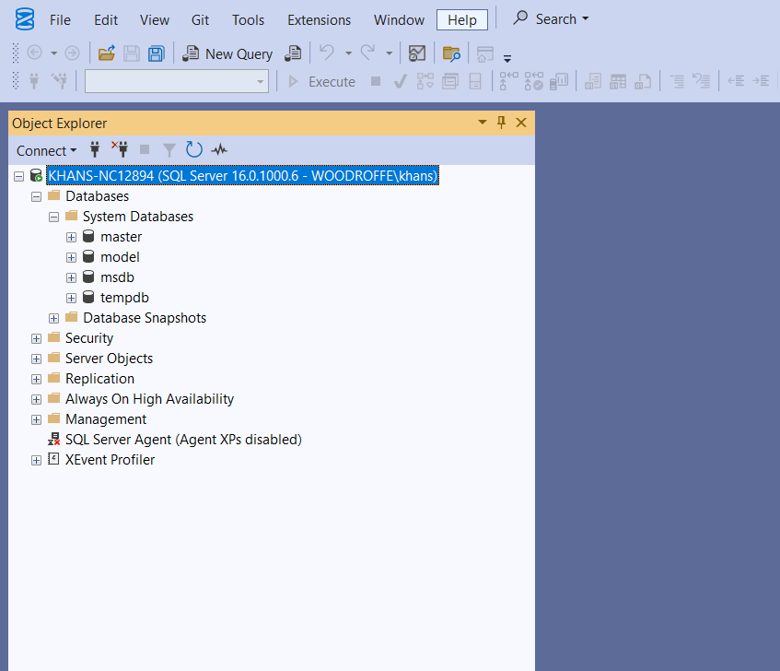

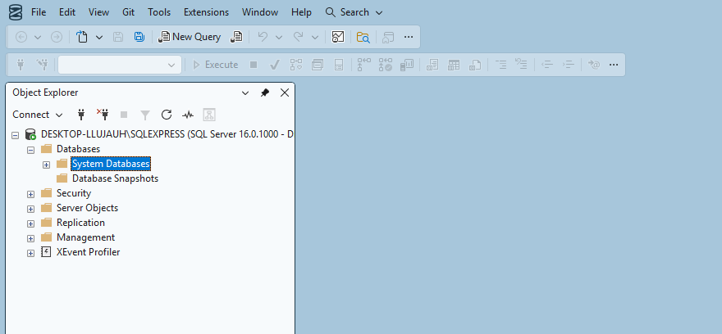

- We are going to import our “Departments” and “Employees” tables from Microsoft Access (lab 1). (Note: the lab professor may require you to use a different table and/or field – see step 2.) The simplest way to do this without any glitches from version mismatches and missing adapters is to export the data from Microsoft Access into separate Microsoft Excel or .csv (comma-separated-value) text files and then import those files into SQL Server: as follows;
  - Open your lab 1 version of the Northwind database that contains the “Departments” table and your updated “Employees” table.
  - Select the “Departments” table and then right mouse click and select the “Export ->Text File” option from the Develop Menu. (See below)
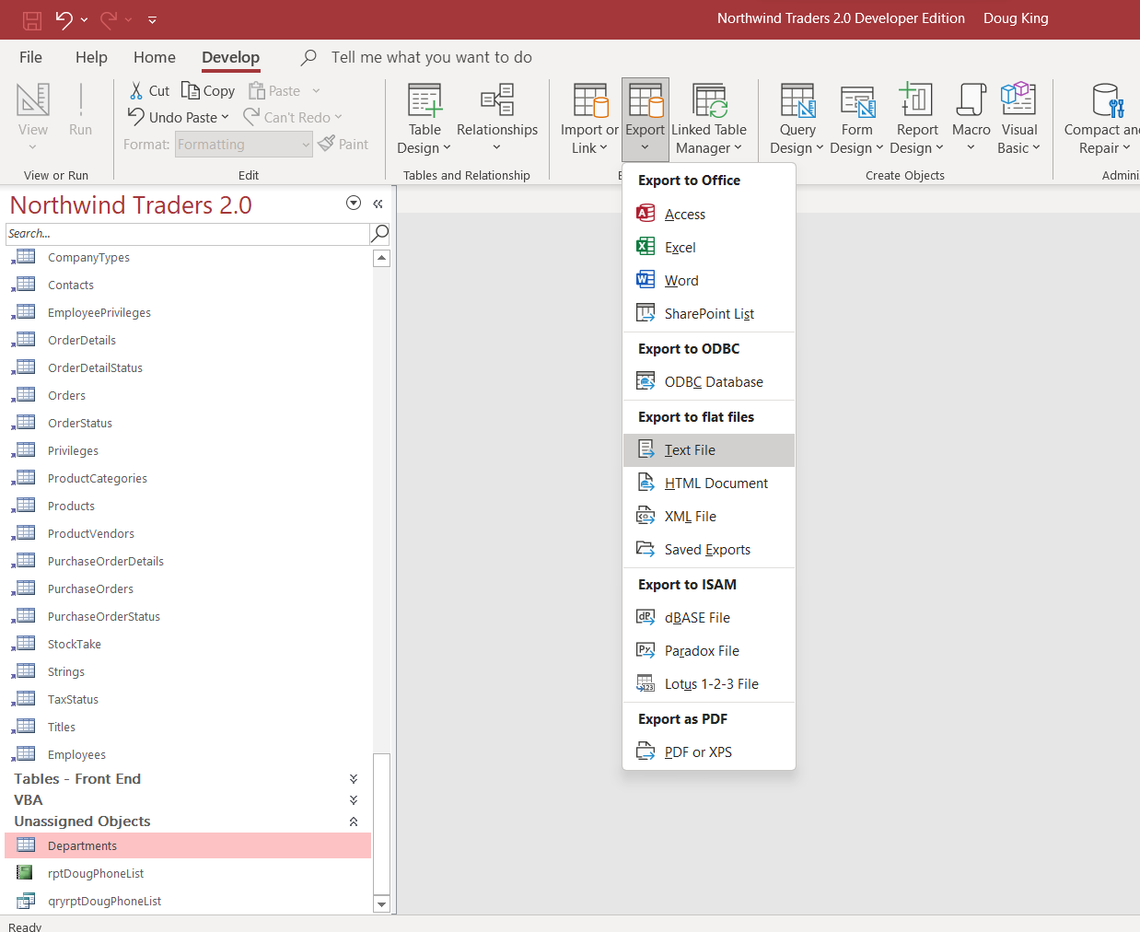
  - You will then be prompted as follows…
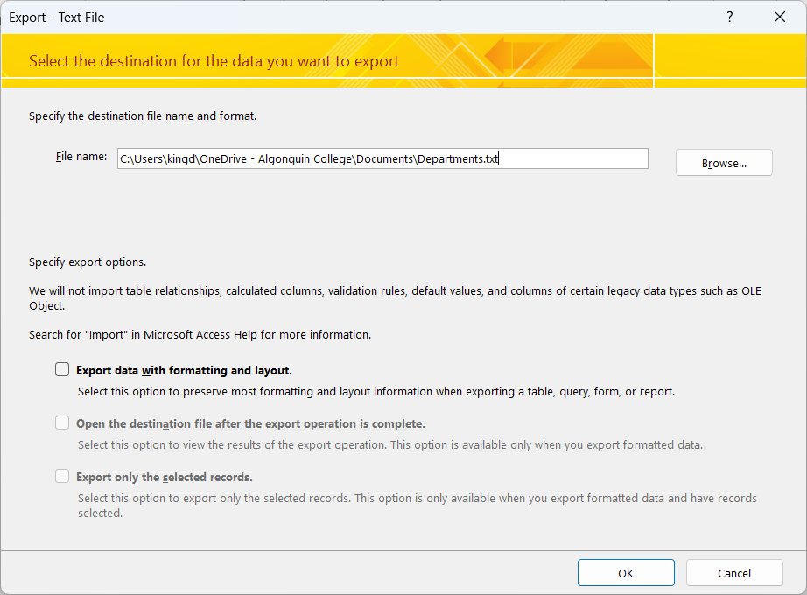
  - DO NOT select the export data with formatting and layout. Then when you click OK you will get prompted for delimiter options….
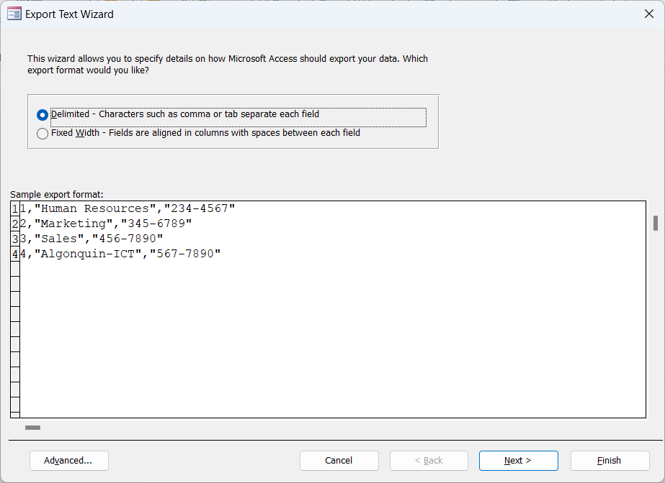it
  - Select the ‘Delimited’ option and click Next. You will then get prompted as follows….
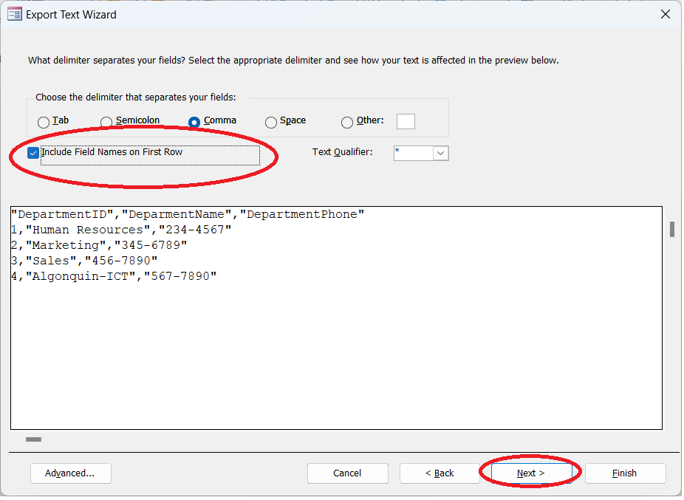
  - Make sure you DO select the “Include Field Names in First Row” option, and then Click Next.
  - Continue the exporting process for the “Departments” table, and repeat the process in a similar fashion for the “Employees” table.
- Continue by using SSMS (or re-open it if you have closed it and connect to your server).
  - Once launched, select “Databases” and create a new one (right-mouse click, etc.) named “lab2”.
  - Select the lab2 database and then use the right-click menu to select the Tasks > Import Flat File option. You want to import the “Departments” text file. The sequence is straightforward (try it) BUT make sure you select the “DepartmentsID” field as the primary key when prompted (see below).
    - When you get prompted for the Primary key
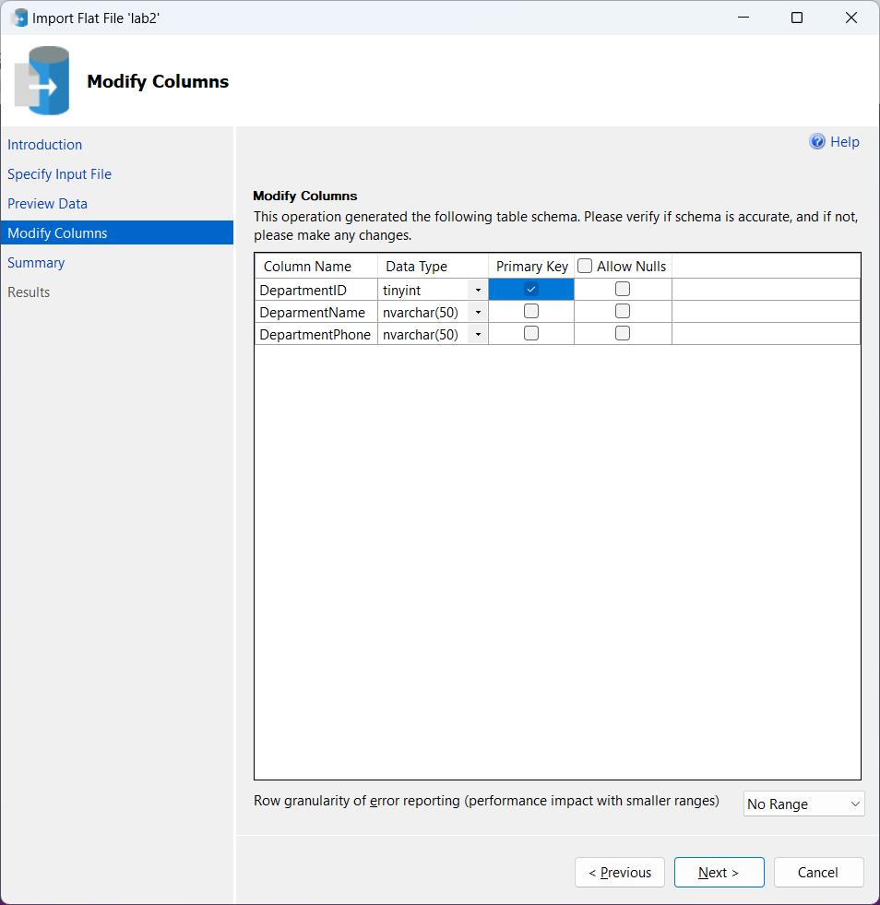
  - Once the Departments table is successfully imported, repeat the process in a similar fashion for the “Employees” table. You should now be able to see your imported tables inside the lab2 database. (Note: the lab professor may require you to use a different table and/or field – see step 2.)
  - Now you can use SSMS to build a New query to verify that the data was imported correctly:
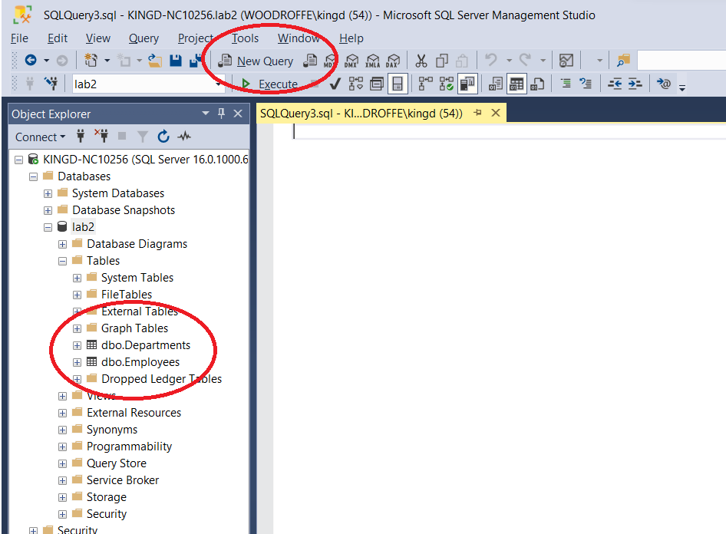
  - and execute it to show all the data in the imported table. Here is my table:
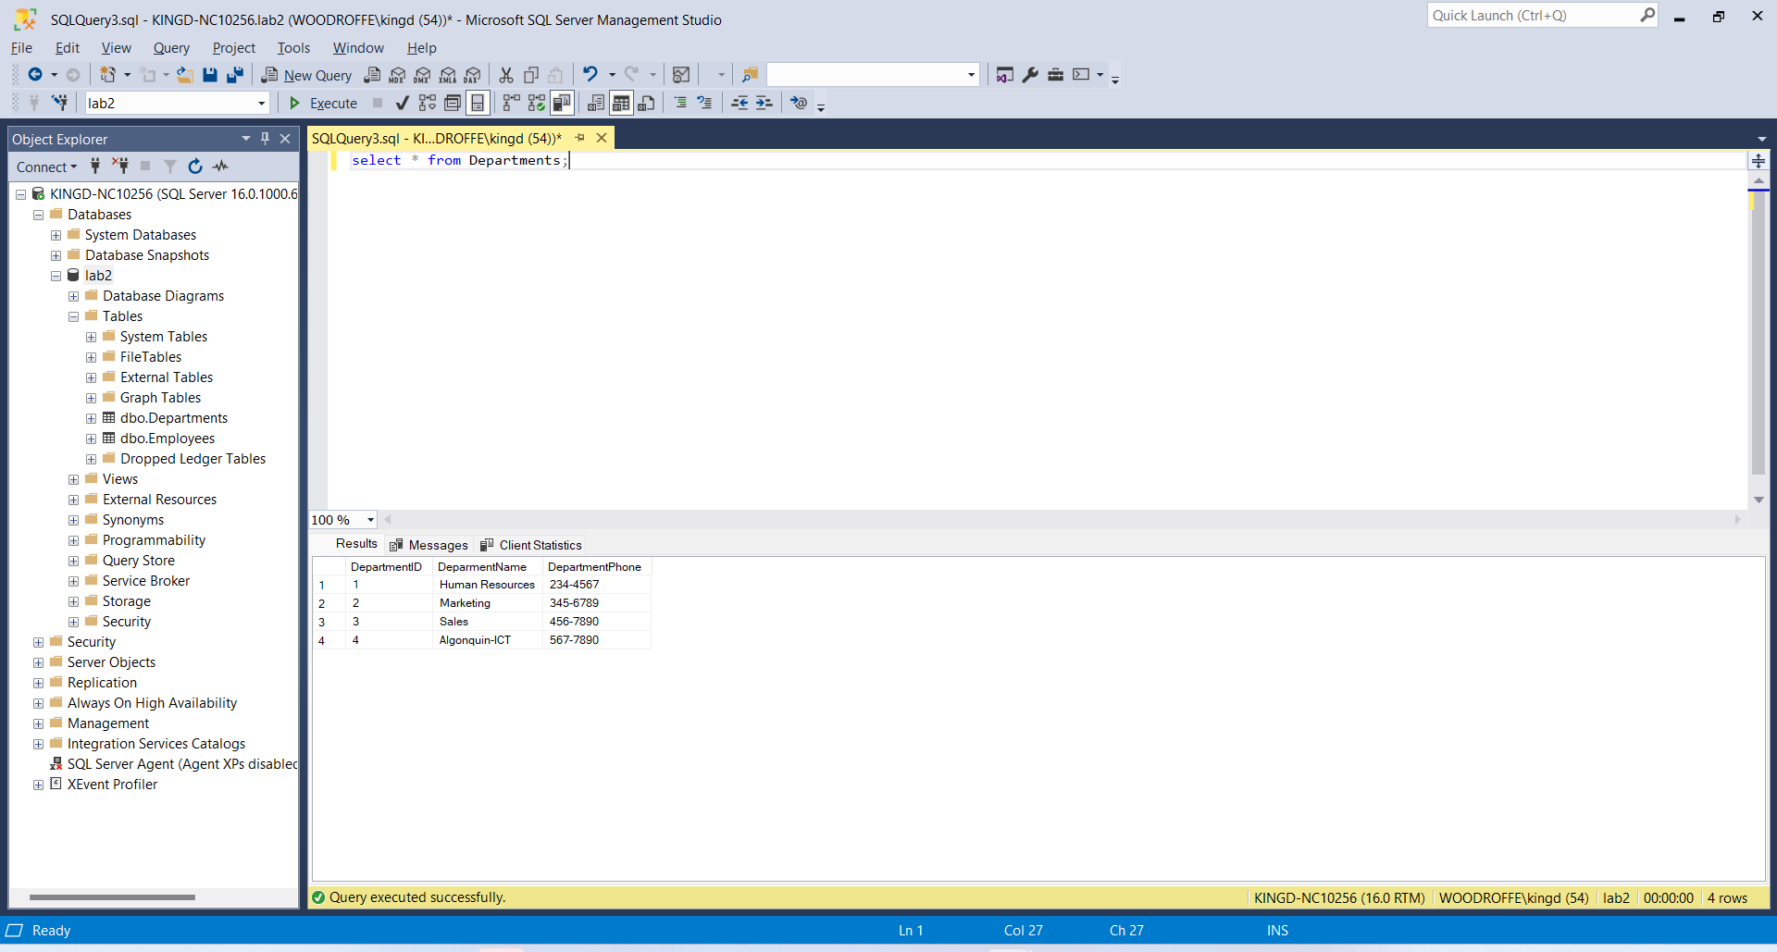
Paste your screen shot here showing your table contents:
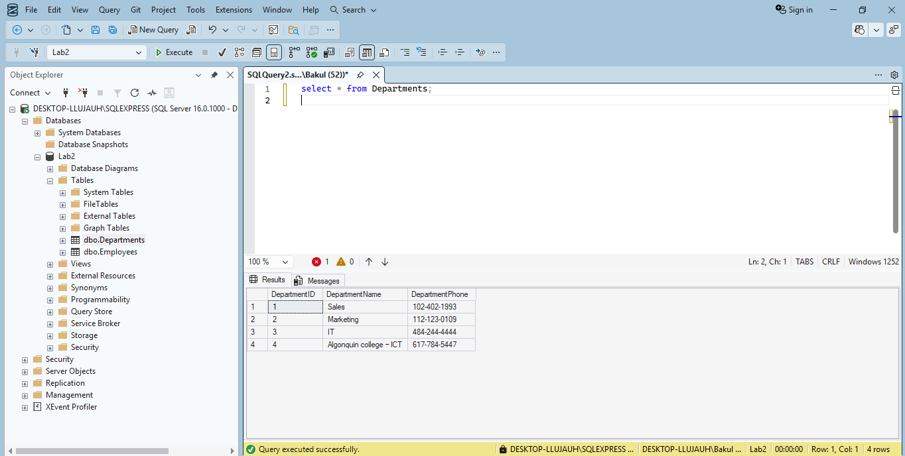
- We want to allow remote applications (not just local SSMS) to connect using a username/password without relying on Windows authentication. This will allow MS-Access and other applications running on a client workstation to access the remote data.
  - Select your server and open the properties window.
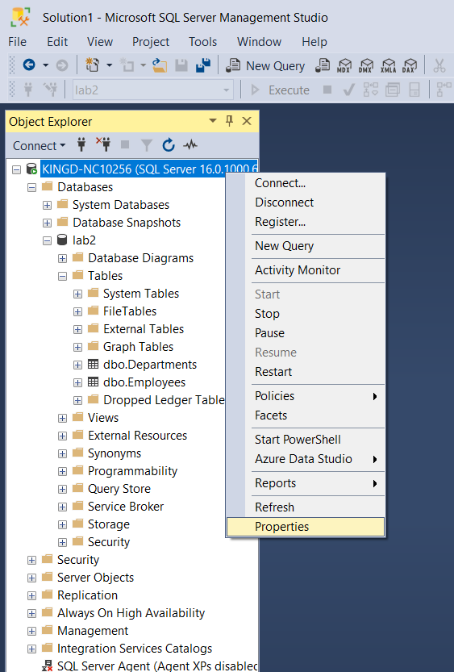
  - In the properties dialog, select the Security page and then the option for “SQL Server and Windows Authentication Mode”.
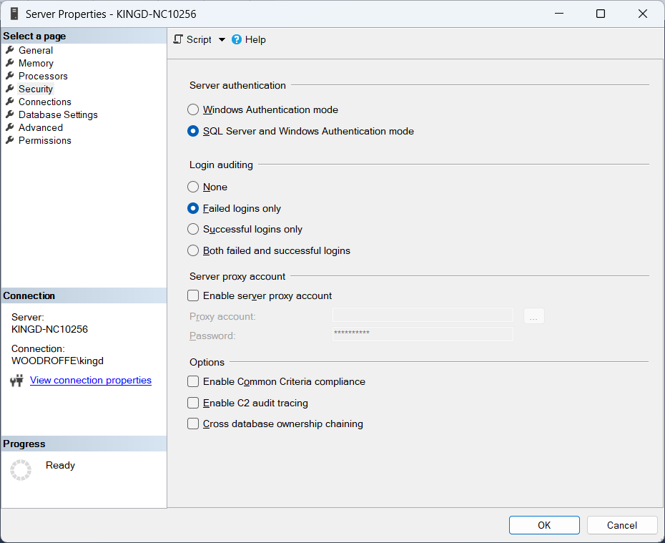
  - On the Connections page, select the “Allow Remote Connections to this server” option.
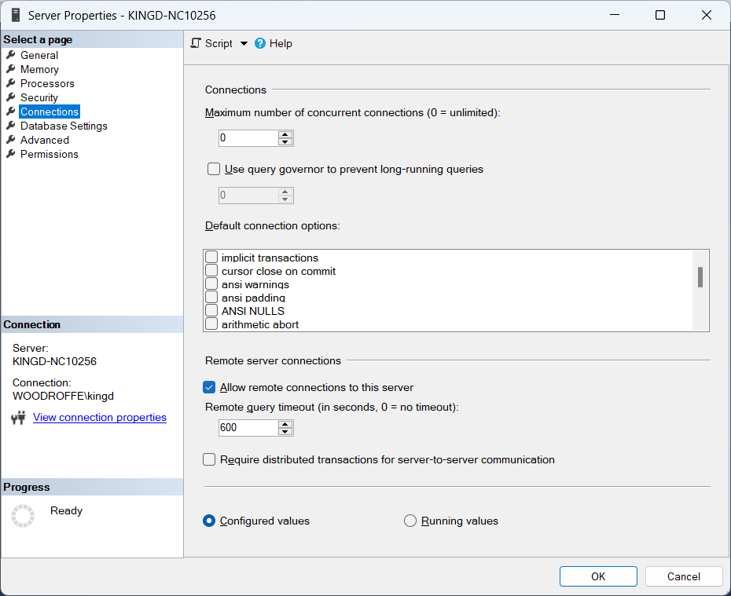
  - After you have made these changes, you will need to restart the server.
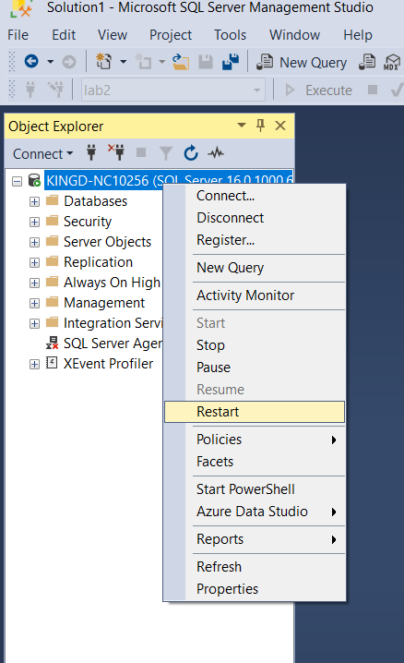
  - One last thing on the server side – we need to create a new user account for our applications to use when they connect. Use yourlastnameUser (e.g., kingUser) with a simple password (e.g., kingPassword123) and perform the following steps:
    - Open the dialog to create a new login
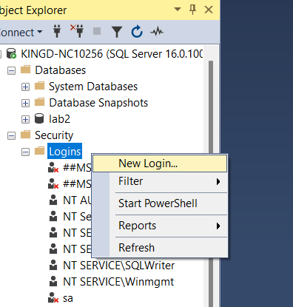
    - In the dialog for new login, select the General page and fill in the following fields. This step needs to be done carefully – make sure you set the default database and unselect the password expiry fields…. Otherwise you will not be able to connect easily from applications.
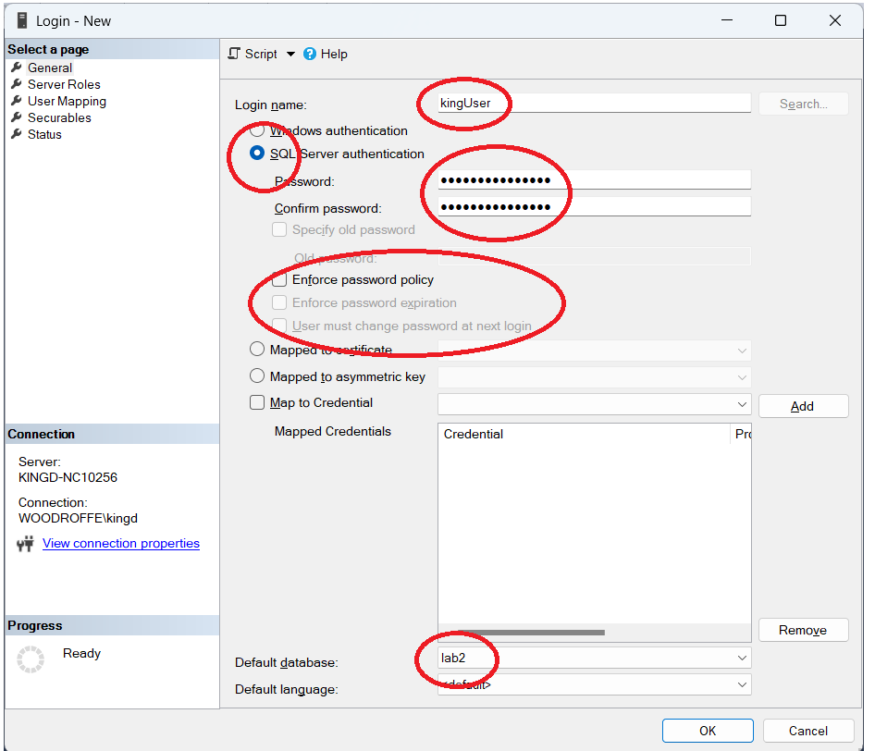
  - If successful, you will see your new login in the list…
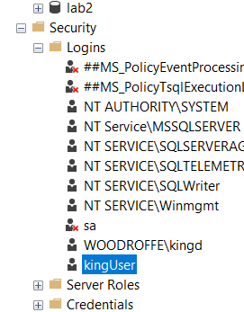
  - Now, while still connected as the Windows login user, (e.g., kingd) run the following sql commands to change the ownership of the database lab2. (you will need to change the login name to yourlastnameUser).

USE lab2;
EXEC sp_changedbowner 'kingUser', 'true';

- Now open a new connection to the (restarted) server and connect using your new login and password. You should be able to see your data in the lab2 database.
  - Provide a screenshot for a query showing the content of each of the tables. Make sure the screenshots clearly show your connection login, the queries being executed, and the results.
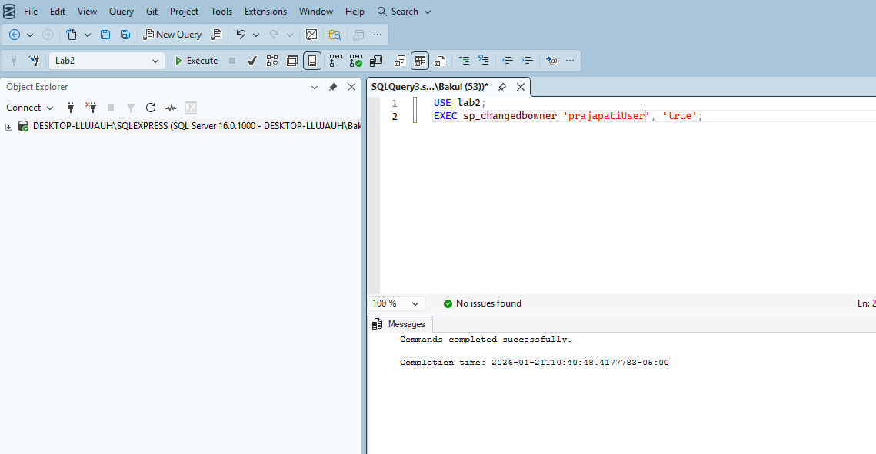
- Make sure you have included all of your screen shots to document your work and submit the file in Brightspace and you’re done!

