CST2355 – Database Systems Lab Assignment 1

Student Name: ___Hiralben Prajapati___
Student ID: ___041219844__
Student email: ___praj0083@algonquinlive.com_

Hand-in:

- This template should be used to submit your lab assignment. That means you should save a copy of these instructions and then add your screenshots and other notes to that copy. Then submit the updated version to Brightspace. This will thoroughly document your work and make it much easier to review before the midterm test.
- Make sure you have enough screenshots to completely document that you have completed all the steps.

Activities (Steps):
- Install MS-Office with MS-Access (if necessary)
  - Use the free MS-Office 365 license that you have been provided by Algonquin.

- Create a new database using Microsoft’s “Northwind” online database template.
  - Open MS-Access
  - Select File > New and search for Northwind
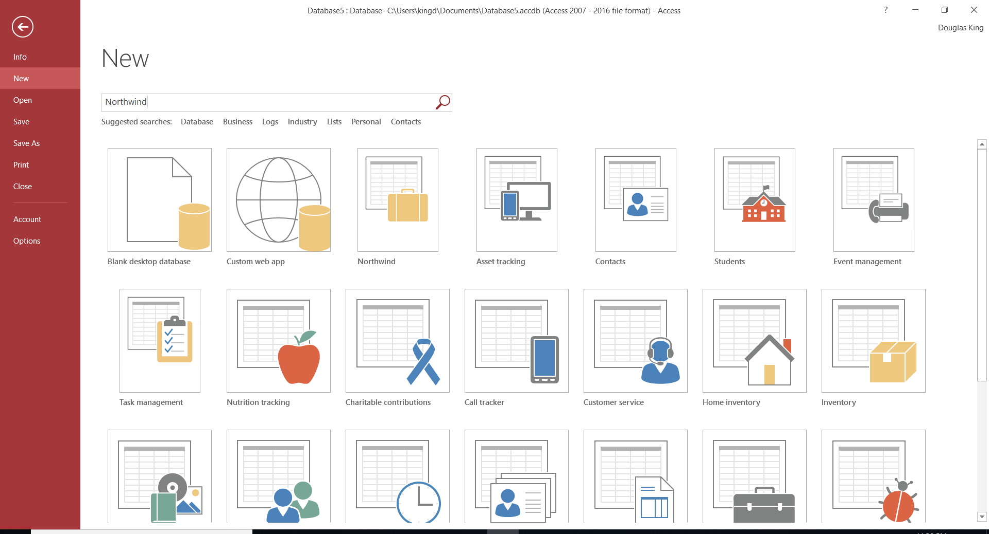

  - If you have the option for a “Northwind Starter” edition – take that option.
  - Once the database is created (it might take a few minutes…), if prompted, enable the content and investigate the Northwind database. Do not worry – if you make a mess, you can always recreate a new copy using the template.
  - Navigate to find the “Employees” table.
    - Open the table and see how easy it is to edit the table contents!
- Investigate the database structure and MS-Access features.
  - Navigate in the list of database objects to find two “reports” (i.e, non-interactive reports– with output in printable format). Provide a screenshot for each of the two reports.
    - First report:
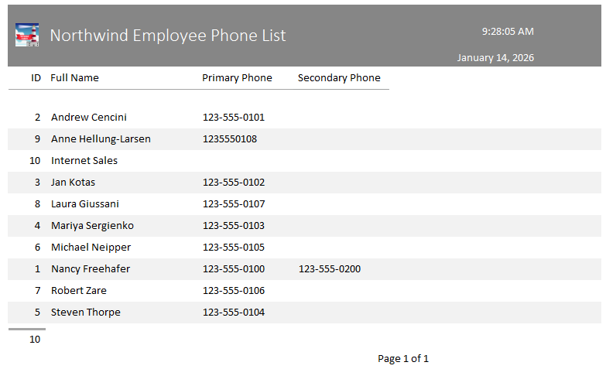

    - Second report:
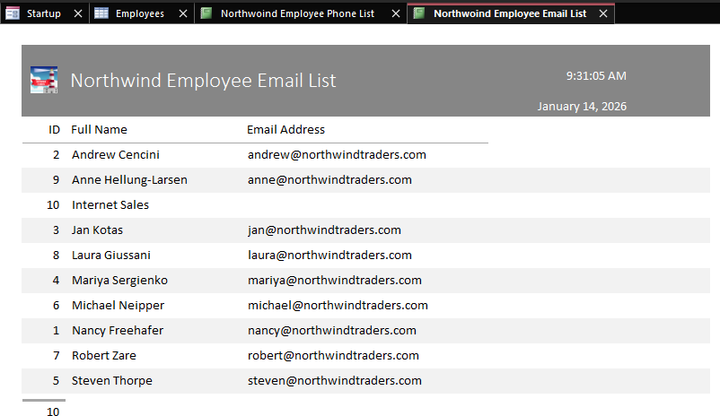

  - Navigate in the list of database objects to find two “forms” (i.e, interactive user interface allowing updates to the underlying data). Provide a screenshot for each of the two forms.
    - First form:
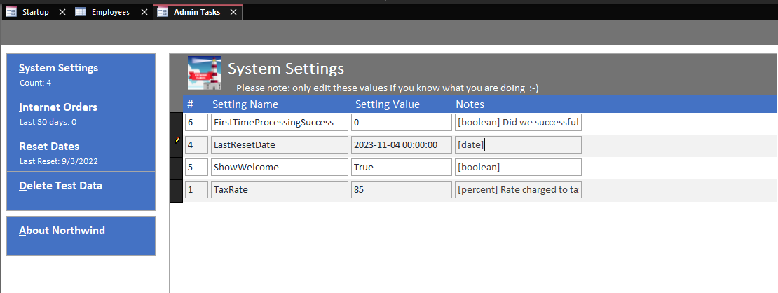

    - Second form:
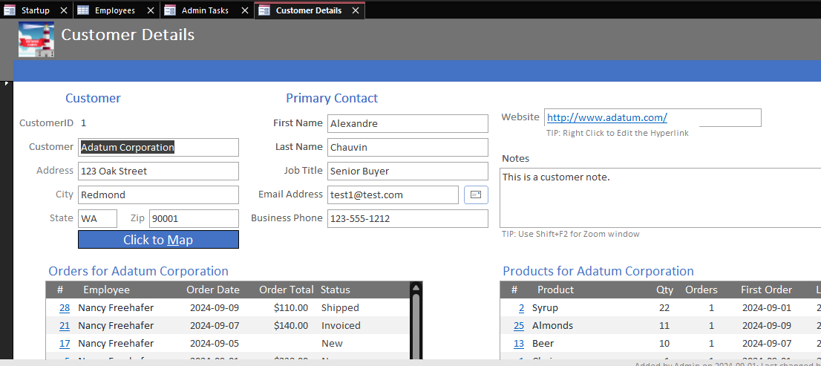
- Now we are going to update one of the reports to create a new report with data from a newly added column.
  - First, we will add a new column called “DepartmentID” to the employee table (Note: the lab professor may require you to use a different table and/or field – see step 2.)
    - Open the table “Employees” in design view.
    - In the list of columns, add a new column called “DepartmentID” of type Number (Long Integer).
    - Save the Employees table and then open it in the “Datasheet View” and update the value of the new field for all of the existing records in the employee table. (Use made up DepartmentID values; 1, 2, or 3.)
    - After updating the existing entries in the “Employees” table, add a new record to the employees table using your own name and with the value 4 for DepartmentID. (IF you have the Northwind Developer version open, and you were prompted for a user, you might find that you have already been added to the employees table….)
    - Provide a screenshot of the “Employees” table showing the updates to the Department column and make sure your own record is visible with the value 4 for DepartmentID.

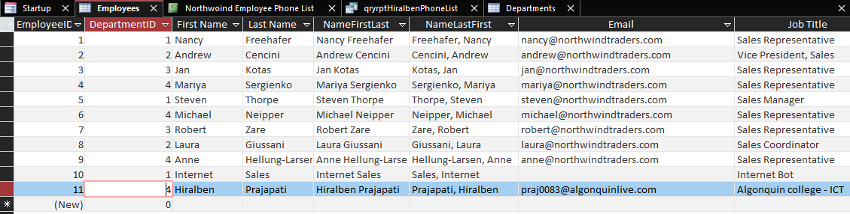

- Create a new table for “Departments” (using the Developer menu), with a numeric primary key called DepartmentID.
  - Add fields to “Departments” table to store the “DepartmentName” and the telephone number (both as text strings).

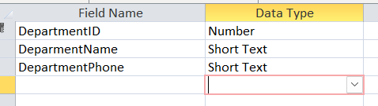
    - Populate the “Departments” table with data for DepartmentID values of 1,2,3, and 4. Use “Algonquin college – ICT” as the department name for the department with DepartmentID having the value 4. This will mean that you are associated with that department.
    - Save the Departments table.
- Open the report that has the “Employee Phone List”. (Depending upon the version of Access you have installed, it likely is called something like ‘rptEmployeePhoneList’). Your record should be visible in the report, listed alphabetically. Provide a screenshot showing you in the report.
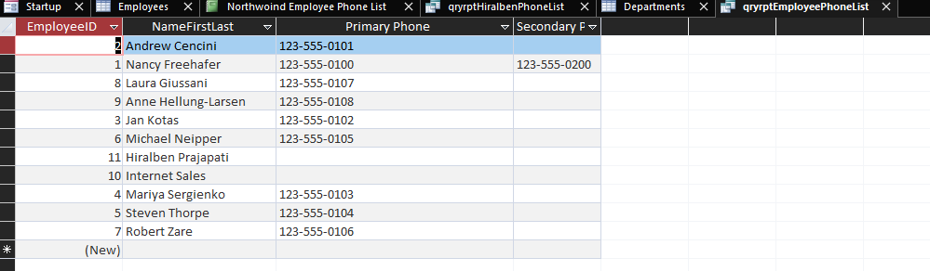
- Switch to “Design View” in the employee phone list, and select the ‘Record Source’ from the property sheet – as shown below – click on the black square in the Design View, and then adjust the property sheet to be able to see which record source has been used. In my case the record source is “qryrptEmployeePhoneList”. See below:
Provide a screenshot showing the name of the record source for your report.
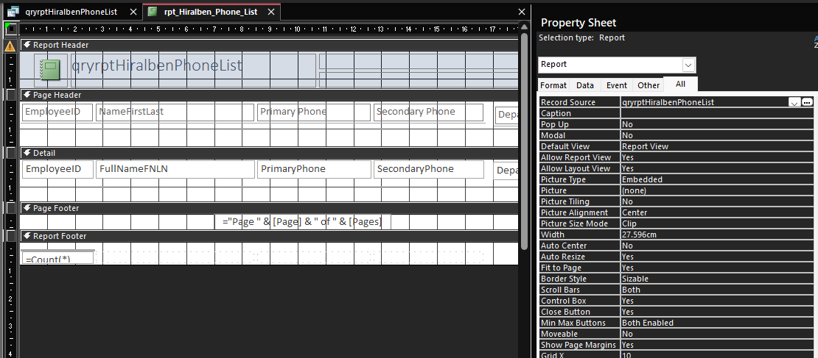

- Now we are going to make a new report, using the beautifully formatted Microsoft report as a model. The new report will also have the department name and department telephone number as additional fields.
  - Here are the steps we will be doing:
    - Copy the report to a new one with your name in it: “rptDougPhoneList”.
    - Edit the new copy of the report to have the new different record source (e.g., qryrptDougPhoneList).
    - Save the edited version of the new copy of the report.
    - Copy the original record source to a new one with your name in it: e.g., “qryrptDougPhoneList”.
    - At this point, you will have your two new items (the new report and the new record source) in the “Unassigned Objects” group at the lower end of the navigation pane (see below).
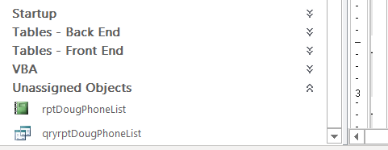
      - Now we will use the following steps to edit the record source to also have the department name and telephone number. This is a bit complicated because we have to change the record source’s underlying query to include a join from the employees table to the departments table…
        - Open the new query (e.g., qryrptDougPhoneList) in Design View. You should see something like this:
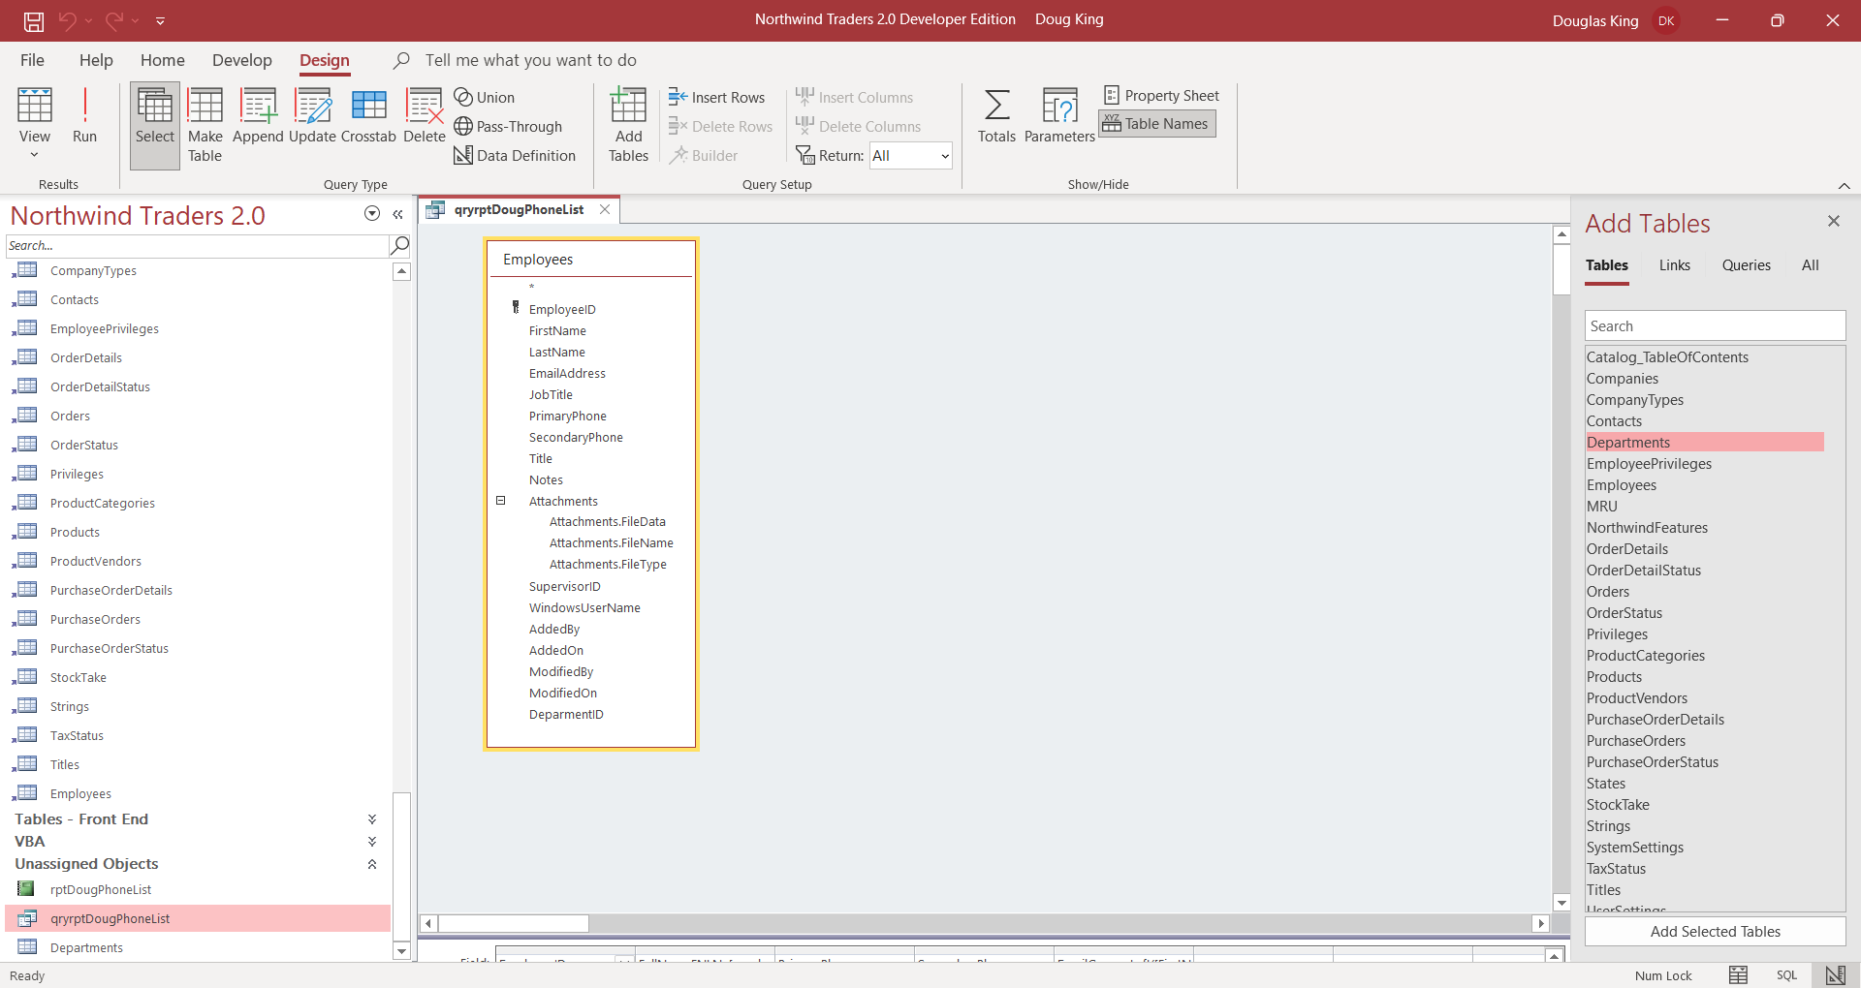
        - In the Design window, from the right mouse click menu, select “Show table” to select the the “Departments” table
        - Create a relationship between Departments.DepartmentID and Employees.DepartmentID by doing (mouse down on Departments.DepartmentID, drag, mouse up on Employees.DepartmentID).
        - Then select the new relationship, right mouse click and set the join type property (see below):
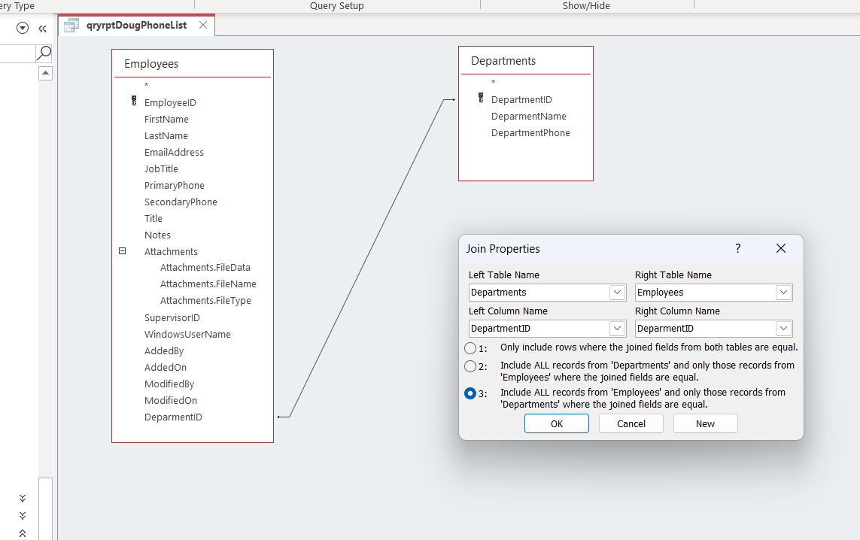

    - Then double click on the “DepartmentPhone” and “DepartmentName” fields to have them added to the select list for the query. Here is the result (save the query).
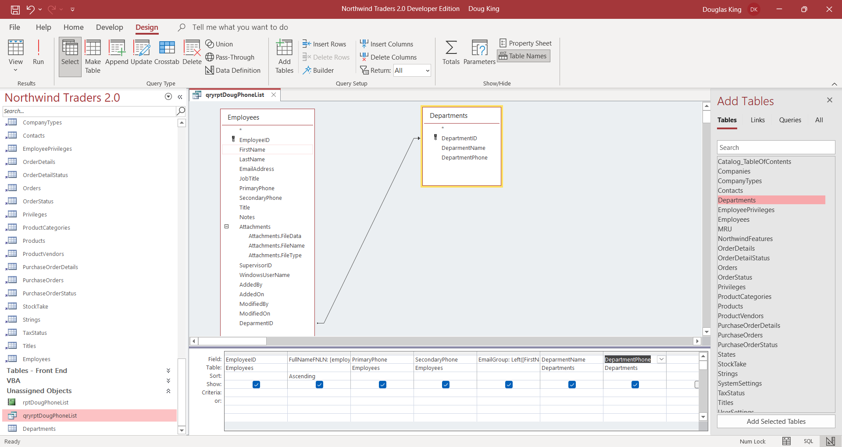
    - Now you just have to edit the copy of the report to include the department name, and telephone number. (Hint: copy one of the other fields in the report’s Design view…. See below)
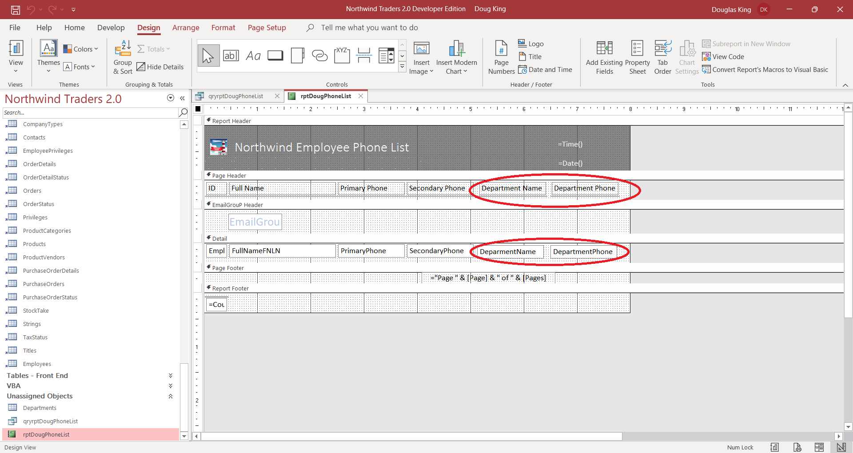
    - Then make a screenshot of the Report View showing your department entry. Here’s mine:
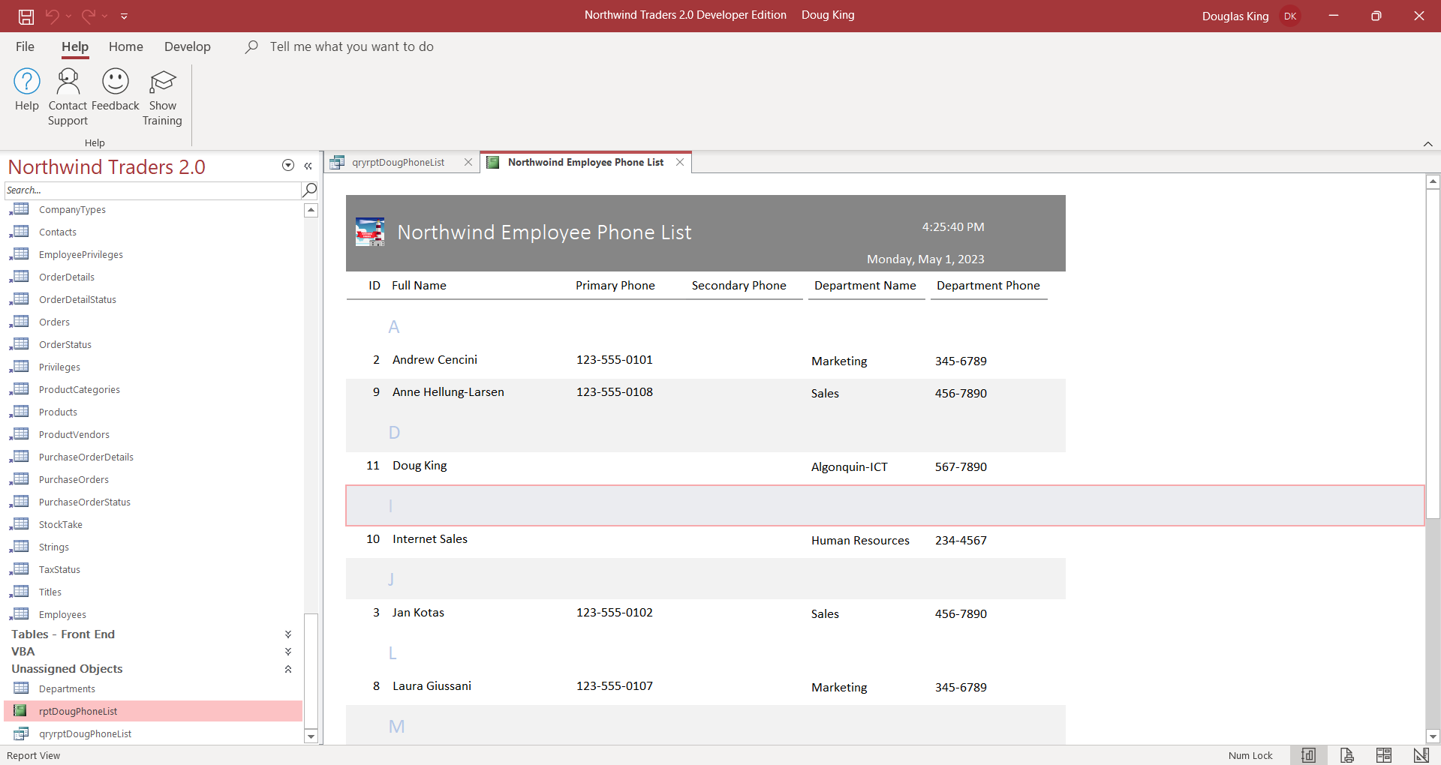
    - Paste your screenshot here:

1.
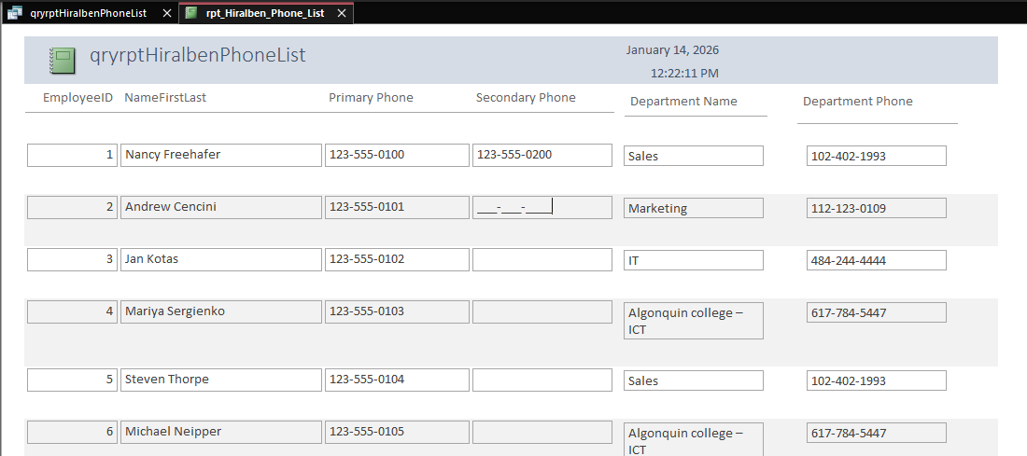

2.
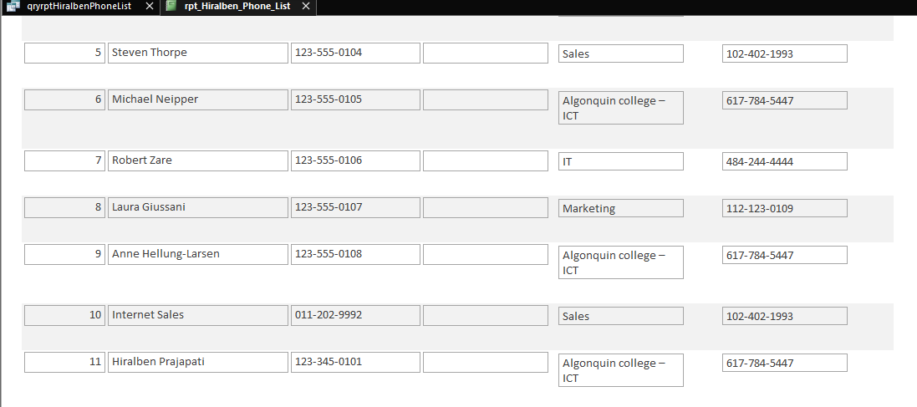

- Make sure you have included all of your screen shots to document your work and submit the file in Brightspace and you’re done!

