ACADEMIC TASK-2 CSE121
(ORIENTATION TO COMPUTING-II)

COMPUTER SCIENCE AND ENGINEERING
Submitted by:
Name: HIRALAL MAHATO
Registration number: 12301526
Roll No.: 63
Section: K23DJ

Submitted to : AYUSHI


LOVELY PROFESSIONAL UNIVERSITY

DECLARATION
I, Hiralal Mahato, a student of Bachelor of Technology under CSE discipline at Lovely Professional University, Punjab, hereby declare that all the information furnished in this project report is based on my own work and is genuine

Hiralal Mahato
Registration Number: 12301526

MOOC Certificate (Technical):
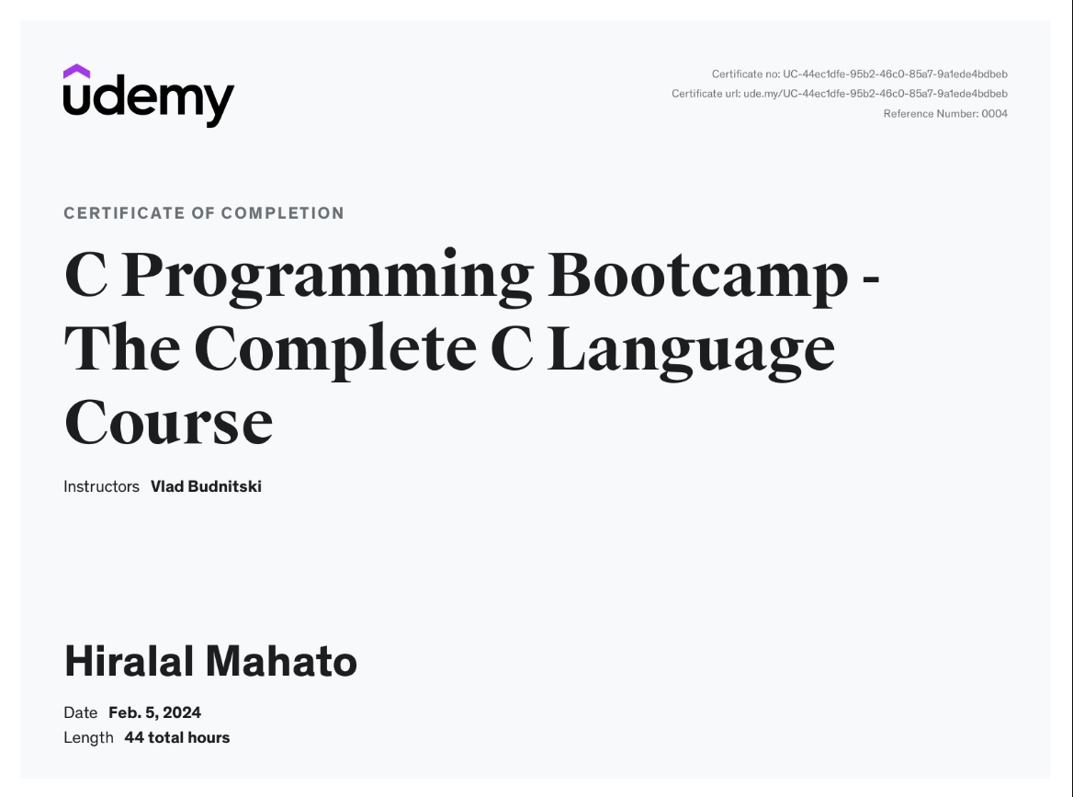

PROFILE CREATION

Profile Creation: Cyber Security
List the name of the companies for the profile of Securityengineer ( At least 5 company names are required)
1. | Google
2. | Amazon
3. | Microsoft
4. | IBM
5. | Cisco

List the Skills required the profile of Securityengineer (can add more columns to list more skills)
1. | Cybersecurity Expertise
2. | Network Security
3. | Penetration Testing
4. | Security Architecture
5. | Incident Response and Forensics

Companies offering package up to 10 Lac
Companies Names: Infosys, Wipro
Designatio n: | Cybersecurity  Analyst,  Information  Security Analyst,  Cyber Risk  Consultant | Required  Industrial  Certifications: | CISSP(Certified Information  Systems Security  Professional),  CEH(Certified Ethical  Hacker)
Job Link (URL): | IBM: https://www.ibm.com/services/security?utm_conte nt=SRCWW&p1=Search&p4=43700068113644965&p5=p&g ad_source=1&gclid=CjwKCAjwh4- wBhB3EiwAeJsppKLcIQmR_6NlhOGs9nCwxZxZlJGTsbu3w6v  KADthAh34S_y4ThWN5BoCBYMQAvD_BwE&gclsrc=aw.ds  Wipro: https://www.naukri.com/wipro-security-jobs
Companies offering package 10 to 20 Lac

Companies Names: McAfee, Cisco, Trend Micro
Designatio n: | Cybersecurity  Engineer, Senior  Security  Consultant,  Security  Operations  Center(SOC)  Analyst | Required  Industrial  Certifications: | CHFI(Computer Hacking  Forensic Investigator,  CCSE(Check Point Certified  Security), CISA(Certified  Information Systems  Auditor
Job Link (URL): | McAfee: https://careers.mcafee.com/global/en  Cisco:https://jobs.cisco.com/jobs/SearchJobs/security?proj ectOffset=0  TrendMicro:https://www.trendmicro.com/en_us/about/careers. html
Companies offering package 20 to 30 Lac
Companies Names: Deloitte, Google, Microsoft, IBM
Designatio n: | Cybersecurity  Consultant /  Analyst,  Cybersecurity  Specialist /  Analyst, Security  Architect /  Specialist | Required  Industrial  Certifications: | CISSP(Certified Information  Systems Security  Professional),  CISM(Certified Information  Security Manager), CISA,  CompTIA Security+, CCSP,  AWS Certified Solutions  Architect,
Job Link (URL): | Deloitte: https://www2.deloitte.com/us/en/pages/careers/ articles/cyber-jobs-deloitte.html  Google: https://www.linkedin.com/jobs/google-  cyber security jobs/?currentJobId=3862428334&originalSubdom ain=in  Microsoft: https://www.linkedin.com/jobs/microsoft-  cyber security jobs/?currentJobId=3864195134&originalSubdom ain=in  IBM: https://www.ibm.com/careers/teams/security
Companies offering package 30 Lac or more
Companies Names: Amazon, Apple, Facebook, Netflix
Designatio n: | Principal Security  Engineer, Security Engineering | Required  Industrial  Certifications: | CISSP, CISM, Apple  Certified Security  Professional (ACSP), AWS
 | Director, Senior  Manager,  Information  Security |  | Certified Security Specialty,  Offensive Security Certified  Expert (OSCE)
Job Link (URL): | Amazon: https://www.amazon.jobs/en/search?base_query =cyber+security&loc_query=&latitude=&longitude=&loc_gr oup_id=&invalid_location=false&country=&city=&region=& county=  Apple: https://jobs.apple.com/en us/search?team=informationsecurity-CORSV-INFOSEC  Netflix: https://jobs.netflix.com/teams/security
*Can add more Job links for same job profile.

Profile Creation: DevOps and Software Engineering
List the name of the companies for the profile of DevOps Engineer and Testing Engineer( At least 5 company names are required)
1. | Amazon Web Services(AWS)
2. | Microsoft(Azure)
3. | Facebook, Instagram(Meta)
4. | Oracle
5. | Apple, Google, Salesforce

List the Skills required the profile of DevOps Engineer and Testing Engineer(can add more columns to list more skills)
1. | Scripting languages (e.g., Python, Shell)
2. | Analytical and critical thinking skills
3. | Cloud platforms (e.g., AWS, Azure, GCP)
4. | Automated testing frameworks (e.g., Selenium,
5. | Test case design and execution

Companies offering package up to 10 Lac
Companies Names: Infosys, TCS(Tata Consultancy Services), Wipro, Cognizant, Tech Mahindra
Designa tion: | Associate Software Required Industrial Java SE Programmer  Engineer, Systems Certifications: (Oracle Certified  Engineer, Associate Professional) or Consultant - DevOps Microsoft Certified:  (for DevOps Azure Fundamentals  Engineer), could be beneficial, Programmer Analyst Certifications: AWS  Certified DevOps  Engineer - Associate,  Azure DevOps Engineer Expert, Certifications in programming languages  (e.g., Java, Python)
Job Link (URL): | Tech Mahindra: https://in.indeed.com/q-tech-mahindra,- devopsengineer-l-gachibowli,-hyderabad,-  telangana jobs.html?vjk=213897a824d6a24a  Infosys: https://www.naukri.com/devops-infosys-jobs Cognizant: https://careers.cognizant.com/professionals/us/ en/cognizant-devops-engineer  Wipro: https://www.linkedin.com/jobs/wiprodevops jobs/?currentJobId=3861591126&originalSubdomain=in Tata Consultancy Service: https://www.naukri.com/devops tcs-jobs
Companies offering package 10 to 20 Lac
Companies Names: Capgemini, Accenture, IBM, HCL technologies
Designa tion: | Software Engineer /  DevOps Engineer,  Associate Developer  (for Software  Engineer), Senior  Software Engineer /  DevOps Engineer | Required Industrial Certifications: | AWS Certified DevOps  Engineer - Associate,  Azure DevOps Engineer Expert, or similar cloud related certifications, Certifications in programming languages  (e.g., Java, Python) or cloud platforms (IBM  Certified Developer - Cloud)

Job Link (URL): | Capgemini: https://www.linkedin.com/jobs/capgemini devops-jobsgreaterbengaluru area/?currentJobId=3772605232&originalSubdomain=in  Accenture:https://www.accenture.com/ch en/careers/jobsearch?jk  =devops&sb=0&vw=0&is_rj=0&pg= 1&ba=technology  IBM:https://www.ibm.com/in en/careers/search?field_keyword_08  %5B0%5D=Software% 20Engineering  HCL Tech: https://www.hcltech.com/careers/devops engineer
Companies offering package 20 to 30 Lac
Companies Names: Dell Technologies, NVIDIA, Adobe, Microsoft, Google
Designa tion: | Software Engineer /  DevOps Engineer,  Software  Development  Engineer / DevOps  Engineer | Required Industrial Certifications: | Google Cloud  Professional DevOps  Engineer, Google Cloud Associate Engineer, or relevant programming certifications, : Microsoft Certified:  Azure DevOps Engineer  Expert, Microsoft  Certified: Azure  Solutions Architect Expert, or relevant programming  certifications
Job Link (URL): | NVIDIA: https://nvidia.wd5.myworkdayjobs.com/NVIDIAExternalCar eerSite  Dell Technologies: https://www.naukri.com/devops-dell jobs Adobe:https://careers.adobe.com/us/en/search results?keywords= devopps  Microsoft: https://www.naukri.com/microsoft-devops-jobs
Companies offering package 30 Lac or more
Companies Names: Amazon (Amazon Web Services - AWS), LinkedIn(Microsoft), Facebook(Meta Platforms)
Designa tion: | Software  Development  Engineer / DevOps  Engineer,  Experienced DevOps | Required Industrial Certifications: | Certifications: Microsoft  Certified: Azure DevOps Engineer Expert, Microsoft Certified: Azure Solutions
 | Engineer |  | Architect Expert, or relevant programming  certifications or relevant programming  certifications
Job Link (URL): | Amazon: https://www.amazon.jobs/en/search?base_query=devops  &loc_query=&latitude=&longitude=&loc_group_id=&invali d_location=false&country=&city=&region=&county= LinkedIn(Microsoft):  https://www.linkedin.com/jobs/view/3868954104/ Meta Platforms: https://www.metacareers.com/areasof work/engineering/?p%5Bteams%5D%5B0%5D=Software+E ngineering&teams%5B0%5D=Software+Engineering
*Can add more Job links for same job profile.

