

**ASSIGNMENT-2**

**Subject:** SOFTWARE ENGINEERING

**SUBMITTED TO:**

MR. DARSHAN SONECHA

Assistant professor

**SUBMITED BY:**

MS. HIRAL BAKHDA

CE-TC1 (SEM.-6)

Enrolment no.-140970107004

**SUBMITED ON:**

1ST FEBRUARY, 2017

**1 |** P a g e HIRAL BAKHDA - 1 4 0 9 7 0 1 0 7 0 0 4

**SDLC - Agile Model**

* **INTRODUCTION:-** 
  + An Agile SDLC model is a combination of the iterative and incremental process models which mainly focuses on the process adaptability and customer satisfaction by rapid delivery of the working software product.
  + Agile method break the product into small incremental builds. These builds are provided in iterations which are carried out for couple of weeks. Every iteration involves cross functional teams working simultaneously on various areas like planning, requirements analysis, design, coding, unit testing and acceptance testing.
  + At the end of the iteration a working product is displayed to the customer and important stakeholders.
* **WHAT IS AGILE?** 
  + According to the traditional method of developing a software there should be some specific steps that has to be followed. For example, if we talk about WATERFALL MODEL there are some specific steps that has to be followed to get the final software product. In this model the output of the previous step would work as the input for the next step, so the out of previous step is necessary for the further development of the software.
  + But in the case of AGILE MODEL the process of making the software is divided into smaller parts and given to different teams, so that each team works simultaneously on the same product. Each built would have a specific feature and at the end when all the built are ready by each team then all this iterations are combined and the final software with full functionality is developed.
  + Agile thought process had started early in the software development and started becoming popular with time due to its flexibility and adaptability.
* **The principles and key features of AGILE MODEL:-** 
  + **Individuals and interactions** - In agile development, self-organization and motivation are important,as are interactions like co-location and pair programming.
  + **Working software** - Demo working software is considered the best means of communication with thecustomer to understand their requirement, instead of just depending on documentation.
  + **Customer collaboration** - As the requirements cannot be gathered completely in the beginning of theproject due to various factors, continuous customer interaction is very important to get proper product requirements.
  + **Responding to change** - agile development is focused on quick responses to change and continuousdevelopment.

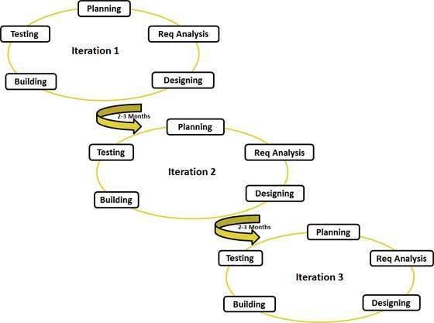

FIG. GRAPHICAL ILLUSTRATION OF THE AGILE MODEL

**The Life Cycle of Agile Model:-**

There are following six phases in every Software development life cycle model:

1. Requirement gathering and analysis
2. Design
3. Implementation or coding
4. Testing
5. Deployment
6. Maintenance

**1) Requirement gathering and analysis:**  Business requirements are gathered in this phase. This phase is the main focus of the project managers and stake holders. Meetings with managers, stake holders and users are held in order to determine the requirements like; Who is going to use the system? How will they use the system?  What data should be input into the system?  What data should be output by the system?  These are general questions that get answered during a requirements gathering phase. After requirement gathering these requirements are analyzed for their validity and the possibility of incorporating the requirements in the system to be development is also studied.

Finally, a Requirement Specification document is created which serves the purpose of guideline for the next phase of the model. The testing team follows the Software Testing Life Cycle and starts the [Test Planning](http://istqbexamcertification.com/what-is-the-purpose-and-importance-of-test-plans/) phase after the requirements analysis is completed.

**2)  Design:**  In this phase the system and software design is prepared from the requirement specifications which were studied in the first phase. System Design helps in specifying hardware and system requirements and also helps in defining overall system architecture. The system design specifications serve as input for the next phase of the model.

In this phase the testers comes up with the [Test strategy](http://istqbexamcertification.com/what-are-the-test-approaches-or-strategies-in-software-testing/), where they mention what to test, how to test.

**3)  Implementation / Coding:**  On receiving system design documents, the work is divided in modules/units and actual coding is started. Since, in this phase the code is produced so it is the main focus for the developer. This is the longest phase of the software development life cycle.

**4)** [**Testing**](http://istqbexamcertification.com/what-is-a-software-testing/)**:**  After the code is developed it is tested against the requirements to make sure that the product is actually solving the needs addressed and gathered during the requirements phase. During this phase all types of functional testing like unit testing, [integration testing](http://istqbexamcertification.com/what-is-integration-testing/), [system testing](http://istqbexamcertification.com/what-is-system-testing/), acceptance testing are done as well as [non-functional testing](http://istqbexamcertification.com/what-is-non-functional-testing-testing-of-software-product-characteristics/) are also done.

**5)  Deployment:** After successful testing the product is delivered / deployed to the customer for their use.

As soon as the product is given to the customers they will first do the [beta testing](http://istqbexamcertification.com/what-is-beta-testing/). If any changes are required or if any bugs are caught, then they will report it to the engineering team. Once those changes are made or the [bugs](http://istqbexamcertification.com/what-is-defect-or-bugs-or-faults-in-software-testing/) are fixed then the final deployment will happen.

**6) Maintenance:** Once when the customers starts using the developed system then the actual problems comes up and needs to be solved from time to time. This process where the care is taken for the developed product is known as maintenance

**3 |** P a g e HIRAL BAKHDA - 1 4 0 9 7 0 1 0 7 0 0 4