**Software Requirement Specification (SRS) for**

**Online Tourist Guide Hiring**

1. **Introduction**
   1. **Purpose**

In this project you can hire guide online. It prevents tourist from getting cheated from the guide on the basis of money. By our project their will be increase in employment and by this guide will be able to earn a regular income.

* 1. **Scope**

In scope:

You can hire tourist guide online.

List of Guides available would be shown of the places you want to visit and also the current weather of the given place is shown.

We provide list of famous places and also the success stories written by tourist.

Even we provide the facility in which if you have hired a guide u can rate him.

We even suggest places to visit for tourist with tight schedule.

Out of scope:

We do not book a hotels for tourist.

We do not plan the entire trip for and also we do not provide transportation to tourists.

* 1. **Definition**

Rating– a classification or ranking of someone or something based on a comparative assessment of their quality, standard, or performance.

Feedback- information about reactions to a product, a person's performance of a task, etc., used as a basis for improvement.

Hire – employ (someone) for wages.

GUI – Graphical User Interface.

1. **Overall Description**
   1. **Product Perspective**

This system is aimed at user who want to Hire the tourist guide which provide them detailed information of the place visited. All the guides will be friendly, interactive and knowledgeable. This system is standalone application. It runs on all browser including Mac and Windows.

* 1. **Product Function**

**System Authorization:**

* Guide Login
* Tourist Login
* Sign up
* Change Password

**Security:**

* Admin can change the security clearance of user
* Delete account
* Change security levels
* Restrict user access

**Information to Display:**

* Guide profile
* List of famous places
* Success stories
  1. **User Characteristic**

User should know to operate the internet and how it works. User should have access to internet for using this system.

* 1. **Principal Actors**
* User
* Admin
* System
  1. **General Constraint**

It requires full internet connection to work properly. It is multi-user system. Anyone can access the website.

1. **Specific Requirement** 
   1. **Functional Requirement**

**Use Case 1: Sign up**

Primary Actor: User

Pre-Condition: Nil

Main Scenario:

* Start the Browser. User has to fill the personal details.
* System authenticates the user.
* User is successfully signed up.

**Use Case 2: login**

Primary Actor: User & Guide

Pre-Condition: Nil

Main Scenario:

* Start the Browser. User is prompted for Username and Password.
* System authenticates the user.
* User is able to access His/hers profile.

Alternate Scenario:

* Authentication fails.
* User is prompted to reenter the password.

**Use Case 3: Change password**

Primary Actor: User & guide

Precondition: User should have account.

Main Scenario:

* User login into account. User selects to change the password.
* User will be able to enter the new password.
* New password is set.

**Use Case 4: Security Clearance**

Primary Actor: Admin

Precondition: Logged in

Main Scenario:

* Admin is allowed to change the security clearance of the user.
* Admin can decide whether the user can access the specific security related information or not.

**Use Case 5: Delete Account**

Primary Actor: Admin

Precondition: Logged in

Main Scenario:

* Admin can delete the account of the suspicious user who has created account in websites.
* Admin can remove the data of user from the server.
* If he finds that user is involved in some malicious activity than he can delete the user account.

**Use Case 6: Description of Guides**

Primary Actor: Guides

Precondition: Logged in

Main Scenario:

* When user login or without login to the account he/she can view the main homepage as well as the details of guides on the website.
* User can view different description of the Guides like name, languages known, etc. Then can hire according to their need.
  1. **Performance Requirement**
* Display of 640*480 resolutions is needed to run the browser on your machine.
* Access to the internet is need. Minimum speed should be 128kbps.
* Minimum Ram should be 512MB.
* Windows vista or higher is needed.
  1. **Design Parameters**
* Security – User should not be allowed to access the system files of the websites. Login information of the users is secured in database.
* Portable – Our system is portable so user can access from anywhere from any place on mobile or laptop provided they have in the internet connection available.
* Performance – website will be load according to the internet speed of the user. If it is good then page will load faster otherwise it will load slower.

1. **Appendix**
   1. **Appendix A : User Screens**

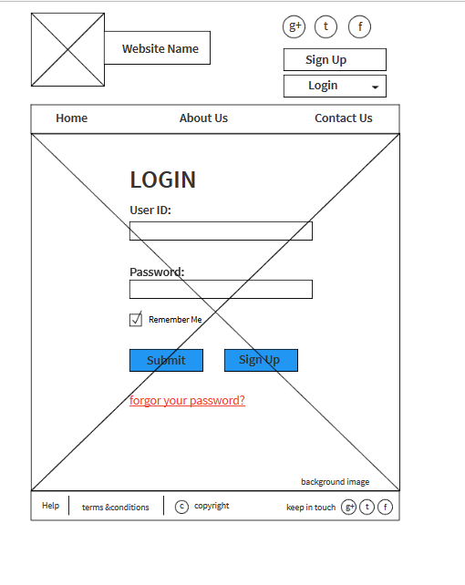

1. Login page layout

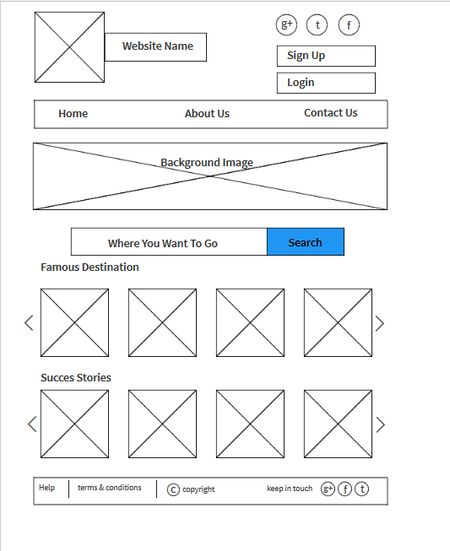

2. Homepage layout

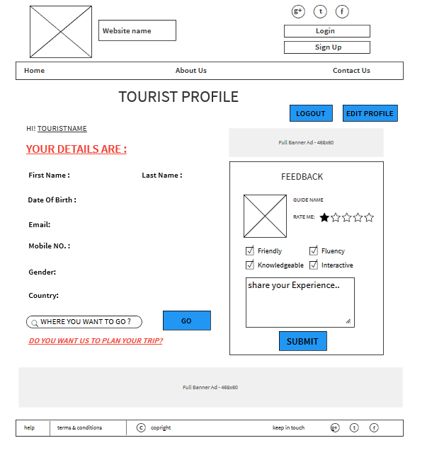

3. Tourist profile layout