***Hiring Tourist Guides Online***

***Waterfall model:***

The Waterfall Model was first Process Model to be introduced. It is also referred to as a linear-sequential life cycle model. It is very simple to understand and use. In a waterfall model, each phase must be completed fully before the next phase can begin. This type of model is basically used for the project which is small and there are no uncertain requirements. At the end of each phase, a review takes place to determine if the project is on the right path and whether or not to continue or discard the project. In this model the testing starts only after the development is complete. In waterfall model phases do not overlap.

***When to use the waterfall model:***

* This model is used only when the requirements are very well known, clear and fixed. Product definition is stable.
* Technology is understood.
* There are no ambiguous requirements.
* Ample resources with required expertise are available freely.
* The project is short.

However, very less Tourist enter action is involved during the development of the product. Once the product is ready then only it can be demoted to the end users. Once the product is developed and if any failure occurs then the cost of fixing such issues are very high, because we need to update everywhere from document till the logic.

***The stages of "The Waterfall Model" are:*** **Requirement Analysis & Specification:**

This phase is focused on possible requirements of the system for the development are captured. Requirements are gathered subsequent to the end user consultation.

In Hiring Tourist Guides Online System the requirements are as follows:

**For Admin Module:**

* This system allows the admin to login with username and password.
* This system allows the admin to add the guides along with his/her profile details.
* This system allows the admin to contact Tourists through Email.
* This system allows the admin to edit the trip details.
* This system allows the admin to View Managers & Tourists details.
* This system allows admin to check on the payment options for tourists.

**For Guide Module:**

* This system allows the Guide to register.
* This system allows the Guide to login with email and password.
* This system allows the Guide to accept/reject tourists.
* This system allows the Guide to view tourists address details.
* This system allows the Guide to interact with tourists for assistance.
* This system allows the Guide to reset password if password is forgotten.
* This system allows the Guide to update his/her personal profile.

**For Tourist Module:**

* This system allows the Tourist to login with email and password.
* This system allows the Tourist to update personal details.
* This system allows the Tourist to reset password if password is forgotten.
* This system allows the Tourist to view his/her trip details.
* This system allows the Tourist to transfer money from his account to another account.
* This system allows the Tourist to recover password.
* This system allows the Tourist to change password.
* This system allows the Tourist to delete profile.
* This system allows the Tourist to review or rate his/her experience with the Guide.

**System & Software Design:**

Prior to beginning the actual coding, it is inevitable to understand what actions are to be taken and what they should like. The requirement specifications are studied in detail in this phase and the design of the system is prepared. The design specifications are the base for the implementation and unit testing model phase.

**Implementation & Unit Testing:**

Subsequent to receiving the system design documents, the work is shared into various modules and the real coding is commenced. The system is developed into small coding units. These units are later integrated in the subsequent phase. Every unit is tested for its functionality.

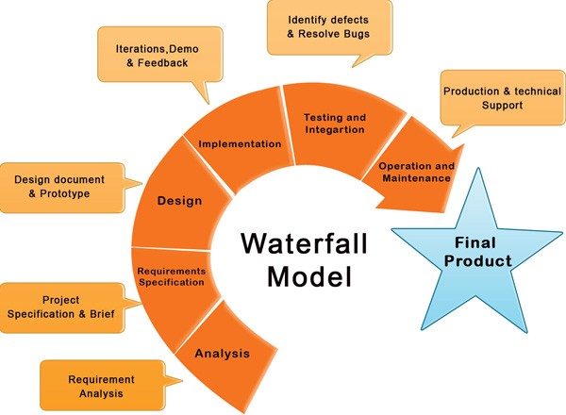

For the development of the Hiring Tourist Guide online system admin or the website developers should have to use MySQL as the back end, HTML as the front end, PHP as the scripting language and JAVA script for the validation.

Justification for using the Tools:

The main reason for using these above mentioned tools is that it is the open source. This means that these tools and servers are freely available on the websites. Developers can freely download these tools and servers from their websites. Not a single penny is used for the purchasing of these tools and servers. If researcher goes for ASP.NET, windows tools then he has to pay handsome amount to the manufacturers of these tools, secondly if any modification has been done then its upgraded version has to be downloaded that means again money, thirdly developers can’t able become a good programmer, because these tools are so much friendly that when developer type any letter, these tools shows the concern function of that letter. He doesn’t know the utility of these functions. MySQL, PHP and HTML are freely available and there is community who are working for the development and modification of these tools, secondly there is no need to join any so called institutes for hands on these tools. Any programmer can visits there free online tutorials and he will become the good programmer within one month. These features encourage the researcher to use these tools. Most important the future modification in the software can easily be done, because researcher doesn’t has to purchase these tools.  
  
**System Testing & Integration:**

The modules that are divided into units are integrated into a complete system and tested for proper coordination among modules and system behaves as per the specifications. Once the testing is completed, the software product is delivered to the Tourist.

when a developer develops hiring Tourist Guide online System, the developer first of all tests all the components by examining each line of code and also integrates all the components together and test them to check if the system has any error, during the implementation stage if there is any error the developer must start all over again by checking and tracing the cause of the error.  
  
**Operations & Maintenance:**

It is a never ending phase. Once the system is running in production environment, problems come up. The issues that are related to the system are solved only after deployment of the system. The problems arise from time to time and need to be solved; hence this phase is referred as maintenance.

In Hiring Tourist Guide online System, This system does not support online chatting among tourists and guides for now.

In the future, online chatting and chat rooms can be incorporated into the system to enable the Tourists to have detail information about the guides and can choose appropriate guides of their type by asking experience of other tourists by chatting with them.

***Advantages of waterfall model:***

* This model is simple and easy to understand and use.
* It is easy to manage due to the rigidity of the model – each phase has specific deliverables and a review process.
* In this model phases are processed and completed one at a time. Phases do not overlap.
* Waterfall model works well for smaller projects where requirements are very well understood.

***Disadvantages of waterfall model:***

* Once an application is in the testing stage, it is very difficult to go back and change something that was not well-thought out in the concept stage.
* No working software is produced until late during the life cycle.
* High amounts of risk and uncertainty.
* Not a good model for complex and object-oriented projects.
* Poor model for long and ongoing projects.
* Not suitable for the projects where requirements are at a moderate to high risk of changing.