WEEK 4 – PREDICTIVE MODELING
Junior Data Analyst – Apparel, Textiles & Fashion

YuvaIntern Internship
Prepared by: Hiral Patil
Task: Week 4 – Predictive Modeling
Dataset: Fashion Market Research Product Data

1. Executive Summary
This report presents the Week 4 predictive modeling task for the Junior Data Analyst internship in the Apparel, Textiles & Fashion domain. The objective was to construct a machine learning model using the cleaned fashion product dataset and use it to estimate selling prices for records where the selling price was unavailable.
The working dataset contains 242 product records. Selling price is available for 189 records and missing for 53 records (21.9%). The model uses four product characteristics—Brand, Category, Sub-Category and Gender—to estimate Selling_Price_INR.
Three regression techniques were compared: Linear Regression, Random Forest and Gradient Boosting. Random Forest produced the strongest test-set performance in this notebook, with the lowest MAE among the three models and an R² of approximately 0.717. It was therefore used to generate price estimates for the 53 records with missing selling prices.
The results indicate that product Category is the strongest model feature in this dataset, with Footwear contributing most strongly to the Random Forest feature-importance output. The predictions should be treated as data-driven estimates rather than guaranteed future prices because the dataset is a product-level cross-sectional sample and does not contain enough historical time-series observations for genuine time-based forecasting.
Actionable takeaway: a fashion business can use this type of model as a supporting tool for price estimation and data completion, while continuing to validate predictions against current market prices, promotions, seasonality and product-level business information.

2. Task Requirements and Objectives
The Week 4 task required the construction of a predictive model based on the analysis from the previous week, prediction of future trends in areas such as pricing or product preferences, use of appropriate statistical or machine learning techniques, and a final document explaining the model, techniques and predictions.
Objectives:
- Prepare a modeling dataset from the cleaned fashion product data.
- Select an appropriate numerical target variable for prediction.
- Train and compare multiple regression models.
- Evaluate model performance using MAE, RMSE and R².
- Use the best-performing model to estimate missing selling prices.
- Interpret the results and state practical business implications and limitations.

3. Dataset Overview
The Product_Data sheet contains 242 usable product records and 11 columns. The dataset includes brand, product name, category, sub-category, gender, selling price, original price, price segment, collection date and source URL.
Metric | Value
Total product records | 242
Total columns | 11
Selling price available | 189
Selling price missing | 53
Selling price missing (%) | 21.9%
Model training records | 151
Model testing records | 38
The source dataset was collected from publicly available official brand sources during the earlier market-research task. It represents a research sample rather than a complete catalog.

4. Target Variable and Feature Selection
Target variable: Selling_Price_INR. This is a continuous numerical variable, so the problem is treated as a regression problem.
Selected predictors:
Feature | Role | Reason
Brand | Input | Captures brand-level price positioning.
Category | Input | Represents broad product type and was highly informative in the fitted model.
Sub_Category | Input | Adds product-type detail within a category.
Gender | Input | Represents the broad target segment recorded in the product data.
Price_Segment was not used as an input because it is derived from price information and could introduce target leakage. Original_Price_INR was also not used because it contains extensive missing information in the source dataset. This keeps the model inputs focused on product characteristics rather than variables directly derived from the target.

5. Data Preparation
Records without a selling price were excluded from model training because a supervised regression model requires known target values. This left 189 records for modeling.
The 189 records were divided into 80% training and 20% testing sets using random_state=42. This resulted in 151 training records and 38 testing records.
Categorical variables were processed using a pipeline: missing categorical values were handled with the most-frequent value, and categorical levels were converted into numerical indicator variables using OneHotEncoder with handle_unknown='ignore'.
This preprocessing was applied inside the model pipeline so that transformation and prediction remained consistent between training and testing data.

6. Predictive Modeling Techniques
Three regression algorithms were implemented and compared:
- Linear Regression – used as a simple baseline model.
- Random Forest Regressor – an ensemble of decision trees capable of learning nonlinear relationships and interactions.
- Gradient Boosting Regressor – a boosting-based ensemble that sequentially improves prediction errors.
The notebook configuration for Random Forest was n_estimators=400, max_depth=8, min_samples_leaf=2 and random_state=42. Gradient Boosting used n_estimators=150, max_depth=2, learning_rate=0.05, loss='huber' and random_state=42.

7. Model Training and Evaluation
The models were evaluated on the held-out test set of 38 records. MAE measures the average absolute prediction error in INR; RMSE gives greater weight to larger errors; and R² indicates the proportion of variation in the target explained by the model on the test set.
Model | MAE | RMSE | R²
Linear Regression | ₹1,871.97 | ₹2,758.83 | 0.6365
Random Forest | ₹1,620.62 | ₹2,435.98 | 0.7166
Gradient Boosting | ₹1,729.24 | ₹2,514.06 | 0.6981
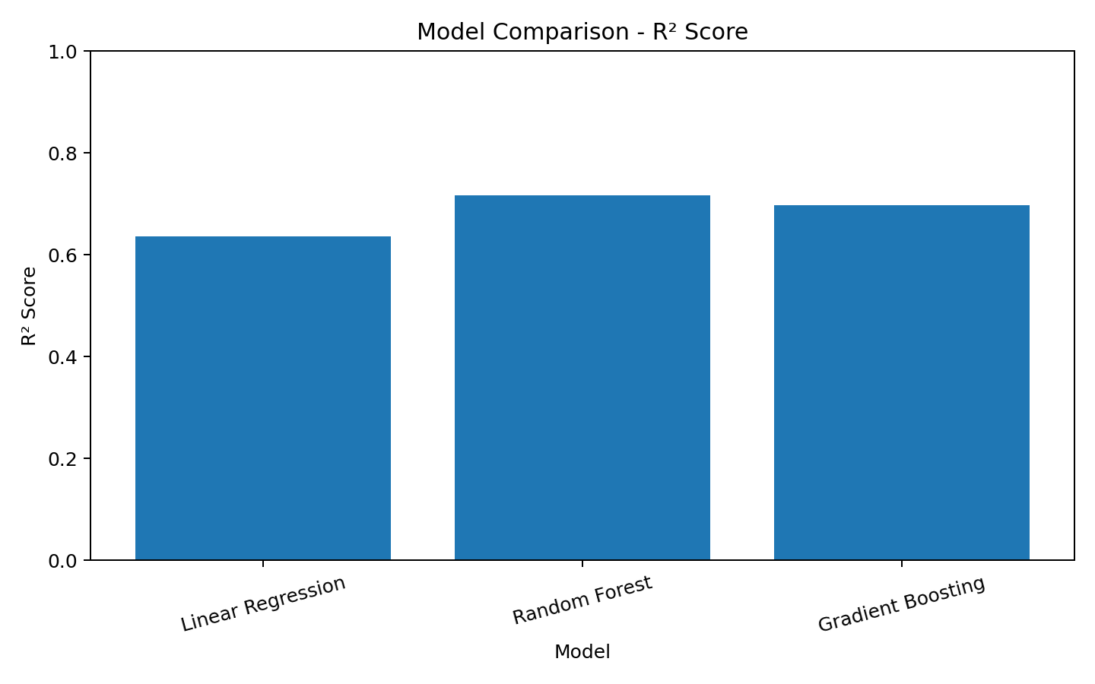
Figure 1. Comparison of R² scores across the three regression models.
Random Forest achieved the best MAE at ₹1,620.62 and the highest R² at 0.7166. Its RMSE was ₹2,435.98. Therefore, Random Forest was selected for the missing-price prediction stage.

8. Actual vs Predicted Results
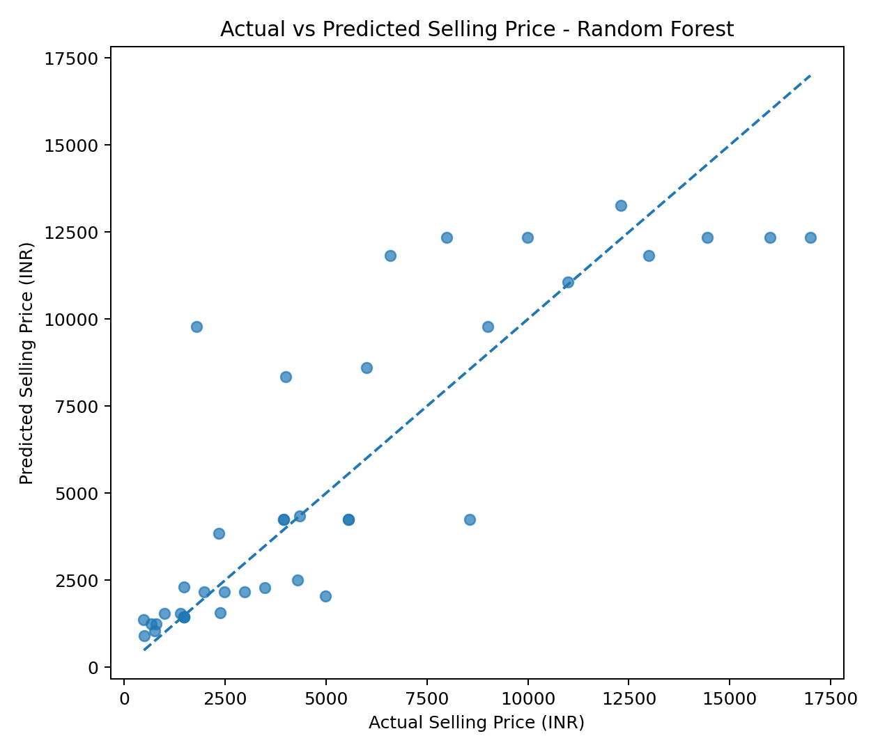
Figure 2. Actual versus predicted selling prices on the Random Forest test set. Points closer to the diagonal represent smaller prediction errors.
The scatter plot provides a visual check of model behavior. Predictions that lie close to the diagonal line are closer to the actual selling price, while larger vertical distances indicate larger errors. The R² value of approximately 0.717 shows that the model explains a substantial portion of the variation in the held-out sample, although prediction error remains and the model is not exact.

9. Prediction Error Analysis
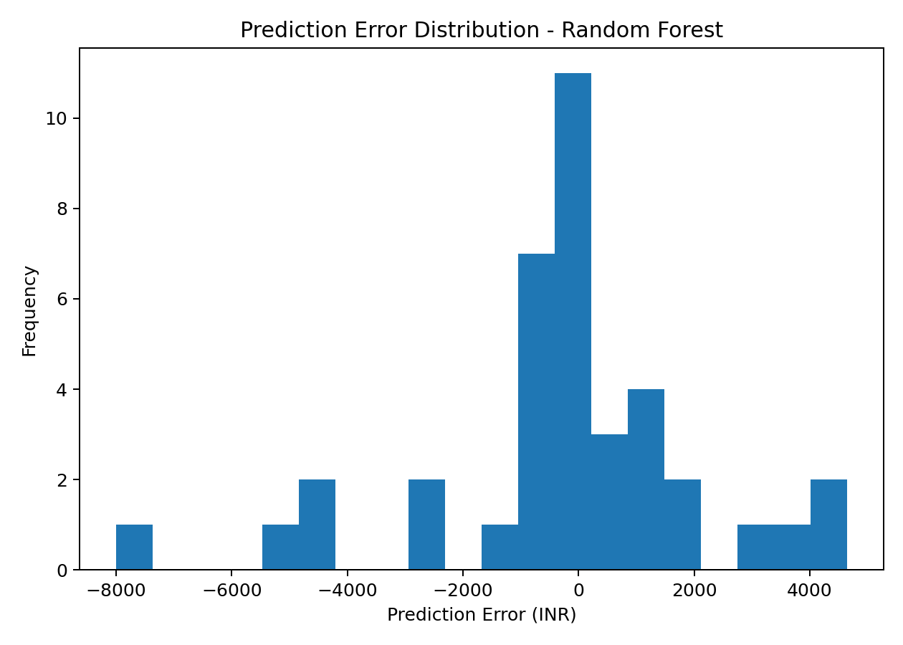
Figure 3. Distribution of prediction errors (actual price minus predicted price).
The Random Forest test-set MAE is ₹1,620.62. A practical interpretation is that, across the held-out test records, the model's predictions differ from the actual selling prices by about ₹1,621 on average when using absolute error. This is an average summary, not a guarantee that every prediction is within that amount.

10. Feature Importance
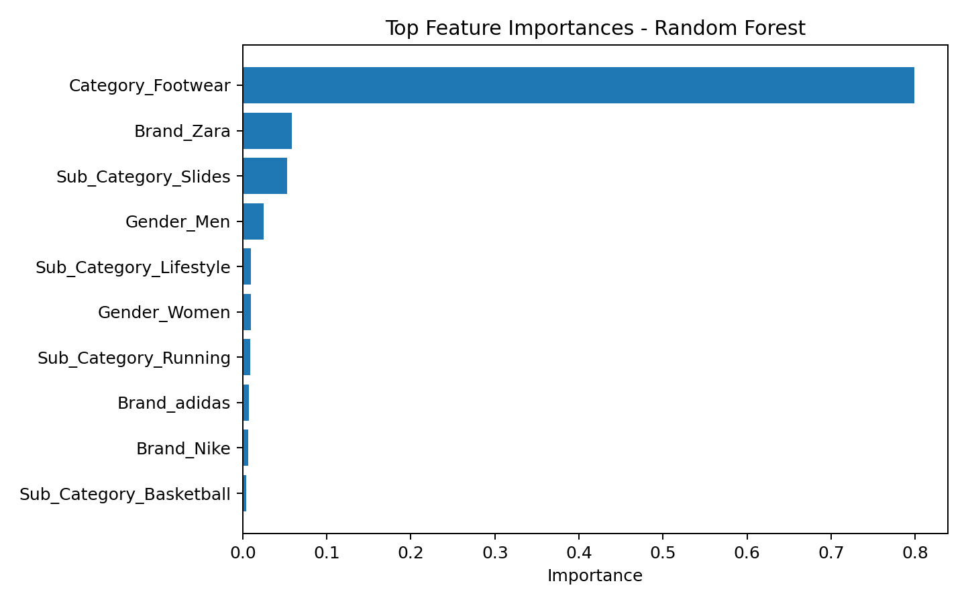
Figure 4. Top feature-importance components from the fitted Random Forest model.
The feature-importance output shows Category_Footwear as the dominant component, with an importance of approximately 0.799 in the fitted Random Forest. Brand_Zara and Sub_Category_Slides are the next-largest individual components in the output. These values indicate how much the fitted tree ensemble relied on each encoded input feature when reducing prediction error; they should not be interpreted as causal effects.
Top encoded feature | Importance
Category_Footwear | 0.7991
Brand_Zara | 0.0583
Sub_Category_Slides | 0.0527
Gender_Men | 0.0251
Sub_Category_Lifestyle | 0.0096
Gender_Women | 0.0096
Sub_Category_Running | 0.0085
Brand_adidas | 0.0069
Brand_Nike | 0.0066
Sub_Category_Basketball | 0.0039

11. Missing-Price Prediction
There are 53 records with missing Selling_Price_INR. The fitted Random Forest was applied to these records to generate estimated selling prices. Predicted values range from approximately ₹1,205 to ₹13,666, with an average predicted price of approximately ₹6,468.
Worked example: the first missing-price record in the prediction output is Record_ID 42, a Nike men's running shoe. The model estimates its selling price at approximately ₹12,623.51. This is an estimated value generated from the product characteristics available to the model; it is not an observed market price.
Record ID | Brand | Product | Predicted Price
42 | Nike | Nike Structure 26 Men's Road Running Shoes | ₹12,623.51
43 | Nike | Nike Domain 3 Low Men's Cricket Shoes | ₹12,264.62
45 | Nike | Nike Air Max 95 Women's Shoes | ₹11,365.85
46 | Nike | Nike Air Max 1 Women's Shoes | ₹11,365.85
47 | Nike | Nike Air Max 1 Men's Shoes | ₹12,348.80
48 | Nike | Nike Air Max 270 Men's Shoes | ₹12,348.80
49 | Nike | Nike Air Max 270 Women's Shoes | ₹11,365.85
50 | Nike | Nike Shox TL Women's Shoes | ₹11,365.85
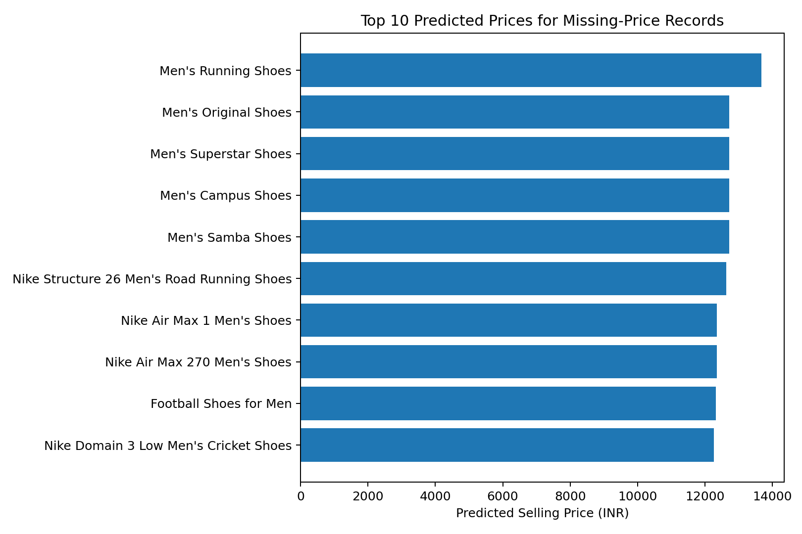
Figure 5. Ten highest predicted selling prices among records with missing observed prices.

12. Model Appropriateness and Accuracy
Random Forest is appropriate for this dataset because the target is numerical while several predictors are categorical. After one-hot encoding, the model can capture nonlinear relationships between product characteristics and price. Comparing three models rather than relying on one algorithm also provides a basic validation of model choice.
The test-set results show that Random Forest outperformed Linear Regression and Gradient Boosting on the selected metrics in this notebook. However, the dataset is relatively small for machine learning, with only 189 observations having known selling prices. Therefore, the reported performance should be interpreted as sample-based and may change when the model is evaluated on a larger or independently collected dataset.

13. Business Insights and Actionable Recommendations
- Use model estimates as a supporting reference when 53 product records have missing selling prices, but validate important prices against current official listings before business use.
- Category is highly influential in the fitted model; pricing analysis should therefore compare products within comparable categories rather than treating all fashion products as one group.
- Use brand and sub-category information alongside category when creating price benchmarks, because the model uses these variables to distinguish product-level price patterns.
- Do not treat the model as an automatic pricing decision-maker. Discounts, seasonality, inventory, promotions, product launches and competitor prices are not represented adequately in the available features.
- Retrain the model periodically when new product and price observations become available. More historical collection dates would make genuine time-based forecasting more defensible.

14. Limitations
- The dataset contains only 242 product records, with 189 records available for supervised price modeling.
- The test set contains only 38 observations, so evaluation metrics can be sensitive to the particular train/test split.
- The data is primarily a product-level snapshot rather than a long historical time series. Therefore, this model estimates selling prices from product characteristics; it does not establish a reliable month-by-month future price forecast.
- Important business variables such as discount percentage, inventory, demand, seasonality, promotion intensity and competitor prices are not included in the model.
- Feature importance indicates model reliance, not causation.
- Predictions for missing prices are estimates and should not be presented as original observed values.

15. Conclusion
The Week 4 predictive modeling task successfully compared three regression approaches using 189 records with known selling prices. Random Forest delivered the strongest test-set performance, with MAE of ₹1,620.62, RMSE of ₹2,435.98, and R² of 0.7166.
The selected model was then used to estimate selling prices for 53 records with missing price values. The exercise demonstrates how machine learning can support structured price estimation and data completion in a fashion analytics workflow.
For stronger future forecasting, the dataset should be expanded with repeated observations over time and additional business variables. This would allow the analysis to move from cross-sectional price estimation toward genuine time-series or demand forecasting.

16. Tools and Technologies
Tool / Library | Purpose
Python | Data processing and machine learning workflow
Pandas | Dataset loading and manipulation
NumPy | Numerical calculations
Matplotlib | Data visualization
Scikit-learn | Preprocessing, regression models and evaluation
Jupyter Notebook | Interactive analysis and reproducible execution
Microsoft Word | Final report preparation

17. Reproducibility
The modeling workflow is documented in the submitted Jupyter Notebook (week4_YuvaIntern.ipynb). The workflow loads the cleaned product dataset, selects the target and predictors, performs the train/test split, applies categorical preprocessing, trains three regression models, compares evaluation metrics, generates visualizations, and predicts missing selling prices.
The report results were reproduced from the same modeling logic and Random Forest configuration used in the notebook. The prediction output can be saved as a CSV for further analysis or inclusion in the internship repository.

Appendix A – Model Configuration
Random Forest configuration used for the selected model:
- n_estimators = 400
- max_depth = 8
- min_samples_leaf = 2
- random_state = 42
- test_size = 0.20
Gradient Boosting configuration used for comparison:
- n_estimators = 150
- max_depth = 2
- learning_rate = 0.05
- loss = 'huber'
- random_state = 42

