YuvaIntern – Junior Data Analyst
WEEK 3 TASK
Data Analysis & Interpretation
Fashion Market Research – Product Portfolio, Pricing & Customer Preference Analysis

Analysis objective
Analyze the cleaned product-level fashion dataset to identify portfolio patterns, pricing structure, product-category concentration, gender-oriented product coverage, brand positioning and actionable competitive insights.

Dataset KPI | Result
Product records | 242
Brands covered | 5
Average selling price shown on dashboard | ₹6.55K
Women-oriented products | 153 (63.22%)
Largest category | Apparel – 147 (60.74%)
Largest identified price segment | Budget – 66 (27.27%)
Prepared for internship submission | Analysis date: September 2026

1. Executive Summary
This report presents the Week 3 analysis of a cleaned fashion-market research dataset containing 242 product records across five brands: Nike, Zara, UNIQLO, adidas and H&M. The analysis focuses on product portfolio structure, pricing, gender-oriented product coverage, category concentration, sub-category representation and brand-level positioning.
The strongest pattern is the concentration of the portfolio in apparel and women-oriented products. Apparel contributes 147 records (60.7%) and footwear contributes 82 records (33.9%), meaning these two categories together account for 94.6% of the sample. Women-oriented products account for 153 records (63.2%), while men-oriented products account for 49 (20.2%).
From a pricing perspective, Budget products are the largest identified segment with 66 records (27.3%), followed by Mid-range with 62 (25.6%). Premium and Luxury/Premium together contribute 61 records (25.2%), indicating that the sample also contains a meaningful higher-price portfolio. A further 53 records (21.9%) are classified as Unspecified for price segment, so this group should be treated as a data-quality consideration rather than a market segment.
Main business takeaway
The sample indicates a broad fashion portfolio with strong apparel and women-oriented coverage, while brand positioning differs materially by observed price levels. The clearest opportunity is to use the category, gender and price-segment patterns together rather than evaluating brands on product count alone.

2. Objectives of the Analysis
- Measure the overall composition of the 242-product research sample.
- Compare product coverage across the five selected brands.
- Identify dominant product categories and sub-categories.
- Analyze gender-oriented product representation as a proxy for customer targeting.
- Evaluate the distribution of Budget, Mid-range, Premium and Luxury/Premium products.
- Compare observed average selling-price positioning across brands.
- Translate the patterns into practical recommendations for assortment, pricing and competitive positioning.

3. Methodology & Analytical Approach
The analysis was performed on the cleaned Week 3 dataset used in the Power BI dashboard. The dashboard contains interactive slicers for Brand, Gender, Category and Price Segment, allowing the user to move from the overall sample to specific portfolio segments.
Stage | Approach
Data scope | 242 product-level records across five brands
Dimensions analyzed | Brand, Category, Sub_Category, Gender and Price_Segment
Numeric measure | Selling_Price_INR; dashboard average used for overall pricing context
Visual analysis | KPI cards, donut charts, bar charts and stacked brand/category comparison
Interpretation | Counts and percentages are treated as sample-level evidence, not total market share or actual sales volume
Important analytical distinction: the dataset contains product listings, not transaction-level units sold or revenue. Therefore, a high product count is interpreted as stronger representation in the collected sample, not as proof of higher sales or customer popularity.

4. Dataset Overview
The final analytical sample contains 242 records representing five brands. Brand coverage is relatively balanced, which makes brand-to-brand comparison more useful than if one brand dominated the sample.
Brand | Records | Share of sample
Nike | 50 | 20.7%
Zara | 50 | 20.7%
UNIQLO | 49 | 20.2%
adidas | 47 | 19.4%
H&M | 46 | 19.0%
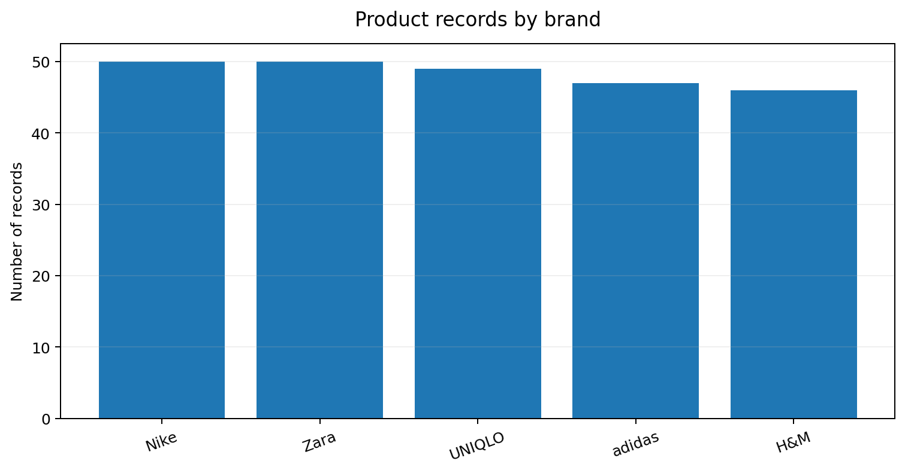
Interpretation: Nike and Zara each contribute 50 records (20.7%), followed by UNIQLO with 49 (20.2%), adidas with 47 (19.4%) and H&M with 46 (19.0%). The difference between the largest and smallest brand sample is only four records, indicating good coverage balance.

5. Product Category Analysis
Category | Records | Share
Apparel | 147 | 60.7%
Footwear | 82 | 33.9%
Innerwear | 8 | 3.3%
Accessories | 2 | 0.8%
Beauty | 1 | 0.4%
Home | 1 | 0.4%
Sportswear | 1 | 0.4%
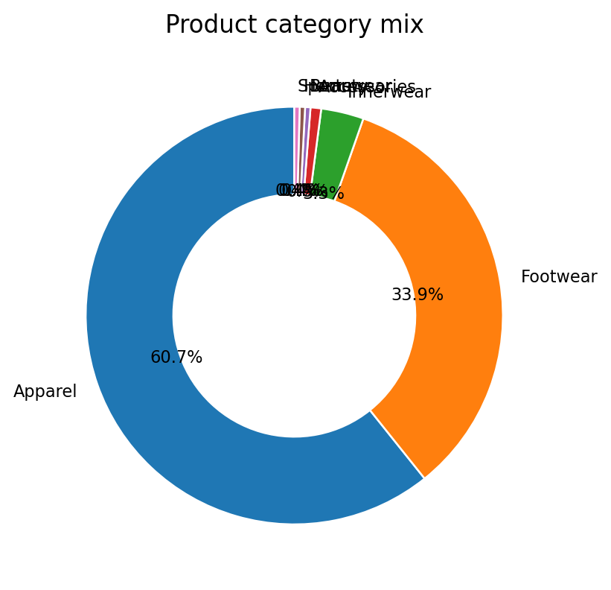

Interpretation
- Apparel is the dominant category with 147 records (60.7%).
- Footwear is the second-largest category with 82 records (33.9%).
- Apparel and footwear together represent 229 of 242 records, or 94.6% of the sample.
- Innerwear contributes 8 records (3.3%), while Accessories contributes 2 (0.8%); Beauty, Home and Sportswear each contribute only 1 record (0.4%).
- The portfolio is therefore highly concentrated in core fashion apparel and footwear rather than diversified evenly across all product categories.
Business implication
A brand using this sample for assortment planning should prioritize depth in apparel and footwear, while treating smaller categories as niche or supporting categories unless further research confirms demand.

6. Gender-Oriented Product Analysis
Gender / Targeting field | Records | Share
Women | 153 | 63.2%
Men | 49 | 20.2%
Unspecified | 34 | 14.0%
Kids | 3 | 1.2%
Unisex | 3 | 1.2%
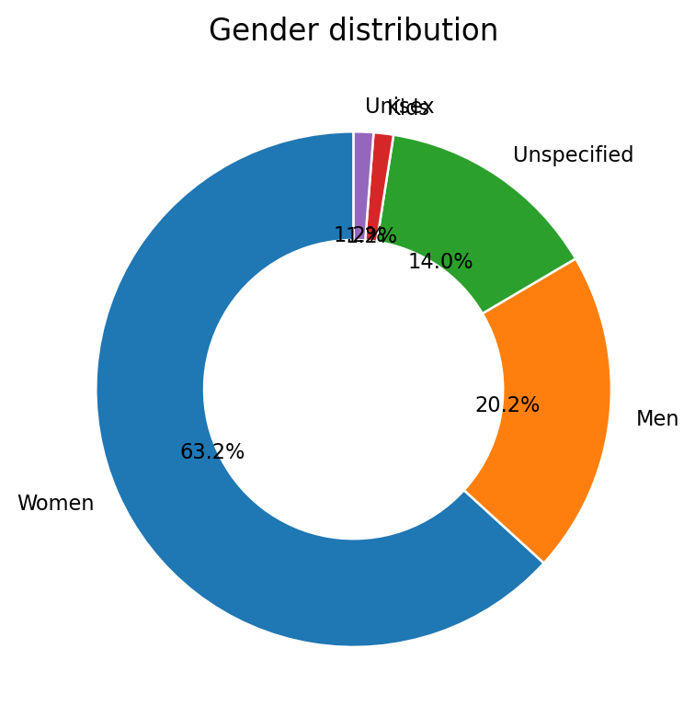

Interpretation
- Women-oriented products account for 153 records (63.2%), making them the largest targeting group by a wide margin.
- Men-oriented products account for 49 records (20.2%).
- The women-oriented sample is 104 records larger than the men-oriented sample, showing a strong female-product concentration.
- 34 records (14.0%) are Unspecified, so the gender mix should not be interpreted as a direct measure of customer demographics.
- Kids and Unisex each contribute only 3 records (1.2%), indicating limited representation in the collected sample.
Analytical caution
This is product-targeting information, not customer-level purchase behavior. It can indicate assortment emphasis, but it cannot prove that women represent 63.2% of actual customers.

7. Pricing & Price-Segment Analysis
Price segment | Records | Share
Budget | 66 | 27.3%
Mid-range | 62 | 25.6%
Unspecified | 53 | 21.9%
Premium | 32 | 13.2%
Luxury/Premium | 29 | 12.0%
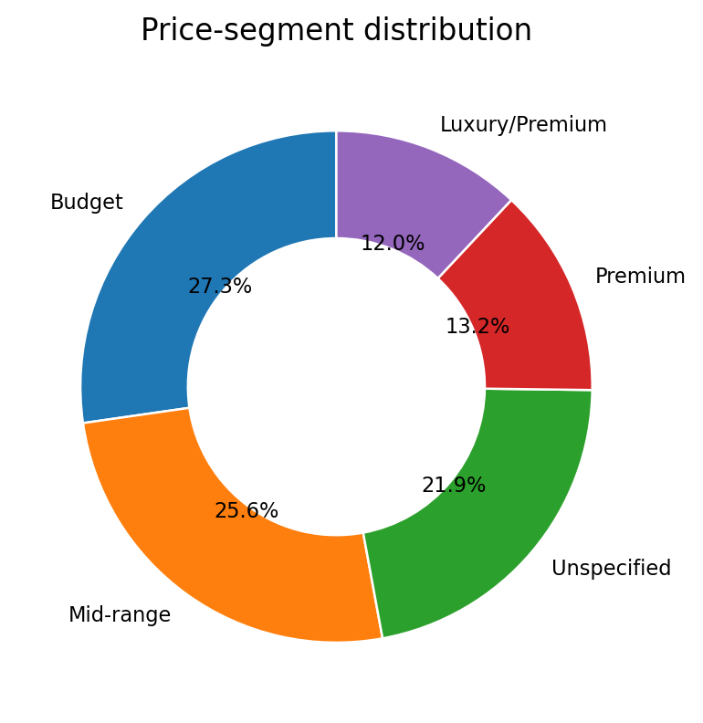

Interpretation
- Budget is the largest identified segment: 66 products (27.3%).
- Mid-range is second: 62 products (25.6%).
- Budget + Mid-range together account for 128 products (52.9%), indicating that more than half of the sample falls into accessible or moderate price positioning.
- Premium and Luxury/Premium together account for 61 products (25.2%), showing a meaningful higher-price component.
- 53 records (21.9%) are Unspecified. This should be treated as a classification/data-quality gap, not as a fifth market segment.

Overall price indicator
The Power BI dashboard displays an overall average selling price of approximately ₹6.55K. At brand level, the observed priced-record averages from the underlying market-research sample show a clear positioning gradient: Nike ≈ ₹10,484, adidas ≈ ₹7,325, Zara ≈ ₹4,310, UNIQLO ≈ ₹2,033 and H&M ≈ ₹1,226.
Brand | Observed average selling price (INR) | Positioning interpretation
Nike | ₹10,484 | Highest observed price level
adidas | ₹7,325 | Upper-mid / premium-oriented
Zara | ₹4,310 | Mid-range fashion-oriented
UNIQLO | ₹2,033 | Accessible everyday apparel
H&M | ₹1,226 | Lowest observed price level
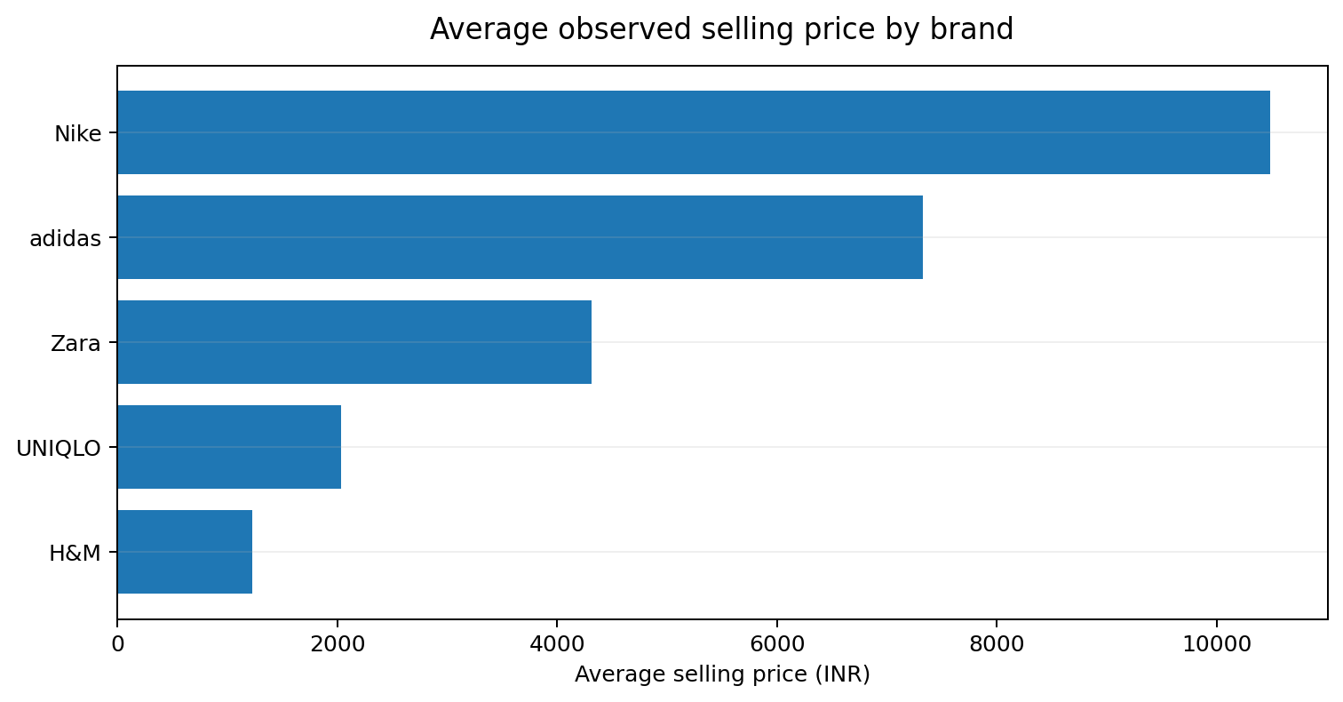
Note: brand-level averages above are based on records with observed selling-price values in the market-research sample; they should not be interpreted as complete brand-wide price averages.

8. Product Sub-Category & Assortment Analysis
Sub-category | Records | Share
Dress | 48 | 19.8%
Lifestyle | 31 | 12.8%
Running | 16 | 6.6%
Originals | 15 | 6.2%
T-Shirt | 15 | 6.2%
Pants | 12 | 5.0%
Top | 9 | 3.7%
Shirt | 8 | 3.3%
Sportswear | 6 | 2.5%
Basketball | 5 | 2.1%
Cricket | 5 | 2.1%
Jumpsuit | 4 | 1.7%
Shorts | 4 | 1.7%
Trousers | 4 | 1.7%
Bra | 3 | 1.2%
Football | 3 | 1.2%
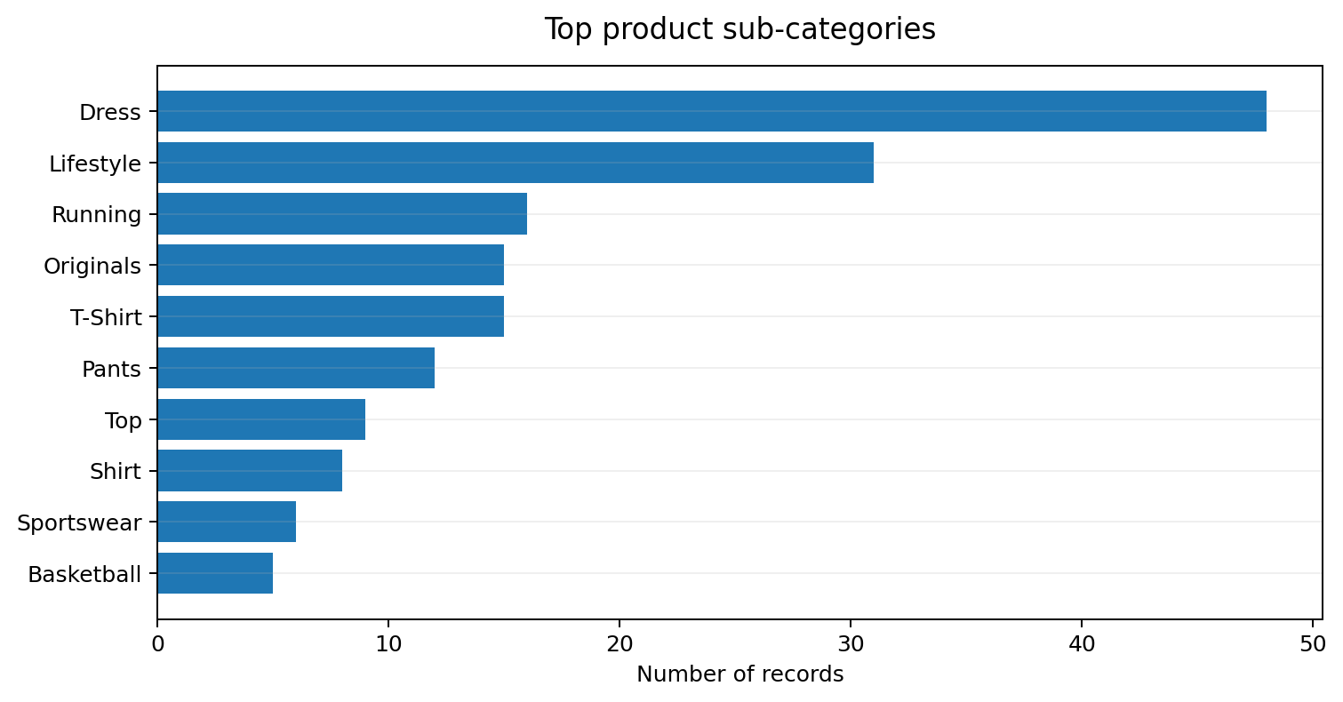

Key patterns
- Dress is the largest sub-category with 48 records (19.8%), indicating strong representation of dress-led apparel.
- Lifestyle follows with 31 records (12.8%), while Running contributes 16 (6.6%).
- Originals and T-Shirt each contribute 15 records (6.2%).
- Pants contribute 12 records (5.0%), followed by Top with 9 (3.7%) and Shirt with 8 (3.3%).
- The concentration in Dress, Lifestyle, Running, Originals and T-Shirt suggests a mix of fashion-led apparel and sports/lifestyle products.
Competitive insight
The sub-category mix shows why a simple brand ranking can be misleading: brands may compete in different product spaces. A stronger competitive comparison combines brand, category and price segment rather than comparing product counts alone.

9. Brand-Level Competitive Interpretation
The five brands occupy visibly different positions in the sample. Product-count coverage is similar, but the observed price levels and category emphasis create distinct competitive profiles.
Brand | Records | Observed avg. price | Analytical profile
Nike | 50 | ≈₹10,484 | Higher-price sports/lifestyle positioning; strong footwear presence in the sample.
adidas | 47 | ≈₹7,325 | Sports, footwear and lifestyle mix with a relatively higher observed price level.
Zara | 50 | ≈₹4,310 | Apparel-heavy, trend-oriented assortment with strong dress representation.
UNIQLO | 49 | ≈₹2,033 | Accessible everyday apparel with strong women-oriented representation.
H&M | 46 | ≈₹1,226 | Lower observed price level and mass-market apparel orientation.

Cross-brand findings
- Nike has the highest observed average selling price among the five brands, indicating the strongest premium pricing position within this sample.
- H&M has the lowest observed average selling price, supporting a more accessible price positioning.
- Zara's strong dress concentration differentiates it from sports-focused brands and supports a fashion/trend-led positioning.
- UNIQLO and H&M are more strongly associated with accessible apparel price points in the observed records.
- Nike and adidas show stronger sports/footwear relevance, creating a different competitive context from Zara, H&M and UNIQLO.

10. Power BI Dashboard Interpretation
The final Power BI page consolidates the analysis into KPI cards, distribution charts, brand comparisons, a brand-category comparison and interactive slicers. The layout is designed as a one-page analytical story: headline metrics at the top, portfolio composition in the middle, and detailed comparisons at the bottom.
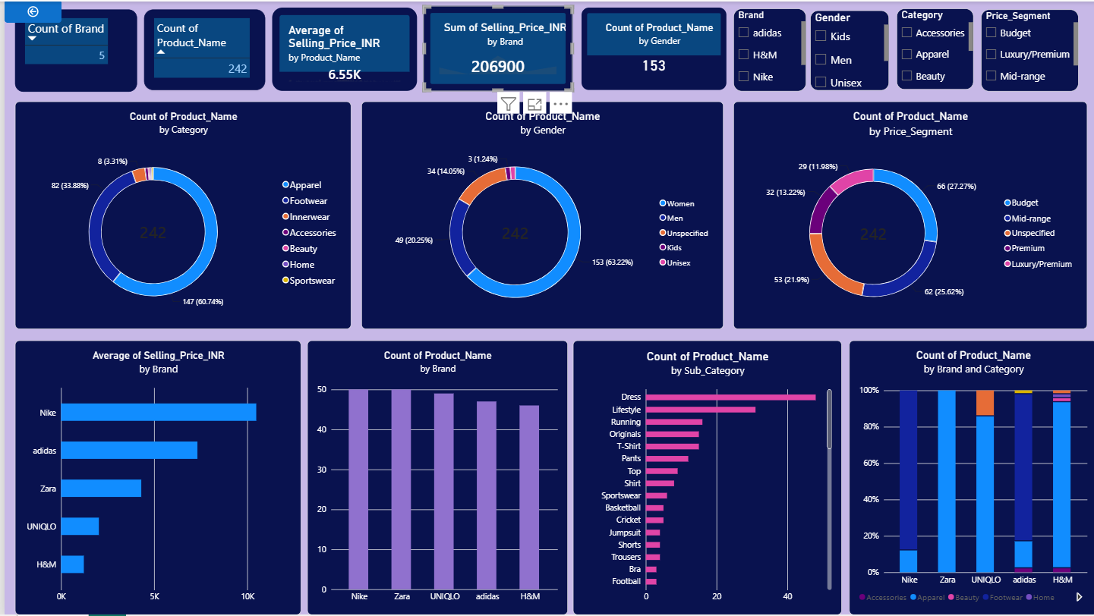
Figure 1. Final Power BI dashboard used for Week 3 analysis.

Dashboard usability
- KPI cards provide an immediate view of record count, brand count, average price and women-oriented product count.
- Donut charts summarize category, gender and price-segment composition.
- Bar charts make brand-level price and product-count comparisons easier.
- The Brand, Gender, Category and Price_Segment slicers allow focused analysis of specific segments.
- The dashboard should be interpreted as a research-sample analysis rather than a complete market-size dashboard.

11. Key Insights & Business Implications
1. Strong apparel concentration
Apparel represents 60.7% of the sample and footwear 33.9%. Together they account for 94.6%, so these are the primary competitive battlegrounds in the collected portfolio.
2. Female-oriented assortment dominates
Women-oriented products account for 63.2% of the records. This suggests that assortment planning and competitive benchmarking should pay particular attention to women's apparel and related sub-categories.
3. Accessible pricing is important
Budget and Mid-range products together represent 52.9% of the sample. This indicates that accessible and moderate price points are highly represented across the collected brands.
4. Premium competition remains significant
Premium and Luxury/Premium together account for 25.2% of records. Higher-priced products are therefore an important part of the competitive landscape, especially for sports/lifestyle brands.
5. Brand positioning differs more than brand coverage
The number of records per brand is tightly clustered, but observed average selling prices range from about ₹1,226 for H&M to ₹10,484 for Nike. This makes price positioning a more informative differentiator than raw product count.
6. Product representation is not sales popularity
The dataset contains product listings, not units sold. Therefore, the number of products in a category or sub-category indicates assortment representation, not actual customer demand.
7. Data classification should remain transparent
The 53 Unspecified price-segment records represent 21.9% of the sample. Keeping them visible prevents false precision and makes the dashboard's data limitations explicit.

12. Strategic Recommendations
Assortment strategy: Maintain strong depth in apparel and footwear, but monitor smaller categories separately to identify whether they represent genuine niche opportunities or simply limited data coverage.
Women’s portfolio: Prioritize women's apparel analysis because it represents 63.2% of the collected sample. Compare dresses, tops, shirts, pants and related price bands across brands.
Price architecture: Use a tiered pricing strategy across Budget, Mid-range and Premium offerings. The sample shows that accessible price points are important while a meaningful premium segment remains present.
Competitive benchmarking: Compare brands within the same category and sub-category before drawing conclusions. For example, compare footwear brands with footwear brands and dress-heavy apparel with comparable apparel assortments.
Data-quality improvement: Continue validating the 53 Unspecified price-segment records and any missing price information before using the dataset for forecasting or financial analysis.
Demand validation: For future analysis, add units sold, sales value, discounts, ratings, reviews or engagement data. These fields would convert assortment representation into stronger evidence about actual customer popularity.
Dashboard usage: Use the slicers to create focused views for each brand and segment. This supports faster competitive questions without rebuilding the report.

13. Limitations & Data Interpretation Notes
- The dataset contains 242 sampled product records and should not be treated as a complete catalogue of the five brands.
- Prices are point-in-time observations and can change with promotions, stock status, new collections and website updates.
- The analysis does not contain transaction volume, units sold or customer purchase history; therefore, product counts are not sales rankings.
- Gender is a product-targeting field, not an observed customer demographic.
- The 53 Unspecified price-segment records reduce the certainty of price-segment comparisons.
- Brand-level average prices are based on observed priced records and should be interpreted as sample-level indicators.

14. Conclusion
The Week 3 analysis converts the cleaned fashion-market dataset into a structured competitive view of product assortment, pricing and targeting. The sample is balanced across five brands, but the portfolio itself is concentrated: apparel and footwear represent 94.6% of records, women-oriented products represent 63.2%, and Budget plus Mid-range products represent 52.9%.
The most important competitive distinction is pricing. The observed average selling-price pattern places Nike at the highest level, followed by adidas, Zara, UNIQLO and H&M. At the same time, the sub-category analysis shows that brands compete through different assortment structures, with dresses, lifestyle products, running products, originals and T-shirts among the most represented areas.
Overall, the analysis provides a clear foundation for market-positioning decisions. The strongest next step would be to combine this assortment-level dataset with actual sales, discount, rating or customer-engagement measures so that product representation can be tested against real demand.

15. Data Sources & References
Primary product data sources retained in the research dataset:
- Nike India – https://www.nike.in/
- adidas India – https://www.adidas.co.in/
- Zara India – https://www.zara.com/in/en/
- H&M India – https://www2.hm.com/en_in/
- UNIQLO India – https://www.uniqlo.com/in/en/
Dashboard design reference: Microsoft Power BI guidance recommends keeping the most important information prominent, using appropriate visual types, maintaining consistent presentation and using slicers/filters to support focused exploration.
Note: All numerical findings in this report are derived from the Week 3 analytical dataset and the final Power BI dashboard; external sources are used only for source traceability and dashboard-design context.

