1 (b).

function [z] = q1b(t, z_0)

% Calculate denominator

z_de = (z_0(1).^2 + z_0(2).^2).^(3/2);

% Calculate z

z_1 = z_0(3);

z_2 = z_0(4);

z_3 = (z_0(1) / z_de)*(-1);

z_4 = (z_0(2) / z_de)*(-1);

% Return

z = [z_1; z_2; z_3; z_4]';

end

**q1b.m**

1 (c).

% clear figure

clf;

% initial values

t_0 = 0;

t_f = 2*pi;

N = 500000;

z_0 = [0.4 0.0 0.0 2.0];

% calculate Z

Z = ForwardEuler(@q1b, t_0, t_f, N, z_0);

z_x = Z(:, 1);

z_y = Z(:, 2);

% plot

hold on;

plot(z_x, z_y);

title('Q1(c) Verify Ellipse');

**q1c.m**

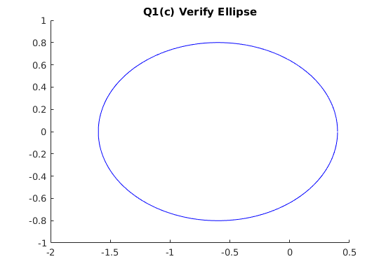

So, it is indeed an ellipse.

2.

Shared Matlab code is presented here:

function [y] = q2func(t, y_0)

y = -2 * t * y_0.^2;

end

**q2func.m**

function [y] = q2func_exact(t)

y = 1 / (1 + t.^2);

end

**q2func_exact.m**

function [err] = q2error(f_n, t, f_exact)

f_n_exact = f_exact(t);

err = f_n - f_n_exact;

end

**q2error.m**

2 (a).

function [y] = MidpointRule (f, t_0, t_f, N, y_0)

% allocate space

y = zeros(N+1, length(y_0));

y(1, :) = y_0';

% calculate h

h = (t_f - t_0) / N;

% iterate

for n = 1:N

t = t_0 + (n-1) * h;

k_1 = f(t, y_0) * h;

k_2 = f(t+h/2, y_0+k_1/2) * h;

y_0 = y_0 + k_2;

y(n+1, :) = y_0';

end

end

**MidpointRule.m**

2 (b).

% clear figure

clf;

% initial values

t_0 = 0;

t_f = 4;

N = 40;

y_0 = 1;

h = (t_f - t_0) / N;

% calculate Y

t = t_0:h:t_f;

len = length(t);

y = zeros(len);

for i = 1 : len

y(i) = q2func_exact(t(i));

end

y_n = ForwardEuler(@q2func, t_0, t_f, N, y_0);

% plot

hold on;

plot(t, y);

plot(t, y_n, '.');

title('Q2(b) ForwardEuler');

**q2b.m**

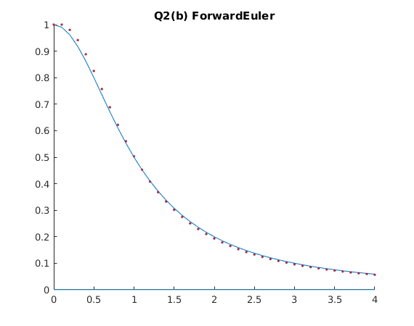

2 (c).

% clear figure

clf;

% initial values

t_0 = 0;

t_f = 4;

N = 40;

y_0 = 1;

h = (t_f - t_0) / N;

% calculate Y

t = t_0:h:t_f;

len = length(t);

y = zeros(len);

for i = 1 : len

y(i) = q2func_exact(t(i));

end

y_n = MidpointRule(@q2func, t_0, t_f, N, y_0);

% plot

hold on;

plot(t, y);

plot(t, y_n, '.');

title('Q2(c) MidpointRule');

**q2c.m**

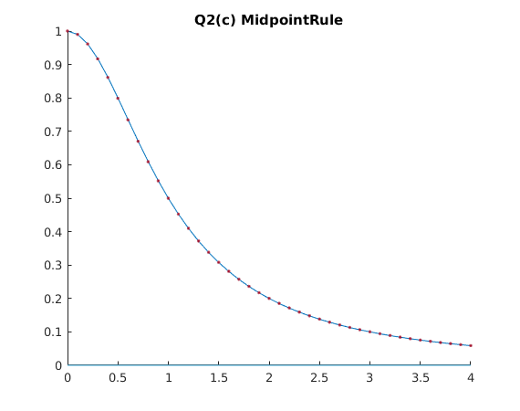

2 (d).

% initial values

y_0 = 1;

t_0 = 0;

t_f = 4;

N = zeros(11, 1);

for i = 0:10

N(i+1) = 2.^i*10;

end

% calculate errors

error = zeros(11, 1);

for i = 1:11

y = MidpointRule(@q2func, t_0, t_f, N(i), y_0);

f_n = y(N(i) + 1);

error(i) = q2error(f_n, t_f, @q2func_exact);

end

disp('Error:');

disp(error);

% calculate error ratios & p-values

error_ratio = zeros(10, 1);

p_val = zeros(10, 1);

for i = 1:10

error_ratio(i) = error(i + 1) / error(i);

p_val(i) = log2(1 / error_ratio(i));

end

disp('Error Ratio:');

disp(error_ratio);

disp('p:')

disp(p_val);

**q2d.m**

Experiment evidences:

|  |  |  |  |
| --- | --- | --- | --- |
| **i** | **Error** | **Error ratio** | **p** |
| 0 | -0.009195833455462 | 0.503344940427460 | 0.990380682354790 |
| 1 | -0.004628676242821 | 0.500494440818975 | 0.998574050296498 |
| 2 | -0.002316626727883 | 0.500091451785889 | 0.999736150052849 |
| 3 | -0.001158525223593 | 0.500022110403486 | 0.999936204271617 |
| 4 | -0.000579288227257 | 0.500006927655467 | 0.999980011150101 |
| 5 | -0.000289648126738 | 0.500002646196381 | 0.999992364711411 |
| 6 | -0.000144824829835 | 0.500001145002375 | 0.999996696225288 |
| 7 | -0.000072412580742 | 0.500000531238298 | 0.999998467171098 |
| 8 | -0.000036206328839 | 0.500000255706248 | 0.999999262187917 |
| 9 | -0.000018103173678 | 0.500000125432825 | 0.999999638077417 |
| 10 | -0.000009051589110 | 0.503344940427460 | 0.990380682354790 |

So, p approximately equals to 1.

Forward Euler method is first order method.

2 (e).

% initial values

y_0 = 1;

t_0 = 0;

t_f = 4;

N = zeros(11, 1);

for i = 0:10

N(i+1) = 2.^i*10;

end

% calculate errors

error = zeros(11, 1);

for i = 1:11

y = MidpointRule(@q2func, t_0, t_f, N(i), y_0);

f_n = y(N(i) + 1);

error(i) = q2error(f_n, t_f, @q2func_exact);

end

disp('Error:');

disp(error);

% calculate error ratios & p-values

error_ratio = zeros(10, 1);

p_val = zeros(10, 1);

for i = 1:10

error_ratio(i) = error(i + 1) / error(i);

p_val(i) = log2(1 / error_ratio(i));

end

disp('Error Ratio:');

disp(error_ratio);

disp('p:')

disp(p_val);

**q2e.m**

Experiment evidences:

|  |  |  |  |
| --- | --- | --- | --- |
| **i** | **Error** | **Error ratio** | **p** |
| 0 | 0.002477321222346 | 0.195801910441708 | 2.352533253483385 |
| 1 | 0.000485064228113 | 0.224080254106996 | 2.157912570345280 |
| 2 | 0.000108693315494 | 0.237558895391946 | 2.073642865416771 |
| 3 | 0.000025821063965 | 0.243912664051205 | 2.035563429456995 |
| 4 | 0.000006298084500 | 0.246989210288278 | 2.017480075764028 |
| 5 | 0.000001555558917 | 0.248502731007491 | 2.008666388012017 |
| 6 | 0.000000386560639 | 0.249253382802279 | 2.004315010248027 |
| 7 | 0.000000096351547 | 0.249627193799754 | 2.002152988319292 |
| 8 | 0.000000024051966 | 0.249813718695707 | 2.001075389155217 |
| 9 | 0.000000006008511 | 0.249906923892663 | 2.000537221765148 |
| 10 | 0.000000001501569 | 0.195801910441708 | 2.352533253483385 |

So, p approximately equals to 2.

Midpoint Rule method is second order method.

5.

Shared Matlab code is presented here:

function theta_dir = dire(x_t, y_t, x_p, y_p, theta_p)

%input:

% x_p x-coord pursuer

% y_p y-coord pursuer

% theta_p direction of motion pursuer

% (angle to x - axis, radians)

% x_t x-coord target

% y_t y-coord target

%output:

% theta_dir direction from pursure to target

% (angle to x - axis, radians)

x_diff = x_t - x_p;

y_diff = y_t - y_p;

theta_dir = atan2( y_diff, x_diff); %range [-pi, +pi]

if( theta_dir < 0.0)

theta_dir = theta_dir + 2.*pi; % now range [0,2*pi]

end

theta_dir = theta_dir + 2*pi*floor( theta_p/(2.*pi) );

% now, theta_dir is in the same interval as theta_pursuer,

% k*2*pi <= theta_pursuer <= (k+1)*2*pi

% k*2*pi <= theta_dir <= (k+1)*2*pi

%

% make sure that we turn in the shortest

% way to point in the right direction, i.e. we don't

% turn the "long way round"

if( (theta_p - theta_dir) > pi)

theta_dir = theta_dir + 2*pi;

elseif( theta_dir - theta_p > pi)

theta_dir = theta_dir - 2*pi;

end

**dire.m**

5 (a).

global METHOD RT SP ST D HD AST

% global values

METHOD = 1; % 1 => ode15s; otherwise => ode45

RT = 0.25;

SP = 2.0;

ST = 1.0;

D = 0.001;

HD = 0.01;

AST = 0.1;

% local values

y_0 = [0.0; 0.0; -pi; 5.0; 5.0; 0.0]; % pursuer | target

t_0 = 0.0;

t_f = 20.0;

tol = 0.000001;

% ode solver options

options = odeset('AbsTol', tol,'RelTol',tol,'MaxOrder',5,'Stats','on',...

'events', 'on', 'Refine',4);

% solve odes

if METHOD == 1

[t,y,te,ye,ie] = ode15s('q5a_fun',[t_0,t_f],y_0,options);

else

[t,y,te,ye,ie] = ode45('q5a_fun',[t_0,t_f],y_0,options);

end;

% plot the trajectory of the pursuer

figure(2);

plot(y(:, 1), y(:, 2));

axis([-1 8 0 12]);

title('The Trajectory of the Pursuer');

xlabel('x(t)'); % x-axis label

ylabel('y(t)'); % y-axis label

% plot the trajectory of the target

figure(3);

plot(y(:, 4), y(:, 5));

axis([-1 8 0 12]);

title('The Trajectory of the Target');

xlabel('x(t)'); % x-axis label

ylabel('y(t)'); % y-axis label

% plot the trajectory of both

figure(4);

hold on;

plot(y(:, 1), y(:, 2));

plot(y(:, 4), y(:, 5), '--');

title('The Trajectory of the Pursuer and Target');

xlabel('x(t)'); % x-axis label

ylabel('y(t)'); % y-axis label

% show hitting time

disp('Hitting time: ');

disp(te);

**q5a.m**

function [dP,halt,direction] = q5a_fun(t,P,flag)

% P is position 6-d vector [x_p, y_p, theta_p, x_t, y_t, theta_t]

% dP is the change of P

global RT SP ST D HD AST

pp = [P(1); P(2); P(3)]; % pursuer position

tp = [P(4); P(5); P(6)]; % target position

% calculate distance between pursuer and target

dp = tp - pp;

distance = norm([dp(1) dp(2)], 2);

if nargin<3 | isempty(flag)

% calculate theta_d

theta_d = dire(P(4), P(5), P(1), P(2), P(3));

% calculate pursuer position change

dP(1) = SP*cos(P(3));

dP(2) = SP*sin(P(3));

dP(3) = SP*((theta_d - P(3) / (abs(theta_d - P(3)) + D)));

% calculate target position change

dP(4) = ST*cos(P(6));

dP(5) = ST*sin(P(6));

dP(6) = ST/RT*AST;

dP = dP';

elseif strcmp(flag,'events')

dP = distance-HD;

halt = 1;

direction = 0;

end;

**q5a_fun.m**

The hitting time for 5(a) is **11.3895**;

Plots are showed in the next page.

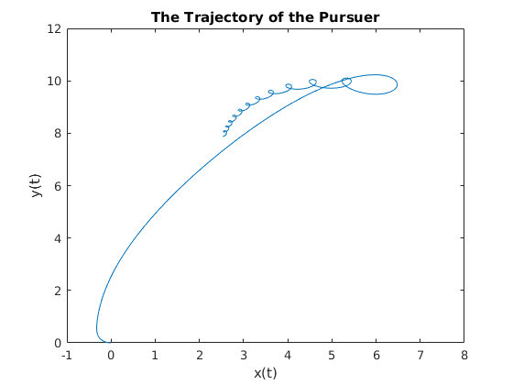

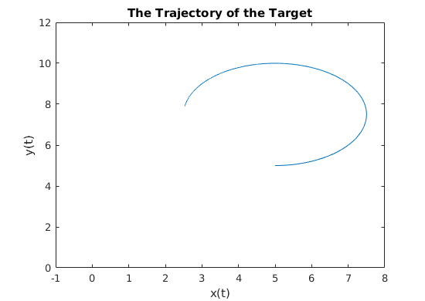

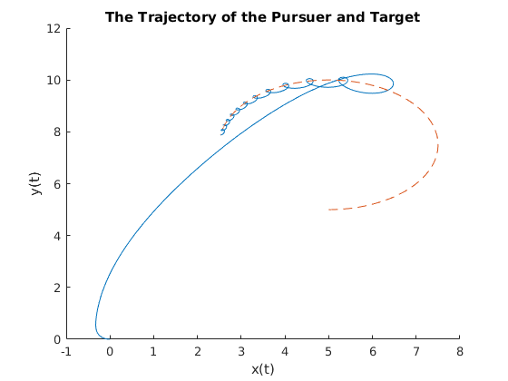

NOTE: **straight line** represents the pursuer, **dash line** represents the target.

5 (b).

|  |  |  |
| --- | --- | --- |
| **tol** | **Hitting Time** | **Number of Function Evaluations** |
|  | 11.2298 | 897 |
|  | 11.2228 | 1040 |
|  | 11.3910 | 1402 |
|  | 11.3895 | 1874 |
|  | 11.3895 | 2402 |
|  | 11.3895 | 3140 |
|  | 11.3895 | 4307 |

With decreasing error tolerance, hitting time is approaching to a fixed value “11.3895”, and the number of function evaluations is increasing.

From that, it is able to conclude that smaller error tolerance make hitting time closer to the real value, but this needs more number of function evaluations.

5 (c).

|  |  |  |
| --- | --- | --- |
| **tol** | **Hitting Time** | **Number of Function Evaluations** |
|  | 11.3749 | 1207 |
|  | 11.5500 | 1675 |
|  | 11.5510 | 2455 |
|  | 11.3895 | 3571 |

Compared with the data with using *ode15s*, *ode45* uses larger number of function evaluations under same error tolerances. Also, *ode45* needs smaller error tolerance than *ode15s* to get to stable hitting time “11.3895”.

From that, it is able to conclude that *ode15s* is more accurate than *ode45* when evaluating the ODEs of this question.

5 (d).

**Pseudo-code description:**

Set in the beginning.

If not halt

Calculate the distance between target and pursuer

Calculate the angular difference of target moving and pursuer moving

Normalize the angular difference to the range

If

If

Else if

Else

If

Else if

**Matlab Code:**

function ret_ang = anglenormalize(theta)

while (theta < 0)

theta = theta + 2*pi;

end

while (theta >= 2*pi)

theta = theta - 2*pi;

end

ret_ang = theta;

**anglenormalize.m**

function [dP,halt,direction] = q5d_fun(t,P,flag)

% P is position 6-d vector [x_p, y_p, theta_p, x_t, y_t, theta_t]

% dP is the change of P

global RT SP ST D HD AST

pp = [P(1); P(2); P(3)]; % pursuer position

tp = [P(4); P(5); P(6)]; % target position

% calculate distance between pursuer and target

dp = tp - pp;

distance = norm([dp(1) dp(2)], 2);

if nargin<3 | isempty(flag)

% calculate theta_d

theta_d = dire(P(4), P(5), P(1), P(2), P(3));

% calculate pursuer position change

dP(1) = SP*cos(P(3));

dP(2) = SP*sin(P(3));

dP(3) = SP*((theta_d - P(3) / (abs(theta_d - P(3)) + D)));

% calculate target position change

dP(4) = ST*cos(P(6));

dP(5) = ST*sin(P(6));

% calculate turning angle change of target

n_theta_p = anglenormalize(P(3));

n_theta_t = anglenormalize(P(6));

if n_theta_p > n_theta_t

n_diff_theta = n_theta_p - n_theta_t;

else

n_diff_theta = n_theta_t - n_theta_p;

end

if distance > 0.7 * RT

% First stage

if n_diff_theta < 0.15

AST = -0.14;

elseif n_diff_theta > 2*pi-0.15

AST = 0.14;

end

else

% Second stage

if n_diff_theta < 1.1

AST = -1;

elseif n_diff_theta > 2*pi-1.1

AST = 1;

end

end

dP(6) = ST/RT*AST;

dP = dP';

elseif strcmp(flag,'events')

dP = distance-HD;

halt = 1;

direction = 0;

end;

**q5d_fun.m**

global METHOD RT SP ST D HD AST

% global values

METHOD = 1; % 1 => ode15s; otherwise => ode45

RT = 0.25;

SP = 2.0;

ST = 1.0;

D = 0.001;

HD = 0.01;

AST = 0;

% local values

y_0 = [0.0; 0.0; -pi; 5.0; 5.0; 0.0]; % pursuer | target

t_0 = 0.0;

t_f = 40.0;

tol = 0.000001;

% ode solver options

options = odeset('AbsTol', tol,'RelTol',tol,'MaxOrder',5,'Stats','on',...

'events', 'on', 'Refine', 4);

% solve odes

if METHOD == 1

[t,y,te,ye,ie] = ode15s('q5d_fun',[t_0,t_f],y_0,options);

else

[t,y,te,ye,ie] = ode45('q5d_fun',[t_0,t_f],y_0,options);

end;

% plot the trajectory of the pursuer

figure(2);

plot(y(:, 1), y(:, 2));

axis([-2 16 0 9]);

title('The Trajectory of the Pursuer');

xlabel('x(t)'); % x-axis label

ylabel('y(t)'); % y-axis label

% plot the trajectory of the target

figure(3);

plot(y(:, 4), y(:, 5));

axis([-2 16 0 9]);

title('The Trajectory of the Target');

xlabel('x(t)'); % x-axis label

ylabel('y(t)'); % y-axis label

% plot the trajectory of both

figure(4);

hold on;

plot(y(:, 1), y(:, 2));

plot(y(:, 4), y(:, 5), '--');

title('The Trajectory of the Pursuer and Target');

xlabel('x(t)'); % x-axis label

ylabel('y(t)'); % y-axis label

% show hitting time

disp('Hitting time: ');

disp(te);

**q5d.m**

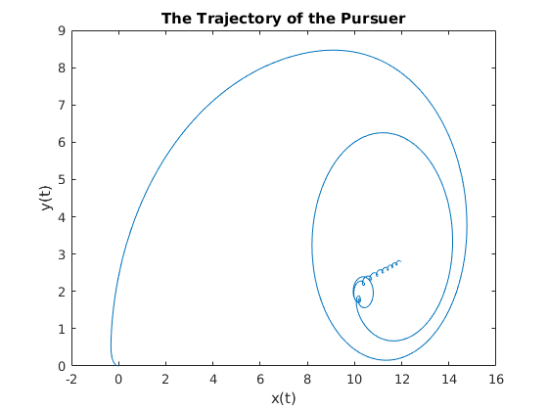

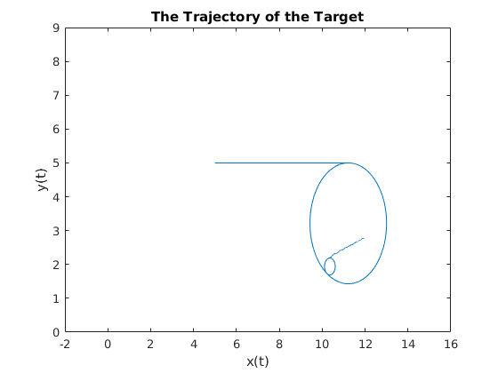

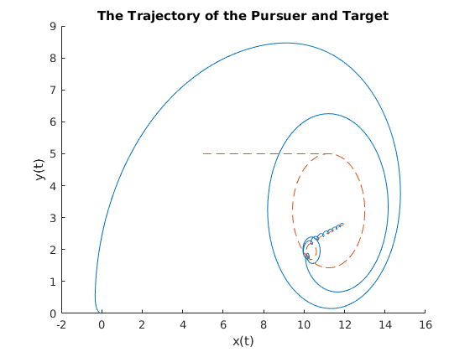

NOTE: **straight line** represents the pursuer, **dash line** represents the target.