3. Code

a = 0.85; % alpha

% a = 0.75;

M = [

1/11, (1-a)/11, (1-a)/11, (9*a+2)/22, (1-a)/11, (1-a)/11, (1-a)/11, (1-a)/11, (1-a)/11, (1-a)/11, (1-a)/11;

1/11, (1-a)/11, (10*a+1)/11, (9*a+2)/22, (8*a+3)/33, (9*a+2)/22, (9*a+2)/22, (9*a+2)/22, (9*a+2)/22, (1-a)/11, (1-a)/11;

1/11, (10*a+1)/11, (1-a)/11, (1-a)/11, (1-a)/11, (1-a)/11, (1-a)/11, (1-a)/11, (1-a)/11, (1-a)/11, (1-a)/11;

1/11, (1-a)/11, (1-a)/11, (1-a)/11, (8*a+3)/33, (1-a)/11, (1-a)/11, (1-a)/11, (1-a)/11, (1-a)/11, (1-a)/11;

1/11, (1-a)/11, (1-a)/11, (1-a)/11, (1-a)/11, (9*a+2)/22, (9*a+2)/22, (9*a+2)/22, (9*a+2)/22, (10*a+1)/11, (10*a+1)/11;

1/11, (1-a)/11, (1-a)/11, (1-a)/11, (8*a+3)/33, (1-a)/11, (1-a)/11, (1-a)/11, (1-a)/11, (1-a)/11, (1-a)/11;

1/11, (1-a)/11, (1-a)/11, (1-a)/11, (1-a)/11, (1-a)/11, (1-a)/11, (1-a)/11, (1-a)/11, (1-a)/11, (1-a)/11;

1/11, (1-a)/11, (1-a)/11, (1-a)/11, (1-a)/11, (1-a)/11, (1-a)/11, (1-a)/11, (1-a)/11, (1-a)/11, (1-a)/11;

1/11, (1-a)/11, (1-a)/11, (1-a)/11, (1-a)/11, (1-a)/11, (1-a)/11, (1-a)/11, (1-a)/11, (1-a)/11, (1-a)/11;

1/11, (1-a)/11, (1-a)/11, (1-a)/11, (1-a)/11, (1-a)/11, (1-a)/11, (1-a)/11, (1-a)/11, (1-a)/11, (1-a)/11;

1/11, (1-a)/11, (1-a)/11, (1-a)/11, (1-a)/11, (1-a)/11, (1-a)/11, (1-a)/11, (1-a)/11, (1-a)/11, (1-a)/11;

];

x = [1/11; 1/11; 1/11; 1/11; 1/11; 1/11; 1/11; 1/11; 1/11; 1/11; 1/11];

disp(M);

for i = 1:15 % iteration times

x = M*x;

end

x

3 (a). M when $α=0.85$

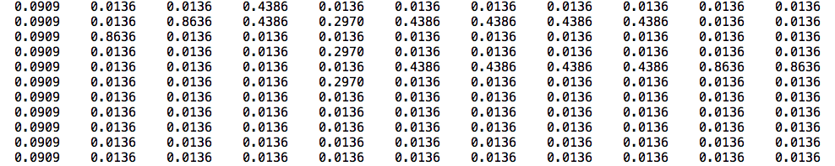

6 (a).

**ConstructPdpe.m**

function [P, d, p, e] = ConstructPdpe(G)

% Get size of matrix G

[row_cnt, col_cnt] = size(G);

% Init. P, d, p, e

P = sparse(row_cnt, col_cnt);

d = sparse(row_cnt, 1);

p = sparse(ones(row_cnt, 1) / row_cnt);

e = sparse(ones(row_cnt, 1));

% Set values

for j = 1:1:col_cnt

% Get the count of all links from node j

link_cnt = full(sum(G(:,j)));

if link_cnt ~= 0

for i = 1:1:row_cnt

is_link = full(G(i, j));

if is_link ~= 0

P(i, j) = 1.0 / link_cnt;

end

end

else

% node j is a dead end

d(j, 1) = 1;

end

end

**MyPageRank.m**

function [p, iter] = MyPageRank(G, alpha)

tol = 0.0000001;

% Make Sparse Matrix P, d

[P, d, p, e] = ConstructPdpe(G);

% Get size of matrix G

[R, C] = size(G);

% Iterate

p_last = p;

iter = 0;

while 1

p = alpha*(P*p+e*(transpose(d)*p)/R)+(1-alpha)*e/R;

iter = iter + 1;

% Check

p_diff = abs(p - p_last);

if max(p_diff(:,1)) < tol

break;

end

p_last = p;

end

6 (b).

**q6b.m**

G = sparse(15, 15);

G(1, 5) = 1;

G(2, 1) = 1;

G(2, 3) = 1;

G(3, 2) = 1;

G(3, 4) = 1;

G(4, 8) = 1;

G(5, 2) = 1;

G(5, 9) = 1;

G(6, 3) = 1;

G(6, 9) = 1;

G(7, 2) = 1;

G(7, 12) = 1;

G(8, 3) = 1;

G(8, 12) = 1;

G(9, 1) = 1;

G(9, 13) = 1;

G(10, 5) = 1;

G(10, 6) = 1;

G(10, 7) = 1;

G(10, 9) = 1;

G(10, 14) = 1;

G(11, 6) = 1;

G(11, 7) = 1;

G(11, 8) = 1;

G(11, 12) = 1;

G(11, 14) = 1;

G(12, 4) = 1;

G(12, 15) = 1;

G(13, 10) = 1;

G(13, 14) = 1;

G(14, 13) = 1;

G(14, 15) = 1;

G(15, 11) = 1;

G(15, 14) = 1;

[p, iter] = MyPageRank(G, 0.75);

p

iter

**Result:**

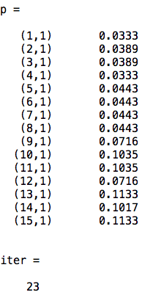

6 (c).

**q6c.m**

load('math_uwaterloo.mat');

alpha = 0.85;

[p, iter] = MyPageRank(G, alpha);

[y I] = sort(p, 'descend');

for n = 1:min(length(I), 20)

disp([num2str(n) ': ' U{I(n)}]);

end

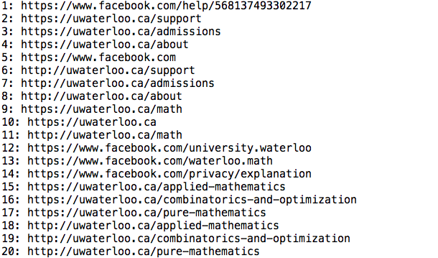

6 (d).

**q6d.m**

load('math_uwaterloo.mat');

alpha = [0.15 0.6 0.75 0.95];

for m = 1:length(alpha)

disp(alpha(m));

[p, iter] = MyPageRank(G, alpha(m));

disp(iter);

[y I] = sort(p, 'descend');

for n = 1:min(length(I), 20)

disp([num2str(n) ': ' U{I(n)}]);

end

end

|  |  |
| --- | --- |
| **Alpha ($α$)** | **Iteration times** |
| 0.15 | 6 |
| 0.6 | 21 |
| 0.75 | 37 |
| 0.95 | 201 |

When $α$ increases, the number of iterations also increases. Also, the number of iterations increases become faster when $α$ increases.

The reason for this relationship is that the convergence of algorithm becomes slower when $α$ increases, and slower convergence of algorithm needs more iterations to make the final values of p have the given tolerance.