IT20116460 – Add package details, Add pickup, view pickup, edit pickups

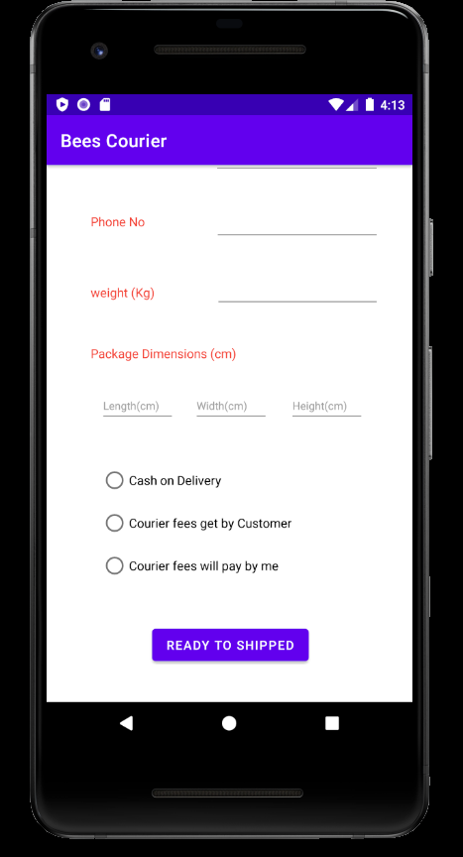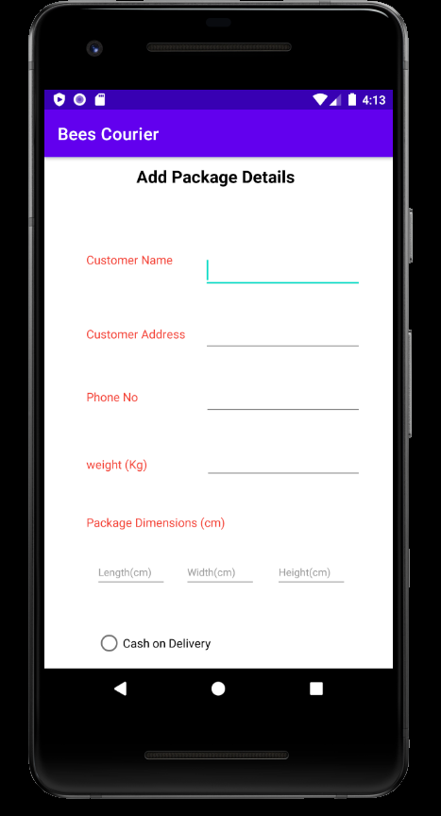

The customer should be directed to the details of the package they are going to send .

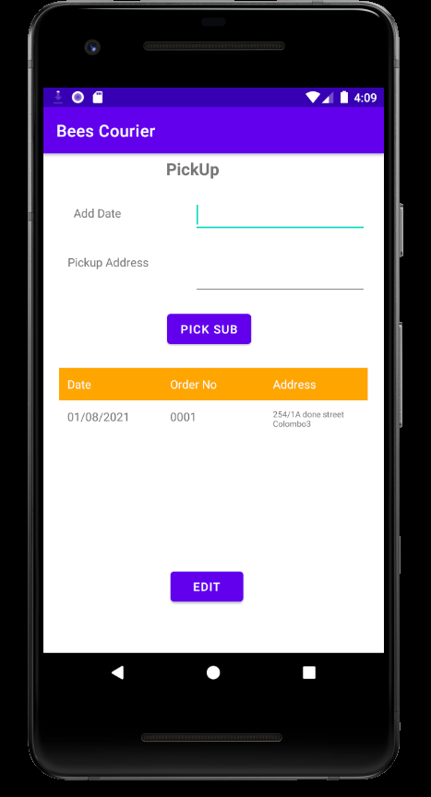

Customer can add their pick up address and date to identify us to get their package and customer can see their pending pickup orders and can edit any time these details.

Usage of resource files

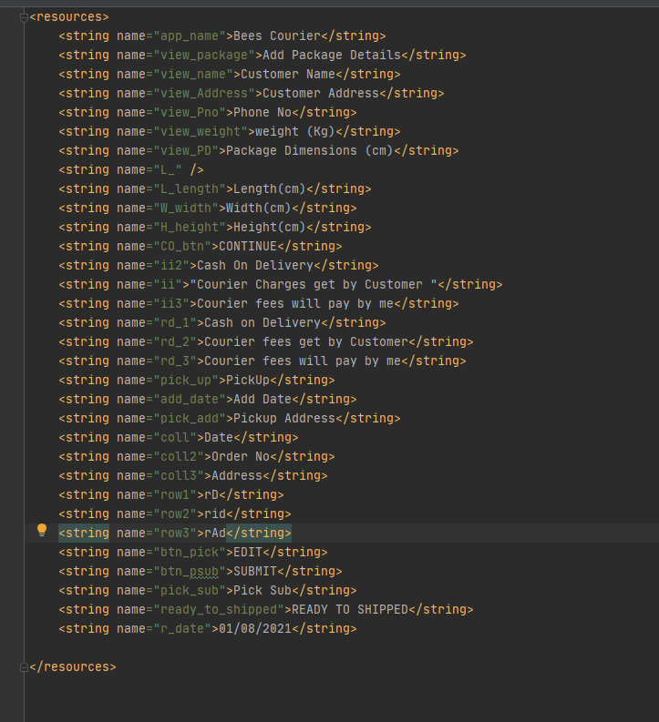

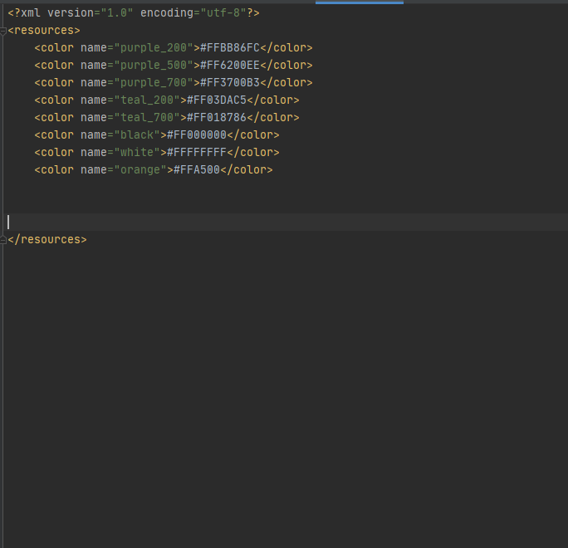

CRUD Operations and functionality of the components:

The customer has to fill in the details of the package they are going to send and enter the sender's name, address and telephone number one by one and then give the weight and size of the parcel.

Also, if you have already received the money in this parcel, you should get the information whether the courier will receive the fee from the sender or the customer will pay for it. It should also be mentioned if you are eligible for cash on deliver.