# Part-1

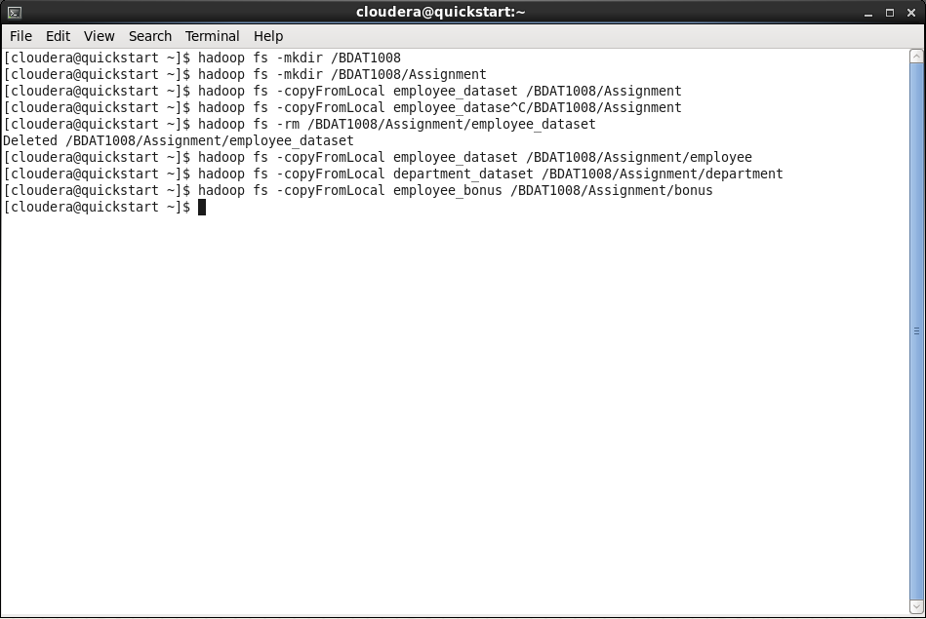

# Part-2

Start spark-shell:

spark-shell --master yarn --jars commons-csv-1.5.jar,spark-csv_2.10-1.5.0.jar

Then import following packages and make sqlContext:

import org.apache.spark.sql.functions._

import org.apache.spark.sql.types._

import org.apache.spark.sql.SQLContext

val sqlContext = new SQLContext(sc)

1. **Create a relation with employee dataset with schema (column names and datatype) and name it employee. Once created, describe the relation.**

val employeeSchema = StructType(Array(

StructField("emp_id", IntegerType, true),

StructField("emp_name", StringType, true),

StructField("emp_job_desc", StringType, true),

StructField("dep_id", StringType, true),

StructField("emp_sal", FloatType, true)))

val employee = sqlContext.read

.format("com.databricks.spark.csv")

.schema(employeeSchema)

.load("hdfs://localhost:8020/BDAT1008/Assignment/employee")

employee.schema

employee.show(10)

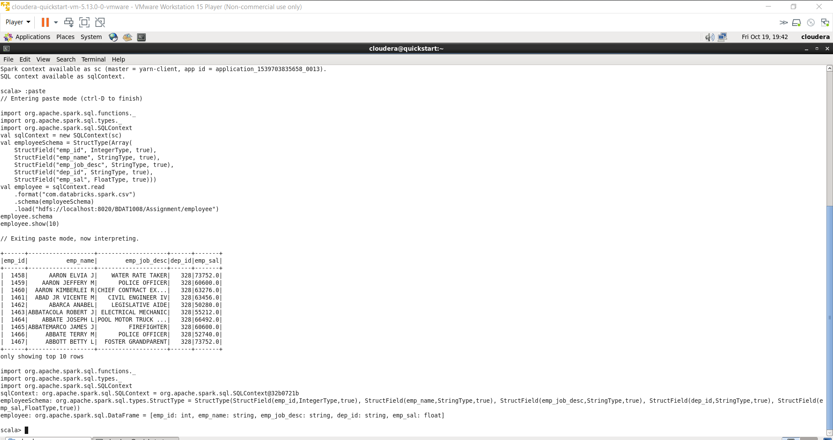

1. **Select the columns from the employee relation. Display 10 of these records on your screen.**

val emp_sel=employee.select(column("emp_name"),column("emp_job_desc"),column("emp_sal"))

emp_sel.schema

emp_sel.show(20)

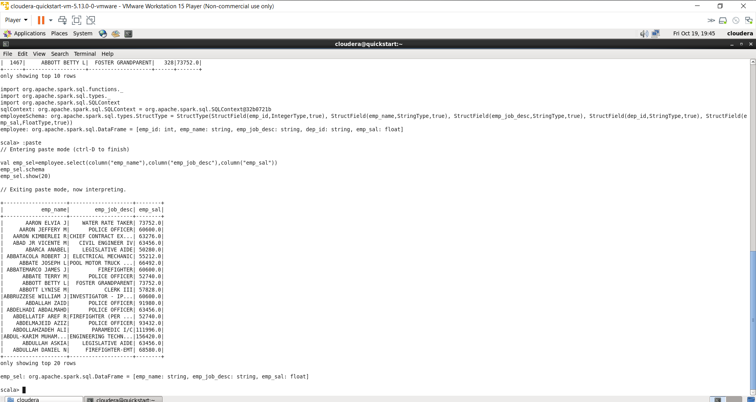

## Create a relation with department dataset with schema (column names and datatype) and name it departments. Once created, describe the relation.

val dep=sqlContext.read.format("com.databricks.spark.csv").option("delimiter",";").load("hdfs://localhost:8020/BDAT1008/Assignment/deaprtment")

val department=dep.withColumn("address",split(regexp_replace('C2,"\\[|\\]",""),"#")).select('C0 as "dep_id",'C1 as "dep_name",split('address(1),",")(0) as "dep_add_street",split('address(2),",")(0) as "dep_add_city",'address(3) as "dep_add_state")

department.schema

department.show()

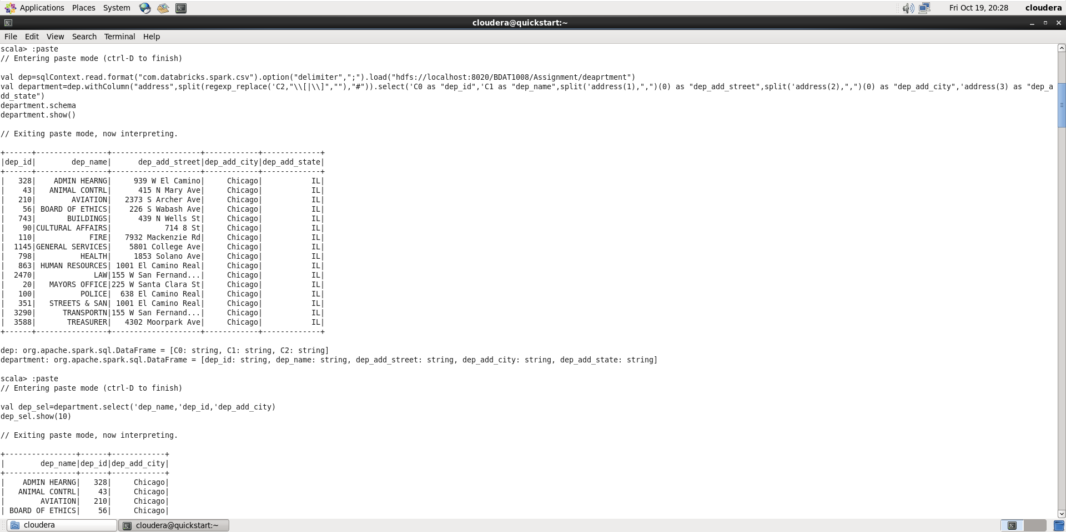

## Select the columns from the department relation. Display 10 of these records on your screen.

val dep_sel=department.select('dep_name,'dep_id,'dep_add_city)

dep_sel.show(10)

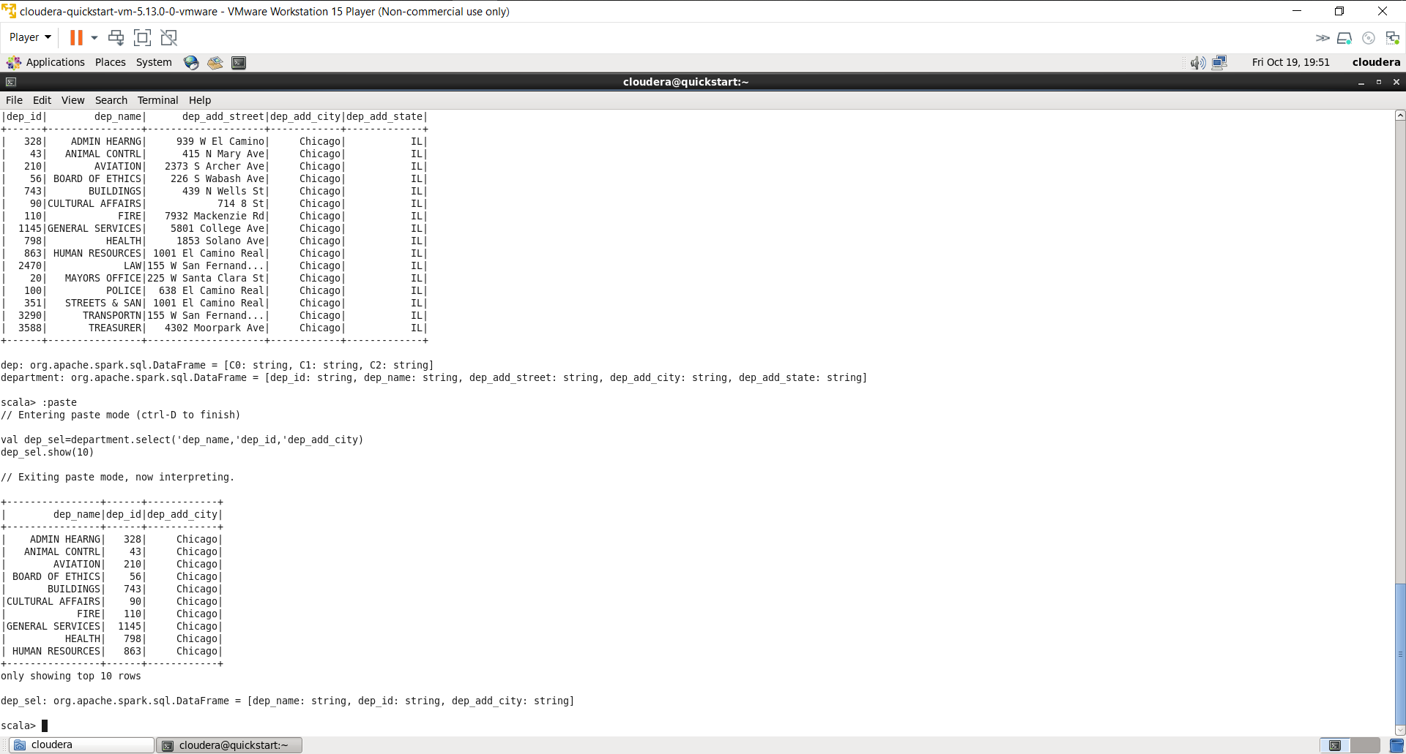

## Create a relation with bonus dataset with schema (column names and datatype) and name it bonus. Once created, describe the relation.

val bonusSchema = StructType(Array(

StructField("emp_id", IntegerType, true),

StructField("emp_bonus", FloatType, true)))

val bonus = sqlContext.read

.format("com.databricks.spark.csv")

.schema(bonusSchema)

.load("hdfs://localhost:8020/BDAT1008/Assignment/bonus")

bonus.schema

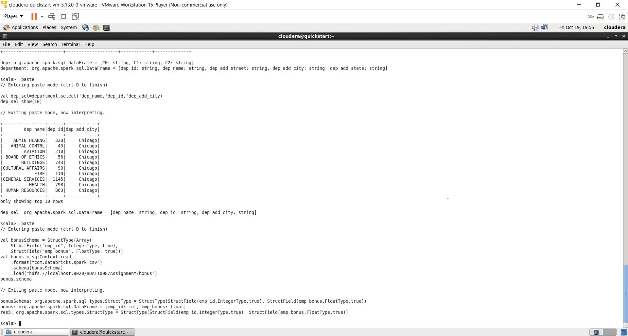

## Select the columns from the bonus relation. Display 10 of these records on your screen.

bonus.show(10)

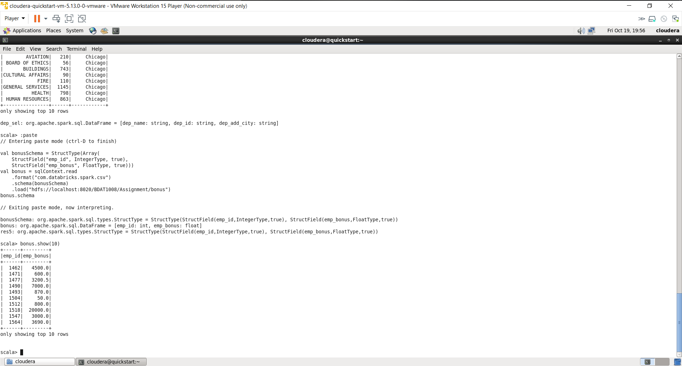

## Join employee and department dataset to display Department Name and Department Address (as 3 separate columns - street, city and state) for each row in employee. Display 10 of these records on your screen.

val employee_department = employee.join(department,Seq("dep_id"),"left_outer")

employee_department.show(50)

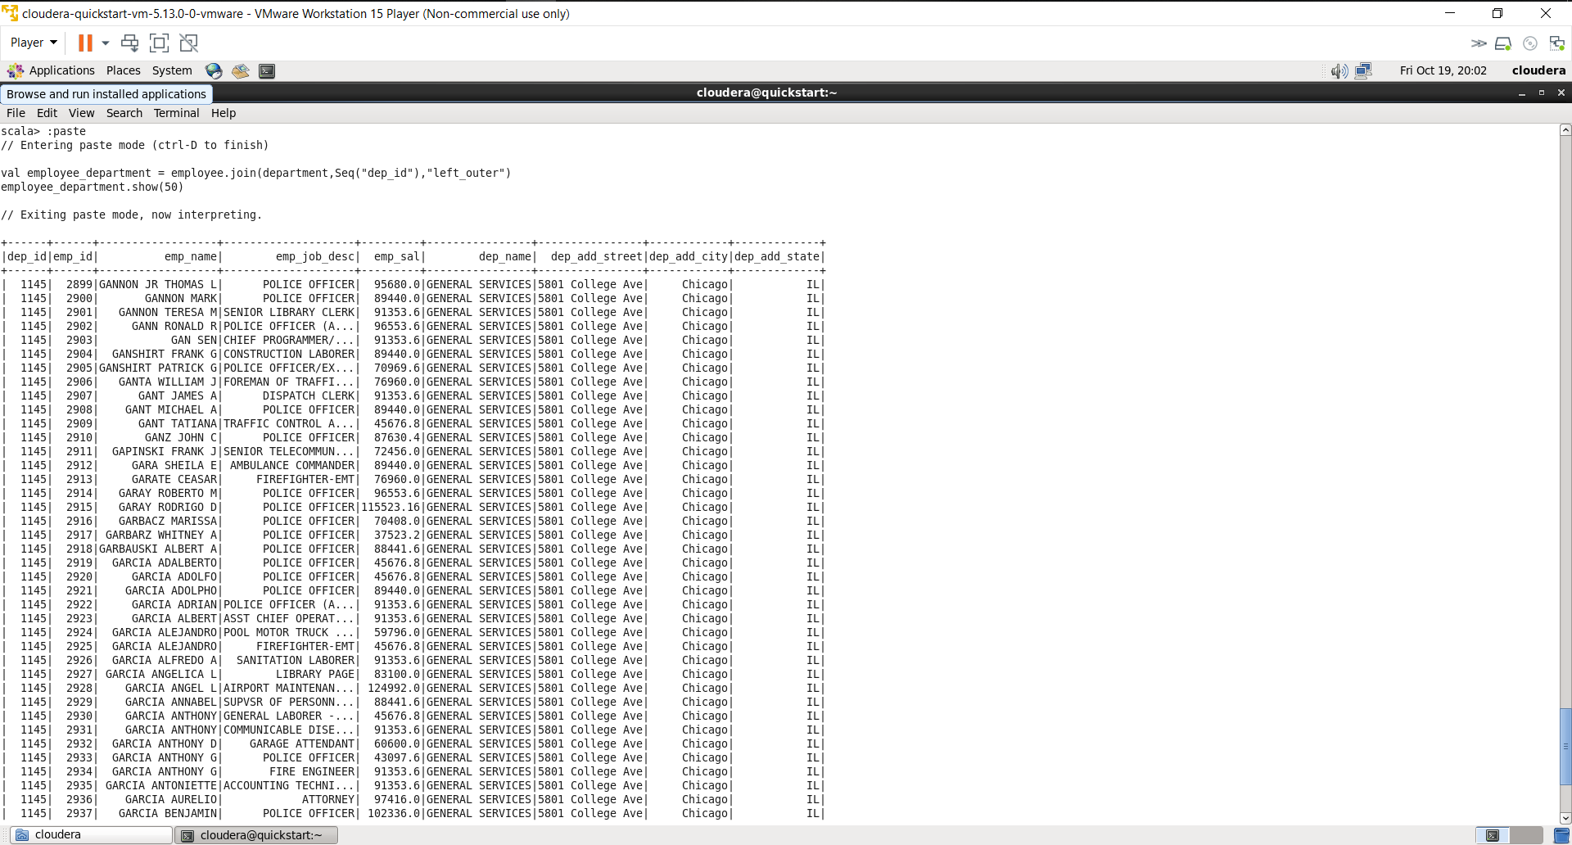

## Display all the employees who received bonus. The result should not display any employees who did not receive a bonus. Display 10 of these records on your screen.

val employee_department_bonus = employee_department.join(bonus,Seq("emp_id"),"left_outer")

val emp_bonus=employee_department_bonus.filter('emp_bonus!==0)

emp_bonus.show(100)

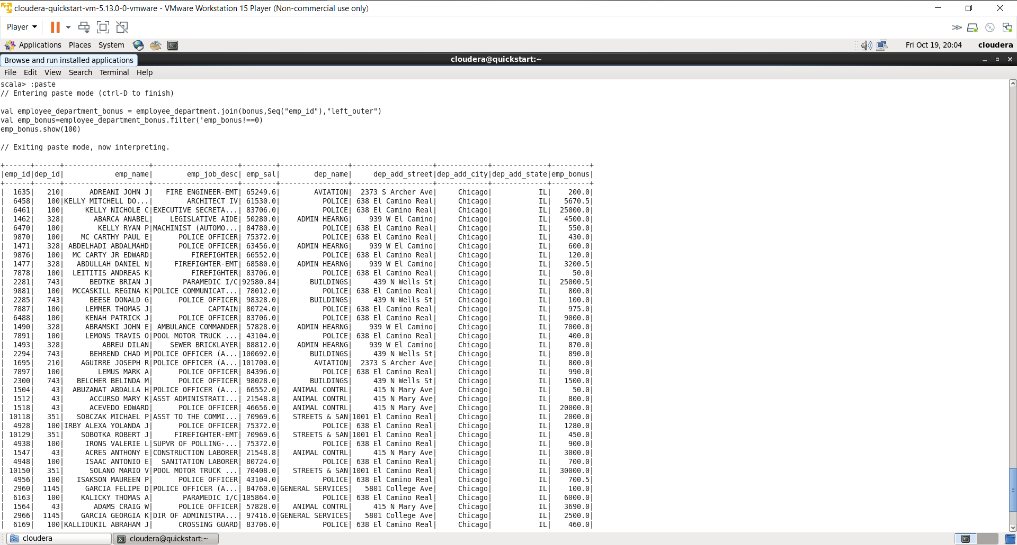

## Display the average bonus by department.

val emp_bonus_dept = employee_department_bonus.groupBy('dep_name)

val avg_bonus_dept = emp_bonus_dept.agg(avg('emp_bonus).alias("average_bonus"))

avg_bonus_dept.show()

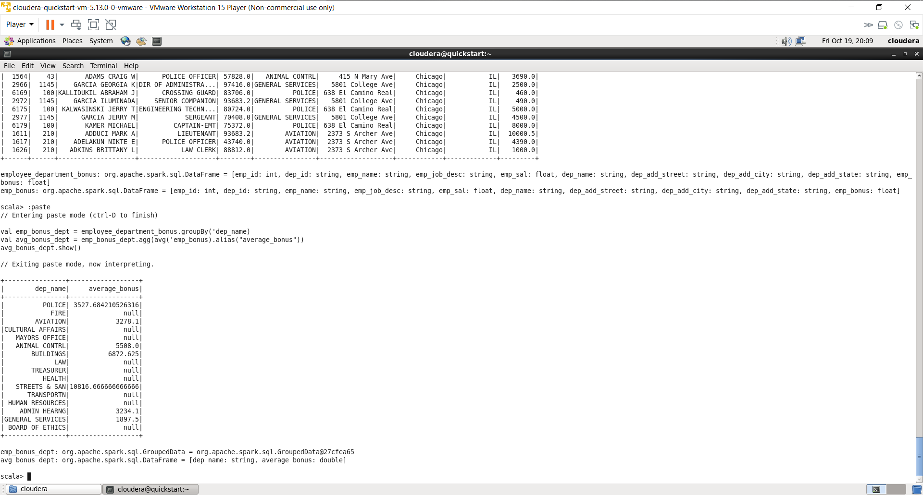

## Display the number of employees in each department.

val emp_dept = emp_bonus_dept.count()

emp_dept.show()

