**Week 3: Singly Linked List**

1. **Aim: Insert a Node at the Tail of a Linked List**

You are given the pointer to the head node of a linked list and an integer to add to the list. Create a new node with the given integer. Insert this node at the tail of the linked list and return the head node of the linked list formed after inserting this new node. The given head pointer may be null, meaning that the initial list is empty.

**Program:**

// Complete the insertNodeAtTail function below.

/*

* For your reference:

*

* SinglyLinkedListNode {

* int data;

* SinglyLinkedListNode* next;

* };

*

*/

SinglyLinkedListNode* insertNodeAtTail(SinglyLinkedListNode* head, int data) {

    if(head == NULL)

    {

        SinglyLinkedListNode *temp = new SinglyLinkedListNode(data);

        head = temp;

        return head;

    }

    SinglyLinkedListNode *cur = head;

    while(cur ->next != NULL)

    {

        cur = cur ->next;

    }

    SinglyLinkedListNode *temp = new SinglyLinkedListNode(data);

    cur ->next = temp;

    return head;

}

**Input & Output:**

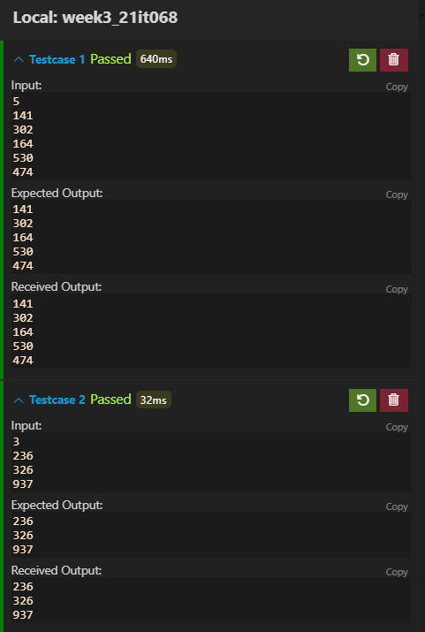



1. **Aim:** **Insert a node at the head of a linked list**

Given a pointer to the head of a linked list, insert a new node before the head. The next value in the new node should point to head and the tail  value should be replaced with a given value. Return a reference to the new head of the list. The head pointer given may be null meaning that the initial list is empty.

**Program:**

// Complete the insertNodeAtTail function below.

/*

 *

For your reference:

  SinglyLinkedListNode {

    int data;

     SinglyLinkedListNode* next;

};

 */

SinglyLinkedListNode* insertNodeAtHead(SinglyLinkedListNode* head, int data) {

    if(head == NULL)

    {

        SinglyLinkedListNode *temp = new SinglyLinkedListNode(data);

        head = temp;

        return head;

    }

    SinglyLinkedListNode *temp = new SinglyLinkedListNode(data);

    temp ->next = head;

    head = temp;

    return head;

}

**Input & Output:**

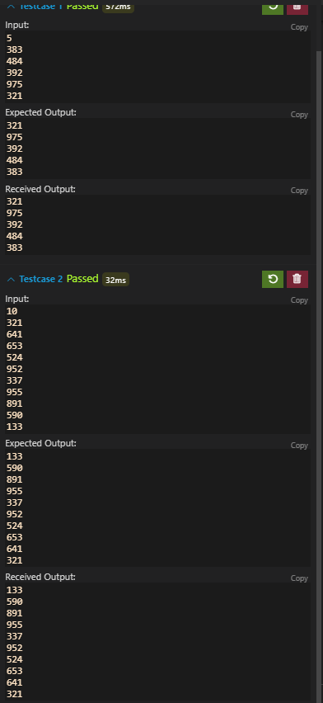



1. **Aim:** **Insert a node at a specific position in a linked list**

Given the pointer to the head node of a linked list and an integer to insert at a certain position, create a new node with the given integer as its data attribute, insert this node at the desired position and return the head node.

A position of 0 indicates head, a position of 1 indicates one node away from the head and so on. The head pointer given may be null meaning that the initial list is empty.

**Program:**

/*

  For your reference:

  SinglyLinkedListNode {

      int data;

      SinglyLinkedListNode* next;

};

 */

SinglyLinkedListNode* deleteNode(SinglyLinkedListNode* llist, int pos) {

    if(pos == 0)

        return llist->next;

    pos --;

    SinglyLinkedListNode *temp  = llist;

    while(pos--)

    {

        temp = temp ->next;

    }

    temp ->next  = temp ->next ->next;

    return llist;

}

**Input & Output:**

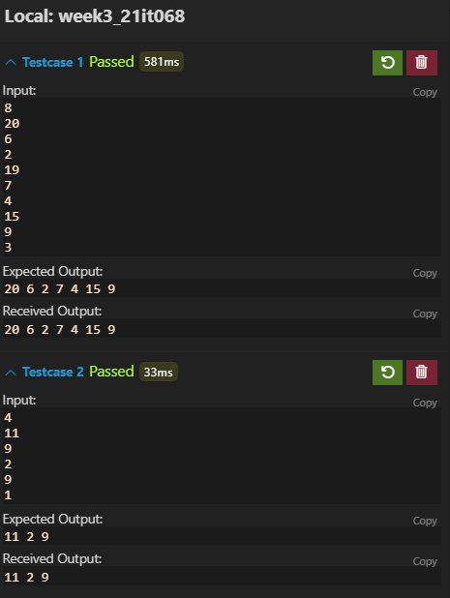



1. **Aim:** **Delete a Node:**

Delete the node at a given position in a linked list and return a reference to the head node. The head is at position 0. The list may be empty after you delete the node. In that case, return a null value.

**Program:**

 * For your reference:

  SinglyLinkedListNode {

    int data;

    SinglyLinkedListNode* next;

 * };

 */

SinglyLinkedListNode* deleteNode(SinglyLinkedListNode* llist, int pos) {

    if(pos == 0)

        return llist->next;

    pos --;

    SinglyLinkedListNode *temp  = llist;

    while(pos--)

    {

        temp = temp ->next;

    }

    temp ->next  = temp ->next ->next;

    return llist;

}

**Input & Output:**

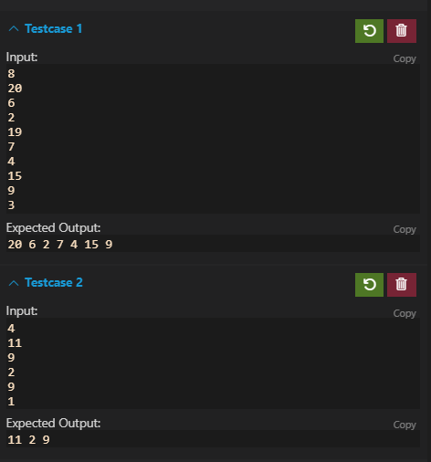

1. **Aim:** **Print in Reverse:**

Given a pointer to the head of a singly-linked list, print each data value from the reversed list. If the given list is empty, do not print anything.

**Program:**

void reversePrint(SinglyLinkedListNode* llist) {

    if(llist == NULL)

    {

        return ;

    }

    reversePrint(llist ->next);

    cout<<llist->data<<endl;

}

**Input & Output:**

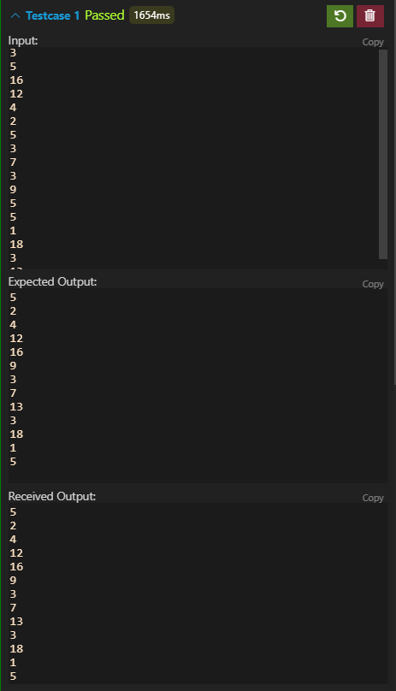

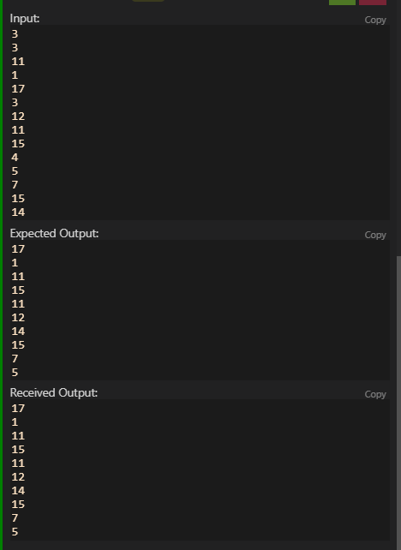

**Conclusion:** From all the above programs we learned the basic operations on Singly Linked List such as   
1. Insertion

2. Deletion

3. Traversing