**Week 10: Stack**

**Aim: Using a helper stick (peg), shift all rings from peg A to peg B using peg C.**

**All rings are initally placed in ascending order, smallest being on top.**

**No bigger ring can be placed over a smaller ring.**

**Program:**

#include <cmath>

#include <cstdio>

#include <vector>

#include <iostream>

#include <algorithm>

using namespace std;

    void towerOfHanoi(int n , char A, char B , char C)

    {

        if(n == 0)

            return;

        towerOfHanoi(n-1,A,C,B);

        cout<<"Move disk "<< n <<" from rod "<<A<<" to rod "<<C<<endl;

        towerOfHanoi(n-1 ,B,A,C);

    }

int main() {

    /* Enter your code here. Read input from STDIN. Print output to STDOUT */

    int n;

    cin>>n;

    towerOfHanoi(n,'A','B','C');

    return 0;

}

**Input & Output:**

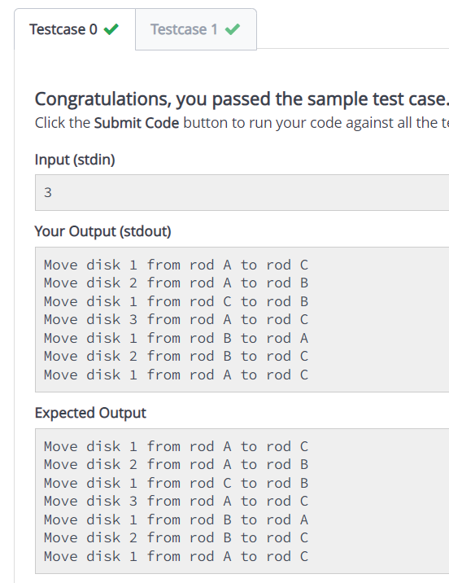

**Conclusion: From the above Program I learned to Solve the famous Tower of Hanoi Problem**