**Practical – 1**

**AIM:**

**Create a webpage demonstrating “Spoural Event '' and its description, providing a link for registration page. Registration form of the student for “Spoural Event'' having different fields like type of event, event listing, Student ID/Group, Branch, etc  
Use Suitable HTML components and its properties wherever required.**

**Source Code:**

<!DOCTYPE html>

<html>

<head>

    <title>Spoural Event</title>

    <style>

        .heading {

            text-align: center;

        }

        form {

            text-align: center;

            font-weight: 500;

            font-size: 20px;

        }

        label {

            display: inline-block;

            width: 100px;

            text-align: right;

        }

    </style>

</head>

<body>

    <h1 class="heading"> SPOURAL 2K23</h1>

    <p>

        Welcome to the "Spoural Event" page! The most awaited Sports and Cultural fest of Charusat University.

        This annual event brings together students, faculty, and staff from our University to participate in a variety

        of

        sports and cultural activities.

    </p>

    <h2 class="heading">Event Details</h2>

    <ul>

        <li>Date: From January 23, 2k23 to February 11, 2k23</li>

        <li>Location: Charusat University</li>

    </ul>

    <h2 class="heading">Registration Form</h2>

    <form>

        <label for="name">Name:</label>

        <input type="text" id="name" name="name"><br><br>

        <label for="email">Email:</label>

        <input type="email" id="email" name="email"><br><br>

        <label for="phone">Phone:</label>

        <input type="tel" id="phone" name="phone"><br><br>

        <label for="college">Charusat Id:</label>

        <input type="text" id="college" name="college"><br><br>

        <label for="year">Year:</label>

        <input type="number" id="year" name="year"><br><br>

        <label for="branch">Branch:</label>

        <input type="text" id="branch" name="branch"><br><br>

        <label for="event">Event:</label>

        <select id="event" name="event">

            <option value="dance">Dance</option>

            <option value="music">Music</option>

            <option value="quiz">Quiz</option>

            <option value="debate">Debate</option>

            <option value="skit">Skit</option>

            <option value="art">Art</option>

            <option value="photography">Photography</option>

            <option value="drama">Drama</option>

            <option value="sports">Football</option>

            <option value="sports">basketball</option>

            <option value="sports">Sports</option>

            <option value="sports">Sports</option>

        </select><br><br>

        <input type="submit" value="Submit">

    </form>

</body>

</html>

**Output:**

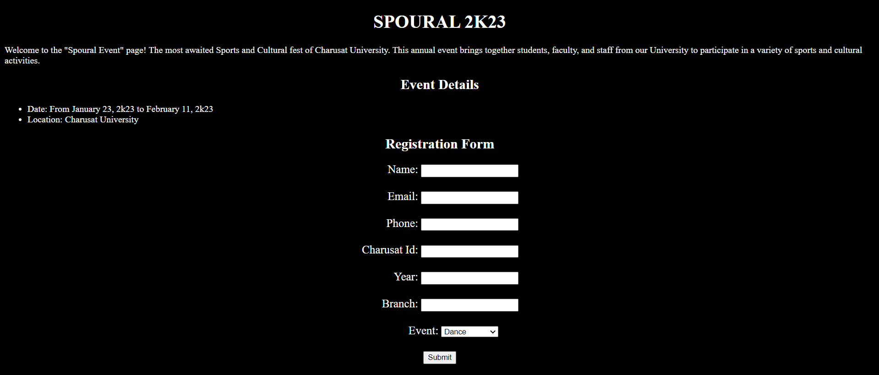

**Conclusion**: From this practical I learned various HTML tags, CSS tags and creation of a web page, with ease.

**Course Outcome:**

Student should able to understand the tools and technologies to design & develop static and dynamic webpages/apps.

Student should able to select appropriate hosting environment.