**Practical – 2**

1. **AIM: Create Basic Calculator using prompt**

**Source Code:**

<!DOCTYPE html>

<html lang="en">

<head>

    <title>Calc</title>

</head>

<body>

    <script>

        let a = prompt()

        console.log(eval(a))

        alert(eval(a))

    </script>

</body>

</html>

**Output:**

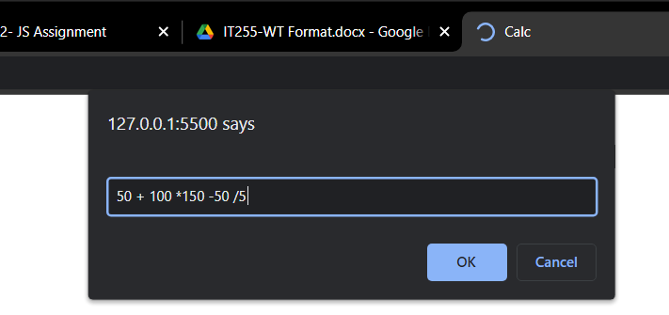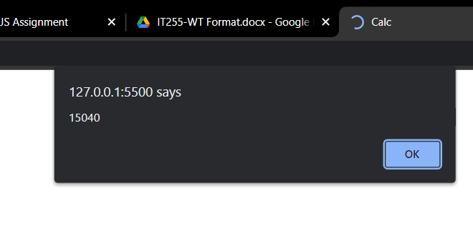

**Conclusion:** From this program I have learned the basics of Javascript and eval function.

1. **AIM: Create Basic Calculator using inputbox**

**Source Code:**

**Html Code**

<!DOCTYPE html>

<html lang="en">

<head>

    <title>Calc</title>

</head>

<body>

    <input type="number" placeholder="vlaue1" id=v1>

    <input type="number" placeholder="vlaue1" id=v2>

    <input type="button" value="+" onclick="f1('+')">

    <input type="button" value="-" onclick="f1('-')">

    <input type="button" value="*" onclick="f1('*')">

    <input type="button" value="/" onclick="f1('/')">

    <ul id="ans">

    </ul>

    <script src="calc.js"></script>

</body>

</html>

**Js code**

function f1(x) {

    var val1 = document.getElementById("v1");

    var val2 = document.getElementById("v2");

    var ans;

    switch (x) {

        case '+':

            ans = parseInt(val1.value) + parseInt(val2.value)

            break;

        case '-':

            ans = parseInt(val1.value) - parseInt(val2.value)

            break;

        case '*':

            ans = parseInt(val1.value) * parseInt(val2.value)

            break;

        case '/':

            ans = parseInt(val1.value) / parseInt(val2.value)

            break;

    }

    let ll = document.createElement("li");

    let t = `${val1.value} ${x} ${val2.value}  =  ${ans}`;

    let text = document.createTextNode(t);

    ll.appendChild(text);;

    document.getElementById("ans").appendChild(ll);

}

**Output:**

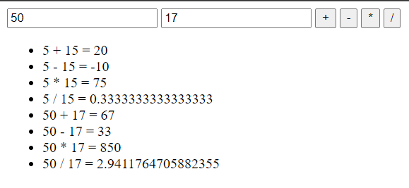

**Conclusion:** From this program I have learned the basics of Javascript and basic function of Dom.

1. **AIM:** **Do temperature Conversion using the input box and display the result on the Web Page. (Celsius to Fahrenheit)**

**Source Code:**

**Html Code**

<!DOCTYPE html>

<html lang="en">

<head>

    <title>Document</title>

</head>

<body>

    <p> Enter tempreature in Celsius</p>

    <input type="text" id="temp_input">

    <input type="button" value="convert" onclick="converter()">

    <ul id="id_text">

    </ul>

    <script src="./temp.js"></script>

</body>

</html>

**Js code**

function converter() {

    let obj = document.getElementById("temp_input")

    let temp = obj.value;

    if (isNaN(temp)) {

        obj.value = "";

        alert("Invalid Input")

    }

    let f;

    f = (temp * 1.8) + 32;

    let ll = document.createElement("li");

    let t = `${temp} in farhenite is ${f}`

    let text = document.createTextNode(t);

    ll.appendChild(text);

    document.getElementById("id_text").appendChild(ll);

}

**Output:**

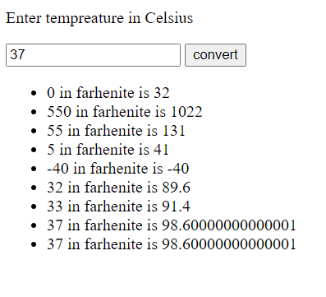

**Conclusion:** From this program I have learned the basics of javascript and basic function of Dom.

**Course Outcome:** Student should able to understand the tools and technologies to design & develop static and dynamic webpages/apps.

Student should able to select appropriate hosting environment