**Practical – 3**

**AIM: Print prime Numbers up to given value in the input box**

**Source Code:**

<!DOCTYPE html>

<html lang="en">

<head>

    <meta charset="UTF-8">

    <meta http-equiv="X-UA-Compatible" content="IE=edge">

    <meta name="viewport" content="width=device-width, initial-scale=1.0">

    <title>Document</title>

</head>

<body>

    <input type="text" id="id_number">

    <button id="id_press">

        print

    </button>

    <p id="id_print"></p>

    <script src="./prime.js"></script>

</body>

</html>

let print_prime = function () {

    const N = document.getElementById("id_number").value;

    if (isNaN(N)) {

        document.getElementById("id_number").value = null

        alert("Invalid Input!");

        return;

    }

    let list = []

    let ans = [];

    for (let i = 0; i <= N; i++) {

        list.push(false);

    }

    for (let i = 2; i <= N; i++) {

        if (list[i] == false) {

            ans.push(i);

            let a = i + i;

            while (a <= N) {

                list[a] = true;

                a = a + i;

            }

        }

    }

    document.getElementById("id_print").innerHTML = ans.toString();

}

let but = document.getElementById("id_press");

but.addEventListener("click", print_prime);

**Output:**

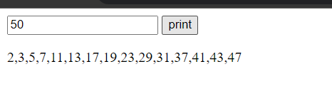

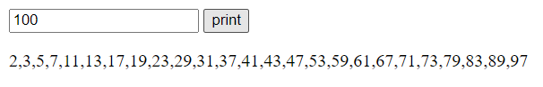

**AIM:** **Write Script to reverse the given input string**

**Source Code:**

<!DOCTYPE html>

<html lang="en">

<head>

    <meta charset="UTF-8">

    <meta http-equiv="X-UA-Compatible" content="IE=edge">

    <meta name="viewport" content="width=device-width, initial-scale=1.0">

    <title>Document</title>

</head>

<body>

    <input type="text" id="id_number">

    <button id="id_press">

        print

    </button>

    <p id="id_print"></p>

    <script src="./reverse.js"></script>

</body>

</html>

let reverseString = function () {

    let textObj = document.getElementById("id_number")

    let text = textObj.value;

    // textObj.value = null;

    let rev = text.split('').reverse().join('');

    document.getElementById("id_print").innerHTML = rev;

}

let button = document.getElementById("id_press");

button.addEventListener("click", reverseString);

**Output:**

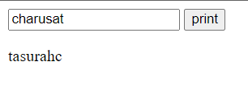

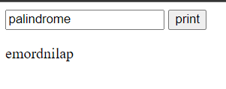

**AIM:** **Create Dynamic Multiplication Table using inputs**

**Source Code:**

<!DOCTYPE html>

<html lang="en">

<head>

    <meta charset="UTF-8">

    <meta http-equiv="X-UA-Compatible" content="IE=edge">

    <meta name="viewport" content="width=device-width, initial-scale=1.0">

    <title>Document</title>

    <style>

        table,

        td {

            border: 1px solid black;

            padding: 5px;

        }

    </style>

</head>

<body>

    <input type="text" id="id_number">

    <button id="id_press">

        print

    </button>

    <div id="table">

    </div>

    <script src="./table.js"></script>

</body>

</html>

console.log("connected");

function table() {

    var rows = document.getElementById("id_number").value;

    var table = document.createElement("table");

    var tableBody = document.createElement("tbody");

    var row, cell, text;

    for (var i = 1; i <= rows; i++) {

        row = document.createElement("tr");

        for (var j = 1; j <= rows; j++) {

            cell = document.createElement("td");

            text = document.createTextNode(i * j);

            cell.appendChild(text);

            row.appendChild(cell);

        }

        tableBody.appendChild(row);

    }

    table.appendChild(tableBody);

    document.getElementById("table").appendChild(table);

}

let button = document.getElementById("id_press");

button.addEventListener("click", table);

**Output:**

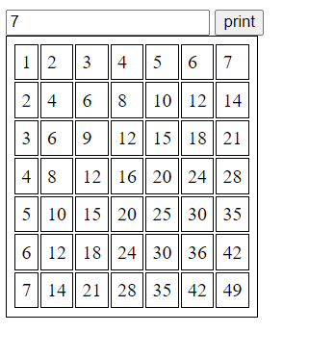

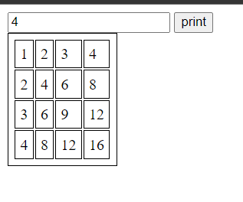

**AIM:** **Find the Age from input date.(Ex. 17 Yrs, 3 Monts,13 Days)**

**Source Code:**

<!DOCTYPE html>

<html lang="en">

<head>

    <meta charset="UTF-8">

    <meta http-equiv="X-UA-Compatible" content="IE=edge">

    <meta name="viewport" content="width=device-width, initial-scale=1.0">

    <title>Document</title>

</head>

<body>

    <input type="text" id="id_number">

    <button id="id_press">

        print

    </button>

    <div id="age">

    </div>

    <script src="./agecalc.js"></script>

</body>

</html>

console.log("connected");

function calculateAge() {

    var input = document.getElementById("id_number").value;

    var birthdate = new Date(input);

    var today = new Date();

    var ageInMilliseconds = today - birthdate;

    var ageInSeconds = ageInMilliseconds / 1000;

    var ageInMinutes = ageInSeconds / 60;

    var ageInHours = ageInMinutes / 60;

    var ageInDays = ageInHours / 24;

    var ageInMonths = ageInDays / 30.4;

    var ageInYears = ageInMonths / 12;

    var years = Math.floor(ageInYears);

    var months = Math.floor(ageInMonths % 12);

    var days = Math.floor(ageInDays % 30.4);

    let te = `${years}Yrs,${months} Months,${days} Days`

    document.getElementById("age").innerHTML = te;

}

let obj = document.getElementById("id_press");

obj.addEventListener("click", calculateAge);

**Output:**

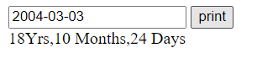

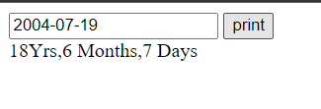

**AIM:** **Find the No. of Days between two given dates**

**Source Code:**

<!DOCTYPE html>

<html lang="en">

<head>

    <meta charset="UTF-8">

    <meta http-equiv="X-UA-Compatible" content="IE=edge">

    <meta name="viewport" content="width=device-width, initial-scale=1.0">

    <title>Document</title>

</head>

<body>

    <input type="text" id="id_date1">

    <input type="text" id="id_date2">

    <button id="id_calc">print</button>

    <div id="diff">

    </div>

    <script src="./no_of_days.js"></script>

</body>

</html>

console.log("connected");

function calculateAge() {

    var input = document.getElementById("id_date1").value;

    var input2 = document.getElementById("id_date2").value;

    var date1 = new Date(input);

    var date2 = new Date(input2);

    var timeDiff = Math.abs(date2.getTime() - date1.getTime());

    var days = Math.ceil(timeDiff / (1000 * 3600 * 24));

    let te = `${days} Days`

    document.getElementById("diff").innerHTML = te;

}

let obj = document.getElementById("id_calc");

obj.addEventListener("click", calculateAge);

**Output:**

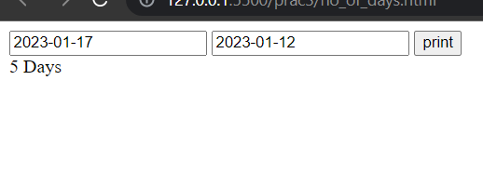

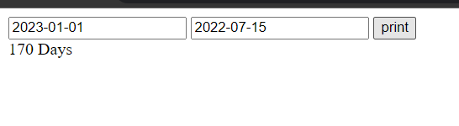

**Conclusion: From the above programs I have learned the function, Date object and events in Java Script.**