**Practical – 4**

**AIM:** **Create Javascript Object of Spoural Registration User input and Display the Object Details on Webpage(Table)**

**Source Code:**

<!DOCTYPE html>

<html lang="en">

<head>

    <meta charset="UTF-8">

    <meta http-equiv="X-UA-Compatible" content="IE=edge">

    <meta name="viewport" content="width=device-width, initial-scale=1.0">

    <title>Document</title>

    <style>

        table,

        tr,

        td {

            border: 2px solid black;

        }

    </style>

</head>

<body>

    <h1>spoural form detail</h1>

    <table id="t"></table>

    <button id="show">show</button>

    <script src="./spoural.js"></script>

</body>

</html>

let obj = {

    name: "Kotak Hiranj",

    branch: "IT",

    id: "21IT068",

    sem: '4th',

}

let tbl = document.getElementById("t");

function suit() {

    Object.entries(obj).forEach(([key, value]) => {

        var tr = document.createElement('tr');

        var td = document.createElement('td');

        td.innerHTML = key;

        tr.appendChild(td);

        tbl.appendChild(tr);

        td = document.createElement('td');

        td.innerHTML = value;

        tr.appendChild(td);

        tbl.appendChild(tr);

    });

}

let btn = document.getElementById('show');

btn.onclick = () => {

    suit()

}

**Output:**

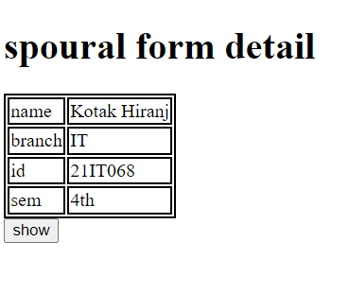

**AIM: Create Car Object and Its methods like isFuelType(CNG, Petrol, Diesel, Hybrid), isType(like SUV, Hatchback,Luxury), isBrand(like BMW, Audi, Tata, Mahindra)**

**Source Code:**

<!DOCTYPE html>

<html lang="en">

<head>

    <meta charset="UTF-8">

    <meta http-equiv="X-UA-Compatible" content="IE=edge">

    <meta name="viewport" content="width=device-width, initial-scale=1.0">

    <title>Cars</title>

</head>

<body>

    <script src="./car.js"></script>

</body>

</html>

const car = {

    isFuelType: "CNG",

    isType: "SUV",

    isBrand: "BMW",

    display() {

        document.write(`<h1>calling by object</h1>this car use  ${this.isFuelType}. type of this car is ${this.isType} and brand is ${this.isBrand}<br>`);

    },

};

console.log(car.display())

function GetDetail(fuel, type, brand) {

    this.isFuelType = fuel;

    this.isType = type;

    this.isBrand = brand;

    this.display = function () {

        document.write(`<h1>calling by Constructor</h1>this car use  ${this.isFuelType}. type of this car is ${this.isType} and brand is ${this.isBrand}`);

    }

};

let ans = new GetDetail("Diesel", "Luxury", "Tata")

console.log(ans.display());

**Output:**

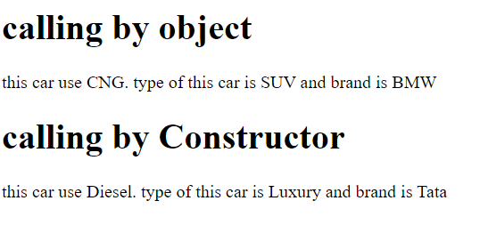

**Conclusion: from the above program I have learned the usage of objects in javasript.**