**Practical – 5**

**AIM:** **Demonstrate various Ways to handle Events**

**Source Code:**

<!DOCTYPE html>

<html lang="en">

<head>

    <meta charset="UTF-8">

    <meta http-equiv="X-UA-Compatible" content="IE=edge">

    <meta name="viewport" content="width=device-width, initial-scale=1.0">

    <title>Document</title>

</head>

<body>

    <button id="addevent"> with add event listener</button>

    <button id="oc" onclick="r();"> with onclick</button>

    <button id="ocd"> with DOM onclick</button>

    <p id="p"></p>

    <script src="./events.js"></script>

</body>

</html>

let p = document.getElementById("p");

function r() {

    p.innerHTML = `handle by onclick in html`

}

let btn1 = document.getElementById("addevent")

let btn2 = document.getElementById("ocd")

btn1.onclick = () => {

    p.innerHTML = `handle with add event listner in js`

}

btn2.onclick = function () {

    p.innerHTML = `handle by with DOM Onclick property in js`

}

**Output:**

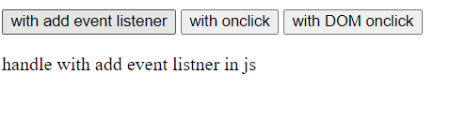

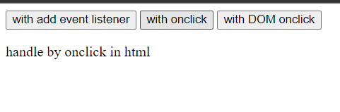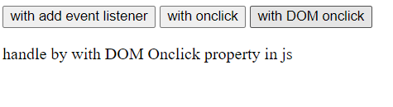

**AIM:** **Write the Script to Change the background color randomly after every 1 mins**

**Source Code:**

<!DOCTYPE html>

<html lang="en">

<head>

    <meta charset="UTF-8">

    <meta http-equiv="X-UA-Compatible" content="IE=edge">

    <meta name="viewport" content="width=device-width, initial-scale=1.0">

    <title>Document</title>

</head>

<body>

    <h1>

        Changing bg color every minute

    </h1>

    <script src="./random_bg.js"></script>

</body>

</html>

const colors = ["violet", "indigo", "blue", "green", "yellow", "orange", "red"];

let getc = function () {

    var color = colors[Math.floor(Math.random() * colors.length)];

    document.body.style.backgroundColor = color;

}

setInterval(getc, 1000);

**Output:**

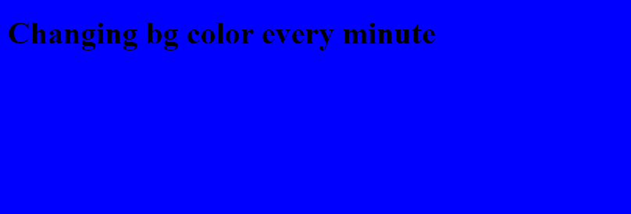

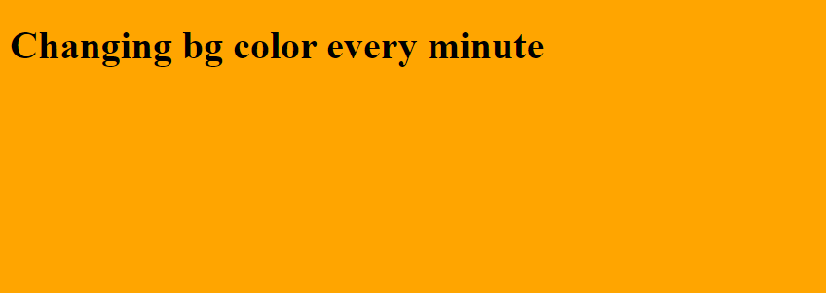

**AIM:** **Create Arrays of Colors and Apply these colors in order to tr background of table**

**Source Code:**

<!DOCTYPE html>

<html lang="en">

<head>

    <meta charset="UTF-8">

    <meta http-equiv="X-UA-Compatible" content="IE=edge">

    <meta name="viewport" content="width=device-width, initial-scale=1.0">

    <title>Document</title>

</head>

<body>

    <table border="2">

        <tr>

            <th> sr. no </th>

            <th> Name </th>

            <th> ID </th>

        </tr>

        <tr>

            <td> 1</td>

            <td> Hiranj </td>

            <td> 21it068 </td>

        </tr>

        <tr>

            <td> 2</td>

            <td> Henil</td>

            <td>21it085</td>

        </tr>

        <tr>

            <td>3</td>

            <td>Hit </td>

            <td> 21it067</td>

        </tr>

        <tr>

            <td> 4 </td>

            <td> Jay</td>

            <td> 21it064</td>

        </tr>

        <tr>

            <td> 5 </td>

            <td> Harshal </td>

            <td>21cs029</td>

        </tr>

        <tr>

            <td> 6 </td>

            <td> keyur </td>

            <td> 21dcs107 </td>

        </tr>

        <tr>

            <td> 7 </td>

            <td> parth </td>

            <td> 21it094</td>

        </tr>

    </table>

    <script src="./table.js"></script>

</body>

</html>

const colors = ["violet", "indigo", "blue", "green", "yellow", "orange", "red"];

let t = document.getElementsByTagName("tr");

for (let i = 0; i < t.length; i++) {

    t[i].style.backgroundColor = colors[i];

}

**Output:**

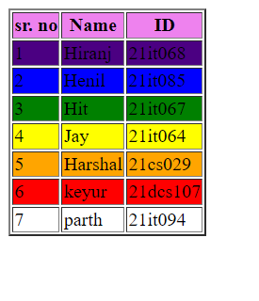

**AIM:** **Zoom image on mouseover and zoom out on mouse out**

**Source Code:**

<!DOCTYPE html>

<html lang="en">

<head>

    <meta charset="UTF-8">

    <meta http-equiv="X-UA-Compatible" content="IE=edge">

    <meta name="viewport" content="width=device-width, initial-scale=1.0">

    <title>Document</title>

    <style>

        img {

            height: 5vh;

            width: 5vh;

        }

    </style>

</head>

<body>

    <img id="id_gojo" src="./download.jpeg">

    <script src="./image.js"></script>

</body>

</html>

console.log("conn")

let img = document.getElementById("id_gojo")

console.log(img)

let zoomIn = function () {

    img.style.height = "50vh";

    img.style.width = "50vh";

}

let zoomOut = function () {

    img.style.height = "5vh";

    img.style.width = "5vh";

}

img.addEventListener("mouseover", zoomIn);

img.addEventListener("mouseleave", zoomOut);

**Output:**

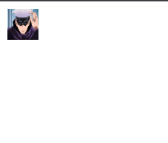

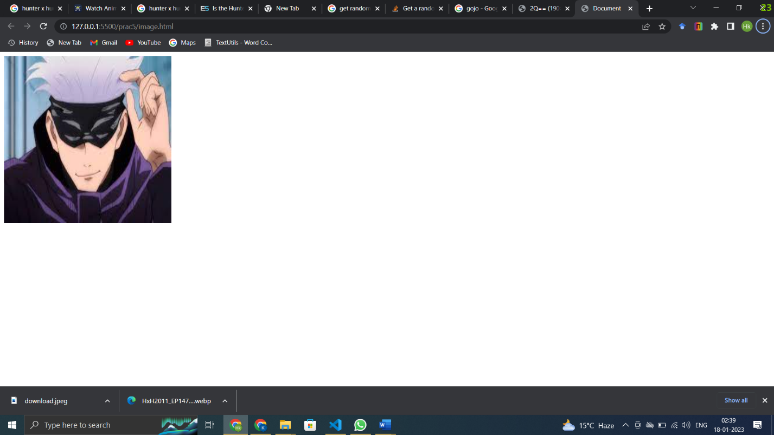

**AIM:** **Change the location of image based on arrow key of keyboard using callback function**

**Source Code:**

<!DOCTYPE html>

<html lang="en">

<head>

    <meta charset="UTF-8">

    <meta http-equiv="X-UA-Compatible" content="IE=edge">

    <meta name="viewport" content="width=device-width, initial-scale=1.0">

    <title>Document</title>

</head>

<body>

    <img id="id_gojo" src="./download.jpeg" style="   position: absolute; left: 0px; top: 0px;">

    <script src="./arrowkey.js"></script>

</body>

</html>

console.log("connected  ")

var img = document.getElementById("id_gojo");

let move = function (e) {

    let key = e.keyCode;

    console.log(key);

    if (key == 39) {

        let inc = parseInt(img.style.left, 10) + 10;

        console.log(inc);

        img.style.left = `${inc}px`;

    }

    if (key == 37) {

        let inc = parseInt(img.style.left, 10) - 10;

        console.log(inc);

        img.style.left = `${inc}px`;

    }

    if (key == 40) {

        let inc = parseInt(img.style.top, 10) + 10;

        console.log(inc);

        img.style.top = `${inc}px`;

    }

    if (key == 38) {

        let inc = parseInt(img.style.top, 10) - 10;

        console.log(inc);

        img.style.top = `${inc}px`;

    }

    console.log(img)

}

document.addEventListener("keydown", move);

**Output:**

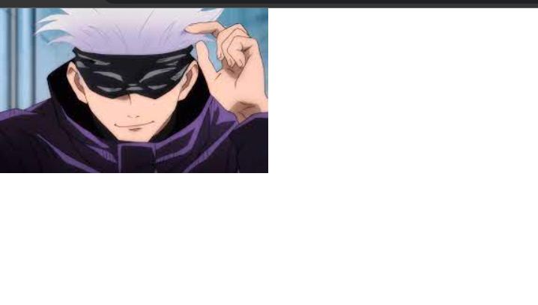

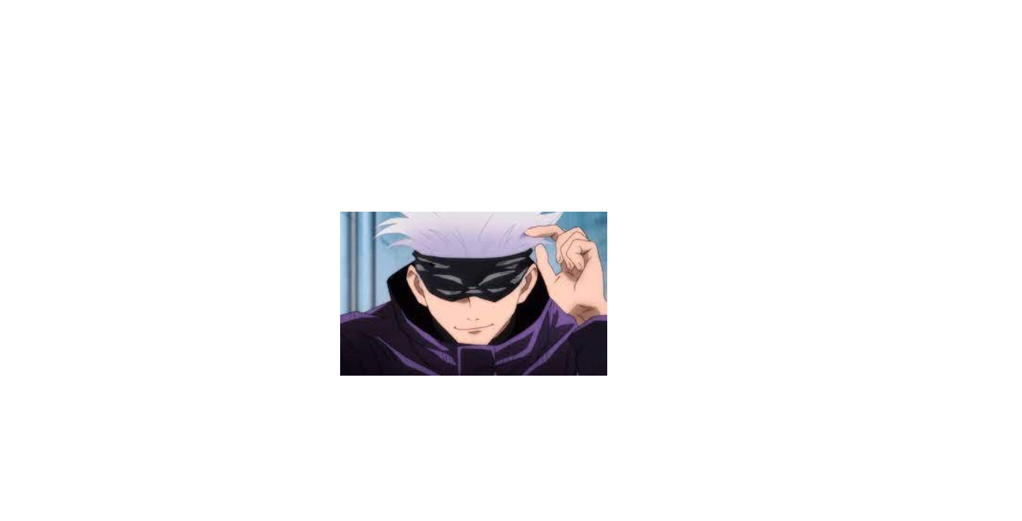

**Conclusion: from the above program I have learned the event handeling in javascript.**