**Practical – 6**

**AIM:**

1. **Demonstrate Class, Properties, Methods and Objects**
2. **Demonstrate how to work with JSON File**
3. **Do Spoural Registration Form Validation (Error object and try…catch..)**

**Source Code:**

<!DOCTYPE html>

<html lang="en">

  <head>

    <title>Class demonstration</title>

    <style>

      .heading {

        text-align: center;

        font-family: "Arial", sans-serif;

      }

      .student-card {

        width: 300px;

        background-color: #f2f2f2;

        border: 1px solid #ccc;

        box-shadow: 2px 2px 4px #ccc;

        margin: 20px auto;

        font-family: "Arial", sans-serif;

        text-align: center;

        cursor: pointer;

        transition: all 0.2s ease-in-out;

      }

      .student-card:hover {

        transform: scale(1.05);

        box-shadow: 4px 4px 8px #ccc;

      }

      .student-name {

        font-size: 24px;

        font-weight: bold;

        margin-bottom: 10px;

      }

      .student-id {

        font-size: 18px;

        font-style: bold;

        margin-bottom: 10px;

      }

      .student-dob {

        font-size: 16px;

        margin-bottom: 10px;

      }

      .student-age {

        font-size: 18px;

        font-weight: bold;

        color: green;

      }

    </style>

  </head>

  <body>

    <h1 class="heading">Class demonstration</h1>

    <script src="index.js"></script>

  </body>

</html>

class Student {

    constructor(name, ID, dob) {

      this.name = name;

      this.ID = ID;

      this.dob = dob;

    }

    getDetails() {

      document.write(`<div class='student-card'>

          <div class='student-name'>

            ${this.name}

          </div>

        <div class='student-id'>

          ${this.ID}

        </div>

        <div class='student-dob'>

          ${this.dob}

        </div>

        <div class='student-age'>

          ${this.getAge()}

        </div>

      </div>`);

    }

    getAge() {

      let today = new Date();

      let birthDate = new Date(this.dob);

      let age = today.getFullYear() - birthDate.getFullYear();

      let m = today.getMonth() - birthDate.getMonth();

      if (m<0 || (m === 0 && today.getDate() < birthDate.getDate()))

      age--;

      return "The age of student is " + age;

    }

  }

  let p1 = new Student("Hiranj ", "21IT068", "03-03-2004");

  let p2 = new Student("Henil", "21IT085", "19-07-2004");

  p1.getDetails();

  p2.getDetails();

**Output:**

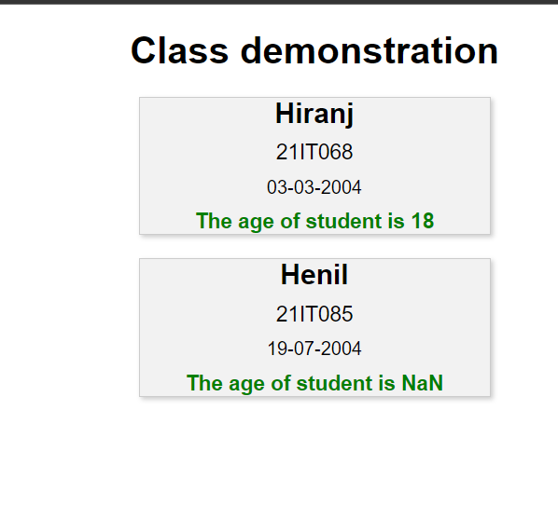

**Source Code:**

<!DOCTYPE html>

<html lang="en">

  <head>

    <title>JSON Demo</title>

    <style>

      body {

        background-color: #f2f2f2;

        font-family: "Arial", sans-serif;

        text-align: center;

      }

      h3, h5 {

        color: #333;

        font-size: 24px;

        margin: 20px 0;

  }

      i {

        color: #666;

        font-size: 18px;

        font-style: italic;

      }

      p {

        font-size: 18px;

        margin: 10px 0;

      }

      #demo {

        padding: 20px;

        margin: 20px auto;

        transition: all 0.2s ease-in-out;

      }

    </style>

  </head>

  <body>

    <h3>Demonstrating how to work with JSON</h3>

    <p><i>JSON stands for JavaScript Object Notation</i></p>

    <p><i>Curly braces hold objects, Square brackets hold arrays</i></p>

    <h5>Creating object from JSON string having array</h5>

    <p id="demo"></p>

    <h5>Javascript JSON Methods</h5>

    <p id="demo1"></p>

    <p id="demo2"></p>

    <script src="script.js"></script>

  </body>

</html>

*let* text =

  '{"employees":[' +

  '{"firstName":"Virat", "lastName":"Kohli"},' +

  '{"firstName":"Sachin", "lastName":"Tendulkar"},' +

  '{"firstName":"Rohit", "lastName":"Sharma"}]}';

*const* obj = JSON.parse(text);

document.getElementById("demo").innerHTML = `

  ${obj.employees[0].firstName} ${obj.employees[0].lastName}<br>

  ${obj.employees[1].firstName} ${obj.employees[1].lastName}<br>

  ${obj.employees[2].firstName} ${obj.employees[2].lastName}`;

*let* student1 = '{"name":"Virat", "age":32, "city":"Delhi"}';

*const* obj1 = JSON.parse(student1);

document.getElementById(

  "demo1"

).innerHTML = `Convert string in JSON format using parse() method<br>${obj1.name}`;

*let* student2 = '{name:"Virat", age:32, city:"Delhi"}';

*const* obj2 = JSON.stringify(student2);

document.getElementById(

  "demo2"

).innerHTML += `<br>Convert JSON object to string using stringify() method<br>${obj2}`;

**Output:**

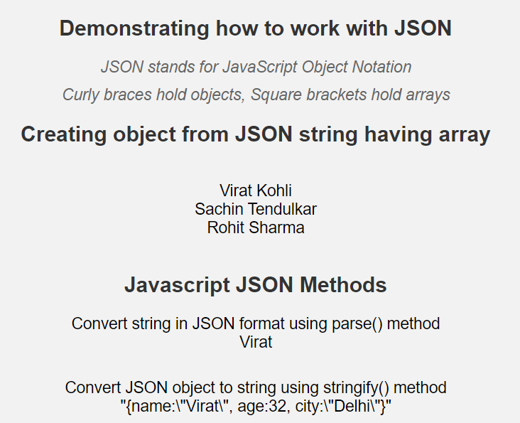

**Source Code:**

<script src="validate.js"></script>

function display(){

    try{

        var name = document.getElementById("name").value;

        var email = document.getElementById("email").value;

        var phone = document.getElementById("phone").value;

        var college = document.getElementById("college").value;

        var year = document.getElementById("year").value;

        var branch = document.getElementById("branch").value;

        if(name == "" || email == "" || phone == "" || college == "" || year == "" || branch == ""){

            throw "Please fill all the fields";

        }

        else if(!validateEmail(email)){

            throw "Please enter a valid email address";

        }

        else if(!validatePhone(phone)){

            throw "Please enter a valid phone number";

        }

        else{

            alert("Registration Successful");

        }

    }

    catch(err){

        alert(err);

    }

}

function validateEmail(email)

{

    var re = /\S+@\S+\.\S+/;

    return re.test(email);

}

function validatePhone(phone)

{

    var re = /^\(?(\d{3})\)?[- ]?(\d{3})[- ]?(\d{4})$/;

    return re.test(phone);

}

**Output:**

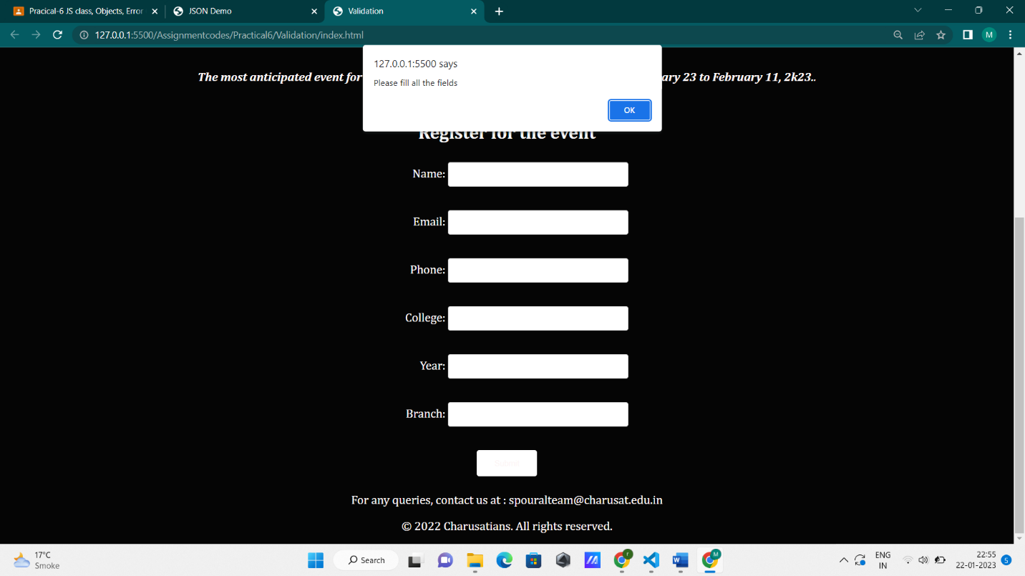

**Conclusion: We can also define many methods along with using constructor in classes. JavaScript Object Notation (JSON) is a standard text-based format for representing structured data based on JavaScript object syntax.**