Technical & User Interaction Implementation Guide: Video Upload System (InrCliq)

1. Executive Summary & Architecture Strategy
To ensure optimal performance and user experience across platforms, InrCliq adopts a dual-strategy video upload pipeline:
- Desktop Web: Uses direct binary streaming of raw source files via chunked uploads without client-side re-encoding, preserving max media quality and preventing desktop CPU lag.
- Mobile Apps (iOS/Android): Performs hardware-accelerated client-side compression before transmission to minimize cellular bandwidth, conserve battery life, and reduce network failure rates.

2. Technical Specifications & Specifications Matrix

Upload Specifications by Platform
- Web Client: Max file size 10 GB | Max duration 240 mins.
- Mobile Apps: Max file size 4 GB | Max duration 240 mins (Recommended: Stories < 250 MB).
- Reels / Stories: Max file size 4 GB.

Web vs. Mobile Architecture Comparison Matrix
Feature | Mobile App Architecture | Web Client Architecture
Client Compression | Yes (Native GPU/Hardware encoder downscales bitrate & resolution) | No (Streams original bit-for-bit raw file)
Max File Size Limit | 4 GB | 10 GB
Device Overhead | High short-term CPU/GPU load during pre-upload compression | Low local CPU load; relies on upload network bandwidth
Transcoding Pipeline | Client compression followed by backend adaptive re-encoding | Pure backend cloud transcoding pipeline

3. Client-Side Implementation Details

Mobile App Compression Engine
Mobile clients must leverage native hardware encoders (MediaCodec on Android, AVFoundation on iOS) prior to upload:
- Resolution Downscaling: Scale 4K/60fps source media to 1080p or 720p.
- Bitrate Reduction: Target standard 4–8 Mbps output bitrates.
- Audio Normalization: Resample stereo audio tracks to standard AAC stereo.

Web Client Processing & Chunking
- Direct Uploads: Bypasses client-side re-encoding (avoiding single-threaded JS/WebAssembly bottlenecks).
- Chunking API: Uses HTML5 File.slice() API to divide files into 4 MB–8 MB chunks.
- Transmission: Sends HTTP POST/PUT chunked requests to storage endpoints over multi-threaded streams.
- Local Inspection: Utilizes HTML5 <video> elements exclusively for local previews, metadata parsing (dimensions/duration), and keyframe thumbnail selection.

4. End-to-End Web UI & Step-by-Step User Workflow

Step-by-Step UI Experience
- 1. Drag and Drop or File Selection (Instant Local Read)
- When the user drags a video file onto the post box or clicks "Add Photos/Video", the UI opens the browser's native file picker or highlights the drop zone.
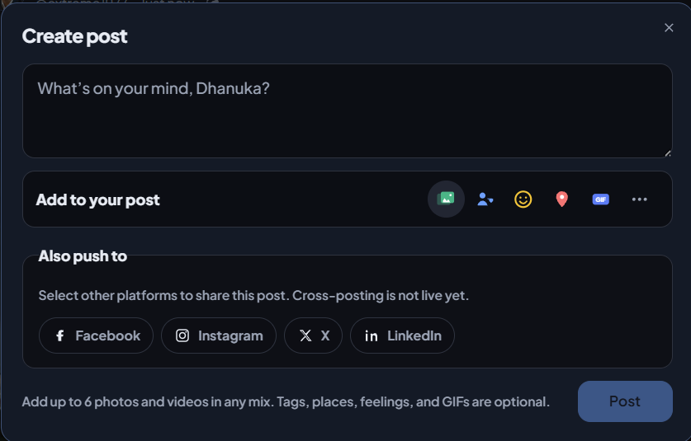
- The browser instantly captures a local reference to the file using JavaScript.
- Verification: The "Create Post" modal transitions from a standard text box into a structured media layout.

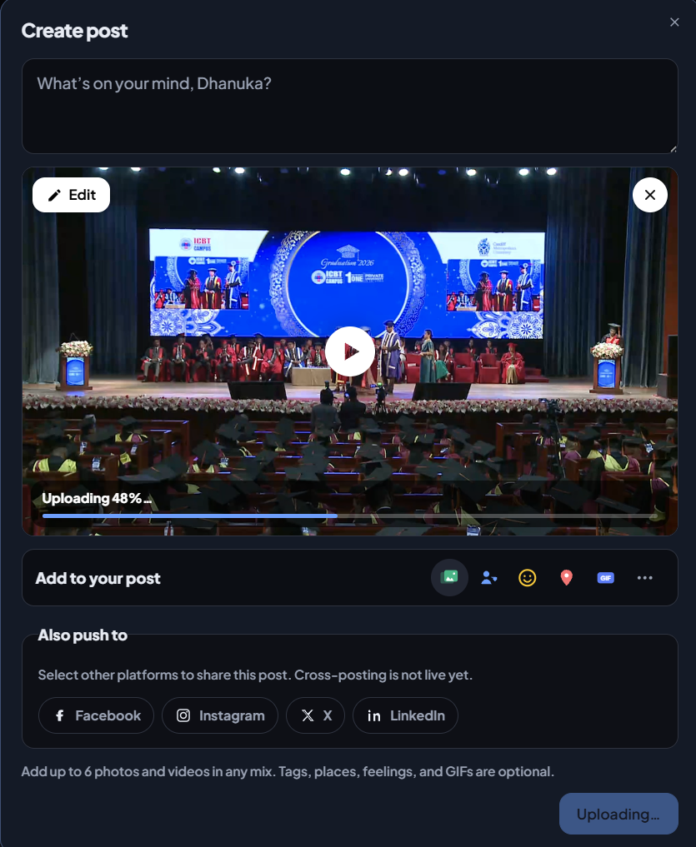

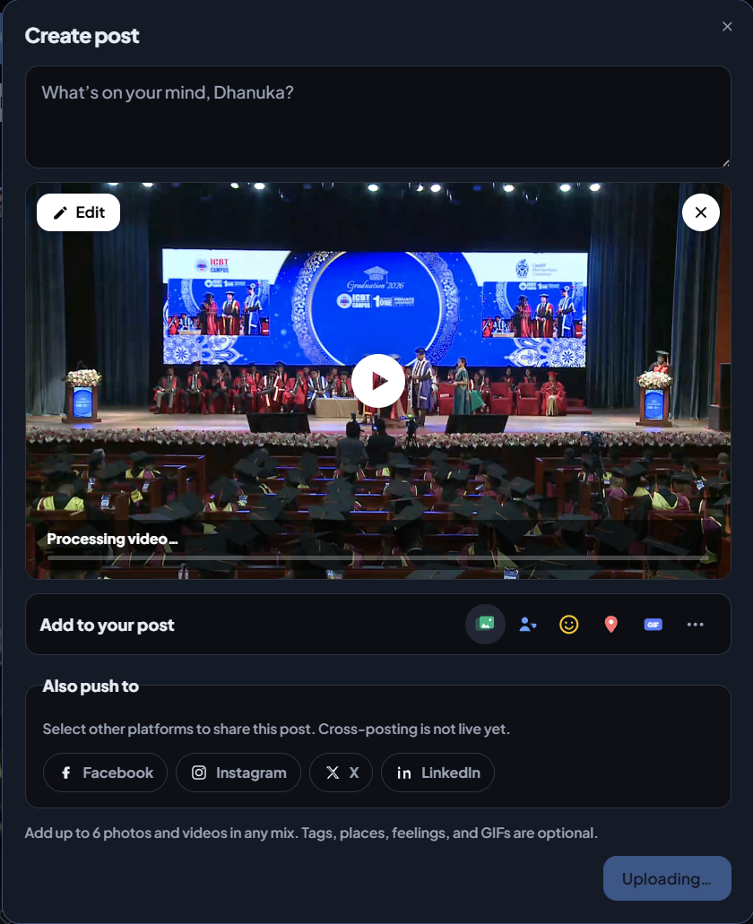
- 2. Instant Local Thumbnail & Video Preview (HTML5 Blob URL)
- Before uploading a single byte to the server, the browser generates a temporary local preview URL (blob:https://...) using HTML5 APIs.
- The user immediately sees a video thumbnail, player frame, and an "Edit" pencil icon.
- Clicking "Edit" allows cropping the video, choosing a custom thumbnail frame, or adding closed captions directly inside the post modal.
- Verification: The video player preview appears in the draft post without any lag or spinner.
- 3. Live Upload Progress Indicator (Byte Tracking)
- As the browser streams 4 MB–8 MB chunks to storage servers, a progress bar overlay or percentage ring (e.g., "Uploading 48%...") appears over the video thumbnail.
- The "Post" button remains temporarily disabled or switches to a pending state.
- If the user attempts to close the modal, the browser triggers a native prompt: "Upload in progress. Are you sure you want to leave?"
- Verification: The percentage increments smoothly as chunks are acknowledged by the backend.
- 4. Cloud Processing Feedback (Backend Transcoding)
- Once the upload reaches 100%, the browser hands off to the cloud transcoding queue, and the progress bar changes state to "Processing video...".

- The user is allowed to click "Post" immediately without waiting for transcoding to finish.
- The draft modal closes, and a small floating notification toast appears at the bottom-left: "Your video is processing. We'll notify you when it's ready to view."
- Verification: The floating toast confirms the job was successfully handed off to backend workers.
- 5. Final Completion Notification (Feed Readiness)
- While the user continues browsing, background notification listeners poll for completion.
- The notification bell icon in the top header lights up with a red dot, accompanied by a push notification: "Your video is ready. You can now watch, edit, or delete it."
- Verification: Clicking the notification opens the published post directly on the user's profile or feed in adaptive stream quality.

5. Error Handling & Resilience
- Network Disruption Handling:
- If the connection drops, the progress bar turns gray with a "Paused — Retrying..." message while JavaScript attempts to re-establish a connection to resume uploading from the last saved chunk index.
- Format & Size Validation:
- Client-side validation checks file size caps (10 GB web / 4 GB mobile) and media types before chunking.
- If validation fails, an inline red alert banner appears inside the modal (e.g., "File exceeds 10 GB limit" or "Unsupported file format"), preventing post submission.

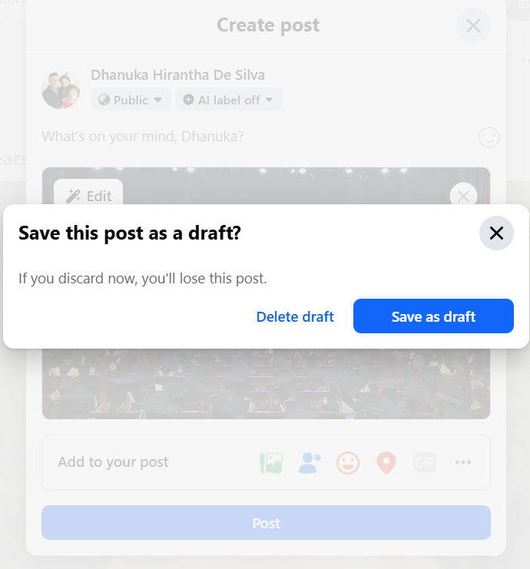

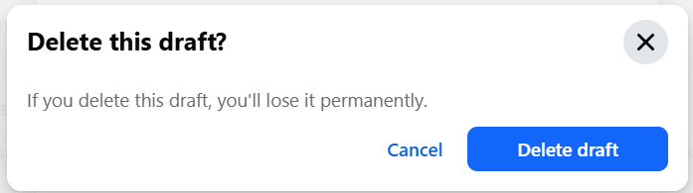

Determining the video user uploads is a Reel or a Standard Feed Video

Facebook determines whether an uploaded video becomes a Reel or a standard Feed Video through automated classification heuristics during the initial post upload, as well as unified video routing rules.
Key Factors Facebook Checks

- Aspect Ratio (Orientation)
  - Vertical (9:16 aspect ratio): Videos with a portrait orientation (e.g., $1080×1920\text{ px}$) automatically trigger the Reel classification engine.
  - Horizontal / Square (16:9 or 1:1): Landscape and square videos default to standard Feed video posts.
- Video Duration (Length)
  - Under 90 seconds (to 3 minutes): Any short vertical clip is flagged for auto-conversion into a Reel.
  - Over 3 to 15 minutes: Longer vertical videos can still be published as Reels, but Meta's unified video player handles them seamlessly.
  - Long-form (Up to 240 minutes): Anything extended (such as webinars or full horizontal recordings) defaults to standard video placement.
- Creation Entry Point & User Intent
  - Dedicated Reel Composer: If uploaded directly through the "Create Reel" camera interface or Meta Business Suite's Reels tab, it is tagged explicitly as type: REEL regardless of minor ratio differences.
  - Standard Post Box: If uploaded via the main "What's on your mind?" feed box, Facebook inspects the media metadata (aspect ratio + duration) to decide whether to prompt: "Your video will be shared as a Reel".
- Meta's Unified Video Pipeline Update
- Meta has unified its video ecosystem. All public video uploads are routed through Meta's unified short-form/Reel video player architecture on mobile feeds.
- However, for your platform InrCliq, keeping a clear classification rule set on upload is recommended:
- Plaintext
- IF aspect_ratio == "9:16" AND duration <= 180_seconds:
- CLASSIFY AS -> Reel (Short-Form Pipeline)
- ELSE IF aspect_ratio == "16:9" OR duration > 180_seconds:
- CLASSIFY AS -> Feed Video (Long-Form Pipeline)

IF aspect_ratio == "9:16" AND duration <= 180_seconds:
CLASSIFY AS -> Reel (Short-Form Pipeline)
ELSE IF aspect_ratio == "16:9" OR duration > 180_seconds:
CLASSIFY AS -> Feed Video (Long-Form Pipeline)

