**FACILITIES:**

With the expansion in academic program ,computer laboratories in the department have risen to nine spread over two buildings. The laboratories are equipped with 200+ computers fully network with state of art server.

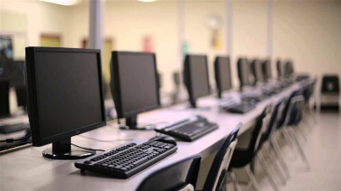

Computer to student ratio is 1:1 .The department is proud of it’s piracy policy .Oracle has contributed software worth more 40 million.

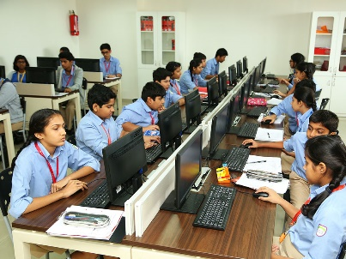

**Faculty:**

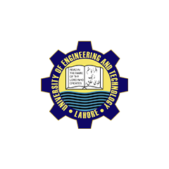

* Prof. Dr. Khaldooon
* Prof. Dr. Shahzad ( chairman )
* Prof. Dr. Samia Farooq

**CONTACT DETAIL:**

For queries contact us on our website.

[www.uet.edu.pk](http://www.uet.edu.pk)

**or**

**call on:**

03025332001

Prepared by: Hira Sohail

Roll no. 2023-CS-76

To the students of the department emphasizing entrepreneurship and ethical standards while encouraging them to remain abreast with latest development in computing tools and uses these skills to

**UNIVERSITY OF ENGINEERING AND TECHNOLOGY**

A brief description of Computer science and Engineering Department is here. 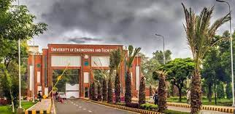

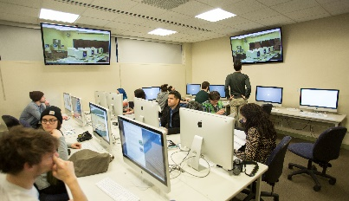

**INTRODUCTION:**

The department of Computer science and engineering was originally developed as department of computer science in 1991.lts history dates back to the year in 1968 when university of engineering and technology lahore established a computer center.This center was responsible for planning and teachin courses in COMPUTER SCIENCE and NUMERICAL ANALYSIS which Here now we also offer double degree program. Three student each from the graduating class of computing science and computer engineering may opt for a second degree I computer and science sbject to fulfill required conditions.

**RESEARCH:**

Estimate theory , signals processing ,database and related areas.

identify and find solutions to find society problems and to use department resources to help government , industry in solving their problems.

Computer science jobs should way more than even going to wall street or being a lawyer – or ,l can argue , than any thing but perhaps biology ,and there is just a tie.

“BILL GATES”

**DEGREE AND DOUBLE DEGREE PROGRAM:**

Here we offer four year degree program in terms of BS honors which was introduced by the department in 1999, and is affiliated by **PEC**(Pakistan Engineering Council PHD , program in computer was launched in 2002 and twenty six students have completed.

formed an integral part of the curriculum for all the disciplines of BSC. The center also offered short courses for other private and public sector organization.