

**Assignment :**

**Submitted by: Hira sohail**

**Subject :**

**Roll no : 76**

**Submitted to: MS ABQA**

YOUR BEAUTIFUL NAME:

Copy living things and nonliving things separately and paste them in the following boxes:

|  |  |  |  |  |
| --- | --- | --- | --- | --- |
| Nonliving Things - Living and Nonliving Things | LIVING THINGS - NON-LIVING THINGS | PPT | What is Book Indexing and Why Do You Need A Book Index? | NON LIVING THINGS on Pinterest | List of Toys Names For Kids (With Pictures) |
| Brown bear - Wikipedia | Zebra Facts | Live Science | Monarch Butterfly | Meaning of chil in English | Rekhta Dictionary | Here Are The Coolest New Cars For 2020 |

|  |  |
| --- | --- |
| LIVING THINGS | NON- LIVING THINGS |
|  |  |
|  |  |
|  |  |
|  |  |



YOUR NAME:

**MATCHING:**

**Rectangle**

**Square**

**Triangle**

**Oval**

YOUR NAME:

Separate consonants and vowels from the following table:

­­­­­­­­­­­­­­­­­­  **Aa Bb Cc Dd**

**Ee Ff Gg Hh**

**Ii Jj Kk Ll**

**Mm Nn Oo Pp**

**Qq Rr Ss Tt**

**Uu Vv Ww Xx**

**Yy Zz**

**Vowels:**

**Consonants:**

YOUR NAME:

1. ________________________ 
2. ________________________ 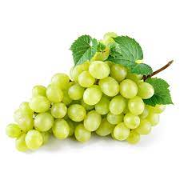
3. ________________________ 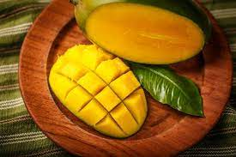
4. _______________________ 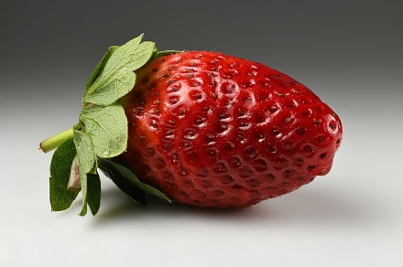

YOUR BEAUTIFUL NAME:

**Copy input and output devices separately and paste them in the following boxes:**

|  |  |  |  |
| --- | --- | --- | --- |
| Computer - Input Devices | Computer monitor - Wikipedia | **What is a Joystick - javatpoint** | **HP 1000W Wireless Neverstop Laser Printer** |
| Surround Computer Speakers with Stereo USB Wired ed Multimedia Speaker for  PC/Laptops/Smart Phone | Why is a scanner considered an input device? - Quora | What is a plotter - javatpoint | Input Devices - Computer Science GCSE GURU |

**PASTE HERE:**

**You have to paste here the input and output devices separately:**

|  |  |
| --- | --- |
| **INPUT DEVICES** | **OUTPUT DEVICES** |
|  |  |
|  |  |
|  |  |
|  |  |

OUTPUT DEVICES ARE THOSE DEVICES WITH THE HELP OF WHICH WE GET DATA AFTER PROCESSING

INPUT DEVICES ARE THOSE DEVICES WITH THE HELP OF WHICH WE CAN ENTER DATA INTO COMPUTER

**YOUR NAME:**

**PDHISAGYMNDABYGIRAHXHYGJTKRFVGYHBGFKHUFSUFSSKGKGASDFARKURFKJKHGADAURUDKHDUFUKHFVAMkA**

**MBG**

** HIDDEN** color all the Aa

**LETTERS Aa**