SESSION 7
UML SEQUENCE AND ACTIVITY DIAGRAMS
AI Interview Preparation Platform
Team: Hirdesh (Team Lead), Mahek Bhatia, Janhavi Srivastava

1. Objective
To model how the objects of the AI Interview Preparation Platform interact over time using a UML sequence diagram, and how the end-to-end mock interview workflow progresses using a UML activity diagram.
Topics covered: sequence diagram design, message flow representation and workflow modelling using an activity diagram.
Deliverable: Sequence and Activity Diagram. Industry mapping: Interaction and Workflow Modelling.

2. Sequence Diagram Design – Lifelines
The scenario modelled is the main success flow of UC-04 Start Mock Interview, which includes UC-05 Generate Questions, UC-06 Submit Answers, UC-07 Evaluate Answers and UC-09 View Feedback Report from Session 5.
Lifeline | Type | Responsibility
Candidate | Actor | Chooses the interview setup, answers questions and reads the feedback report.
Web App (Frontend) | Boundary / UI | Collects input, shows questions and displays the report.
Backend API | Control / service | Coordinates the session, calls the AI service and applies business rules.
AI Service (External) | External system | Generates questions and evaluates answers, returning scores and feedback.
Database | Data store | Saves sessions, questions, evaluations and reports.

3. Message Flow Representation
Messages are numbered in time order from top to bottom. Solid arrows are synchronous calls and dashed arrows are return messages.
No. | From → To | Message | Type
1 | Candidate → Web App | Select type, role, difficulty | Synchronous
2 | Web App → Backend API | startInterview(type, role, level) | Synchronous
3 | Backend API → AI Service | generateQuestions(role, level) | Synchronous
4 | AI Service → Backend API | questions[ ] | Return
5 | Backend API → Database | saveSession(questions) | Synchronous
6 | Backend API → Web App | firstQuestion | Return
7 | Web App → Candidate | Display question | Return
8 | Candidate → Web App | Answer (voice / text) | Synchronous
9 | Web App → Backend API | submitAnswer(answer) | Synchronous
10 | Backend API → AI Service | evaluate(question, answer, criteria) | Synchronous
11 | AI Service → Backend API | score + feedback | Return
12 | Backend API → Database | saveEvaluation(score, feedback) | Synchronous
13 | Backend API → Web App | nextQuestion / sessionComplete | Return
14 | Candidate → Web App | Finish interview | Synchronous
15 | Web App → Backend API | getReport(sessionId) | Synchronous
16 | Backend API → Database | fetchEvaluations(sessionId) | Synchronous
17 | Backend API → Web App | feedback report | Return
18 | Web App → Candidate | Display feedback report | Return

Combined fragments used
- loop [for each interview question]: messages 8–13 repeat until all questions are answered.
- opt [evaluation fails / times out]: the Backend API retries within configured limits or marks the evaluation as pending (as in the UC-07 exception flow).
Database return messages are omitted from the figure to keep it readable.

4. Sequence Diagram
The sequence diagram for the mock interview scenario is provided on the Sequence Diagram page at the end of this document. Lifelines run vertically, the vertical position of a message shows its order in time, and the loop and opt frames show repetition and the failure path.

5. Workflow Modelling – Activity Diagram
The activity diagram models the mock interview workflow with swimlanes (partitions) showing who performs each activity. The diagram is provided on the Activity Diagram page at the end of this document.
Swimlane | Responsibility
Candidate | Logs in, selects the interview setup, answers questions and reviews the report.
Platform (Web App + API) | Validates credentials, requests questions, presents them, stores results and compiles the report.
AI Service | Generates the interview questions and evaluates each answer.

ID | Activity / Node | Swimlane | Type / Flow
A-01 | Start | Candidate | Initial node
A-02 | Register / Login | Candidate | Action
A-03 | Credentials valid? | Platform | Decision: [valid] to A-04; [invalid] back to A-02
A-04 | Select interview type, role and difficulty | Candidate | Action
A-05 | Request question generation | Platform | Action
A-06 | Generate interview questions | AI Service | Action
A-07 | Display next question | Platform | Action (merge point for the loop)
A-08 | Answer by voice or text | Candidate | Action
A-09 | Send answer for evaluation | Platform | Action
A-10 | Evaluate answer (score + feedback) | AI Service | Action
A-11 | Store score and feedback | Platform | Action
A-12 | More questions? | Platform | Decision: [yes] back to A-07; [no] to A-13
A-13 | Compile feedback report | Platform | Action
A-14 | View feedback report | Candidate | Action
A-15 | End | Candidate | Final node

6. UML Notation Notes
- Lifeline: dashed vertical line below a participant box showing its existence over time.
- Synchronous message: solid line with a filled arrowhead; the sender waits for a response.
- Return message: dashed line with an open arrowhead carrying the result back to the caller.
- Combined fragment (loop, opt): labelled frame that marks repetition or conditional behaviour.
- Swimlane: partition of an activity diagram that assigns each action to a responsible actor or system.
- Decision / merge: diamond with guard conditions such as [valid] and [no] on the outgoing flows; the loop-back flow merges into A-07.
- Initial and final nodes: filled circle starts the flow; circle with a filled centre ends it.

7. Industry Mapping – Interaction and Workflow Modelling
Modelling Concept | Platform Example | Industry Practice
Sequence diagram (interaction modelling) | Web App, Backend API, AI Service and Database exchanging messages in a mock interview. | Designing API contracts and service-to-service calls; deriving integration test cases.
Message flow | Synchronous calls and returns such as evaluate() and score + feedback. | Defining request/response payloads, timeouts and error handling between components.
Activity diagram (workflow modelling) | Login to question loop to report across three swimlanes. | Business process modelling, user-journey mapping and workflow automation.
Decisions and loops | Credentials valid? and More questions? | Business rules, validation gates and retry logic in production workflows.

8. Assumptions
- The scenario is based on the use cases defined in Session 5; no new use cases are introduced.
- The AI provider (Gemini/OpenAI) is shown as an external AI Service lifeline and swimlane.
- The main success flow is modelled; failure paths are limited to the evaluation retry/pending case and invalid login.
- Optional speech and pacing analysis (UC-08) is not shown, to keep the diagrams readable.
- AI feedback is preparation guidance, not a guarantee of hiring outcomes.

9. Submission Checklist
☐ Sequence diagram with lifelines and numbered messages
☐ Message flow table with loop and opt fragments
☐ Activity diagram with swimlanes, decisions and loop
☐ Activity node table and industry mapping

SEQUENCE DIAGRAM
AI Interview Preparation Platform – Mock Interview Scenario
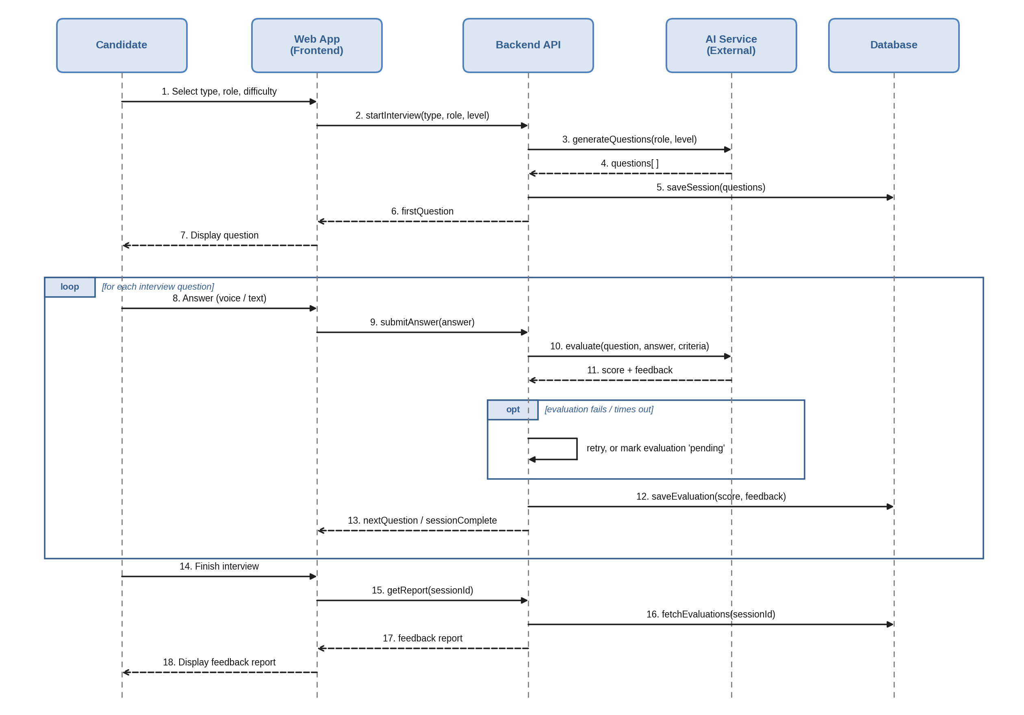
Note: Solid arrows are synchronous calls; dashed arrows are returns. Review message order and labels before submission.

ACTIVITY DIAGRAM
AI Interview Preparation Platform – Mock Interview Workflow
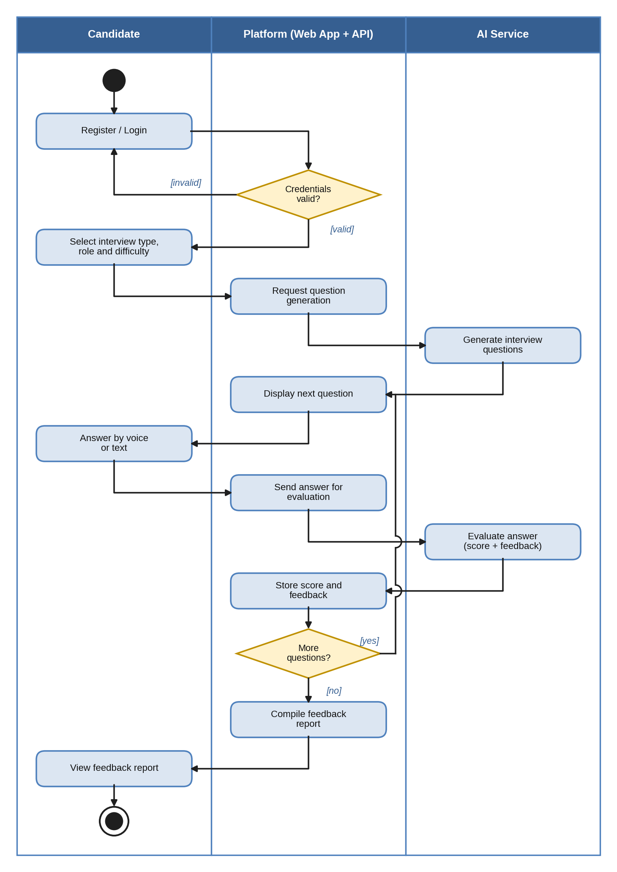
Note: Diamonds are decisions; the [yes] flow loops back to Display next question.

