SESSION 9
SOFTWARE ARCHITECTURE DESIGN
AI Interview Preparation Platform – System Architecture
Team: Hirdesh (Team Lead), Mahek Bhatia, Janhavi Srivastava

1. Objective
To define the system architecture of the AI Interview Preparation Platform using layered architecture, the client-server model and a conceptual microservices view, and to identify the design patterns applied.
Deliverable: System Architecture Diagram. Industry mapping: System Architecture Planning.

2. Architectural Drivers
These requirements, taken from the earlier sessions, shape the architecture.
Driver | Requirement | Architectural Impact
Security | Protect user accounts, resumes and the AI provider key. | Authentication in the API layer; AI calls made only from the server.
Modifiability | The AI provider may change; new evaluators may be added. | AI access isolated behind M-09; interfaces between layers.
Performance | AI calls take time and can fail. | Timeouts, retries, and a 'pending' evaluation status.
Scalability | Many candidates may practise at once. | Stateless server so more instances can be added behind a load balancer.
Maintainability | Three developers working in parallel. | Clear layers and module boundaries from Session 8.

3. Layered Architecture Design
The application server uses three layers. Each layer depends only on the layer directly below it, which keeps changes local and makes each layer testable on its own.
Layer | Responsibility | Components | Rule
1. Presentation / API | Receives requests, validates input, checks authentication, returns responses. | REST controllers, auth and validation | No business logic
2. Business Logic | Implements interview, resume, evaluation, report and admin rules. | M-01 to M-08 | Calls Layer 3 only
3. Data Access / Integration | Stores and retrieves data; communicates with the AI service. | M-10 repositories, M-09 AI client | No business rules
Closed layering is used: a request cannot skip a layer. Shared modules M-01, M-09 and M-10 are built first and reused by the layers above.

4. Client-Server Architecture
The platform follows a three-tier client-server model, shown in the System Architecture Diagram at the end of this document.
Tier | Role | Notes
Client | Web browser for candidates and admins; captures text or voice answers and shows results. | Thin client with no secrets or AI keys.
Application Server | Hosts the layered application and enforces all business rules. | Stateless; uses a token for each request.
Data Tier | Relational database and file storage for resumes. | Reached only through M-10.
External AI Service | Generates questions and evaluates answers. | Reached only through M-09 over HTTPS.
Communication: the client sends HTTPS requests with JSON payloads (REST). The server processes each request and returns a response, and the AI call is made by the server on behalf of the client.

5. Microservices (Conceptual)
A conceptual microservices view splits the platform into independently deployable services behind an API gateway. Each service owns its data, and asynchronous events (through a message broker) notify other services. This view is shown on the Microservices Architecture page and is not implemented in the current scope.
Service | Responsibility | Modules
Auth Service | Registration, login, roles | M-01
Resume Service | Resume upload and analysis | M-02
Interview Service | Session flow; coordinates question and evaluation services | M-03
Question Service | Question generation through the AI client | M-04
Evaluation Service | Answer scoring and feedback | M-05
Report and Progress Service | Reports and trends; reacts to EvaluationReady events | M-06, M-07
Admin Service | Categories and monitoring | M-08
Comparison and recommendation:
Aspect | Layered Monolith | Microservices
Deployment | One unit; simple | Many units; needs orchestration
Scaling | Scale the whole application | Scale only busy services (e.g. Evaluation)
Complexity | Low | High: network failures, distributed data
Team size fit | Small team (this project) | Larger, independent teams
Recommendation: start with a modular layered monolith, which suits the team size and project scope. Keep module boundaries clean so Question and Evaluation (the AI-heavy parts) can later be extracted as services if load requires it.

6. Design Patterns Applied
Pattern | Category | Where Applied | Benefit
MVC / MVP | Architectural | Web UI (view), controllers, domain classes (model) | Separates UI from logic
Repository | Structural | M-10 Data Access Layer | Hides database details
Adapter / Gateway | Structural | M-09 AI Service Client | Provider can be swapped
Strategy | Behavioral | Evaluators for text and speech in M-05 | Adds evaluators without edits
Factory | Creational | Creates question sets by interview type (technical, behavioral, mixed) | Centralises creation logic
Observer / Events | Behavioral | Notifying when an evaluation or report is ready | Loose coupling between modules
Facade | Structural | API layer exposing simple operations over several services | Simple interface for the client

7. Quality Attribute Tactics
Quality | Tactic
Security | HTTPS, token-based authentication, role checks, resume file type and size validation, API key stored only on the server.
Reliability | Timeouts and limited retries for AI calls; evaluation marked pending if the AI service fails.
Performance | Evaluate each answer while the candidate continues; cache stable data such as interview categories.
Scalability | Stateless application servers; database access through repositories.
Maintainability | Layered structure, module boundaries and interface-based dependencies.
Privacy | Resumes and answers visible only to their owner and authorised admins.

8. Industry Mapping – System Architecture Planning
Architecture Concept | Platform Example | Industry Practice
Layered architecture | Presentation, business and data access layers | Standard structure for enterprise web applications
Client-server | Browser, application server, database, external AI | Web and mobile applications with cloud back ends
Microservices | Conceptual split behind an API gateway | Scaling large systems, independent team deployment
Design patterns | Repository, Adapter, Strategy, Factory | Shared vocabulary in design reviews and code reviews
Architecture diagram | Tiers, layers and external systems on one view | Architecture decision documents and stakeholder reviews

9. Assumptions
- Module IDs follow the Session 8 decomposition.
- The AI provider (Gemini/OpenAI) is an external system reached only through M-09.
- The implementation uses a layered monolith; microservices are shown conceptually.
- Technology choices (database, framework, hosting) are left open at this stage.

10. Submission Checklist
☐ Layered architecture design
☐ Client-server description
☐ Conceptual microservices view
☐ Design patterns table
☐ System Architecture Diagram

SYSTEM ARCHITECTURE DIAGRAM
AI Interview Preparation Platform – Layered Client-Server View
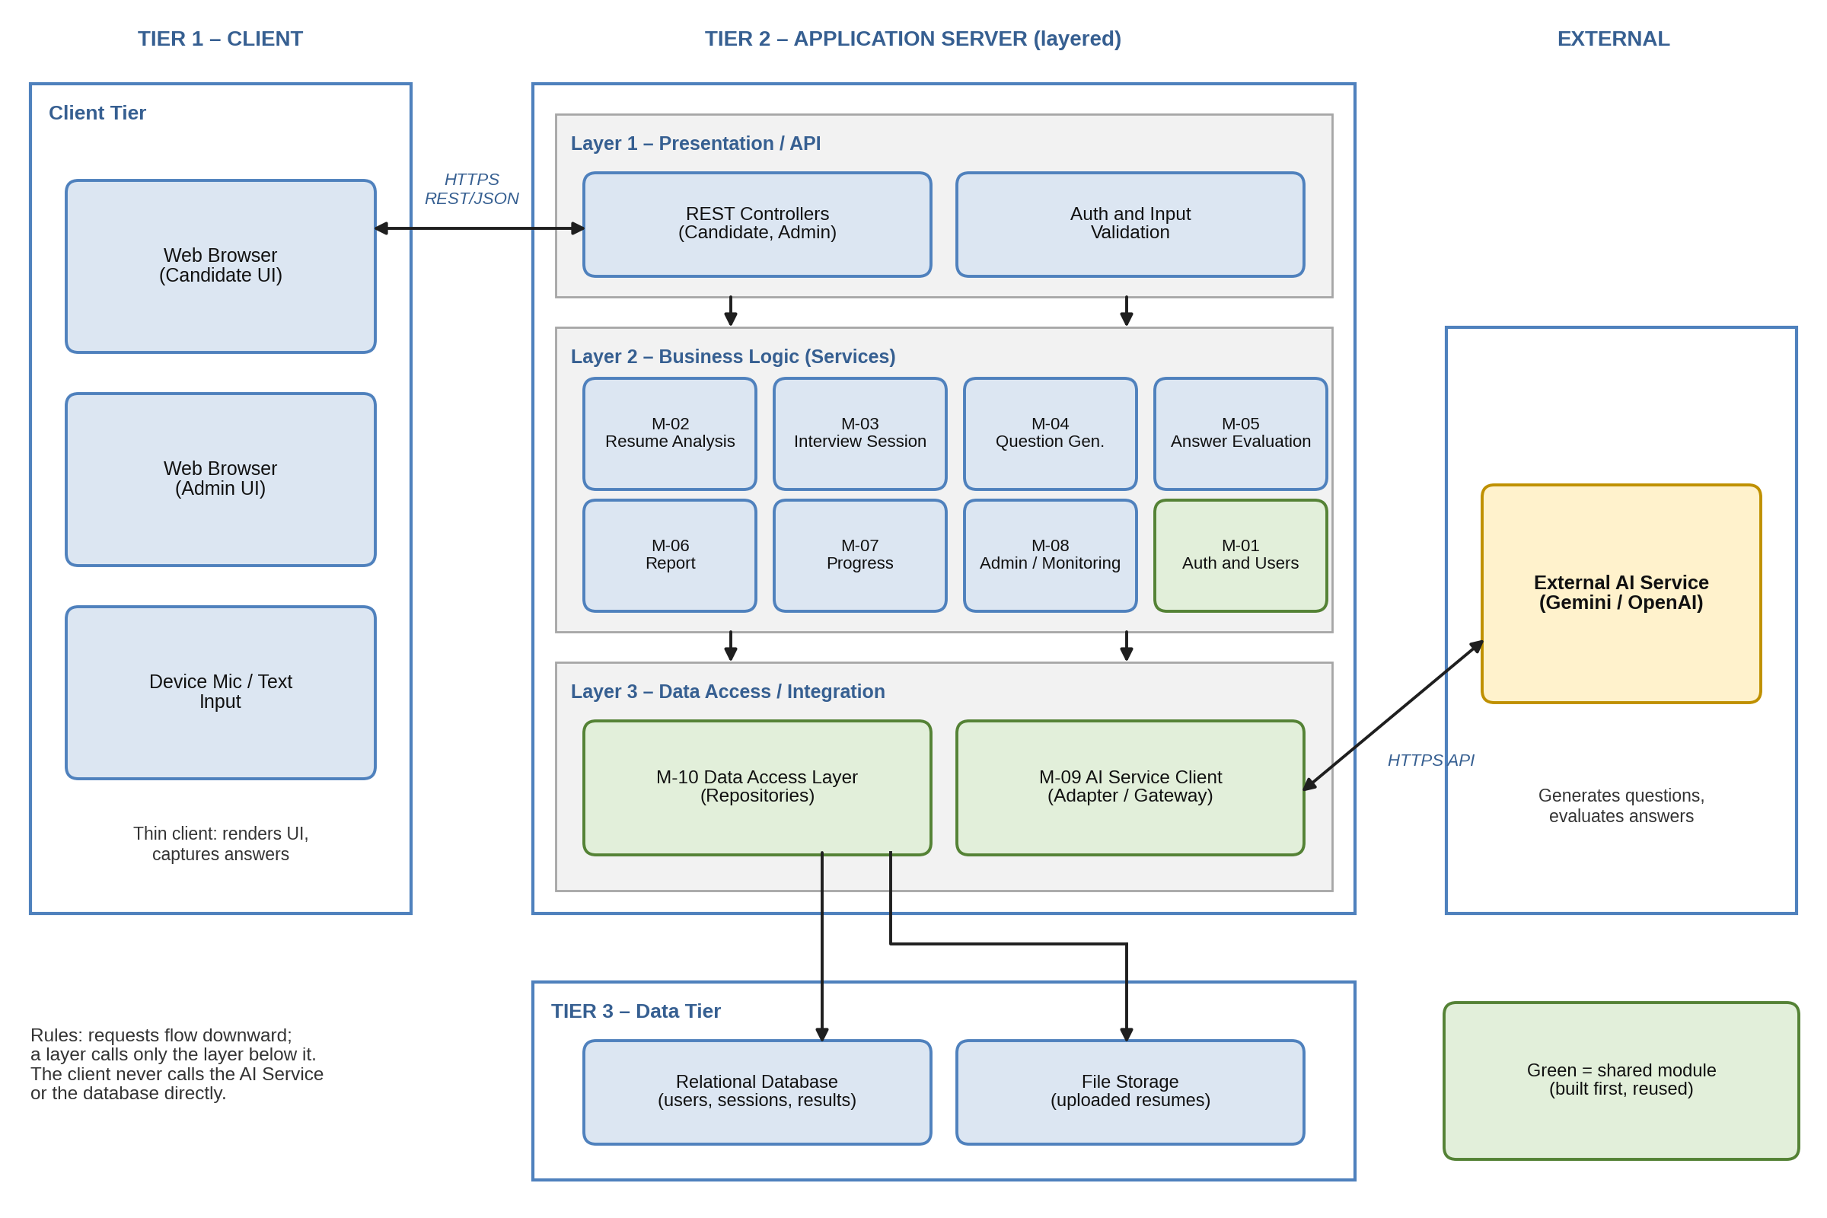
Note: Green modules are shared and built first. Arrows between layers show allowed dependencies.

MICROSERVICES ARCHITECTURE (CONCEPTUAL)
AI Interview Preparation Platform – Future Service Decomposition
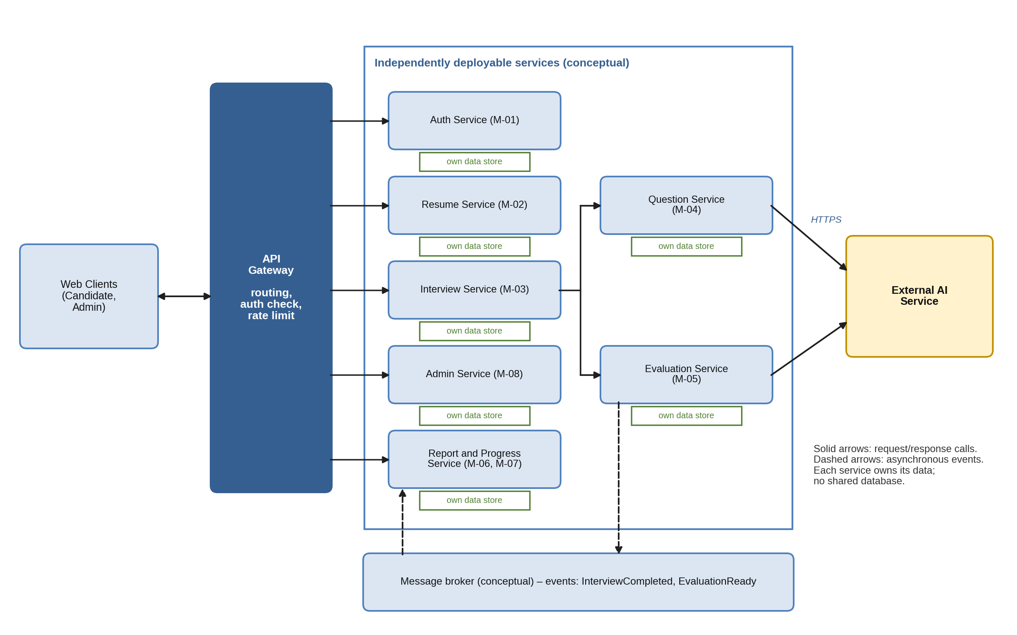
Note: Conceptual view only; the current implementation is a layered monolith.

