SESSION 8
SOFTWARE DESIGN PRINCIPLES
AI Interview Preparation Platform – Design Analysis Report
Team: Hirdesh (Team Lead), Mahek Bhatia, Janhavi Srivastava

1. Objective
To analyse the design of the AI Interview Preparation Platform using core software design principles: modularization, coupling and cohesion, function-oriented versus object-oriented design, and top-down versus bottom-up design.
Deliverable: Design Analysis Report. Industry mapping: Software Design Engineering.

2. Modularization
The platform is divided into ten modules, each owning one clear responsibility and tracing back to the Session 5 use cases. The module hierarchy is shown on the Module Decomposition page at the end of this document.
ID | Module | Responsibility | Use Cases
M-01 | Authentication and Users | Registration, login, roles and account status. | UC-01, UC-11
M-02 | Resume Analysis | Validates and parses resumes; assesses ATS fit and skill gaps. | UC-02, UC-03
M-03 | Interview Session | Creates sessions, tracks progress and receives answers. | UC-04, UC-06
M-04 | Question Generation | Builds role- and difficulty-specific questions. | UC-05
M-05 | Answer Evaluation | Scores answers and produces feedback; optional speech metrics. | UC-07, UC-08
M-06 | Report and Feedback | Compiles and presents the session report. | UC-09
M-07 | Progress Tracking | Aggregates scores across sessions into trends. | UC-10
M-08 | Admin and Monitoring | Manages categories and monitors platform health. | UC-12, UC-13
M-09 | AI Service Client | Single gateway to the external AI provider (calls, retries, timeouts). | UC-03, UC-05, UC-07
M-10 | Data Access Layer | Repository interfaces for storing and reading all data. | All

Modularization benefits for this platform:
- Parallel work: the three team members can build M-02, M-03/M-04/M-05 and M-06/M-07 independently.
- Replaceability: only M-09 knows which AI provider is used, so switching providers does not affect other modules.
- Testability: each module can be tested with mocked neighbours, for example M-05 with a fake M-09.

3. Coupling and Cohesion Analysis
Coupling analysis. Coupling measures how strongly modules depend on one another; lower is better. From lowest to highest: data, stamp, control, common and content coupling.
Module Interaction | Coupling Type | Level | Assessment / Improvement
M-03 → M-04 (role, level) | Data | Low | Only simple values are passed. Acceptable.
M-04, M-05, M-02 → M-09 | Data | Low | Called through one interface, so the provider can be swapped.
M-06 → M-05 (stored results) | Data | Low | Shared through the database, not direct calls. Acceptable.
M-01 → M-08 (user object) | Stamp | Medium | Whole user record is passed. Pass only user ID and role.
M-03 → M-05 (mode flag) | Control | Medium | A flag selects text or speech evaluation. Use separate strategy classes.
All modules → settings | Common | High (risk) | Global configuration is shared. Inject settings through constructors.
All modules → M-10 | Data | Low | Repository interfaces hide the database, so there is no direct SQL access.

Cohesion analysis. Cohesion measures how closely the elements inside a module belong together; higher is better. From highest to lowest: functional, sequential, communicational, procedural, temporal, logical and coincidental.
Module | Cohesion Type | Level | Rationale
M-04 Question Generation | Functional | High | Every element serves one task: producing questions.
M-05 Answer Evaluation | Functional | High | All elements contribute to scoring and feedback.
M-09 AI Service Client | Functional | High | Only provider communication and error handling.
M-03 Interview Session | Sequential | High | Output of each step (create, ask, receive) feeds the next.
M-02 Resume Analysis | Sequential | High | Validate, extract, assess, report in order.
M-06 / M-07 Report, Progress | Communicational | Medium | Operate on the same evaluation data; could share a result model.
M-01 Authentication and Users | Communicational | Medium | Login and user management share user data.
M-08 Admin and Monitoring | Logical | Low (risk) | Groups categories, users and monitoring. Split into Category Management and Monitoring.
Overall result: the design mostly achieves low coupling and high cohesion. Three improvement actions are recorded in Section 7.

4. Function-Oriented vs Object-Oriented Design
Aspect | Function-Oriented Design | Object-Oriented Design | Platform Application
Basic unit | Functions and procedures | Objects and classes | Classes such as InterviewSession, Question, Evaluation
Data | Shared, often global data | Encapsulated inside objects | Session state kept inside the session object
Decomposition | By function (what the system does) | By entity (what the system is made of) | Entities match nouns in the use cases
Reuse | Function libraries | Inheritance, composition, interfaces | Common Evaluator interface for text and speech
Change impact | Data changes can affect many functions | Changes are localised in a class | Provider change confined to M-09
Best suited to | Fixed, calculation-driven processes | Evolving systems with many entities | Interview platform with growing features
Decision: Object-oriented design is chosen as the main approach because the platform has clear entities (Candidate, Interview Session, Question, Answer, Evaluation, Report), supports polymorphic evaluators and is expected to evolve. Function-oriented design is used inside methods and utility steps such as resume parsing and score calculation.

5. Top-Down and Bottom-Up Design
Aspect | Top-Down Design | Bottom-Up Design | Platform Application
Starting point | Overall system goal | Low-level reusable components | Goal: help candidates practise interviews
Process | Break the system into subsystems, then modules | Build and test basic modules, then combine | Four Level 1 groups split into ten modules
Strength | Clear structure and traceability to requirements | Early reuse and early testing of core parts | Both are used together
Risk | Low-level details found late | Components may not fit the final system | Interfaces fixed early to avoid mismatch
Approach used (hybrid):
- Top-down: the platform was decomposed from the system level into Candidate, AI, Admin and Common services, then into modules M-01 to M-10 (see the figure).
- Bottom-up: shared modules M-01, M-09 and M-10 are built and tested first, then reused by the feature modules.
- Integration order: M-10 → M-09 → M-01 → M-04/M-05 → M-03 → M-06/M-07 → M-08.

6. Design Principles Applied
Principle | Application in the Platform
Single responsibility | Each module has one reason to change (for example, M-04 only builds questions).
Separation of concerns | Presentation, business logic, AI access and storage are kept in different layers.
Information hiding | Provider details are hidden in M-09; database details are hidden in M-10.
Open/closed | New evaluators (such as speech) are added without changing existing code.
Dependency inversion | Modules depend on interfaces, not on concrete AI or database classes.
Reuse | Shared modules serve every feature module.

7. Findings and Recommendations
- Split M-08 Admin and Monitoring into Category Management and Platform Monitoring to raise cohesion from logical to functional.
- Replace the whole-user object passed to Admin with user ID and role to reduce stamp coupling.
- Remove global configuration access by injecting settings, and use a strategy class instead of the text/speech flag in M-05.
- Introduce a shared result model for M-06 and M-07 to raise their cohesion.

8. Industry Mapping – Software Design Engineering
Design Concept | Platform Example | Industry Practice
Modularization | Ten modules with traced use cases | Service or package boundaries in monoliths and microservices
Coupling and cohesion | Analysis tables with improvement actions | Design reviews and static-analysis metrics for maintainability
Object-oriented design | Entity classes and an Evaluator interface | Domain-driven design and design patterns
Top-down and bottom-up | Hierarchy plus shared modules built first | Architecture planning combined with reusable internal libraries

9. Assumptions
- The module list is derived from the Session 5 use cases and the Session 7 interactions.
- Coupling and cohesion levels are qualitative judgements, not tool-measured metrics.
- The AI provider (Gemini/OpenAI) stays outside the platform and is reached only through M-09.
- The module split may be refined during implementation.

10. Submission Checklist
☐ Modularization table
☐ Coupling and cohesion analysis
☐ Function-oriented vs object-oriented comparison
☐ Top-down and bottom-up analysis
☐ Module decomposition figure

MODULE DECOMPOSITION
AI Interview Preparation Platform – Top-Down Hierarchy
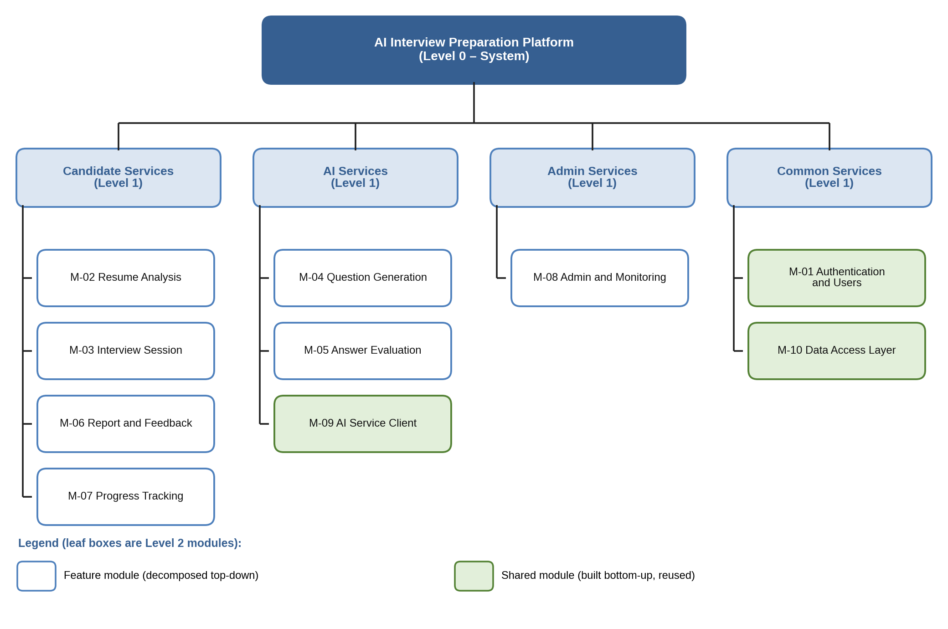
Note: Green modules are shared and built bottom-up; module IDs match the modularization table.

