SESSION 5
USE CASE MODELLING
AI Interview Preparation Platform
Team: Hirdesh (Team Lead), Mahek Bhatia, Janhavi Srivastava

1. Objective
To identify the actors, system functions, system boundary and interactions for the AI Interview Preparation Platform using UML use case modelling.

2. Actors
Actor | Type | Responsibility
Candidate | Primary | Practises interviews, uploads a resume, reviews feedback and tracks progress.
Admin | Administrative | Manages users and interview categories and monitors the platform.
External AI Service | Supporting external system, if separately deployed | Generates interview questions and evaluates answers, resume content and speech metrics.

3. Use Case Identification
ID | Use Case | Actor(s)
UC-01 | Register / Login | Candidate
UC-02 | Upload Resume | Candidate
UC-03 | Analyze Resume for ATS and Skill Gaps | Candidate; AI Service
UC-04 | Start Mock Interview | Candidate
UC-05 | Generate Questions | AI Service
UC-06 | Submit Answers | Candidate
UC-07 | Evaluate Answers | AI Service
UC-08 | Analyze Speech and Pacing | AI Service (conditional)
UC-09 | View Feedback Report | Candidate
UC-10 | Track Performance | Candidate
UC-11 | Manage Users | Admin
UC-12 | Manage Interview Categories | Admin
UC-13 | Monitor Platform | Admin

4. Use Case Diagram
The editable diagram is supplied separately as AI_Interview_Platform_Use_Case_Diagram.drawio. Open it in diagrams.net (draw.io). Solid lines show actor associations. Dashed arrows labelled <<include>> show required reused behavior; <<extend>> shows conditional behavior.
Note: External AI Service is an actor only if it is modelled outside the platform boundary. If AI processing is considered an internal capability, show the relevant functions as internal use cases instead.

5. Use Case Narratives

UC-04: Start Mock Interview
Primary actor: Candidate
Preconditions: Candidate is registered and logged in.
Main success flow: 1. Select technical, behavioral or mixed interview. 2. Choose target role and difficulty. 3. System generates relevant questions. 4. Candidate answers by voice or text. 5. System evaluates the responses. 6. System creates and displays a report.
Alternative / exception flow: If speech input fails, candidate can type an answer. If question generation fails, system offers retry.
Postconditions: Interview session and report are saved to the candidate history.

UC-03: Analyze Resume
Primary actor: Candidate
Preconditions: Candidate is logged in and has a supported resume file.
Main success flow: 1. Upload resume. 2. System checks file type and size. 3. System extracts resume text. 4. Candidate selects a target role. 5. System assesses ATS-oriented structure and skill alignment. 6. System shows strengths and skill gaps.
Alternative / exception flow: If file is unsupported or unreadable, system requests another upload.
Postconditions: Resume analysis is displayed and may be saved in history.

UC-09: View Feedback Report
Primary actor: Candidate
Preconditions: Candidate is logged in and has a completed interview.
Main success flow: 1. Open interview history. 2. Select a session. 3. System retrieves its report. 4. System displays answer quality, strengths, improvement areas and available communication metrics.
Alternative / exception flow: If report is still processing, system shows pending status; if no interview exists, system prompts the candidate to practise.
Postconditions: Candidate can review and use the report to plan further practice.

UC-11: Manage Users
Primary actor: Admin
Preconditions: Admin is authenticated and authorized.
Main success flow: 1. Open user management. 2. Search or select a user. 3. View or update permitted account details/status. 4. System validates and saves the change. 5. System confirms the result.
Alternative / exception flow: If permission is insufficient or user is not found, system rejects the action with a message.
Postconditions: Authorized change is saved and auditable.

UC-07: Evaluate Answers
Primary actor: AI evaluation component
Preconditions: An interview question and candidate answer are available.
Main success flow: 1. Platform sends the question, answer and role criteria to the evaluation component. 2. Component assesses relevance, correctness, clarity and completeness. 3. It returns a score and actionable feedback. 4. Platform stores the result and adds it to the report.
Alternative / exception flow: If evaluation fails or times out, platform retries within configured limits or marks the evaluation pending.
Postconditions: Evaluation result or clear pending/error status is associated with the interview session.

6. UML Relationship Notes
- Association: solid line connecting an actor to a use case in which it participates.
- <<include>>: required reused behavior. Example: Start Mock Interview includes Generate Questions. Submit Answers includes Evaluate Answers.
- <<extend>>: conditional or optional behavior. Example: Analyze Speech and Pacing may extend Evaluate Answers when audio analysis is enabled.
- System boundary: rectangle containing functions delivered by the AI Interview Preparation Platform.

7. Assumptions
- Candidate is the primary end user.
- Gemini/OpenAI is shown as an external actor only if the AI provider is outside the platform boundary.
- Five narratives are included as a practical submission set; follow any different count required by the instructor.
- AI feedback is preparation guidance, not a guarantee of hiring outcomes.

8. Submission Checklist
☐ Use case identification table
☐ UML use case diagram
☐ Five use case narratives
☐ Editable .drawio source file

USE CASE DIAGRAM
AI Interview Preparation Platform
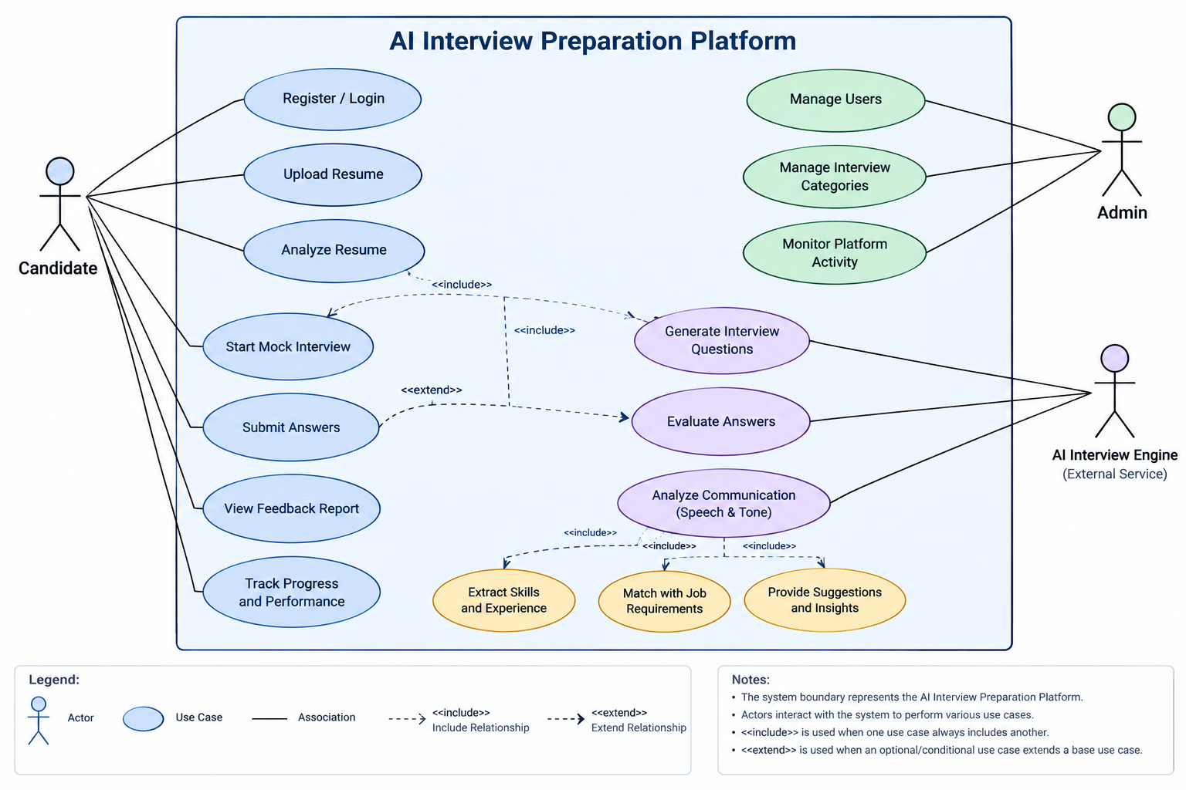
Note: The editable diagram is also available separately in diagrams.net (.drawio) format. Review the relationship arrows and labels before submission.

