Capacitor Selection and Reliability Optimization System for a DC–DC Converter
MATLAB-Based Research Framework with Commercial Component Screening and Simulink Validation Plan
Prepared for research development | October 2026

Abstract
This report presents a staged framework for selecting commercially available output capacitors for a closed-loop buck converter. The prototype combines analytical ripple-current calculations, tolerance-aware capacitance screening, ESR-related ripple and loss estimates, a ten-part commercial shortlist, strict qualification flags, and a weighted scoring architecture. The baseline is a 24 V input, 12 V output reference, 1 mH inductor, 50 kHz switching frequency, and 3.75 Ω load. Calculations yield an ideal duty ratio of 0.5, 0.12 A peak-to-peak inductor ripple, approximately 34.6 mA capacitor RMS ripple current, and 3 µF ideal minimum capacitance for a 100 mV capacitive-ripple target. A nominal 22 µF candidate has 17.6 µF minimum capacitance under a ±20% tolerance. The report distinguishes provisional estimates from verified ratings and does not declare a final winner because several data fields remain incomplete.
Index Terms—capacitor selection, buck converter, ESR, ripple current, reliability, lifetime estimation, optimization, MATLAB, Simulink.

I. INTRODUCTION
Output capacitors influence ripple, load-step response, thermal stress, control-loop behavior, footprint, cost, and service life. This project frames capacitor selection as constrained optimization with data provenance and validation.

II. OBJECTIVES AND SCOPE
Derive application requirements, maintain a traceable commercial database, apply hard constraints, estimate ripple and ESR loss, distinguish provisional scores from strict qualification, and define repeatable Simulink/hardware validation.

III. SYSTEM MODEL AND BLOCK DIAGRAM
The model uses 24 V input, 12 V reference, 1 mH inductor, 50 kHz PWM, and 3.75 Ω fixed load. The cyclic-load profile must be held constant across candidate tests.
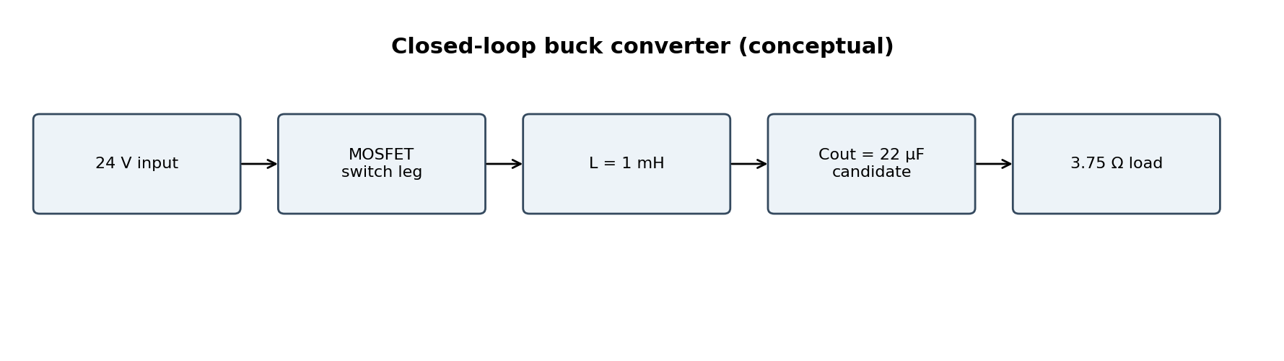
Fig. 1. Conceptual buck converter block diagram.
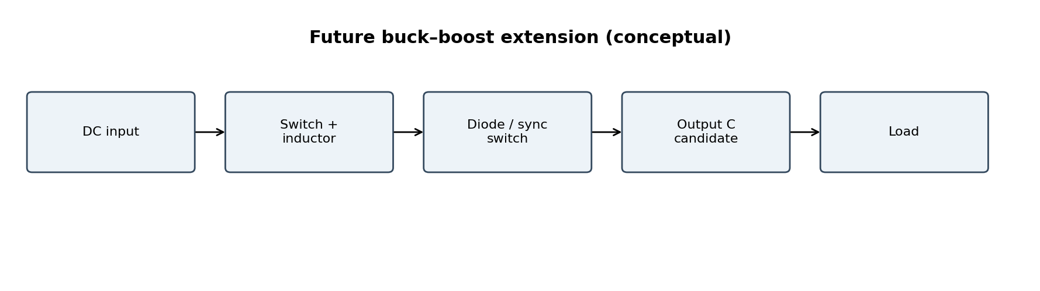
Fig. 2. Future buck–boost extension.

IV. PARAMETER CALCULATIONS
D=Vout/Vin=0.5. ΔIL=(Vin−Vout)D/(Lfs)=0.120 A p-p. IC,rms≈ΔIL/(2√3)=0.0346 A. Iout=3.20 A; Pout=38.4 W. For 100 mV capacitive ripple, ideal Cmin=3.00 µF. A 22 µF capacitor with −20% tolerance has 17.6 µF minimum and ideal capacitive ripple 17.05 mV p-p. This is a lower bound, not a transient/stability design guarantee.

V. COMMERCIAL CANDIDATES
The ten candidates below are a research shortlist, not a set of fully verified interchangeable components. The Panasonic 35SVPF22M official page reports 22 µF, 35 V, 35 mΩ at 100 kHz, 2.6 A at 100 kHz and 105°C, and 5000 h at 105°C. The Panasonic EEE-HB1V220AP page reports 55 mA at 120 Hz but no ESR in the product table. Other entries require exact datasheet verification.
Manufacturer | Part number | V | ESR mΩ | Ripple A | Data note
Panasonic | EEE-HB1V220AP | 35 | Unknown | 0.055 | 55 mA at 120 Hz; ESR not published in product table
Panasonic | 25TQC22MD2 | 25 | 60 | 1.4 | Prior listing; verify exact datasheet conditions
Panasonic | 35SVPD22M | 35 | 50 | 2.3 | Prior listing; verify exact datasheet conditions
KEMET | T521V226M025ATE045 | 25 | 45 | 2.0 | 45 mΩ at 100 kHz; 2 A distributor listing
KEMET | T521B226M025ATE100 | 25 | 100 | 1.1 | Prior listing; verify exact datasheet conditions
KEMET | A758EK226M1EAAE050 | 25 | 50 | 2.0 | Prior listing; verify exact datasheet conditions
Nichicon | FP-025ME220M-SSR | 25 | 40 | 2.1 | Prior listing; verify exact datasheet conditions
Panasonic | 35SVF22M | 35 | 35 | 0.82 | Verify exact ripple-current conditions
Panasonic | 35SVPF22M | 35 | 35 | 2.6 | Official data: 2.6 A at 100 kHz, 105°C; 5000 h at 105°C
Panasonic | EEE-FN1V220R | 35 | 700 | 0.16 | Prior listing; verify exact datasheet conditions

VI. ALGORITHM EVOLUTION: V1–V4
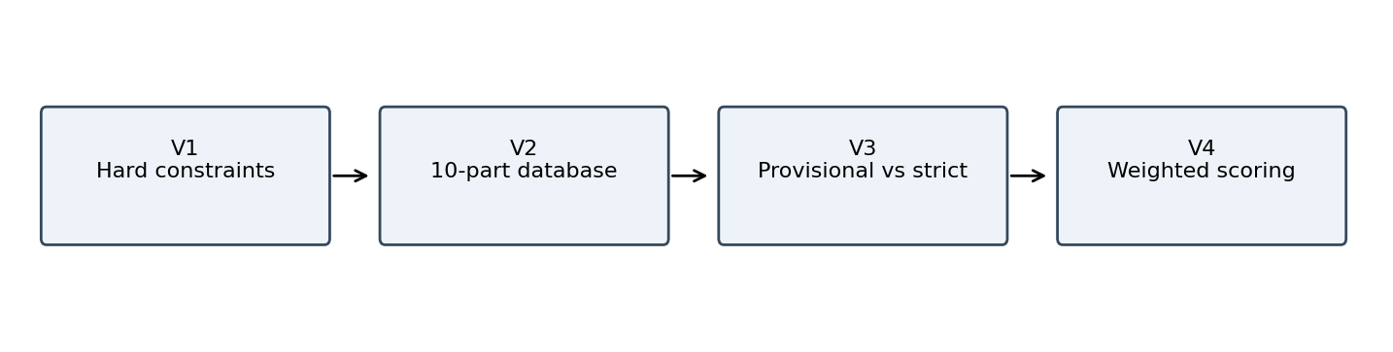
V1: basic calculations and hard constraints. V2: exact commercial parts and ESR-aware estimates. V3: provisional versus strict qualification. V4: weighted electrical/reliability/lifetime/cost scoring with missing values left unknown.

VII. SCORING METHODOLOGY
Weights: electrical 30%, reliability 30%, lifetime 25%, cost 15%. Electrical subscore: ripple 70%, ESR loss 30%. Relative lower-is-better normalization maps the minimum in the candidate set to 100 and maximum to 0. This is not an absolute quality score. FinalScore remains unavailable until verified current margin, lifetime at operating temperature, and comparable price data are supplied.

VIII. PRELIMINARY RESULTS
The lowest estimated ripple is approximately 21.245 mV p-p for Panasonic 35SVF22M and 35SVPF22M, followed by 21.845 mV for Nichicon FP-025ME220M-SSR. These are estimates based on entered ESR, not measurements. Current script result: nine provisional passes and zero fully qualified candidates because all verification flags are false.
Part number | ESR mΩ | Ripple mV p-p | Loss µW | Electrical score
35SVF22M | 35.0 | 21.25 | 42.00 | 100.0
35SVPF22M | 35.0 | 21.25 | 42.00 | 100.0
FP-025ME220M-SSR | 40.0 | 21.85 | 48.00 | 99.2
T521V226M025ATE045 | 45.0 | 22.45 | 54.00 | 98.5
35SVPD22M | 50.0 | 23.05 | 60.00 | 97.7
A758EK226M1EAAE050 | 50.0 | 23.05 | 60.00 | 97.7
25TQC22MD2 | 60.0 | 24.25 | 72.00 | 96.2
T521B226M025ATE100 | 100.0 | 29.05 | 120.00 | 90.2
EEE-FN1V220R | 700.0 | 101.05 | 840.00 | 0.0

IX. OUTPUT RESPONSE
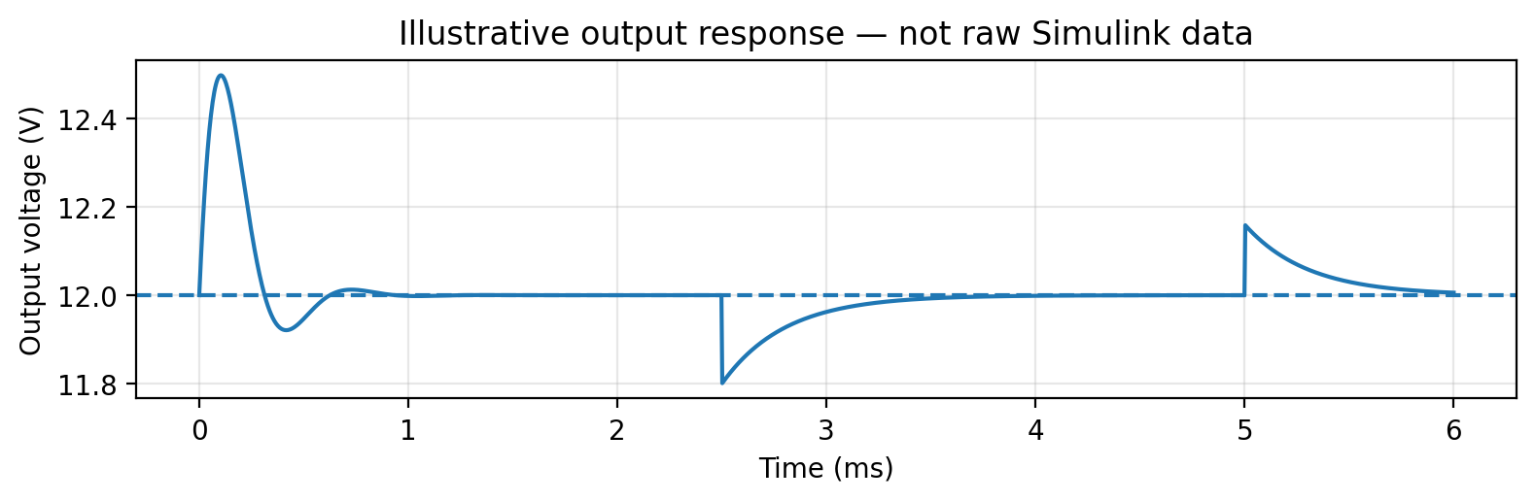
Fig. 4. Illustrative response only; not raw Simulink data.
Screenshots qualitatively showed startup overshoot near 13.06 V and settling near 12 V, with load disturbances around 2.5 ms and 5 ms. The plot is constructed for illustration only. Measure actual ripple from exported Scope data across several settled 20 µs switching periods.
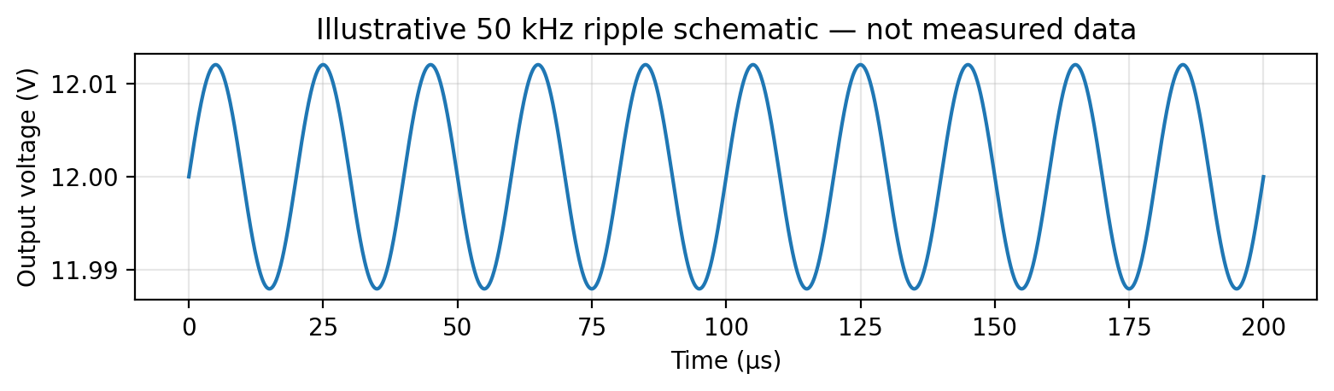
Fig. 5. Illustrative switching ripple schematic, not measured.

X. SIMULINK VALIDATION
Keep source, controller, solver, initial conditions, load profile and measurement window identical. Change only capacitor parameters. Record steady-state ripple, mean output, startup overshoot, load-step undershoot/overshoot, settling time and capacitor RMS current. Unknown ESR must not be replaced by zero.

XI. LIMITATIONS
ESR depends on frequency and temperature; ripple ratings may use different conditions; the ripple equation is first-order; life models differ by technology; prices and thermal data are missing for most parts. Verify package, polarity, derating, surge/inrush requirements and latest datasheets.

XII. RESEARCH ROADMAP
Verify every data record and provenance; add frequency-dependent impedance and thermal models; perform sensitivity/Monte Carlo analysis; automate Simulink sweeps; validate on hardware; extend to buck–boost, DC-link, filters, motor drives and IC decoupling.

XIII. CONCLUSION
The prototype combines transparent calculations, a ten-part shortlist, provisional ranking and strict qualification gates. It does not yet establish a final winner. Datasheet verification and repeatable simulation measurements are the next steps.

XIV. REPOSITORY AND REPRODUCIBILITY
No GitHub repository has been created from this chat. The included source package is ready to upload. Suggested repository name: capacitor-selection-optimization-system. Replace https://github.com/<your-username>/capacitor-selection-optimization-system with the actual URL after creating it; this is a placeholder, not an active repository.

REFERENCES
[1] Panasonic Industry, 35SVPF22M product specifications: https://industrial.panasonic.com/ww/products/pt/os-con/models/35SVPF22M
[2] Panasonic Industry, EEEHB1V220AP product specifications: https://industrial.panasonic.com/ww/products/pt/aluminum-cap-smd/models/EEEHB1V220AP
[3] KEMET T521V226M025ATE045, DigiKey product/datasheet information: https://www.digikey.in/en/products/detail/kemet/T521V226M025ATE045/5131700
[4] IEEE Author Center templates: https://template-selector.ieee.org/
[5] MathWorks MATLAB tables: https://www.mathworks.com/help/matlab/tables.html
[6] MathWorks Simulink: https://www.mathworks.com/help/simulink/

