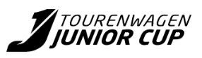
Race Director Decision

Event: | ADAC Racing Weekend
Track: | {{trackName}}
Date: | {{createdAt}}

From: | The Race Directer
Cc: | The Clerk of the Course  The Stewards of the Meeting  The Sekretary of the Meeting  The Timekeeper
To the driver: | {{carNumber}} - {{driverName}}
Competitor: | {{teamName}}

The Race Director imposes a: | {{penalty}}
Cause: | {{cause}}
Session: | {{eventType}}

Datum/Uhrzeit | {{createdAt}}

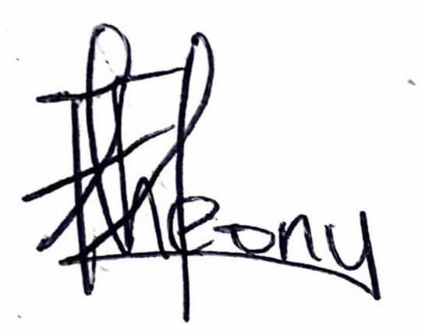

Marco Kolb

Race Director ADAC Tourenwagen Junior Cup

