Can this approach find the leads we want?
A real search through LeadPilot AI (VARSA) using the Apollo API, in plain words
Test date: 22 October 2026 · Environment: local dev server, Docker PostgreSQL, live Apollo and OpenAI keys
Prompt used: “Find Heads of Sales at software companies in the United States with 50 to 200 employees”
This document answers three questions: did the search work, were the leads a good fit, and which kinds of leads this Apollo-based approach can and cannot give us, and why.

Contents
1. The short answer 3
2. What we tested, step by step 4
3. What came back 6
3.1 Scorecard against the prompt 6
4. Why the industry was ignored 9
4.1 What happens to the 100 people Apollo returns 9
5. Proof that Apollo can find software companies 10
6. Which leads this approach can and cannot give us 11
6.1 Things we CAN get 11
6.2 Things we CANNOT reliably get 11
7. What to change to get the right leads 13
8. Evidence from this run 13
8.1 Server log (abridged) 13
8.2 API responses 13
8.3 Direct Apollo calls (free search endpoint) 13
8.4 Files from this run 14

1. The short answer
Did it work?
Yes. The app took the prompt, asked Apollo, unlocked emails and saved 10 leads in 27 seconds. Every lead has a verified business email and a LinkedIn profile. The AI (OpenAI) read the prompt correctly and wrote a short “why reach out” note for each lead.

Were the leads the best fit?
Only partly. All 10 are senior sales people in the United States at companies with 54 to 190 employees, which is exactly what we asked for. But only 1 of the 10 works at anything close to a software company. The other 9 are in automotive, textiles, real estate, insurance, mortgages, publishing, machinery and solar hardware.
So the leads are real, reachable and senior, but most are in the wrong industry.

Why?
The app understands the word “software” but never sends it to Apollo. It only sends job titles, country and company size. Apollo therefore returns every sales head in the US at a 51–200 person company (173,128 people) and the app simply saves the first 10 that have a verified email.
Apollo itself can filter by industry. We proved it with a direct call: adding the keyword tag “software” cuts the pool from 173,129 to 39,790 people, almost all at software companies. This is a small code change, not a limit of Apollo.

2. What we tested, step by step
- Signed in as the test user and opened the Lead Finder.
- Sent the prompt above and asked for 10 leads (the app's batch size is 100 people per run; we capped the saved result at 10).
- Watched the search run: prompt interpreted by OpenAI, filters sent to Apollo, 100 people pulled from page 1, 100 emails unlocked, 10 leads saved.
- Opened the results page, the All Leads page and the admin API Health page, and exported the batch as CSV.
- Checked every lead against the four things the prompt asked for: title, country, company size, industry.
- Called the Apollo search API directly (search is free, no credits) with and without an industry filter to see what Apollo can really do.
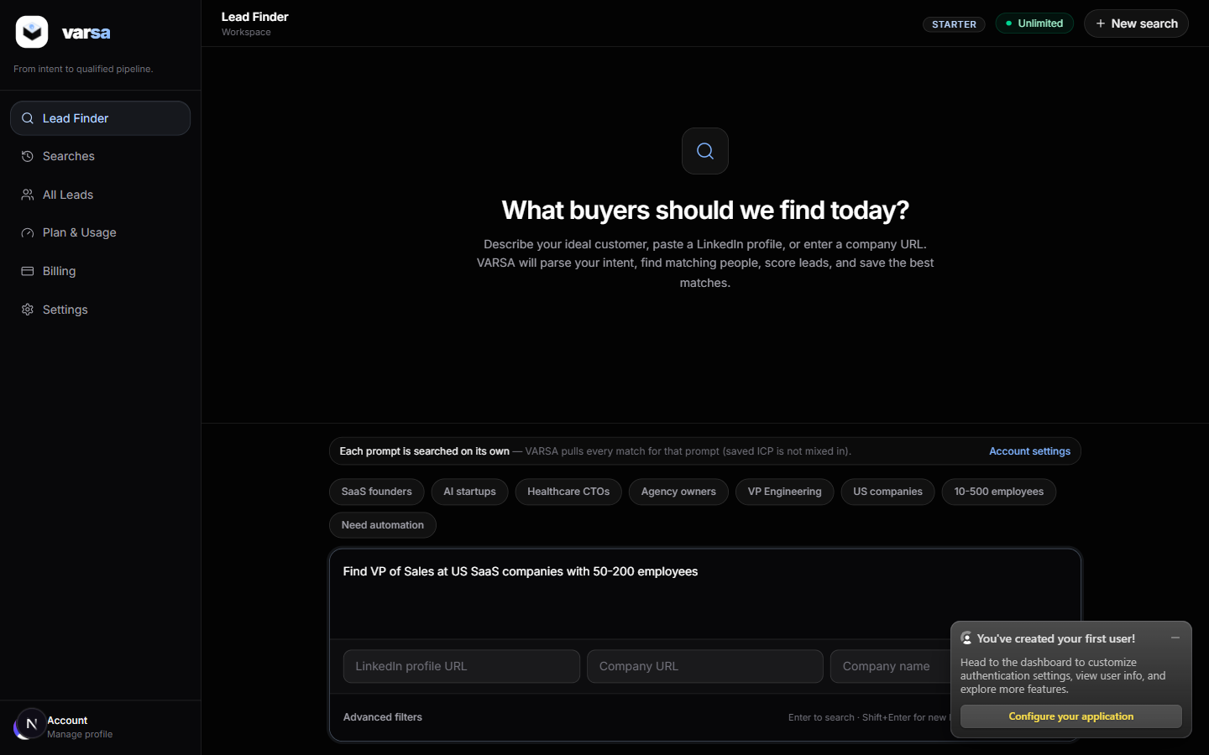
Figure 1. The prompt as typed in the Lead Finder before the run.
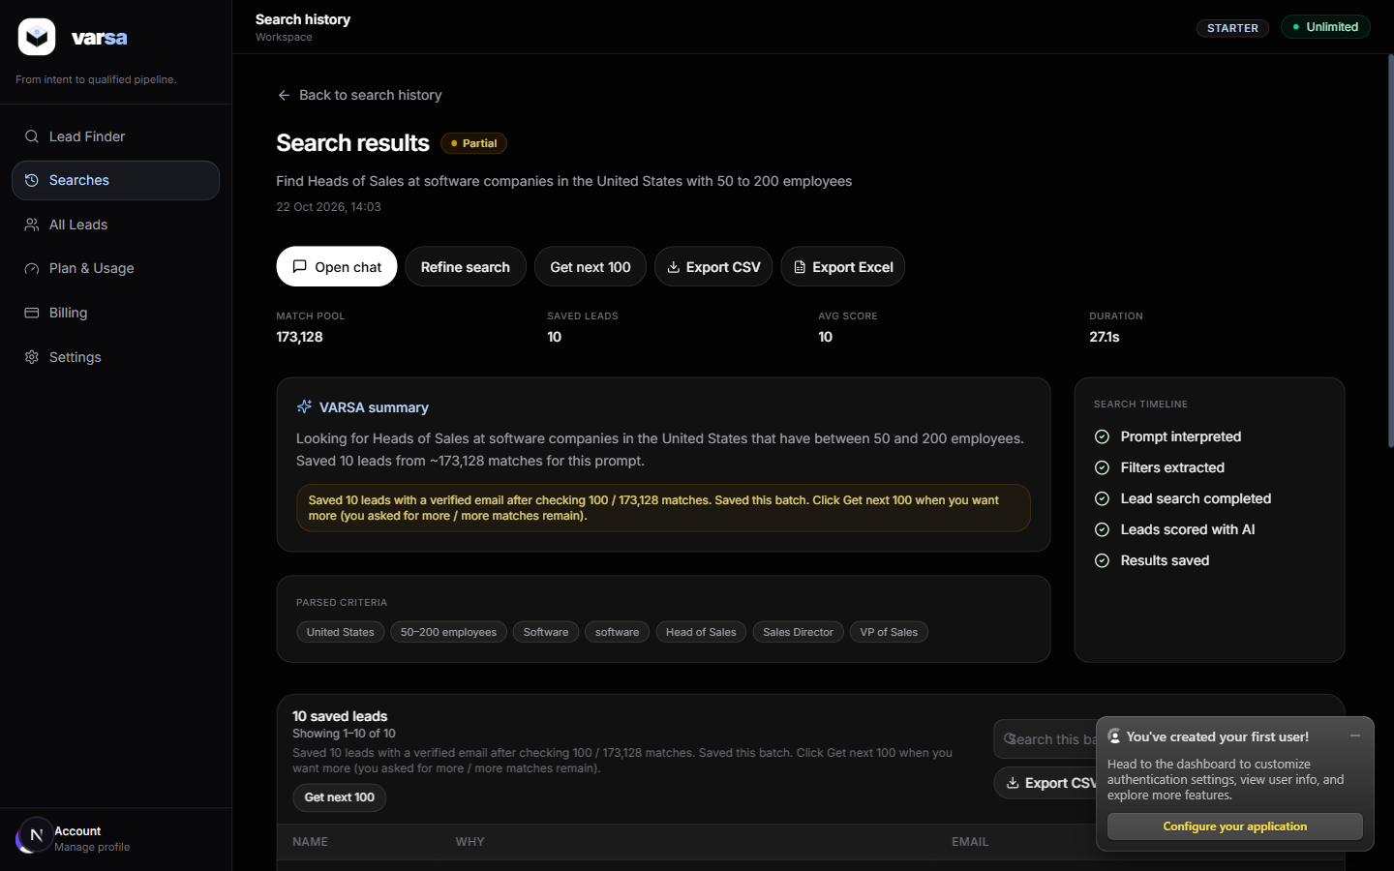
Figure 2. Result header: 173,128 matches in the pool, 10 saved, average score 10, 27.1 seconds. Note the “Software” chip under Parsed criteria.

3. What came back
The 10 saved leads, with the four checks from the prompt. Company size and industry are the values Apollo returned.
Name | Title | Company | Industry (Apollo) | Staff | Software company?
Gregory Lewis | Head of Sales, Director | FLEXRACK by Qcells | semiconductors | 60 | No
Brent Gardner | VP and Sales Director | Central Valley Automotive Group | automotive | 75 | No
Kenny Cohen | VP of Sales / Director of Sales | American Dawn | textiles | 140 | No
Ryan Peterson | Sales Director, Head of Sales | Chromatic | IT & services | 73 | Partly (IT services, closest to software)
Lori Martinsek | VP Sales Director | Publication Services | publishing | 180 | No
Ryan Skelly | VP & Sales Manager | Standard Mortgage Corporation | financial services | 150 | No
Denise Biorn | VP / Sales Manager | Chicago Title King-Pierce-Kitsap | real estate | 150 | No
Luther Hoy | VP / Sales Manager | Eaheart Industrial Service | machinery | 60 | No
Avi Oren | VP Sales Manager | The Kislak Company | real estate | 54 | No
Renee Azelby | VP, Sales Manager | Jimcor Agencies | insurance | 190 | No

3.1 Scorecard against the prompt
What the prompt asked for | Result | Notes
Head of Sales (or similar senior sales title) | Yes, 10 of 10 | Apollo's “similar titles” option widened this to VP Sales, Sales Director and Sales Manager. All are senior sales roles.
In the United States | Yes, 10 of 10 | All in US states (MD, CA, FL, IA, IL, TX, WA, VA, NJ).
50 to 200 employees | Yes, 10 of 10 | Range 54–190. The size filter was sent to Apollo and worked.
At software companies | No, 1 of 10 | Industry was never sent to Apollo. One lead (Chromatic, IT services) is close; nine are unrelated industries.
Usable email | Yes, 10 of 10 | All marked “verified” by Apollo. 79 of the 100 people pulled had an email; 5 were skipped as unverified.
Meaningful score | No | Every lead scored 10/10. The score rewards senior sales titles and never deducts for a wrong industry, so it cannot separate good from bad here.
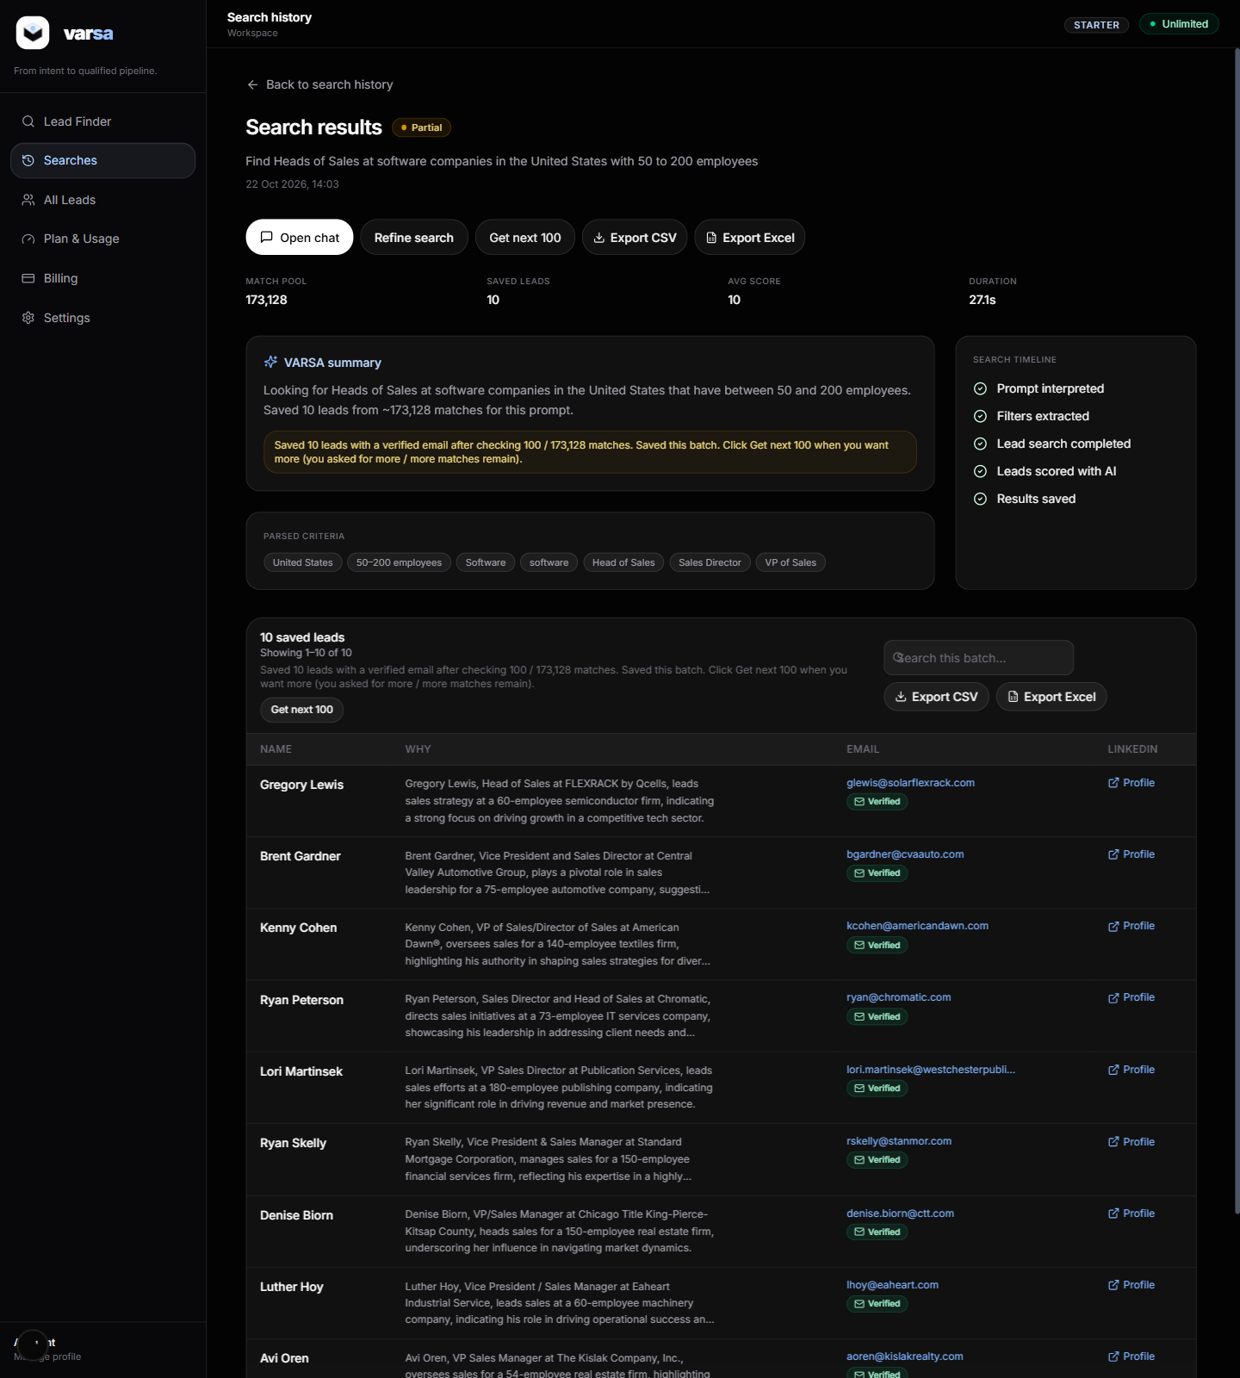
Figure 3. The 10 saved leads with AI-written “why” notes, verified emails and LinkedIn links. The notes are accurate about each person but do not mention that the company is not a software company.
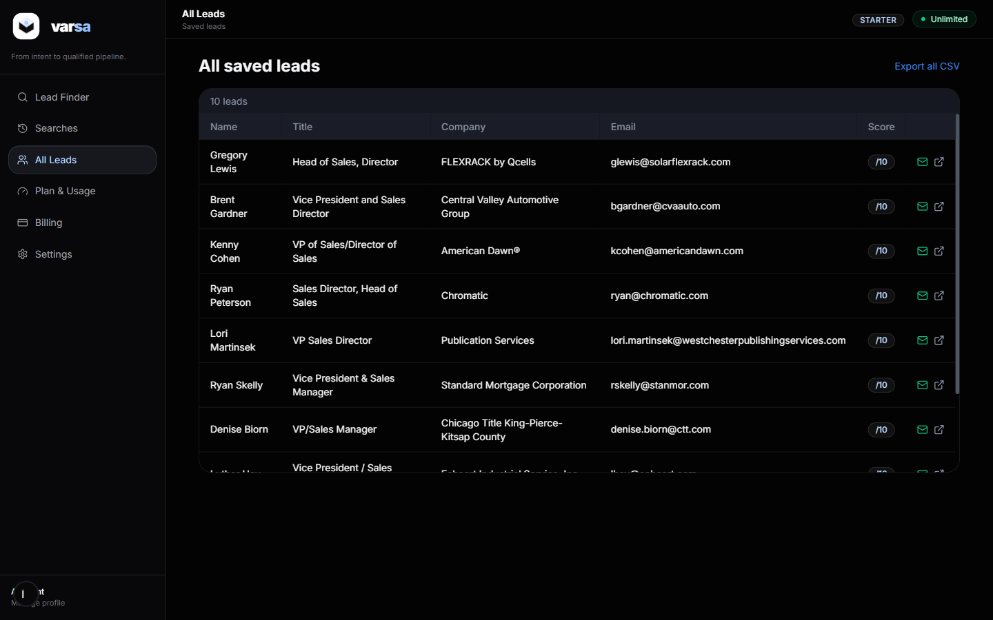
Figure 4. The All Leads page after the run.

4. Why the industry was ignored
This is what the server actually sent to Apollo, copied from the app's own log for this search:
person_titles: ["Head of Sales", "Sales Director", "VP of Sales", "Sales Manager"]
person_locations: ["United States"]
organization_num_employees_ranges: ["51,200"]
include_similar_titles: true
q_keywords: null
industry: "Software" <- kept as a label only; Apollo never receives it
-> Apollo: total_entries = 173,128

The AI parser (OpenAI, now working because credits were added) did understand the prompt. It produced industry = “Software” and the right titles, country and size. The gap is in the code that turns the parsed criteria into Apollo filters: it has fields for titles, locations, employee ranges, keywords and company domains, and nothing for industry. The “Software” chip on the results page therefore shows what was understood, not what was filtered.

4.1 What happens to the 100 people Apollo returns
- Apollo returns 100 people per page in Apollo's own order (not by fit).
- The app scores all 100 with the heuristic rules. Senior sales titles get the maximum score, so everyone scores 10.
- The app unlocks the email of all 100 (this is the paid step: one Apollo credit per person).
- It keeps the ones with a verified email and saves the first 10 because we asked for 10.
Cost note
Asking for 10 leads still unlocked 100 people, because the batch size is fixed at 100 and the requested count only caps what is saved. That is roughly 100 Apollo enrichment credits for 10 saved leads. If you only want 10, the unlock step should stop at 10 (plus a small buffer for people without emails).

5. Proof that Apollo can find software companies
We called Apollo's people search directly with the same titles, country and size, then added an industry filter. Search calls are free, so this spent no credits. Counts are Apollo's total_entries for each filter set.
Filter set | People in pool | What the first results look like
A. Exactly what the app sends today | 173,129 | FLEXRACK by Qcells (solar), Central Valley Automotive, American Dawn (textiles), Chromatic
B. A + organization keyword tag “software” | 39,790 | Chromatic, Software Solutions, LOC Software, Procede Software
C. A + free-text keyword “software” | 448 | RFgen Software, Smart Software, SafetyChain Software (only companies with “software” in their text)
D. Exact titles only (no similar titles) + tags “software”, “saas” | 6,261 | RFgen Software, LOC Software, SafetyChain Software, Assembly Software

Reading this: option B is the one we want for “software companies”. It keeps the pool large (almost 40,000 people) but limited to software businesses. Option C is too narrow because it only matches companies that literally say “software”. Option D shows how much the “similar titles” switch widens the pool (6,261 exact Heads/VPs of Sales versus 39,790 with similar titles).
Apollo also has a formal industry filter (organization_industry_tag_ids) that uses Apollo's industry list instead of free keywords. Either option is a few lines of code in the filter builder.

6. Which leads this approach can and cannot give us
“Apollo supports” means the Apollo API has the filter or data. “Wired in app” means this codebase already sends it. Where Apollo supports something the app does not send, it is a code change, not a data limit.

6.1 Things we CAN get
What you want | Apollo supports | Wired in app | In simple words
People by job title (Head of Sales, CTO, Founder, etc.) | Yes | Yes | Works well. Apollo can match exact titles or “similar” titles. Similar is broader but less precise.
People in a country, state or city | Yes | Yes | Works. US, UK, specific cities, all fine.
Companies of a certain size | Yes | Yes | Works. Ranges like 11–50, 51–200, 201–500 employees. Sizes are Apollo's estimates.
Companies in an industry (software, healthcare, etc.) | Yes | Not wired | Apollo can do it (shown above). The app does not send it yet. This is the main reason today's leads were off-target.
Verified business email | Yes (1 credit per person) | Yes | About 8 in 10 people had an email; the app keeps only those Apollo marks “verified”. Verified means Apollo checked it, not a guarantee it will never bounce.
LinkedIn profile link | Yes | Yes | Returned for every lead.
People at a specific company (by name or website) | Yes | Yes | You can paste a company URL or name and get its decision makers.
Seniority level (C-level, VP, Director, Manager) | Yes | Not wired | Apollo has a seniority filter. The app relies on title words instead.
Companies using a given technology (e.g. Salesforce, Shopify) | Yes | Not wired | Apollo has a technology filter. Not connected in the app.
Company revenue range or funding stage | Yes | Not wired | Available in Apollo, not sent by the app.
Phone numbers | Yes (extra credits, async) | Not wired | Apollo returns phones through a separate, slower request. The app does not ask for them.
Larger volumes | Yes | Yes | 100 people per batch, “Get next 100” for more. Apollo allows up to 50,000 search calls a day; the real limit is your enrichment credits.

6.2 Things we CANNOT reliably get
What you want | Can we get it? | Why not, in simple words
Companies that “need” our product or have a specific pain | No | Apollo stores who people are, not what problems they have. The AI “why” note is written from the title and company only, so it sounds confident but adds no real intent signal.
People who are actively looking for a job (open to work) | Weak | Apollo has no such flag. The app only looks for words like “open to work” in the headline, which few people write. Expect very few hits.
A guaranteed-accurate industry or company size | Partly | These are Apollo's estimates. They are usually right, but a company can be tagged under a neighbouring industry (Chromatic was “IT & services” rather than “software”).
People who are not in Apollo's database | No | If Apollo has not indexed the person, no filter will find them. Coverage is strongest for US and English-speaking B2B companies.
Personal (non-work) emails | Partly | Apollo can reveal some personal emails, and the app asks for them, but availability is low and using them for cold outreach has compliance issues.
Perfect email deliverability | No | “Verified” reduces bounces but does not remove them. Keep a bounce check in your sending tool.
A score that ranks fit | Not yet | Today's score gives 10/10 to anyone with a senior sales title. It needs to deduct points for the wrong industry, size or location before it is useful.
Exact matches on vague prompts | No | If the prompt does not state industry, size or location, the pool is huge and the first 100 Apollo returns are effectively random within the title match.

7. What to change to get the right leads
In order of impact. The first two fix today's result; the rest make the leads cheaper and better ranked.
- Send the industry to Apollo. When the parser finds an industry or keywords, pass them as organization keyword tags (or Apollo industry tag ids). Today's prompt would then search 39,790 software-company sales heads instead of 173,128 of everyone.
- Be honest in the UI. Only show criteria chips for filters that were actually sent, or mark the rest as “not filtered”.
- Unlock only what was asked for. If the user asks for 10 leads, unlock 10 plus a small buffer, not 100. That cuts Apollo credit use by up to 90% on small requests.
- Make the score mean something. Deduct points when industry, size or location do not match the prompt, and sort by that score before unlocking emails, so credits go to the best-fit people first.
- Use Apollo's seniority filter. Cheaper and more precise than relying on title words plus “similar titles”.
- Optional extras. Technology, revenue and funding filters are available in Apollo if prompts start asking for them.

8. Evidence from this run

8.1 Server log (abridged)
parse_ok provider=OPENAI titles=[Head of Sales, Sales Director, VP of Sales, Sales Manager]
locations=[United States] employeeRanges=[51,200] industry=Software qKeywords=null
apollo_variant label="exact AI filters" totalEntries=173128 pagePeople=100
stage: fetch peoplePulled=100 durationMs=1328
stage: score scored=100 scoreProvider=HEURISTIC durationMs=13
stage: unlock attempted=100 unlockedEmail=79 durationMs=15616 (10 chunks of 10)
stage: why leads=10 provider=OPENAI durationMs=9752
batch_complete fetched=100 savedWithEmail=10 skippedUnverified=5 lastPage=1 totalPages=10

8.2 API responses
POST /api/leads/find {prompt, requestedLeadCount: 10, skipClarification: true}
-> 200 {searchId: "cmvjun6ol001mtdwcdofw3eds", status: "RUNNING", criteria: {industry: "Software", country: "United States",
companySizeMin: 50, companySizeMax: 200, jobTitles: [...4], keywords: ["software"]}}
GET /api/searches/{id} -> 200 {search: {status: "COMPLETE", displayStatus: "partial", totalFound: 173128,
totalQualified: 10, averageScore: 10, durationMs: 27090, aiProviderUsed: "HEURISTIC" (scoring)}, leads: [10]}
GET /api/export/csv?searchId={id} -> 200, 10 rows, columns: Name, Title, Company, Industry, Employees, Location,
Email, Email Status, LinkedIn, Score, Priority, Match Signals, Why Reach Out, Customized Email Draft, Created At
GET https://api.apollo.io/v1/auth/health -> {healthy: true, is_logged_in: true}

8.3 Direct Apollo calls (free search endpoint)
POST https://api.apollo.io/api/v1/mixed_people/api_search
A: titles + US + 51,200 + similar titles -> total_entries 173,129
B: A + q_organization_keyword_tags: ["software"] -> total_entries 39,790
C: A + q_keywords: "software" -> total_entries 448
D: exact titles + US + 51,200 + tags ["software","saas"] -> total_entries 6,261
Note: search responses mask last names and omit email, industry and size until a person is enriched (1 credit).

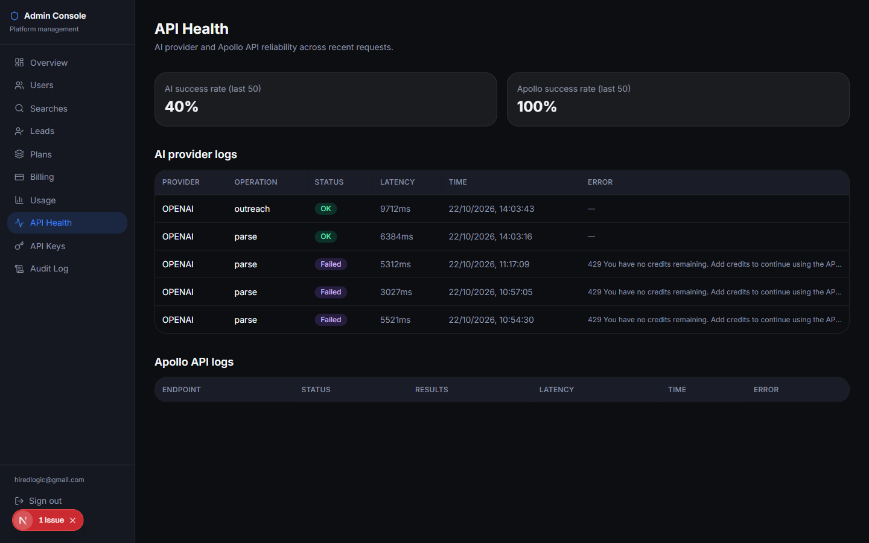
Figure 5. Admin API Health after the run: OpenAI parse and outreach calls succeeded (earlier failures were from before credits were added).

8.4 Files from this run
File | What it is
docs/evidence/search-result.json | Full response of GET /api/searches/{id} with the 10 leads
docs/evidence/export.csv | The CSV export of the batch, as a user would download it
docs/evidence/apollo-A..D.json | Raw Apollo responses for the four direct filter tests (first 25 people each)
docs/LeadPilot-Setup-Verification-Report.docx | The earlier setup and environment verification report

