LeadPilot AI (VARSA)
Local Setup, Environment and Verification Report
Project: versa-main · Stack: Next.js 15, Clerk, Prisma + PostgreSQL, Apollo, OpenAI, Stripe
Date: 22 October 2026
Environment: Windows 11, Node 24.16, Docker Desktop 29.5, PostgreSQL 16 (Docker)
This document records how the application was understood, configured, repaired and verified on a local machine. Every claim is backed by a command output, an API response or a screenshot captured during the verification run.

Contents
1. Executive summary 3
2. What the application is 3
2.1 Stack and responsibilities 3
2.2 Request flow for a search 4
3. Environment verification 5
3.1 Where each value came from 5
3.2 Files written 5
3.3 Prisma CLI reading .env 5
4. Infrastructure and build checks 6
4.1 Database 6
4.2 Typecheck, lint and tests 6
4.3 Dev server boot 6
5. Defects found and fixed 7
6. Verified walkthrough with screenshots 8
6.1 Marketing site (public) 8
6.2 Authentication 9
6.3 Application workspace (signed in) 10
6.4 Admin console (static login from env (1)) 13
7. API outputs captured from the signed-in session 17
8. Open items and recommendations 20
9. How to run it 20

1. Executive summary
The application now installs, boots, authenticates users, completes onboarding, serves the lead-finder dashboard, exposes a working admin console, and passes its full automated test suite. Four defects were found during verification and fixed in source. Two external accounts need attention before AI parsing and paid billing can be exercised.
Area | Result | Evidence
Dependencies (npm install) | PASS | 421 packages installed, prisma client generated
PostgreSQL (Docker, port 5434) | PASS | Container healthy; 7 migrations applied; 4 plans seeded
Environment (.env.local + .env) | VERIFIED | Merged with your env (1) file; see Section 3
TypeScript typecheck | PASS | tsc --noEmit exit 0
Lint (next lint) | PASS | No ESLint warnings or errors on changed files
Unit + integration tests | PASS | 16 files, 151 tests, 0 failures
Clerk authentication | WORKING | Keyless dev instance; sign-up, email code, new-device code, sign-in
Onboarding + dashboard | WORKING | /onboarding -> /app, searches, billing, settings, usage
Admin console (static login) | WORKING | Login with env (1) admin credentials; users, plans, API health
Apollo API key | VERIFIED | GET /v1/auth/health -> healthy: true, is_logged_in: true
OpenAI API key | LIMITED | Key valid but account has no credits (429 credit_balance_exhausted)
AI prompt parsing | FALLBACK | Heuristic parser returns full criteria when AI fails (bug fixed)
Stripe billing | NOT CONFIGURED | Optional locally; BILLING_ENFORCE unset so all users get Starter
Real lead search (Apollo credits) | NOT RUN | Deliberately skipped to avoid spending Apollo credits

2. What the application is
LeadPilot AI, branded VARSA in the interface, is a B2B lead-finder SaaS. A user describes an ideal customer in plain language; the server turns that into Apollo people-search filters, fetches a batch of matching people, unlocks verified emails, scores each lead with an AI model (or a heuristic fallback) and saves them for export.

2.1 Stack and responsibilities
Layer | Technology | Where in the code
Web framework | Next.js 15 App Router, React 19, Tailwind 4 | src/app/**, src/components/**
Authentication | Clerk (@clerk/nextjs 7) | src/middleware.ts, src/components/auth/**, src/lib/auth/**
Database | Prisma 5 + PostgreSQL 16 | prisma/schema.prisma, prisma/migrations, src/lib/db/prisma.ts
Lead data | Apollo.io People Search + enrichment | src/lib/apollo.ts, src/lib/providers/people-data.ts
AI | OpenAI -> Groq -> Gemini -> Claude fallback chain; heuristic parser | src/lib/services/ai/**, src/lib/heuristic-parse.ts
Billing | Stripe subscriptions, usage caps per plan | src/lib/billing/**, src/app/api/stripe/**
Admin | Static email/password login, signed cookie | src/lib/admin/**, src/app/admin/**
Search pipeline | Batch runner with credit holds | src/lib/pipeline/**, src/lib/services/leads/**

2.2 Request flow for a search
- User signs in through Clerk; middleware protects /app and returns 401 JSON for unauthenticated /api calls.
- getCurrentUser() maps the Clerk user to a database User row (created on first visit).
- requireActiveSubscription() ensures a plan; with BILLING_ENFORCE unset it assigns Starter automatically.
- requireOnboardingComplete() forces the four-step ICP onboarding before any search.
- POST /api/leads/find parses the prompt (AI or heuristic), checks for clarifying questions, creates a LeadSearch row and runs the batch in the background.
- runBatch() reserves credits, pages Apollo, verifies candidates, unlocks emails, writes AI reasoning and commits or refunds credits.

3. Environment verification
You supplied a file named env (1) in the project root. It was compared with the .env.local created during setup and with the variables the code actually reads. Secrets are never printed in this document; only their source and status are recorded.

3.1 Where each value came from
Variable | Source used | Verification
DATABASE_URL | Docker Postgres (port 5434), kept | Your env (1) pointed at localhost:5432, which is another project's container (recruiterdemo-postgres-1) and rejected the password. Docker DB on 5434 is migrated and seeded.
ADMIN_EMAIL / ADMIN_PASSWORD | env (1) | POST /api/admin/auth/login -> 200 {success:true}; wrong password -> 401; admin pages render.
ENCRYPTION_KEY | env (1) (35 chars) | Meets the 32-character minimum; admin session cookies signed and accepted.
APOLLO_API_KEY | env (1) (identical to sibling Versa project) | GET https://api.apollo.io/v1/auth/health -> {healthy:true, is_logged_in:true}
OPENAI_API_KEY | env (1) | Key authenticates but returns 429 credit_balance_exhausted. The earlier key from the Versa project has the same problem (same org).
CLERK_SECRET_KEY / NEXT_PUBLIC_CLERK_PUBLISHABLE_KEY | Left empty on purpose | Clerk 7 keyless mode provisioned a dev instance; keys stored in .clerk/.tmp/keyless.json (git-ignored).
NEXT_PUBLIC_CLERK_* URLs | .env.example defaults | /login, /register, /auth/continue redirects observed in the browser run.
STRIPE_* | Empty | Not required: isBillingEnforced() is false, so Starter plan is auto-assigned.
CRON_SECRET | Generated | Required by /api/cron/release-stale; route refuses to run without it.
LEAD_* / APOLLO_* / AI_* tuning | .env.example defaults | Read by apollo-config.ts and pipeline/run.ts; batch size clamps to 10-200.
APIFY_API_TOKEN, APIFY_OPEN_TO_WORK_ACTOR, LEAD_SOURCE_CSV_PATH, PLAYWRIGHT_STORAGE_STATE_PATH | Carried over from env (1), commented | No references anywhere in src/, prisma/, scripts/ or tests/. They belong to an older variant of the app and are ignored by this codebase.

3.2 Files written
File | Purpose
.env.local | Runtime configuration for Next.js (all variables above).
.env | DATABASE_URL only. The Prisma CLI (migrate, seed, studio, and the build script) reads .env, not .env.local. Verified with prisma migrate status without exporting anything.
tests/setup-env.ts | Loads .env and .env.local into every vitest worker so npm test works out of the box.
.clerk/.tmp/keyless.json | Written by Clerk on the first browser visit (temporary dev keys).

3.3 Prisma CLI reading .env
$ npx prisma migrate status
Datasource "db": PostgreSQL database "leadpilot", schema "public" at "localhost:5434"
7 migrations found in prisma/migrations
Database schema is up to date!

4. Infrastructure and build checks

4.1 Database
$ docker compose up -d postgres
PostgreSQL ready after 4s
leadpilot-postgres postgres:16-alpine Up (healthy) 0.0.0.0:5434->5432/tcp

$ npx prisma migrate deploy
20260617214518_init ... 20260824151500_reconcile_leads_returned
All migrations have been successfully applied.

$ npx prisma db seed
Seeded plans: free-trial, starter, pro, agency

$ psql: select slug, "leadsPerMonth" from "Plan";
free-trial|25 starter|500 pro|2500 agency|10000

4.2 Typecheck, lint and tests
$ npx tsc --noEmit -> exit 0
$ npx next lint --file ... -> No ESLint warnings or errors
$ npm test (vitest run)
Test Files 16 passed (16)
Tests 151 passed (151)
Duration 8.41s

Before the test-env fix, two database-backed test files failed with "Environment variable not found: DATABASE_URL" because vitest does not load .env.local and Next's own loader skips .env.local when NODE_ENV=test. The setup file in tests/setup-env.ts resolves this.

4.3 Dev server boot
$ npx next dev -p 3000
Next.js 15.5.19 - Local: http://localhost:3000
Environments: .env.local, .env
Ready in 15.2s
GET / -> 200
GET /app -> redirect to /login?redirect_url=... (unauthenticated)
GET /api/searches-> 401 {"error":"Unauthorized"} (unauthenticated)

5. Defects found and fixed
Each defect was reproduced in the running app, fixed in source, and re-verified. No behaviour outside the described paths was changed.
# | File | Problem observed | Fix applied
1 | src/lib/auth/get-current-user.ts | Right after sign-up, /auth/continue, the app layout and API calls ran concurrently; each saw no User row and called prisma.user.create(). The second insert failed with P2002 unique constraint on clerkId and the page crashed with a server-side exception. | Catch P2002 and re-read the row by clerkId. Creation is now idempotent.
2 | src/components/auth/LoginForm.tsx | Clerk's new-device check returns status needs_client_trust after a correct password. The form only handled 'complete', so every sign-in from a new browser showed 'Invalid email or password'. Captured from the Clerk API: first_factor_verification.status = verified, status = needs_client_trust. | Added a second step: prepareSecondFactor({strategy:'email_code'}), a code input, attemptSecondFactor, then setActive. Resend and back actions included.
3 | src/lib/services/ai/aiRouter.ts | When every AI provider failed, the router threw the raw provider message (e.g. '429 You have no credits remaining'). parsePrompt.ts and pipeline/api.ts only fall back to the heuristic parser when the message contains 'All AI providers failed', so searches hard-failed with HTTP 500. | Throw 'All AI providers failed: <last error>'. Verified: POST /api/ai/parse-prompt now returns 200 with provider HEURISTIC, parseMode all_ai_providers_failed.
4 | vitest.config.ts, tests/setup-env.ts | Two DB-backed test files could not see DATABASE_URL under vitest. | Setup file parses .env and .env.local into process.env for each worker. 151/151 tests pass with plain npm test.

6. Verified walkthrough with screenshots
The screenshots below were captured by an automated Chromium session against http://localhost:3000 after the fixes. The test account is leadpilot2+clerk_test@example.com (Clerk's test-email convention, verification code 424242).

6.1 Marketing site (public)

Figure 1. Landing page, GET / -> 200. Public routes are allowed by the middleware without a session.
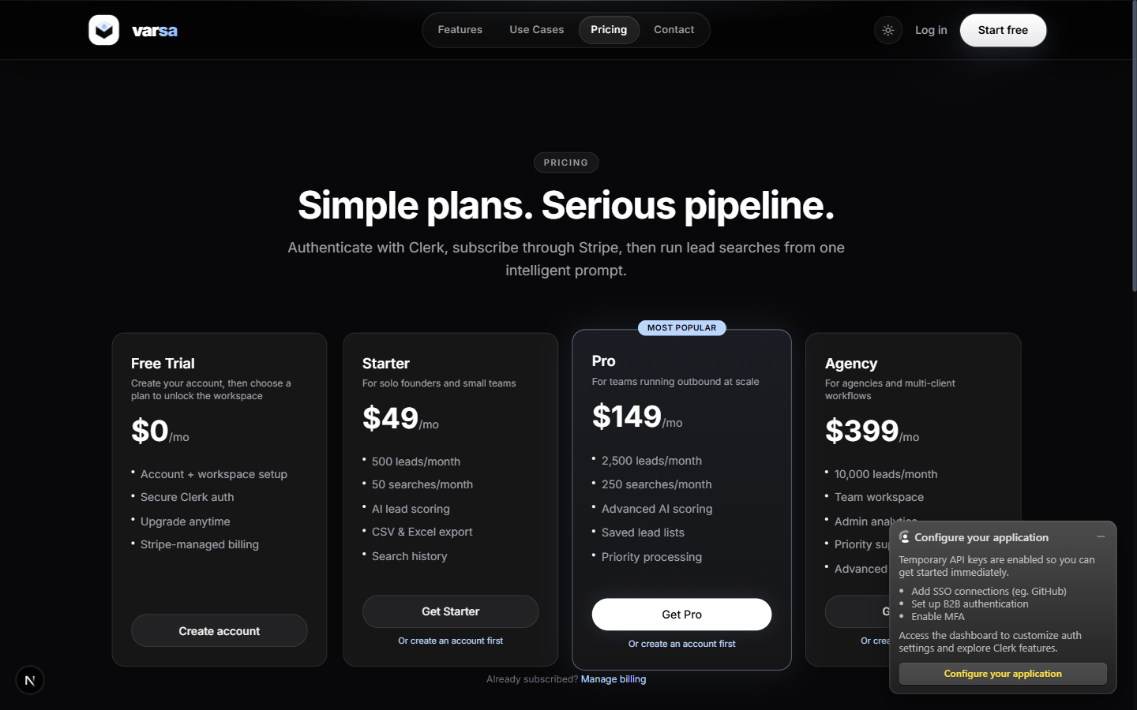
Figure 2. Pricing page, GET /pricing -> 200. Plans mirror the seeded Plan table.

6.2 Authentication
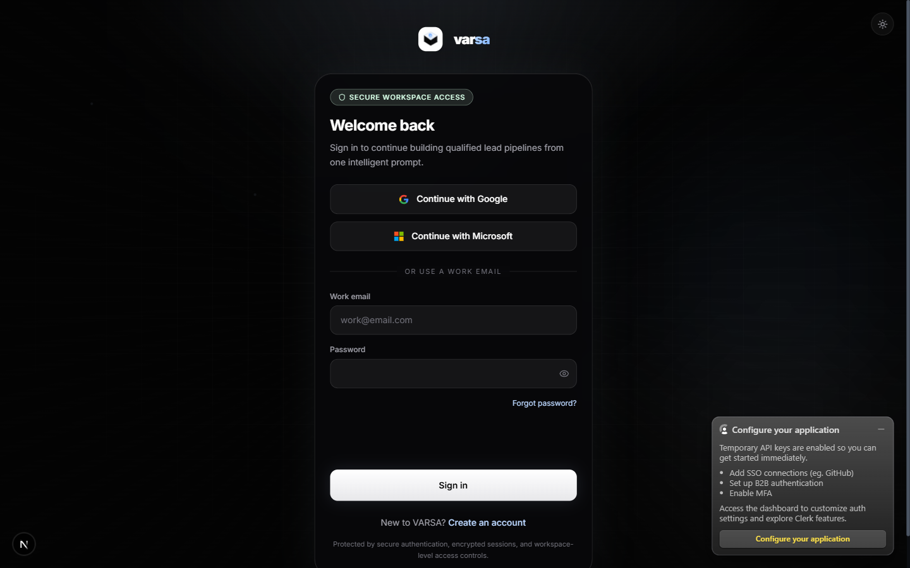
Figure 3. Login page. The 'Configure your application' panel is Clerk's keyless-mode prompt; it disappears once real keys are set.
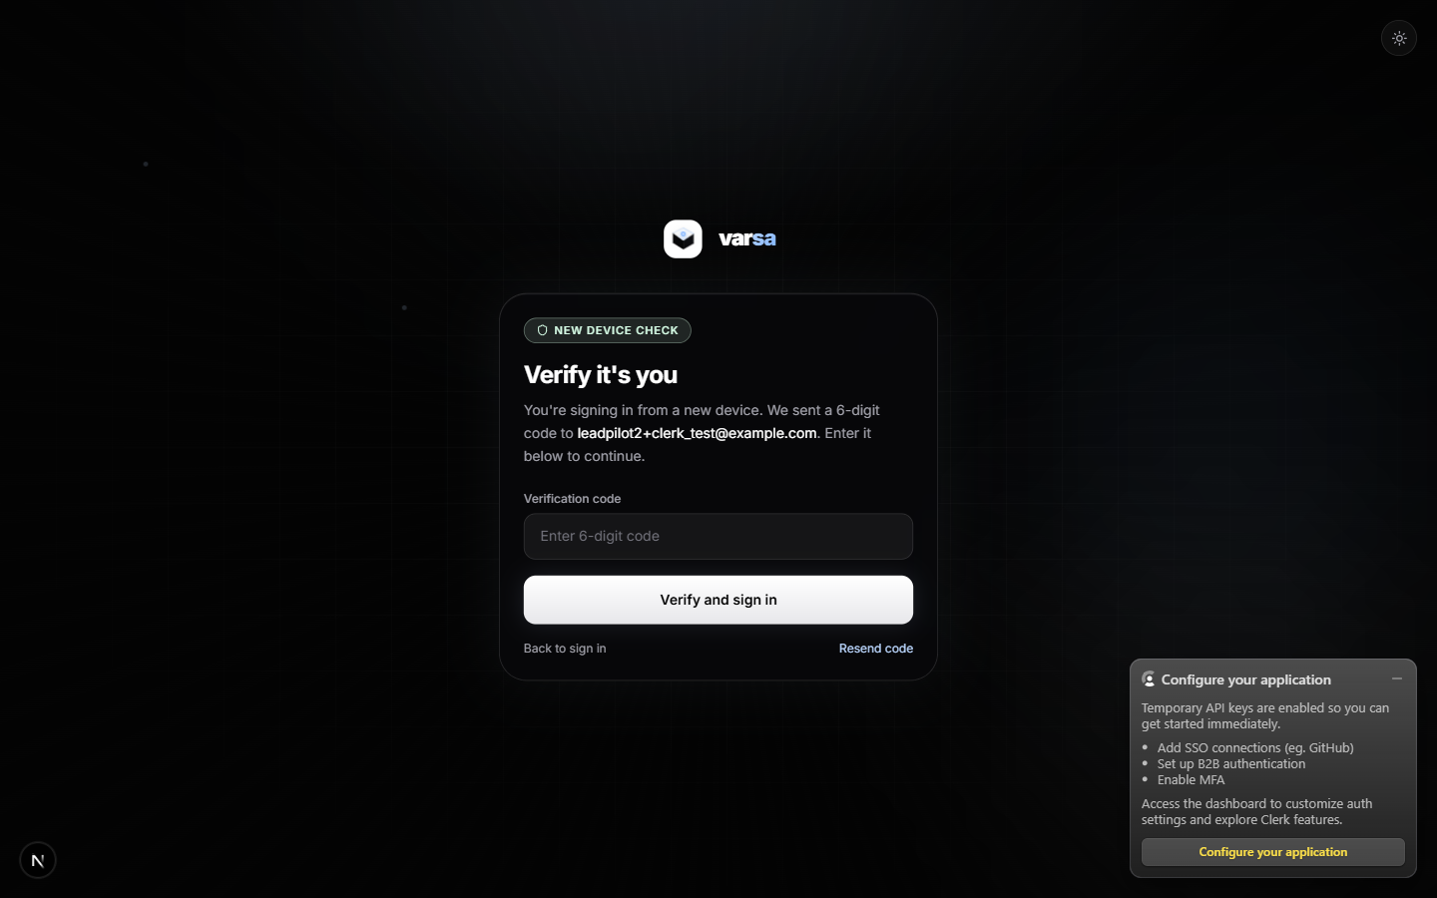
Figure 4. New-device verification step added by fix #2. Clerk returned needs_client_trust after the password was verified.
Sign-up was also exercised end to end: register form -> email code -> /auth/continue -> /onboarding. Clerk's Cloudflare Turnstile blocks headless browsers, so the run used a visible Chromium window; this does not affect real users.

6.3 Application workspace (signed in)
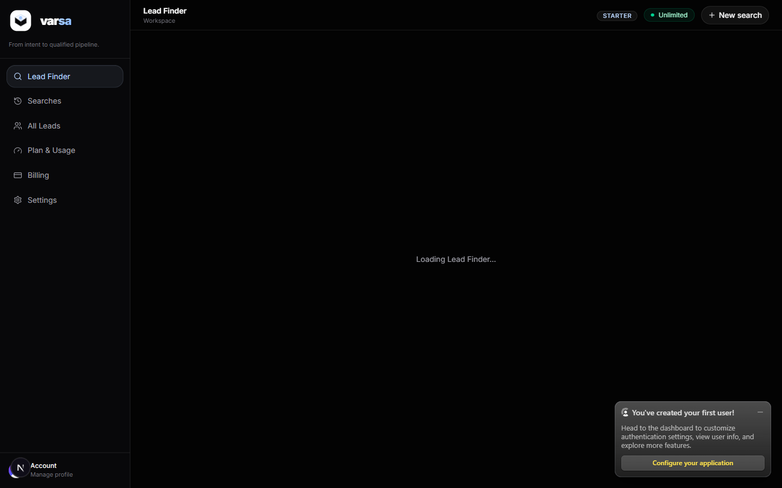
Figure 5. /app Lead Finder dashboard after onboarding. Plan badge shows STARTER / Unlimited because billing enforcement is off locally.
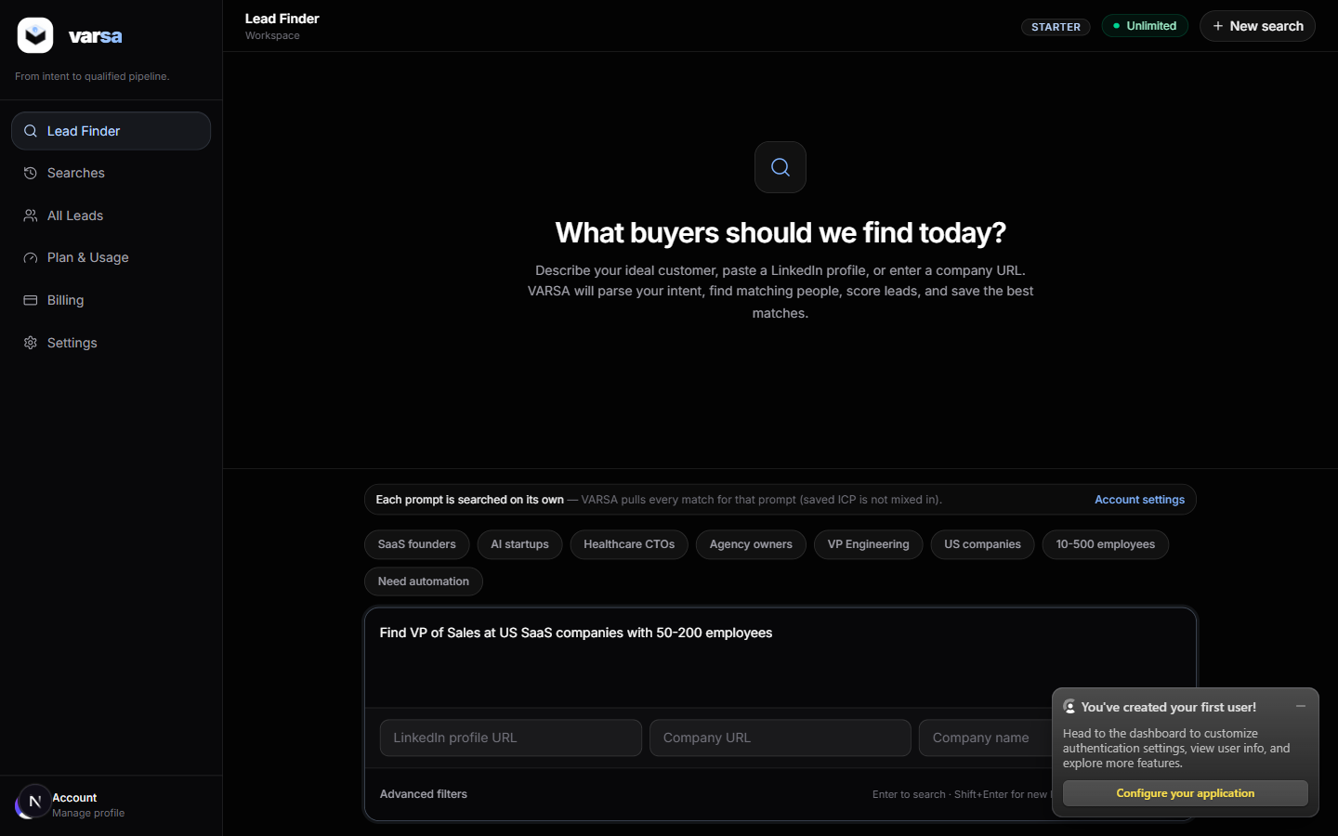
Figure 6. Prompt composer with a sample request typed. The search itself was not submitted to avoid spending Apollo credits.
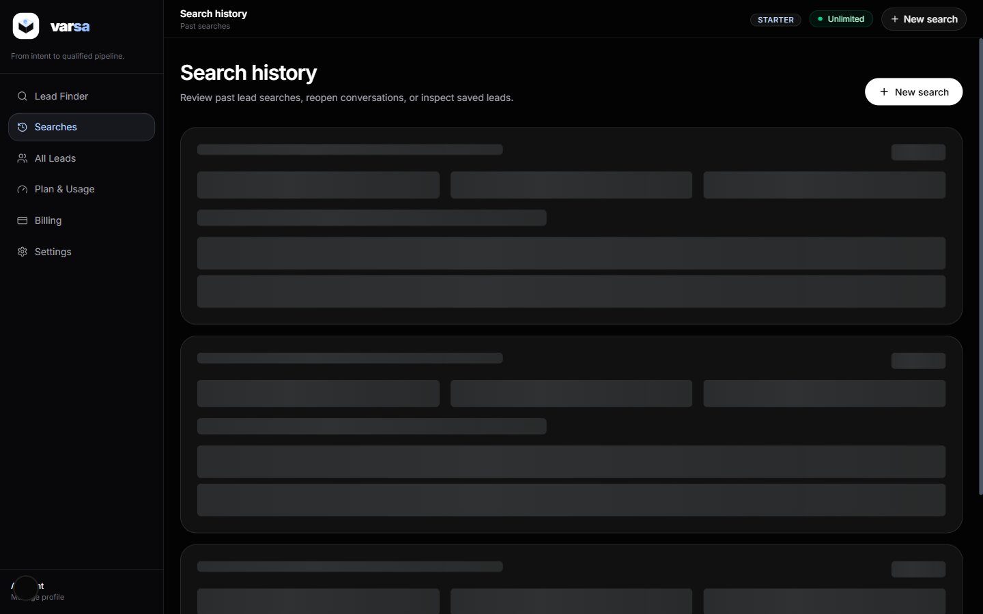
Figure 7. /app/searches history page (empty, no searches run).
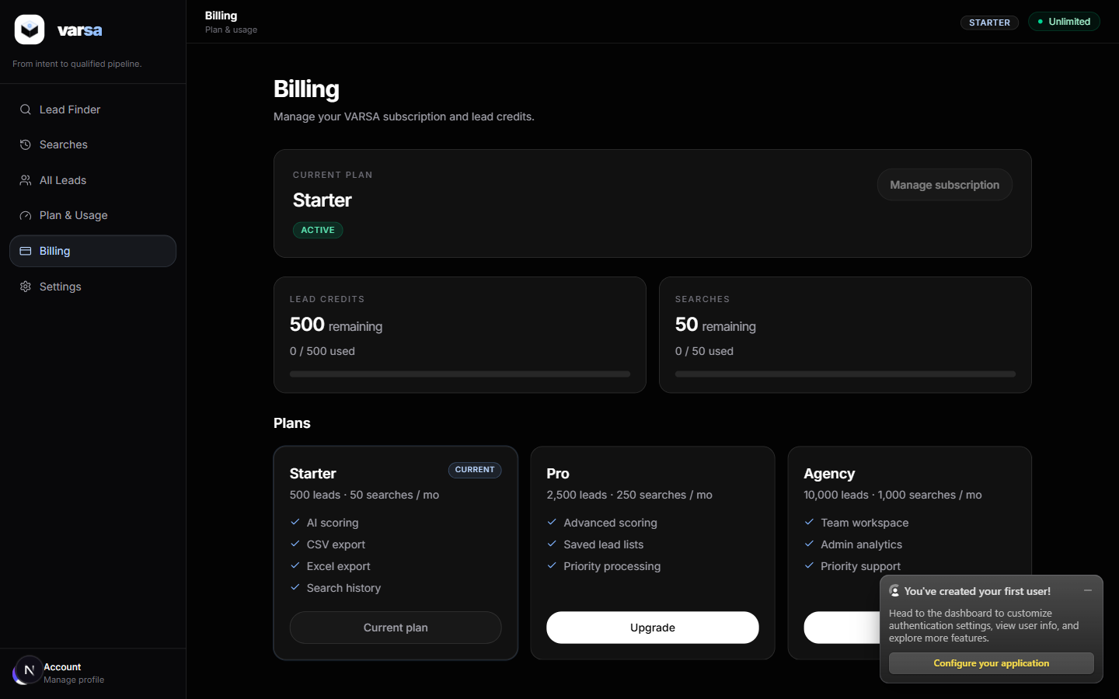
Figure 8. /app/billing. Starter plan, 500 lead credits, 50 searches; Stripe not configured.
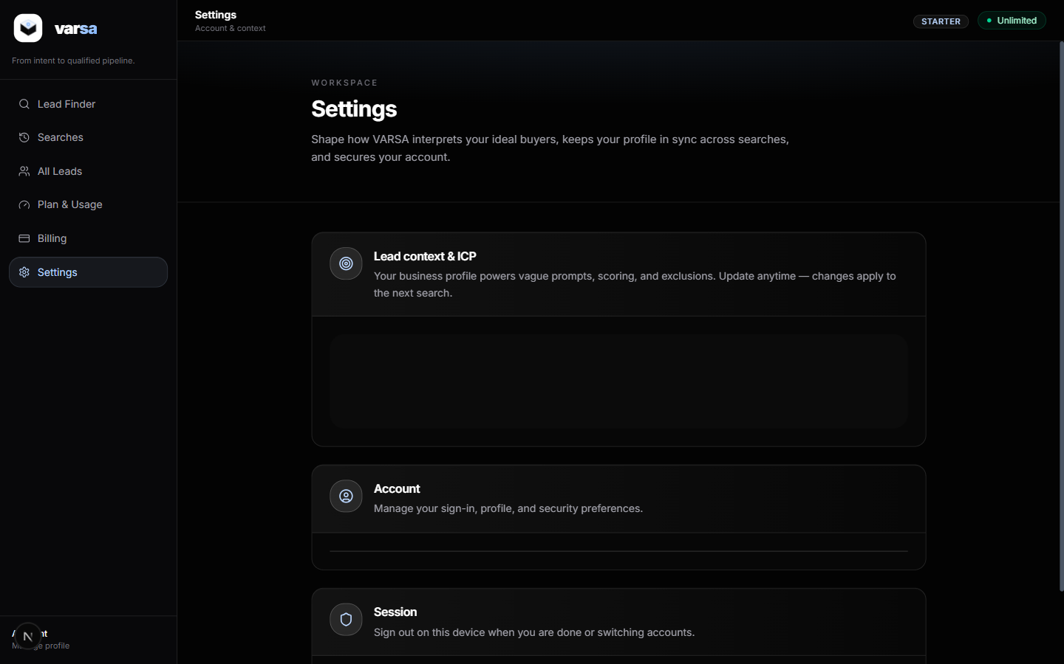
Figure 9. /app/settings: saved ICP context from onboarding.
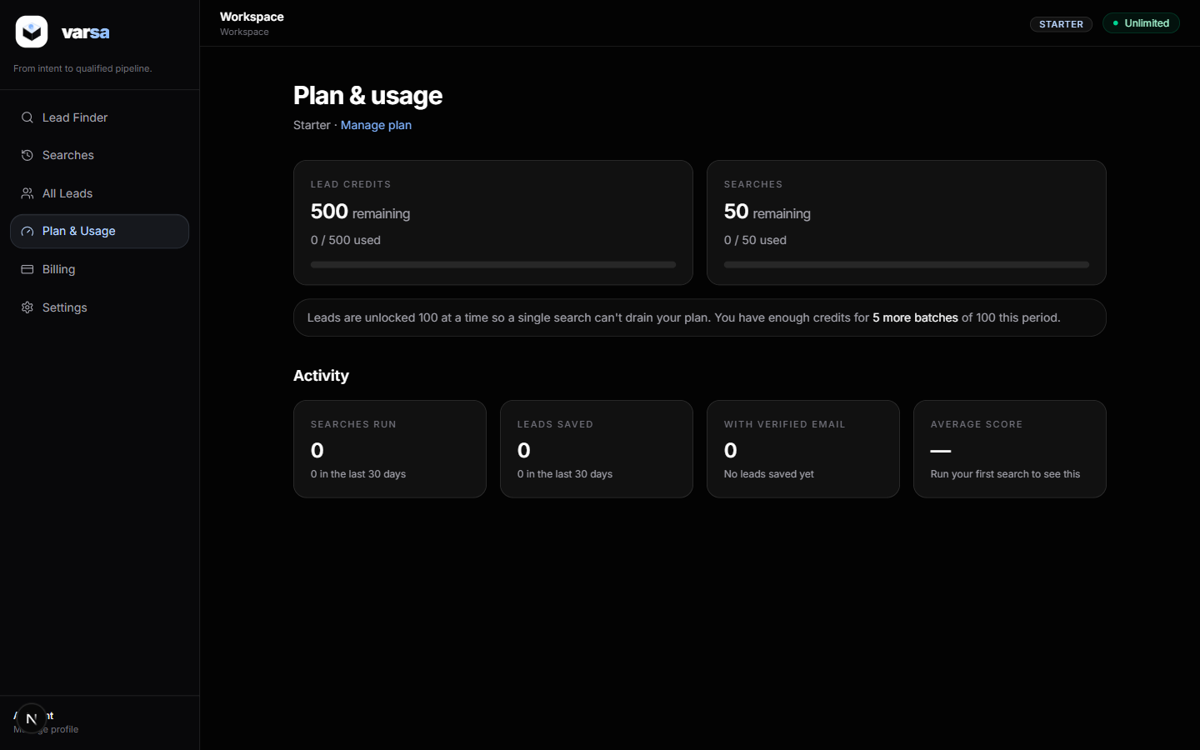
Figure 10. /app/usage: monthly usage meter from UsageRecord.

6.4 Admin console (static login from env (1))
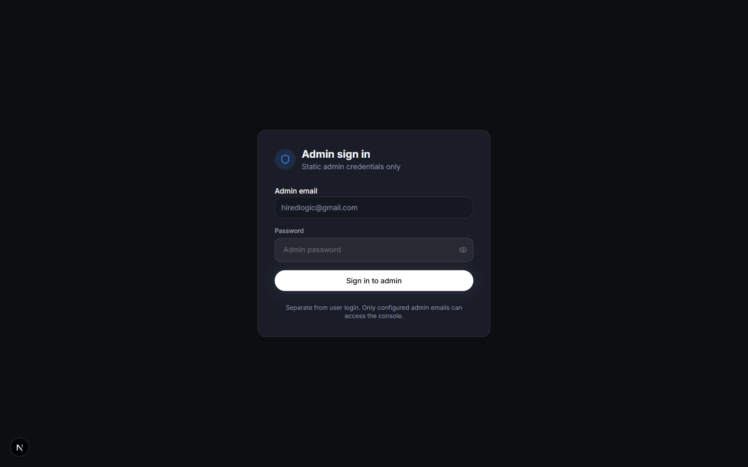
Figure 11. /admin/login. Separate from Clerk; validates ADMIN_EMAIL + ADMIN_PASSWORD and sets an HMAC-signed cookie using ENCRYPTION_KEY.
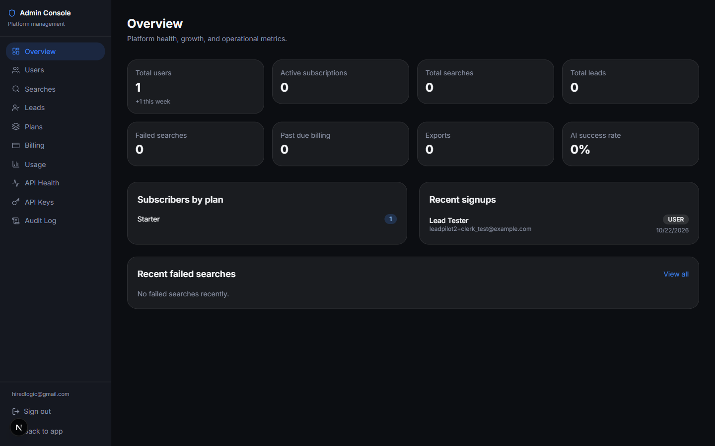
Figure 12. /admin overview: 1 user, 1 Starter subscriber, recent signup listed.
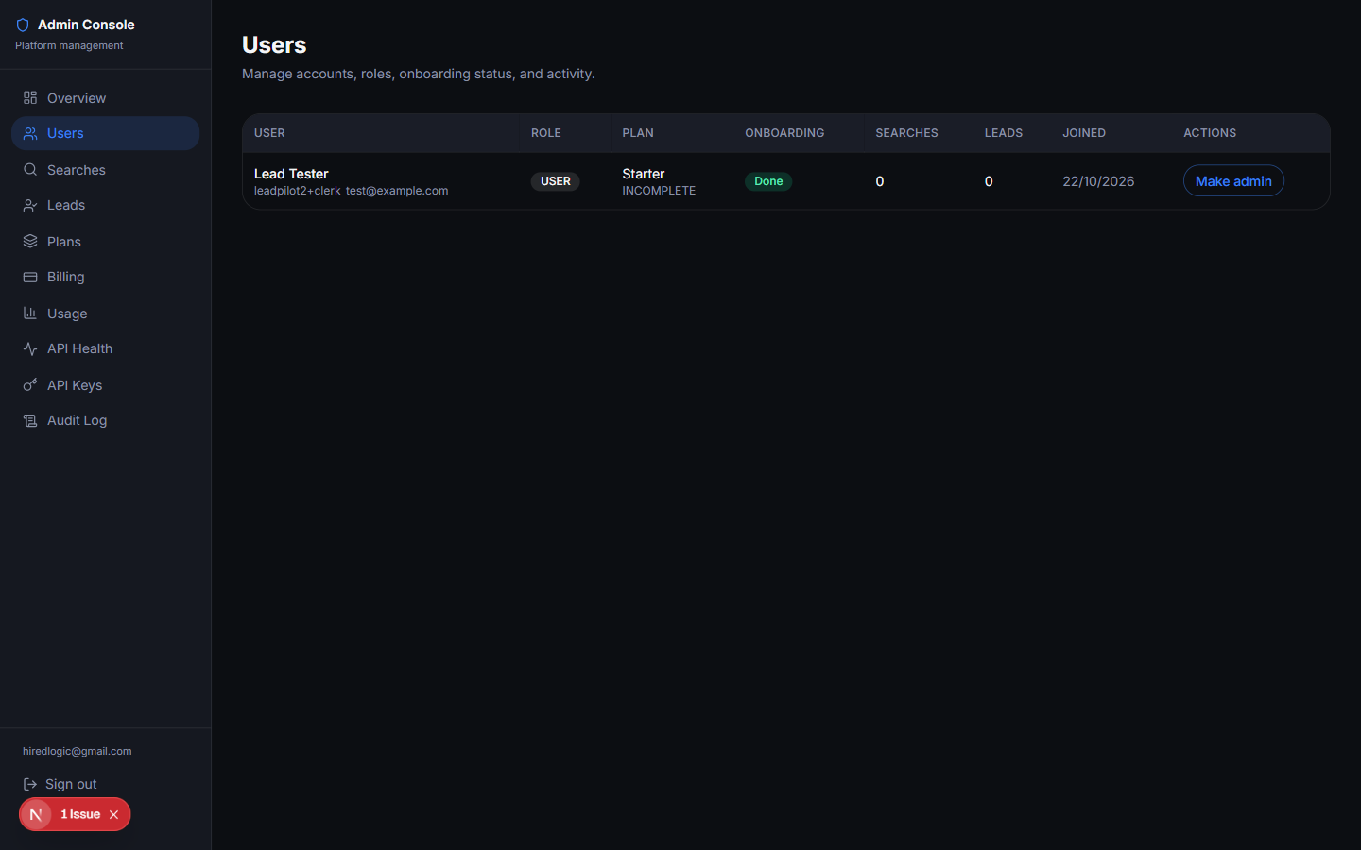
Figure 13. /admin/users: the test user created through Clerk sign-up and synced by getCurrentUser().
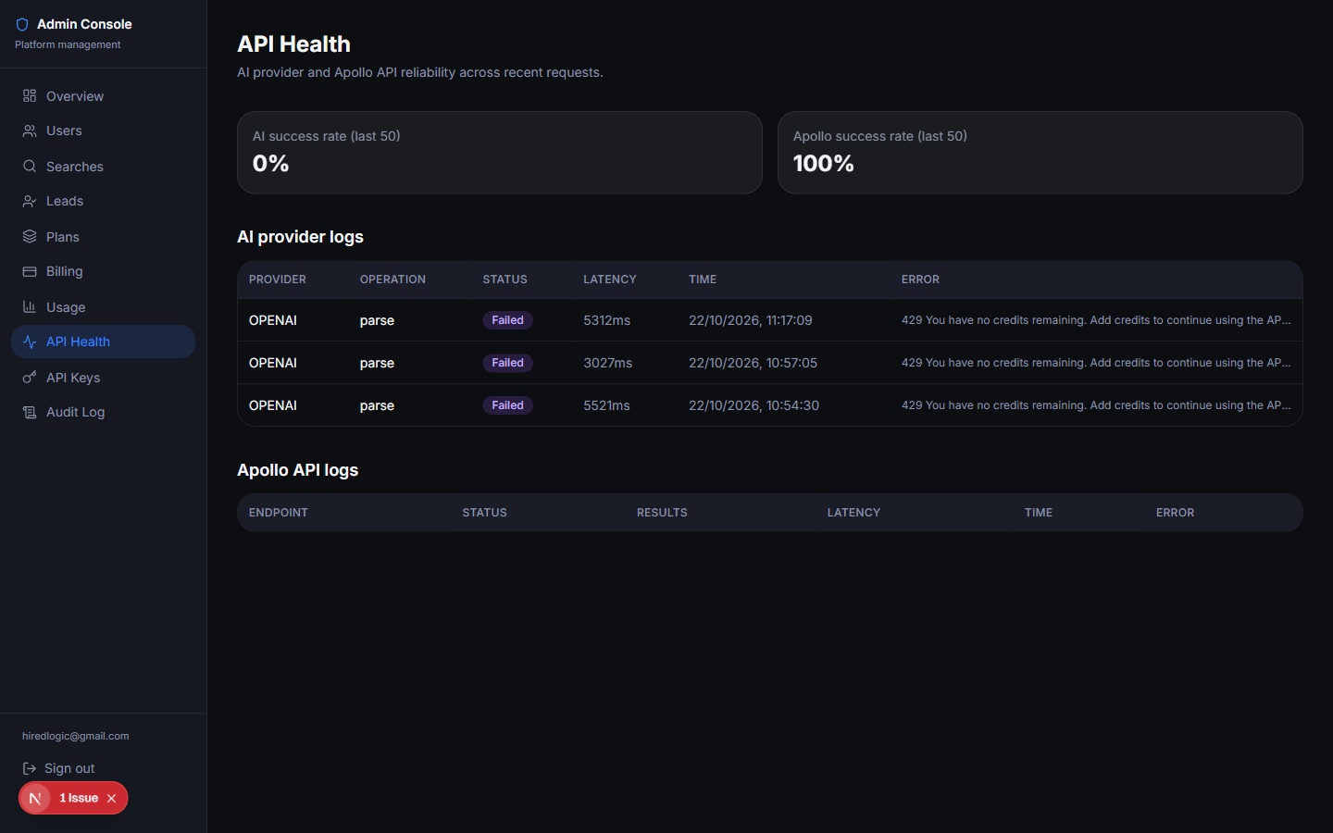
Figure 14. /admin/api-health: OpenAI parse attempts logged as failed (no credits). Apollo success rate 100% (health check only).
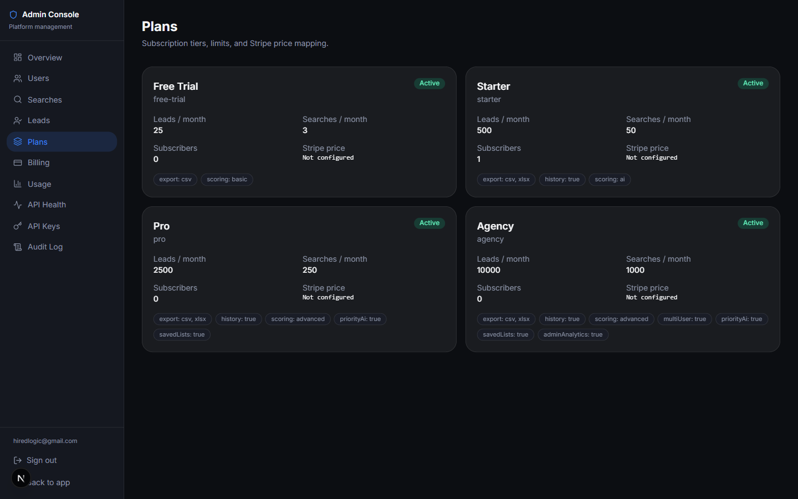
Figure 15. /admin/plans: the four seeded plans.

7. API outputs captured from the signed-in session

GET /api/billing/status -> HTTP 200
Subscription snapshot. status INCOMPLETE is the placeholder row created by ensureDefaultPlanSubscription(); hasActiveSubscription is true because billing is not enforced.
{
"isAuthenticated": true,
"hasActiveSubscription": true,
"isActive": true,
"status": "INCOMPLETE",
"subscriptionStatus": "INCOMPLETE",
"planName": "Starter",
"planSlug": "starter",
"displayPlanName": "Starter",
"cancelAtPeriodEnd": false,
"currentPeriodStart": null,
"currentPeriodEnd": null,
"stripeCustomerId": null,
"usage": {
"periodKey": "2026-10",
"periodStart": "2026-10-01T04:00:00.000Z",
"periodEnd": "2026-11-01T03:59:59.999Z",
"leadsUsed": 0,
"leadsLimit": 500,
"leadsRemaining": 500,
"searchesUsed": 0,
"searchesLimit": 50,
"searchesRemaining": 50,
"leadsPercent": 0,
"searchesPercent": 0,
"usageExceededPlan": false
},
"availablePlans": [
{
"key": "starter",
"name": "Starter",
"monthlyLeads": 500,
"monthlySearches": 50,
"features": [
... (truncated)

GET /api/billing/usage -> HTTP 200
Usage meter used by the sidebar badge.
{
"plan": "Starter",
"leadsUsed": 0,
"leadsLimit": 500,
"searchesUsed": 0,
"searchesLimit": 50,
"leadsRemaining": 500,
"searchesRemaining": 50,
"usageExceededPlan": false,
"billingEnforced": false
}

GET /api/searches -> HTTP 200
Search history; empty because no search was run.
{
"searches": []
}

GET /api/onboarding/context -> HTTP 200
The ICP saved through POST /api/onboarding/context during the run (onboardingCompleted: true).
{
"context": {
"id": "cmvjnta1w000aw6pt4i12vyd4",
"userId": "cmvjn6hu40000w6pto6dnch1k",
"companyName": "Acme Outbound",
"websiteUrl": "https://acme.example.com",
"businessDescription": "We sell outbound sales automation software to B2B SaaS companies.",
"targetMarket": "B2B SaaS",
"mainOffer": "Outbound automation platform",
"targetIndustries": [
"Software"
],
"targetCountries": [
"United States"
],
"companySizeMin": 11,
"companySizeMax": 200,
"targetTitles": [
"Head of Sales",
"VP Sales"
],
"targetSeniorities": [],
"excludedIndustries": [],
"excludedTitles": [],
"preferredBuyingSignals": [],
"highQualityLeadNotes": null,
"badLeadNotes": null,
"preferredOutreachAngle": null,
"servicesToSell": [
"Outbound automation"
],
"minLeadScore": 7,
"onboardingCompleted": true,
"createdAt": "2026-10-22T14:51:57.045Z",
... (truncated)

POST /api/ai/parse-prompt -> HTTP 200
Prompt -> structured criteria. provider HEURISTIC and parseMode all_ai_providers_failed show fix #3 working while OpenAI has no credits.
{
"criteria": {
"industry": "SaaS",
"country": "United States",
"companySizeMin": 50,
"companySizeMax": 200,
"jobTitles": [
"VP",
"Vice President",
"Sales Director",
"VP Sales",
"Head of Sales"
],
"keywords": "SaaS",
"summary": "Find VP of Sales at US SaaS companies with 50-200 employees",
"searchIntent": "Find VP of Sales at US SaaS companies with 50-200 employees",
"openToWork": false,
"requireEmail": false,
"apollo": {
"personTitles": [
"VP",
"Vice President",
"Sales Director",
"VP Sales",
"Head of Sales"
],
"personLocations": [
"United States"
],
"qKeywords": "SaaS",
"employeeRanges": [
"11,50",
"51,200"
],
... (truncated)

GET /api/settings -> HTTP 404
Intentional 404: API key management is server-side only (see route comment).
{
"error": "API key management is not available in the app."
}

Admin API (cookie session)
POST /api/admin/auth/login {email, password} -> 200 {"success":true}
POST /api/admin/auth/login (wrong password) -> 401
GET /api/admin/users -> 200 {"users":[{"email":"leadpilot2+clerk_test@example.com","role":"USER",...}]}
GET /api/admin/api-health -> 200 {"ai":[{"provider":"OPENAI","operation":"parse","success":false,"errorMessage":"429 You have no credits remaining..."}], ...}

External provider checks
GET https://api.apollo.io/v1/auth/health (x-api-key) -> 200 {"healthy":true,"is_logged_in":true}
POST https://api.openai.com/v1/chat/completions (env (1) key)
-> {"error":{"type":"insufficient_quota","code":"credit_balance_exhausted", ...}}

8. Open items and recommendations
- OpenAI credits. Both available keys belong to an account with no credits. Add credits, or set GROQ_API_KEY (free tier) in .env.local; the router falls through OpenAI -> Groq -> Gemini -> Claude automatically. Until then, prompt parsing and lead scoring use the heuristic fallback.
- Clerk keys. Keyless mode is for development only. Click 'Configure your application' in the app to claim the instance, then paste CLERK_SECRET_KEY and NEXT_PUBLIC_CLERK_PUBLISHABLE_KEY into .env.local. Production also needs the Clerk webhook at /api/webhooks/clerk.
- Stripe. Not needed locally. For paid gating set the STRIPE_* variables, BILLING_ENFORCE=true and NEXT_PUBLIC_BILLING_ENFORCE=true, and point the Stripe webhook at /api/stripe/webhook.
- Real lead search. Everything up to POST /api/leads/find was verified. Submitting a search will spend Apollo credits (one batch = up to LEAD_BATCH_SIZE people), so it was left for you to trigger.
- Test data. A test user (leadpilot2+clerk_test@example.com) and its ICP context exist in the local database and in the keyless Clerk instance. Remove them when no longer useful.
- Unused variables. APIFY_*, LEAD_SOURCE_CSV_PATH and PLAYWRIGHT_STORAGE_STATE_PATH from env (1) are not read by this codebase and can be deleted from .env.local.

9. How to run it
# 1. Start Docker Desktop, then:
docker compose up -d postgres
# 2. First time only (already done on this machine):
npm install && npx prisma migrate deploy && npx prisma db seed
# 3. Run
npm run dev
# 4. Open http://localhost:3000/login in a normal browser
# Admin console: http://localhost:3000/admin/login (ADMIN_EMAIL / ADMIN_PASSWORD from .env.local)
# 5. Tests
npm test

Related files: README.md (updated with a 'Local auth without Clerk keys' section), .env.example, docker-compose.yml, docs/ARCHITECTURE.md, docs/SRS.md.

