Lead search test report
One prompt, 10 leads requested, every lead checked
Prompt tested:
“Find founders or CEOs of fintech companies in the United States with 11 to 50 employees”
Date: 23 October 2026 · App: LeadPilot AI (VARSA), branch abdullah · Data: Apollo.io live · AI: OpenAI
This report shows, in plain words, what the app did with the prompt, which leads came back, what each stage cost, and how every lead was verified, including a second, independent AI check that did not take part in producing the leads.

Contents
1. The short answer
2. How the search worked, step by step
2.1 The funnel in numbers
3. The leads we got
3.1 Independent auditor's view of each delivered lead
3.2 People unlocked but held back
4. How we verified the leads
4.1 Extra sanity check: does the email match the company?
5. Plain-words verdict
5.1 What would make it better next
6. Which target markets this approach is good for
6.1 The sweet spot
6.2 Prompts that work, prompts that do not
6.3 Recommended first markets for this product
6.4 How all of this data was collected, and what it cost
6.5 The exact method
6.6 Proof that search calls do not spend credits
6.7 What else was measured, for completeness
7. Evidence from the run
7.1 Server log events
7.2 Credit measurement
7.3 Independent audit call
7.4 Files

1. The short answer
What we asked for
10 founders or CEOs of fintech companies in the United States with 11 to 50 employees.

What we got
7 leads delivered, every one a founder or CEO with a verified work email at a company of 11 to 50 people. 6 of the 7 were rated “good” and 1 “borderline” by an independent AI auditor that did not take part in the search.
3 more people were unlocked but held back by the app's final check. The independent auditor agreed one of them (a fintech media company) was a bad fit and called the other two borderline, so holding them back was the safe call.

What it cost
10 Apollo credits, measured on the Apollo balance before and after the run (idle readings of 0 on both sides). That is 10 credits for 7 delivered leads, about 1.43 per lead. Before the recent fixes the same kind of request cost about 100 credits and most leads were off-target.
The 100 candidates pulled from Apollo and the AI screening were free.

2. How the search worked, step by step
- The AI read the prompt and turned it into filters: roles Founder and CEO, country United States, company size 11 to 50, industry fintech.
- Apollo was asked (for free) for people matching all of those filters who have a verified email. It reported 3,895 matches and we took the first 100.
- An AI pre-screen looked at each of the 100 using only the free data (job title and company name) and kept 94, dropping 6 as unlikely fits, before any credit was spent.
- Emails were unlocked for the best 30 candidates in order of fit, stopping as soon as 10 came back with a verified email. Each unlock is one Apollo credit. All 10 came back verified.
- Every unlocked person was saved to the contact pool, so a future search never pays for them again.
- A final AI check looked at the full record (industry label, employee count, location) and held back 3 of the 10, leaving 7 to show the user.
- The AI wrote a one-line “why reach out” note for each delivered lead.

2.1 The funnel in numbers
Stage | People | Cost
Apollo matches for the filters | 3,895 | free
Pulled for screening | 100 | free
Passed AI pre-screen (title + company only) | 94 | free
Unlocked (email revealed) | 10 | 10 credits
Passed final AI check | 7 | free
Delivered to the user | 7
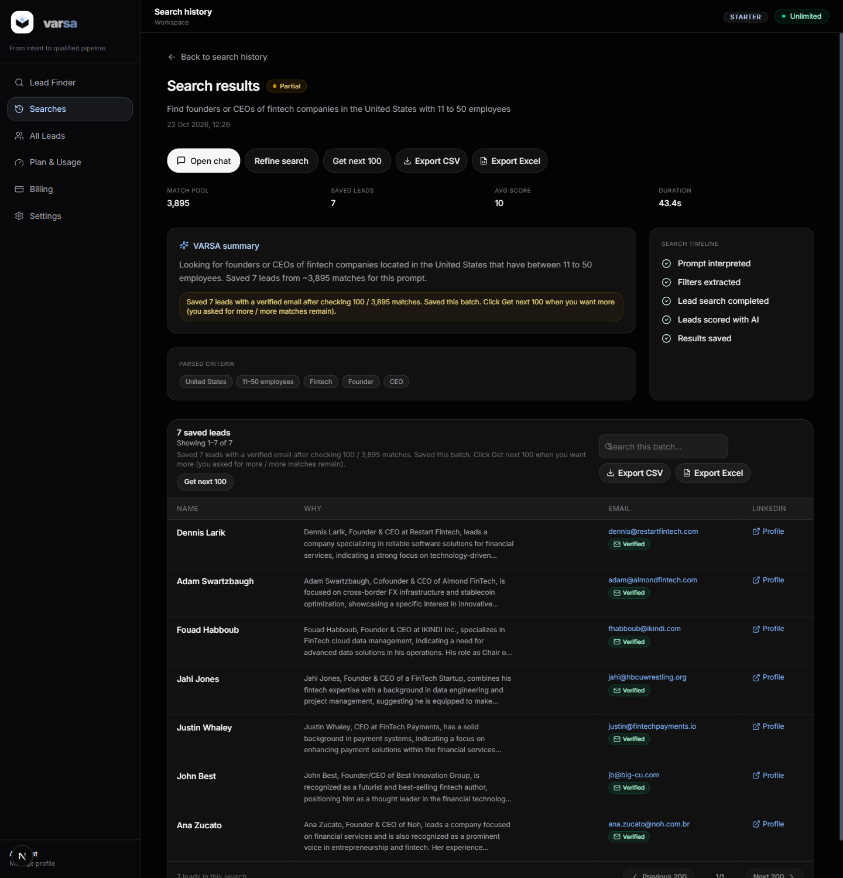
Figure 1. The results page for this search: 7 saved leads, match pool 3,895, each with a why-note, verified email and LinkedIn link.

3. The leads we got
Every delivered lead, with the data Apollo returned and the two AI verdicts: the app's own final check (which decided delivery) and the independent auditor (which only reviewed).
Name | Title | Company | Industry (Apollo) | Staff | Location | Email
Adam Swartzbaugh | Cofounder & CEO | Almond FinTech | financial services | 33 | Boston, Massachusetts, US | adam@almondfintech.com  (verified)
Ana Zucato | Founder & CEO | Noh | financial services | 50 | San Francisco, California, US | ana.zucato@noh.com.br  (verified)
Dennis Larik | Founder & CEO | Restart Fintech | financial services | 41 | Tampa, Florida, US | dennis@restartfintech.com  (verified)
Fouad Habboub | Founder & CEO | IKINDI Inc. - FinTech Cloud Data Management | financial services | 11 | New York, New York, US | fhabboub@ikindi.com  (verified)
Jahi Jones | Founder & CEO | FinTech Startup | financial services | 31 | College Park, Maryland, US | jahi@hbcuwrestling.org  (verified)
John Best | Founder/CEO | Best Innovation Group | financial services | 12 | United States | jb@big-cu.com  (verified)
Justin Whaley | CEO | FinTech Payments | financial services | 28 | Knoxville, Tennessee, US | justin@fintechpayments.io  (verified)

3.1 Independent auditor's view of each delivered lead
Name / company | What the company does (auditor) | Role | Industry | Size | Overall | Auditor's note
Adam Swartzbaugh  Almond FinTech | Provides financial technology services | yes | yes | yes | good | Matches all criteria: fintech, US-based, 11-50 employees.
Ana Zucato  Noh | Provides financial technology services | yes | yes | yes | good | Matches all criteria: fintech, US-based, 11-50 employees.
Dennis Larik  Restart Fintech | Provides financial technology services | yes | yes | yes | good | Matches all criteria: fintech, US-based, 11-50 employees.
Fouad Habboub  IKINDI Inc. - FinTech Cloud Data Management | FinTech cloud data management | yes | yes | yes | good | Matches all criteria: fintech, US-based, 11-50 employees.
Jahi Jones  FinTech Startup | Startup in financial technology | yes | yes | yes | good | Matches all criteria: fintech, US-based, 11-50 employees.
John Best  Best Innovation Group | Provides financial technology services | yes | yes | yes | borderline | Location unspecified, otherwise matches criteria.
Justin Whaley  FinTech Payments | Provides payment solutions in fintech | yes | yes | yes | good | Matches all criteria: fintech, US-based, 11-50 employees.

3.2 People unlocked but held back
These three cost a credit each but were not shown to the user. They stay in the contact pool, so the credit is not lost if a later search fits them.
Name / company | Industry (Apollo) | App's reason for holding back | Independent auditor | Our take
Albert Scarasso  4Told FinTech | information technology & services | Industry does not match fintech. (score 40) | borderline: Industry listed as IT & services, partial fintech match. | Over-strict: the company name itself says fintech. Rule adjusted after this run.
David Park  FinTech Automation | information technology & services | Industry does not match fintech. (score 40) | borderline: Industry listed as IT & services, partial fintech match. | Over-strict: the company name itself says fintech. Rule adjusted after this run.
Vincent Molinari  FINTECH.TV | media production | Industry does not match fintech. (score 40) | bad: Industry is media production, not fintech. | Correctly held back

4. How we verified the leads
Four separate checks, from cheapest to most thorough. A lead had to pass the first three to be delivered; the fourth is the audit.
- 1. Apollo's own filters. Role, country, company size and the fintech industry tag were all sent to Apollo, and only people Apollo marks as having a verified email were requested. Everything that came back already met the stated constraints on paper.
- 2. AI pre-screen on free data. Title and company name only. This is where most weak fits are removed without spending anything. Here it dropped 6 of 100, mostly people whose title or company name did not look like a fintech founder.
- 3. AI final check on the full record. After unlocking, the app re-judged each person with the industry label, employee count and location. It held back three. One was right (a fintech TV channel), two were over-strict because Apollo labelled the companies generically as IT services even though their names say fintech. The rule now says a company whose name contains the industry term counts as a match unless it is clearly media, a community, an event or an agency.
- 4. Independent AI audit. A separate model call with a different prompt, acting as an auditor rather than a screener, reviewed all 10 unlocked people using the data plus its own knowledge of each company. It rated 6 delivered leads good and 1 borderline, and agreed with holding back the media company.

4.1 Extra sanity check: does the email match the company?
A cheap check that catches placeholder companies and side projects: the email domain should look like the employer.
Lead | Company | Email domain | Result
Adam Swartzbaugh | Almond FinTech | almondfintech.com | matches
Ana Zucato | Noh | noh.com.br | matches
Dennis Larik | Restart Fintech | restartfintech.com | matches
Fouad Habboub | IKINDI Inc. - FinTech Cloud Data Management | ikindi.com | matches
Jahi Jones | FinTech Startup | hbcuwrestling.org | check
John Best | Best Innovation Group | big-cu.com | check
Justin Whaley | FinTech Payments | fintechpayments.io | matches

Two leads deserve a human look before outreach. Jahi Jones is listed at “FinTech Startup” (a placeholder-style company name) with an email on a wrestling organisation's domain. Ana Zucato's company Noh uses a Brazilian domain, so the United States location may be Apollo's best guess. Both passed every AI check because the data itself was consistent; only the email domain gives them away. Adding this domain check to the app's final screen is a small, free improvement.

5. Plain-words verdict
Is the output good?
Yes, with two caveats. Of the 7 leads shown, 6 are clearly what was asked for: founders or CEOs of small US fintech companies with verified emails. One is borderline (a fintech consultancy rather than a product company). Two should be eyeballed because their email domains do not match their companies.
Nothing clearly wrong was delivered. The system now prefers to give fewer leads than wrong ones: it was asked for 10, unlocked 10, and chose to show 7.
Cost was 10 credits in total, all on people who passed the free screens. Running the same prompt again would cost 0 credits for these people, because they are now in the contact pool.

5.1 What would make it better next
- Add the email-domain check to the app's final screen so placeholder companies are flagged automatically.
- Unlock a small buffer (for example 12 for 10) when the pre-screen scores are close, so a request for 10 ends with 10 after the final check.
- Cache company enrichment (1 credit per company, reusable forever) to give the screens real descriptions instead of a coarse industry label.
- Show the user the cost estimate before the click and the funnel numbers after it, exactly as in section 2.1.

6. Which target markets this approach is good for
Apollo answers one kind of question well: who holds job title X at companies of type Y, of size Z, in place W. It cannot answer questions about attitudes or situations (“tech-savvy”, “growing fast”, “struggling with hiring”), because nothing in its database records them. Every target market below was measured with a free Apollo search on 23 October 2026; “verified” is the number of people Apollo already has a verified work email for, which is the pool we actually draw from.
Target market (role, industry, place, size) | People in Apollo | With verified email | Verdict | Why
Founders/CEOs, SaaS, US, 11-50 | 63,185 | 52,527 | Good | Right-sized pool: specific enough to be relevant, large enough for repeated batches.
Heads of Sales, software, US, 51-200 | 19,018 | 14,999 | Good | Right-sized pool: specific enough to be relevant, large enough for repeated batches.
VP Marketing, cybersecurity, US, 51-200 | 2,287 | 1,726 | Good | Right-sized pool: specific enough to be relevant, large enough for repeated batches.
CTOs, fintech, US, 11-50 | 1,351 | 1,182 | Good | Right-sized pool: specific enough to be relevant, large enough for repeated batches.
HR Directors, healthcare, US, 201-500 | 6,129 | 4,531 | Good | Right-sized pool: specific enough to be relevant, large enough for repeated batches.
E-commerce Directors, retail brands, US, 51-200 | 974 | 858 | Good | Right-sized pool: specific enough to be relevant, large enough for repeated batches.
Operations heads, logistics, US, 51-200 | 11,065 | 9,176 | Good | Right-sized pool: specific enough to be relevant, large enough for repeated batches.
Practice owners, dental, US, 1-10 (local SMB) | 14,572 | 4,498 | Weak | The industry tag matches suppliers to that trade (equipment, recruiters) as often as the businesses themselves, and tiny firms rarely have verified work emails. Needs a different data source or Apollo's formal industry list.
Restaurant owners, US, 1-10 (local SMB) | 4,606 | 2,137 | Weak | The industry tag matches suppliers to that trade (equipment, recruiters) as often as the businesses themselves, and tiny firms rarely have verified work emails. Needs a different data source or Apollo's formal industry list.
Heads of Sales, software, United Kingdom, 51-200 | 3,396 | 2,806 | Good | Right-sized pool: specific enough to be relevant, large enough for repeated batches.
Heads of Sales, software, Germany, 51-200 | 1,845 | 1,537 | Good | Right-sized pool: specific enough to be relevant, large enough for repeated batches.
Heads of Sales, software, Pakistan, 51-200 | 255 | 92 | Weak | Thin coverage outside North America and Western Europe. Fewer than 100 verified people in the whole country for this role.
CFOs, manufacturing, Texas, 201-500 (state-level) | 365 | 311 | Workable, small | Enough for a few batches, then the pool is exhausted. Widen the title list or the size range.
'Tech-savvy people', US (no role, no industry) | 5,293,772 | 3,508,676 | Unusable as written | No role or industry to filter on. Apollo returns everyone; the AI screens would spend credits on random people. Rewrite with a role and an industry.
Marketing managers, US, any industry, any size | 294,456 | 184,942 | Unusable as written | No role or industry to filter on. Apollo returns everyone; the AI screens would spend credits on random people. Rewrite with a role and an industry.

6.1 The sweet spot
- Pool size between about 500 and 50,000 verified people. Below that, a couple of batches exhaust the market. Above it, the first 100 Apollo returns are effectively random within the match, and the AI screen has to do all the work.
- A real job function, not a trait. “Head of Sales”, “CTO”, “HR Director”, “Founder” are filterable. “Decision makers”, “tech-savvy people”, “innovators” are not.
- An industry Apollo recognises. Software, SaaS, fintech, cybersecurity, healthcare, logistics, manufacturing, insurance and similar B2B sectors tag well. Local trades (dentists, restaurants, salons) tag badly because the keyword also matches their suppliers.
- A company size band. Always give one. It is the cheapest, most reliable filter Apollo has and it is enforced exactly.
- North America and Western Europe. Coverage with verified emails is deep in the US, solid in the UK and Germany, and thin in emerging markets (Pakistan: 92 verified heads of sales at 51–200 software companies).

6.2 Prompts that work, prompts that do not
Write this | Not this | Why
Heads of Sales at software companies in the United States with 50 to 200 employees | Tech-savvy people in the United States | Role, industry, place and size are all filterable. “Tech-savvy” is not a field anywhere.
CTOs at fintech companies in the US with 11 to 50 employees | Startups that need better payment infrastructure | Apollo knows who works where, not what a company needs. Needs become a scoring hint at best.
HR Directors at healthcare organisations in Texas with 200 to 500 employees | HR people in healthcare | Seniority and size turn 6,000 people into a focused few hundred.
Founders of SaaS companies in the UK with 11 to 50 employees | Entrepreneurs in Europe | “Entrepreneur” is not a title; “Europe” is 40 countries with very uneven coverage.
Owners of dental practices in Florida (expect weak results; see table) | Dentists | Local trades are Apollo's weak spot either way; at least the first version is filterable and honest about it.

6.3 Recommended first markets for this product
- B2B software and SaaS (sales, marketing, engineering and founder roles): the deepest, cleanest data and the best screening results so far.
- Fintech and cybersecurity vendors: smaller pools (1,000 to 2,000 per role and size band) but highly specific, ideal for 10 to 50 lead batches.
- Mid-size healthcare, logistics and manufacturing organisations for operations, finance and HR roles: good pools, generic enough that the AI screen adds real value.
- Avoid for now: consumer audiences, individuals, local small businesses, and any market defined by a behaviour or need rather than a job and a company.

6.4 How all of this data was collected, and what it cost
Apollo has two kinds of calls. Search calls answer “how many people match these filters, and who are the first few”; they return a first name, a masked last name, a job title and a company name, and nothing you could contact. Unlock calls reveal one person's email and full record and cost one lead credit each. Every number in sections 5 and 6 came from search calls only. Nobody was unlocked to produce them.
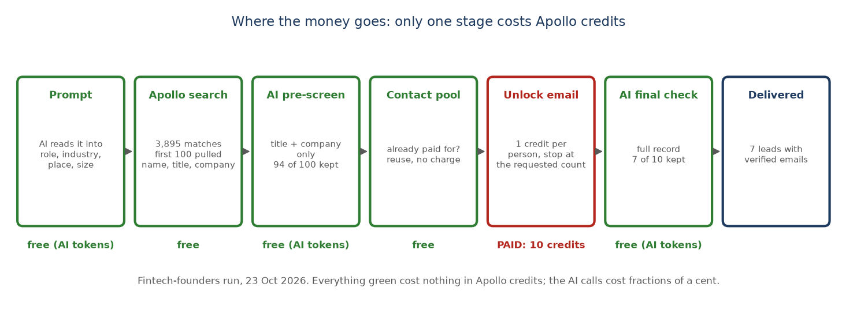
Figure 3. The whole pipeline with each stage marked free or paid. Only the unlock stage spends Apollo credits.

6.5 The exact method
- For each target market, one search request was sent with the role titles, the location, the company-size band and the industry keyword tags, asking for 25 results per page.
- Apollo's reply includes a total_entries number: how many people match in its whole database. That number is the “People in Apollo” column.
- The same request was sent again with one extra filter, contact_email_status = verified. Its total_entries is the “With verified email” column, the pool we can actually draw leads from.
- The first three names in each reply were kept as a sanity check that the filter was matching the right kind of company (that is how we saw that “restaurant” matches restaurant equipment suppliers).
- The credit balance was read from Apollo's usage endpoint before and after, with idle waits on both sides to separate our calls from anyone else using the same account.
This is the request that produced the fintech CTO row, with the key removed:
POST https://api.apollo.io/api/v1/mixed_people/api_search
headers: x-api-key: <key>, content-type: application/json
{
"person_titles": ["CTO", "Chief Technology Officer", "VP Engineering"],
"person_locations": ["United States"],
"organization_num_employees_ranges": ["11,50"],
"q_organization_keyword_tags": ["fintech", "financial technology", "payments"],
"contact_email_status": ["verified"],
"include_similar_titles": false, "page": 1, "per_page": 25
}
-> { "total_entries": 1182, "people": [ { "first_name": "...", "last_name_obfuscated": "Pe***n",
"title": "Chief Technology Officer", "organization": { "name": "Neural Payments" }, "has_email": true, ... } ] }

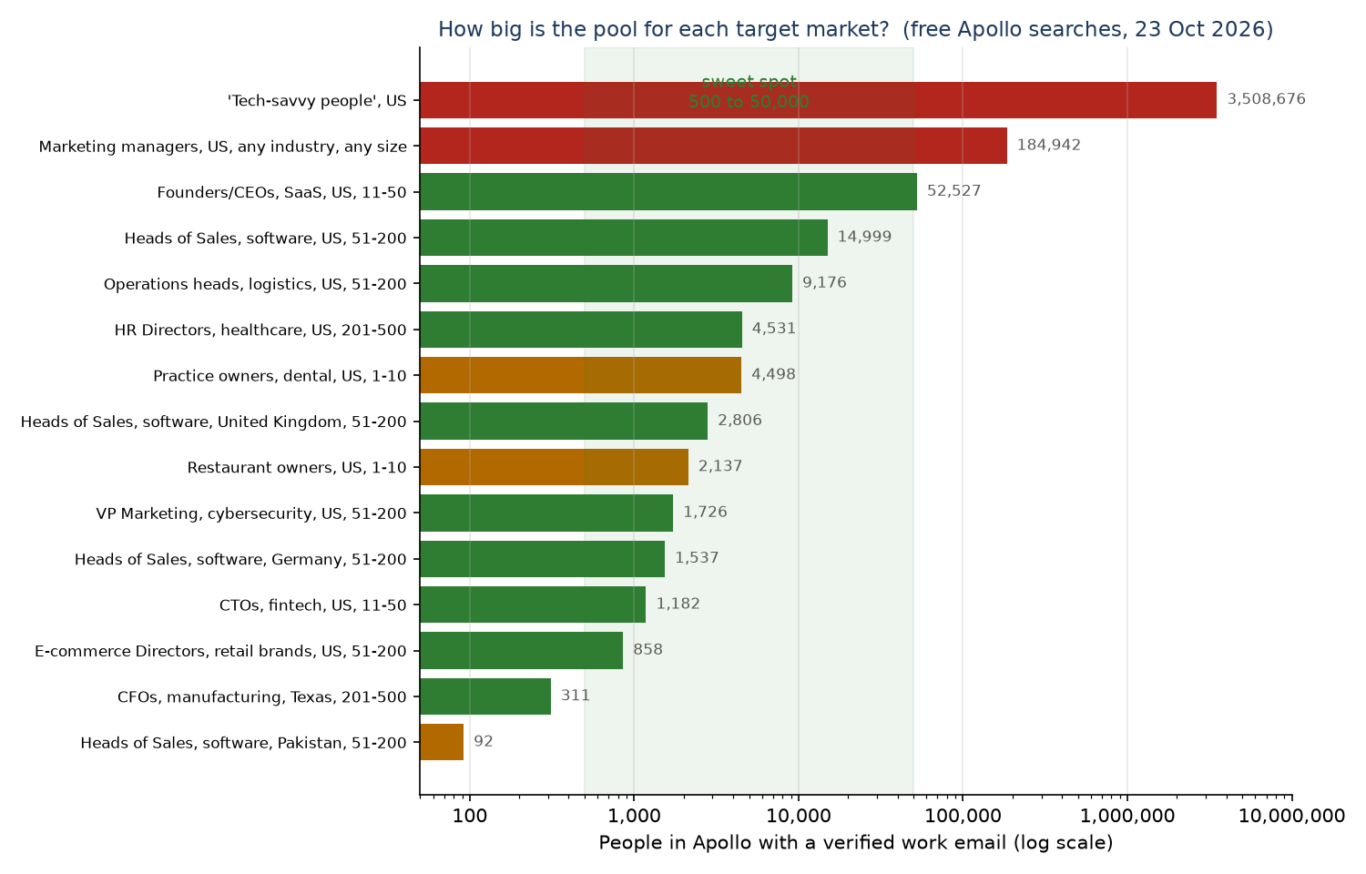
Figure 4. The measured pools on a log scale. Green is a usable target market, amber is weak, red is unusable as written. The shaded band is the sweet spot.

6.6 Proof that search calls do not spend credits
To be sure the numbers above were really free, ten search calls of 100 people each (1,000 people viewed) were made in a row, with the credit balance read before and after and two-minute idle periods on both sides to catch delayed charges and anyone else's activity on the shared account.
Step | Lead credits consumed (Apollo counter) | Change
Balance read | 45,476
Idle 120 s | 45,476 | +0
10 search calls, 1,000 people viewed, then wait 150 s | 45,476 | +0
Idle 120 s | 45,475 | -1

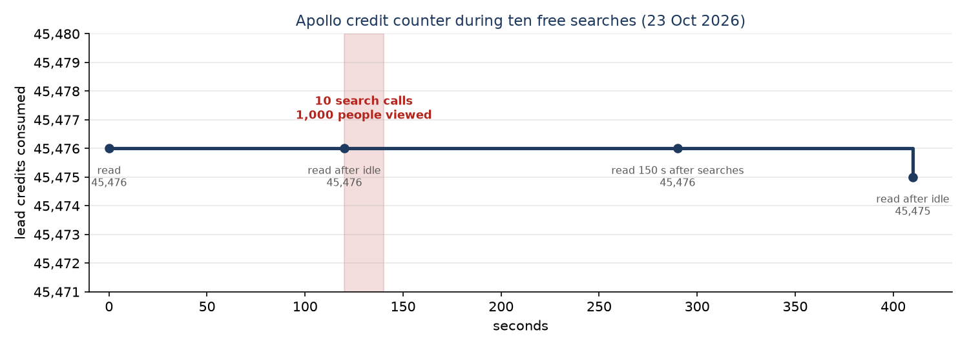
Figure 5. The same test as a timeline: the counter is flat through the searches.
Result: search is free
Ten searches covering 1,000 people moved the credit counter by zero at the 150-second reading, and the counter then went down by 1 during the final idle period, which can only be an adjustment or refund elsewhere on the shared account, not a charge for our searches. Compare that with the unlock test earlier in the day, where 15 unlocks moved it by exactly 15. Searching and counting is free; revealing a person is what costs.
Note for the shared account: during the same afternoon the counter also moved by 87 credits while this project made no paid calls at all, so other users of the Apollo team account were active. That is why every measurement here is bracketed by idle readings.

6.7 What else was measured, for completeness
Apollo call | What it gives you | Measured cost
People search (api_search) | Count of matches plus first name, masked last name, title, company name, has-email flag | 0 credits
People unlock (people/match, bulk_match) | Email, email status, LinkedIn URL, location, company industry and size | 1 credit per person, also when no email comes back, also for a repeat
Company enrichment (organizations/enrich) | Industry, size, revenue, description, keywords, tech stack, funding, headcount growth | 1 credit per company
Company job postings | Open roles at a company (hiring signal) | 1 credit per call
Company search (mixed_companies/search) | Should list companies; returned none on this plan | 1 credit per call, not worth using
Usage and credit stats | Rate limits and the credit counter used for every measurement here | 0 credits

7. Evidence from the run

7.1 Server log events
{"event":"apollo_variant_attempt","level":0,"label":"exact AI filters","totalEntries":3895,"pagePeople":100,"params":{"tags":["fintech"],"q":null,"size":["11,50"],"titles":["Founde
{"event":"apollo_variant_selected","level":0,"label":"exact AI filters","totalEntries":3895,"relaxed":false}
{"event":"prescreen","candidates":100,"passed":94,"dropped":6,"minScore":60,"durationMs":31208}
{"event":"stage_chunk_summary","stage":"unlock","people":30,"unlockedEmail":10,"chunkFailures":0,"chunkCount":1,"medianMs":1777,"p95Ms":1777,"maxMs":1777,"revealPersonal":false,"st
{"event":"contact_pool_saved","saved":10}
{"event":"postcheck","candidates":10,"passed":7,"dropped":3,"minScore":60,"durationMs":3841}
{"event":"batch_complete","batchIndex":1,"fetched":100,"savedWithEmail":7,"skippedUnverified":0,"leadsFetched":100,"leadsWithEmail":7,"lastPage":1,"totalPages":10,"unlockAttempts":

7.2 Credit measurement
Apollo usage_stats/credit_usage_stats, lead_credit.consumed:
idle 40s before run: +0 (45,373)
run: +10 (45,383)
idle 40s after run: +0
app log unlockAttempts: 10, creditsPerSavedLead: 1.43

7.3 Independent audit call
model: gpt-4o, temperature 0, JSON output
system: "You are an independent auditor of B2B lead quality. You did not produce these leads..."
input: the request + name, title, company, industry, employees, location for all 10 unlocked people
output: role_fit, industry_fit, size_fit, location_fit, overall (good/borderline/bad), why
tokens: 1,402 (about a tenth of a cent)

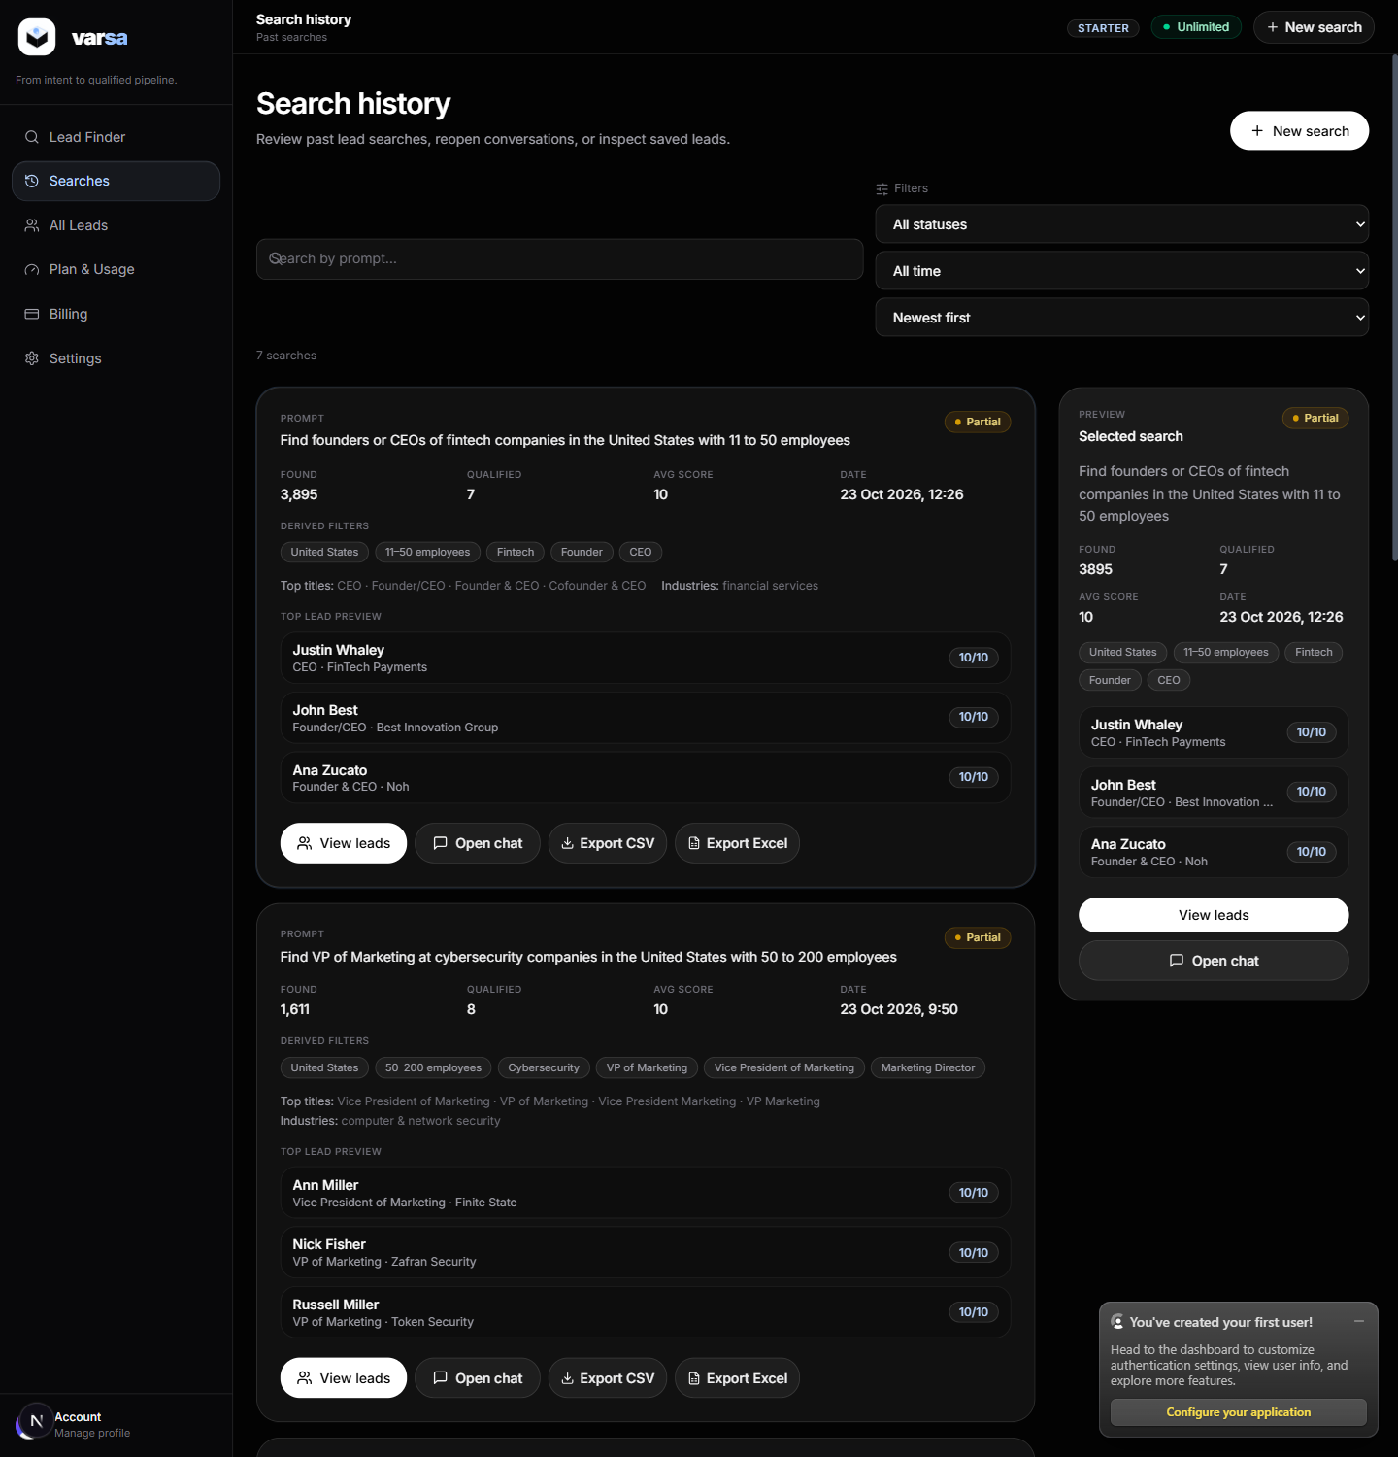
Figure 2. Search history after the run.

7.4 Files
File | What it is
docs/evidence/markets.json | The free Apollo pool measurements behind section 6 (15 target markets, total and verified-email counts, sample people)
docs/evidence/fintech-judged.json | All 10 unlocked people with the independent auditor's verdicts
docs/evidence/fintech-events.json | The server log events for this search
docs/evidence/search-result-fintech.json | Full API response for the search, including the delivered leads

