CSCI 4131 – Internet Programming

Assignment 3

1 Description

The objective of this assignment is to expose you to the layering and positioning features that CSS provides. In this assignment you will create the rainbow squares page. The page itself will only contain the html (no styling). Styling will be placed in a separate file.

2 Requirements

Develop the rainbow squares page as seen below using HTML5 and CSS. Your styling should be contained within a separate file. Please pay careful attention to the color settings and overlay behavior of each square: from top to bottom, the color of each square corresponds to a color of the rainbow and each subsequent square overlaps the preceding one. However, the text and border color of each square corresponds to the colors of the rainbow from bottom to top. The odd square out (the black one) should be positioned relative to the right side of the square, whereas all of the others should be positioned relative to the left. This will allow the black square to move from left to right as the screen size changes.

You should test your webpage with either Firefox or Chrome. Tell us which was used at the bottom of your webpage.

Figure 1: The rainbow squares page

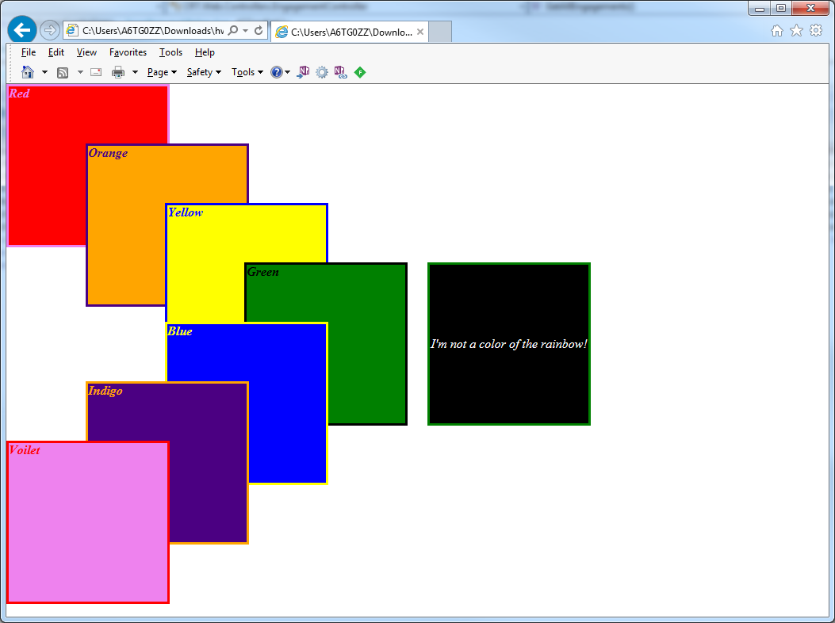

3 Evaluation

Your submission will be graded on the following items:

HTML and CSS files pass w3schools validator (http://validator.w3.org) without errors. Warnings are accepted. 20 points

Styling is present in a separate file. 10 points

Each square is colored accordingly. 10 points

Border and text colors are correct. 10 points

Squares overlap each other. 10 points

All text appears in italics. 5 points

At the bottom of the webpage, tell us which browsers you used to test your HTML. Should include at least Firefox or Chrome. 5 points

Your submission should be packaged in a zip file. When opened, it must create a directory titled ‘<UMN internet ID>’ containing all of your files. 10 points