CSCI 4131 – Internet Programming

Assignment 4

1 Description

The objective of this assignment is to expose you to JavaScript programming and the document object model. In this assignment you will extend the rainbow squares page created in the last assignment by recreating the view below but rotating it 180 degrees and appending it to the prior view (the text within each square should not be rotated).

2 Requirements

Develop the rainbow squares page as seen below using HTML5, CSS, and JavaScript where your JavaScript code appends to the view below the original but rotated 180 degrees. Your styling should be contained within a separate file as well as your JavaScript code. Please pay careful attention to the color settings and overlay behavior of each square: from top to bottom, the color of each square corresponds to a color of the rainbow and each subsequent square overlaps the preceding one. However, the text and border color of each square corresponds to the colors of the rainbow from bottom to top. In the rotated version, the rainbow colored squares should slide to the right when your resize your window, but the black square should remain fixed. Your JavaScript code must be used for appending the additional elements; the html page must be the same as that submitted for the prior assignment (no styling). Styling will be placed in a separate file as well as the JavaScript code.

You should test your webpage with either Firefox or Chrome. Tell us which was used at the bottom of your webpage.

Figure 1: The rainbow squares page

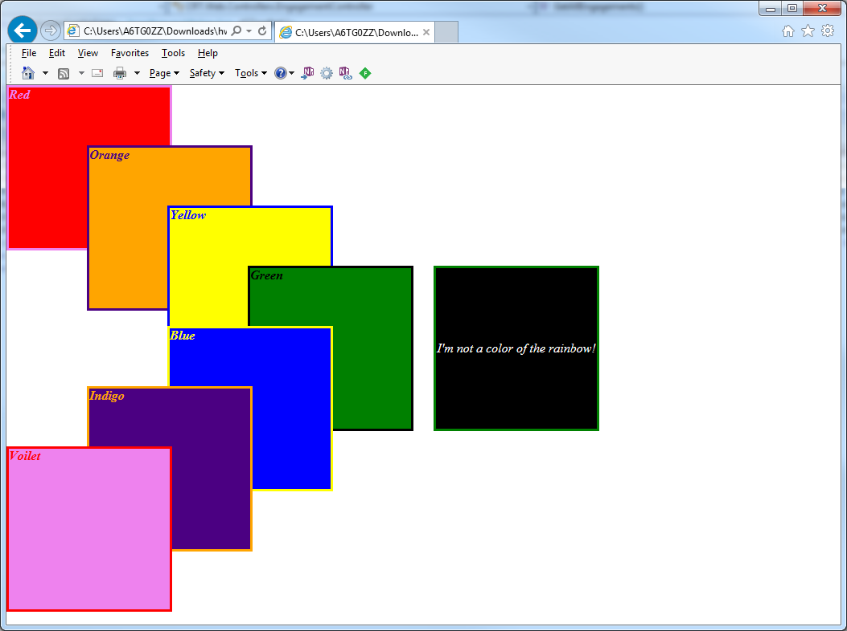

3 Evaluation

Your submission will be graded on the following items:

HTML and CSS files pass w3schools validator (http://validator.w3.org) without errors. Warnings are accepted. 20 points

Styling is present in a separate file. 10 points

JavaScript is present in a separate file. 20 points

Each square is colored accordingly. 5 points

Border and text colors are correct. 5 points

Squares overlap each other. 5 points

All text appears in italics. 5 points

At the bottom of the webpage, tell us which browsers you used to test your HTML. Should include at least Firefox or Chrome. 5 points

Your submission should be packaged in a zip file. When opened, it must create a directory titled ‘<UMN internet ID>’ containing all of your files. 10 points