**Spring 2017: CSci-4131 Internet Programming**

**Assignment 8: PHP Programming, JSON, and the Address Book**

Posted: Tuesday 4/11/17, Due: 11:55 pm, Monday, 4/17/17

Task: The purpose of this assignment (an extension of assignment 7) is to illustrate the use of PHP as a server side programming language that processes form submission data as well as displays the results in an JSON data format.

Problem Statement: You will have to write a webpage PHP script file that captures address information via a form element that when submitted, displays a growing address list of address information in JSON format (one entry is below). The data submitted will be sent initially and subsequently be sent to your PHP file that generates an html webpage that when submitted, returns and updates the lower portion of your webpage with your submitted form elements as an JSON formatted string. This will require you to think about how session state should be handled. There are multiple approaches to this type of problem (cookies, hidden variables, PHP’s own session state management system which I recommend).

Functionality: The form should validate any null (blank) entries except for Address Line 2 and not allow submission of the form data until all entries have been filled in (a simple JavaScript alert works for this to tell the end user that they left something out). Once all required entries are in place, your JavaScript code shall allow the form to submit the data to your PHP file. Your PHP file should then echo the data back in format JSON format which is then displayed on the lower portion of your webpage and allow for the additional form address entries (the prior form entries should be cleared to allow for new entries). New entries should be comma separated (were growing a list that will ultimately end up in a database in the next assignment).

Wireframe:

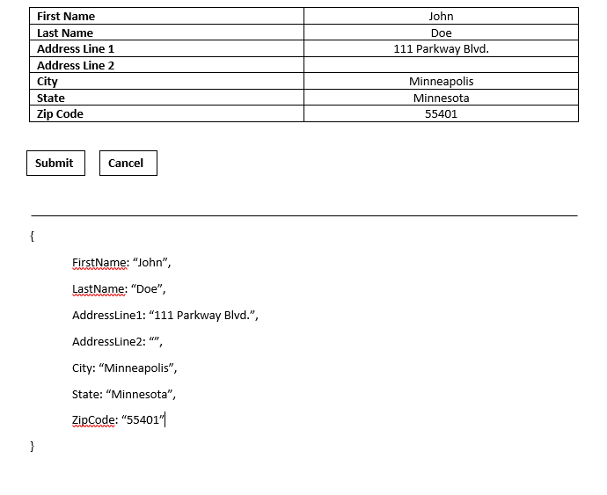

Grading Criteria:

1. Your submitted CSS files passes thee CSS validator checks - 5 points.
2. Your Javascript code which validates the form entries and then submits them – 15 points.
3. Your PHP script echos back the form entered data in JSON format and regenerates the form– 35 points.
4. Your Javascript code is in a separate file – 5 points.
5. Your PHP code is in a separate file – 5 points.
6. Your CSS code is in a separate file – 5 points.
7. Correct submission format – 5 points.

Submission Instructions:

Your submission should be packaged in a tarball or zip file. When opened, it must create a directory titled ‘<UMN internet ID>’ containing all of your files. UMN internet id should be your x.500 id. You will lose AT LEAST 5 points if you do not do this correctly. Include all the files we require to run your Web Pages in your the following files in your submission including pictures and external JavaScript files. Your submission should include at least:

• The PHP file containing your code. • A CSS stylesheet containing your code • A JavaScript file containing your code • A README file: the file should include your student ID, name, and x500 ID, and anything else you want