1. You should have to develop a database structure as per below given instructions
   1. Database should be in MSSQL
   2. Database should have tables which contains the information about Managers and Employees and departments. You are free to develop database tables, but you just follow some standard naming conventions.
2. You should download a zip file that project by given link. You download it and open into visual studio 2012/2013. Complete that project with the below requirements.

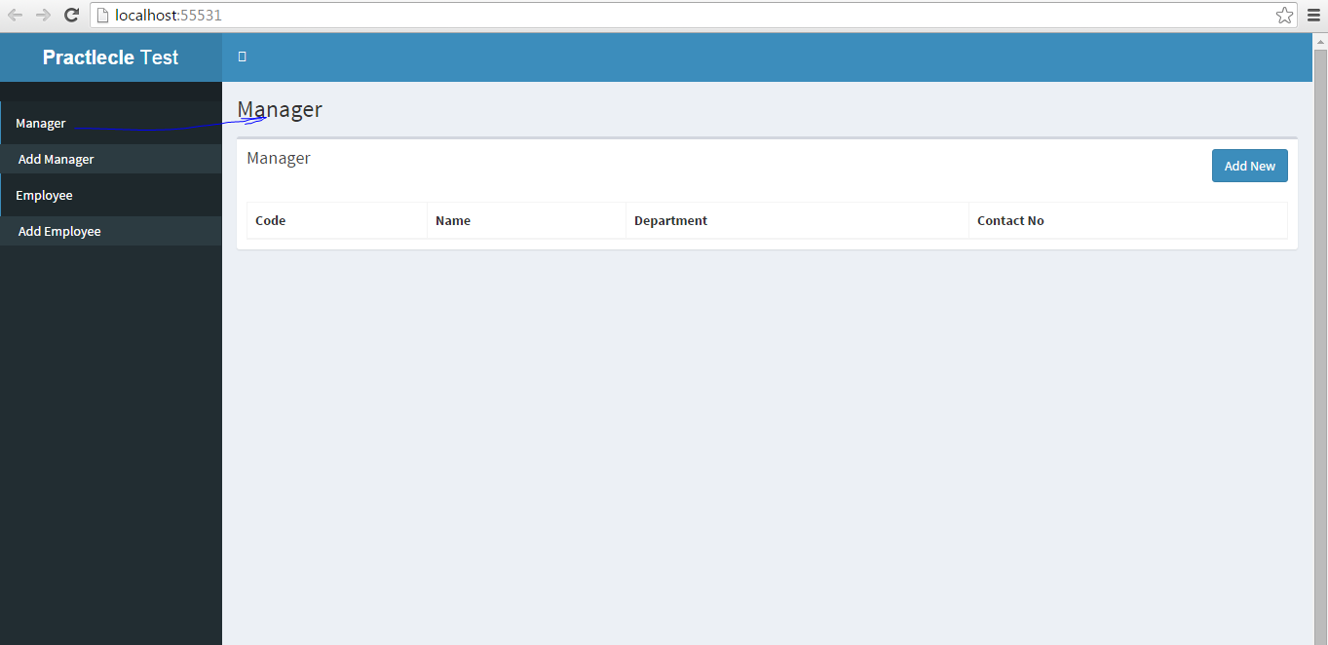

In the above screen, Need to show Managers with their code, Name, Department name, contact Numbers.

Do Same as Employee screens.

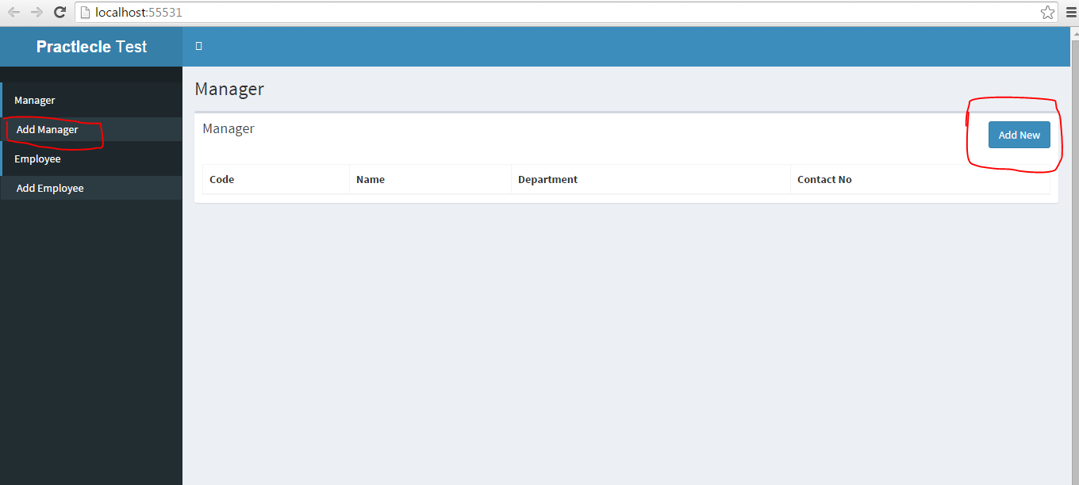

When user click on “Add Manager” or “Add New” button, then user is able to redirect to “Add manager” .