**MODULE: 9 ReactJs Intro**

**1. What is React Js?**

**Ans :**

* React.js is an open-source JavaScript library.
* React is a tool for building UI components.
* React is a JavaScript library for building user interfaces.

**2. What is NPM in React Js?**

**Ans :**

* npm is the package manager for node.js.
* JavaScript that is commonly used to manage and install dependencies in a React project.
* NPM allows developers to easily share and distribute code packages (libraries, modules, and tools) that can be used in their projects.

**3. What is Role of Node Js in react Js?**

**Ans :**

* NodeJS is a framework of JavaScript which is mainly used for working with the backend of our application or building the backend using JavaScript.
* Node.js **handles requests and authentication from the browser.**
* Node is  used for creating networking and server-side apps.

**4. What is CLI command In React Js?**

**Ans :**

* CLI commands are currently only used to create a passable version of a react application using the command line.
* CLI is a command line program that accepts text input to execute operating system functions.

**5. What is Components in React Js?**

**Ans :**

* Components are independent and reusable bits of code. They serve the same purpose as JavaScript functions, but work in isolation and return HTML.
* Components come in two types, Class components and Function components, in this tutorial we will concentrate on Function components.

**6. What is Header and Content Components in React Js?**

**Ans :**

* In React.js, the concepts of "Header" and "Content" components are not predefined. They are typically used as generic terms to describe different parts or sections of a user interface in a React application.
* For example, you might create separate components for the header and content of a webpage

**Header Component:**

* The "Header" component in a React application is often used to represent the top section of a webpage or application. It may include elements such as the navigation bar, logo, user authentication status, or any other information that is consistently displayed at the top of the page.

**Content Component:**

* The "Content" component is typically used to encapsulate the main content area of a webpage or application. It may include different sections, components, or modules that make up the primary user interface content.

**7. How to install React Js on Windows, Linux Operating System? How to Install NPM and How to check version of NPM?**

**Ans :**

* Step :1node.js & npm Install
* Step :2To Check version of npm , open cmd and write this command npm –vfor check npm version.

**8. How to check version of React Js?**

**Ans :**

* To Check version of npm , open cmd and write this command npm –vfor check npm version.

**9. How to change in components of React Js?**

**Ans :**

* setState() enqueues changes to the component state.

**10. How to Create a List View in React Js?**

**Ans :**

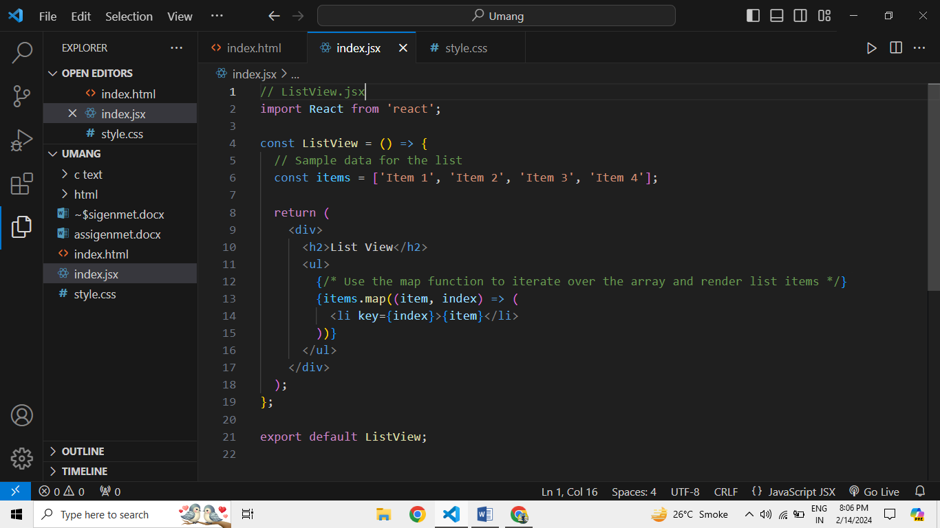

**11. Create Increment decrement state change by button click?**

**Ans :**

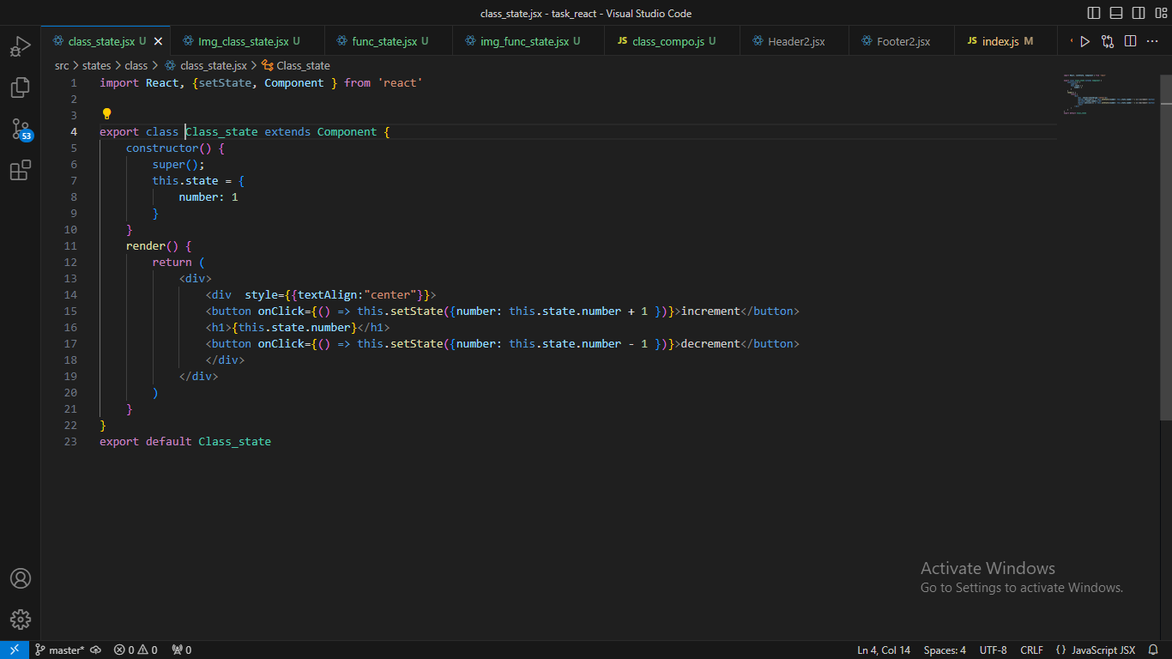

**12. E-COMMERECE WEBSITE :**

**GITHUB LINK :** [**https://github.com/hiren0711/tourism-website**](https://github.com/hiren0711/tourism-website)

**Result :**

