**Prof.V.B.Shah Institute of Management & R.V.Patel College of Commerce (Eng.Med.) &**

**V.L.Shah College of Commerce (Guj.Med.) &**

**Sutex Bank College of Computer Applications &**

**Science, Amroli**

**(Accredited ‘B’ (CGPA 2.55) by NAAC Dec.-2009)**

**VEER NARMAD SOUTH GUJARAT UNIVERSITY, SURAT.**

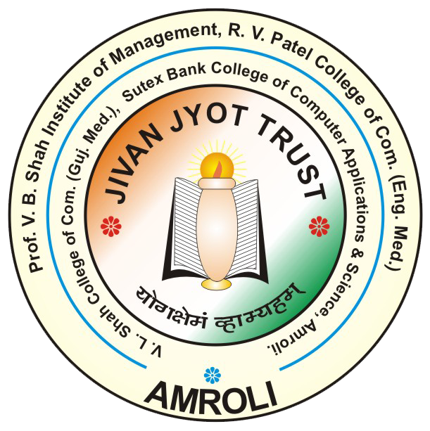

**PROJECT REPORT**

**ON**

**Agriculture Management App**

**SUBMITTED BY:**

|  |  |  |
| --- | --- | --- |
| Roll No | Student Name | SID |
| 747 | **BHALANI HIREN** | **21410454** |
| 764 | **BHUVA KISHAN** | **21410396** |
| 756 | **KATHIRIYA RISHIL** | **21410422** |
| 750 | **DHAMELIYA ABHI** | **21410493** |

|  |  |  |
| --- | --- | --- |
| Sr.  No. | Chapter | Page No. |
| 1 | **Introduction**  1.1 Overview |  |

**1.Introduction**

* 1. Overview

Welcome to AgriConnect, your revolutionary Android app designed to redefine how farmers connect, manage resources, trade, and stay informed in the agricultural landscape. With an unwavering focus on delivering a seamless user experience and real-time interactions, AgriConnect stands as your all-inclusive solution, empowering farmers to thrive in every aspect of their farming journey.

**1. Cultivating Connections for Collective Growth**

AgriConnect isn't just an app; it's a dynamic farming community where cultivators unite to connect, share knowledge, and learn together. Our intuitive social networking feature allows farmers to build relationships, exchange insights, and collaborate on best practices. Whether you're a seasoned farmer or a novice, AgriConnect cultivates a sense of unity that elevates your farming endeavors.

**2. Efficient Worker Management**

Efficient worker management is vital for farm operations. AgriConnect streamlines this process by facilitating worker recruitment, allowing you to post job listings, review worker profiles, and hire worker with the right skills for your tasks. Our app ensures that your workforce is skilled, available, and ready to contribute to your farm's success.

**3. Seamlessly Bridging Trade and Commerce**

AgriConnect provides a platform for farmers to sell their agricultural produce, livestock, and even repurpose used tools and accessories. This simplified trading process enables farmers to showcase their products and connect directly with buyers. From fresh harvests to outgrown equipment, you can effortlessly find interested buyers within the app, enhancing your profitability.

**4. Convenient Procurement for Enhanced Productivity**

From seeds and fertilizers to machinery and tools, AgriConnect offers a streamlined shopping experience for all your agricultural needs. Explore a curated selection of products from trusted sellers and make purchases that contribute to your farm's growth. Our platform simplifies the procurement process, saving you time and resources.

**5. Informed Decision-Making**

AgriConnect keeps you informed with real-time weather updates, government schemes, and the latest news impacting the agricultural sector. Access accurate weather forecasts to make informed decisions about your crops. Stay updated on government initiatives that could benefit your farm and remain ahead of the curve with the latest industry trends.

**6. Bridging Languages, Fostering Unity**

AgriConnect acknowledges India's linguistic diversity, offering the app in 12 local languages. Our commitment to inclusivity ensures that every farmer, regardless of language, can harness the app's potential and benefits.

**7. Real-Time Integration with Firebase**

AgriConnect leverages the power of real-time Firebase database technology to provide you with a seamless and dynamic user experience. Enjoy instant updates, swift information sharing, and an app that feels alive and responsive.

AgriConnect isn't just an app; it's your ally in cultivating prosperity. Join us in revolutionizing Indian agriculture through connectivity and innovation. Experience the synergy of seamless connections, efficient resource management, amplified trade opportunities, and vital insights with AgriConnect. Download the app now and embark on a journey of growth an

* 1. **Project Profile**

|  |  |
| --- | --- |
| Agriculture Management System | |
| Project title: | Agriculture Management System |
| Frontend: | X.M.L. |
| Backend: | Java, Firebase |
| Operating system : | android |
| Platform: | Android studio, firebase console |
| Documentation tool: | Microsoft word |
| Internal Guide: | Priyanka.D.Chauhan |
| Submitted to: | Priyanka.D.Chauhan |

2. Objectives

Start to End Process:

1. Collecting information for system (Requirement Gathering and Analysis).

2. Preparing the design of the system through information.

3. Creating model class definition and implementation.

4. Integration of Front-end and Back-end.

5. Custom Functions & Validations.

6. Making responsive design.

7. Testing.

8. Debugging and code optimization.

3. System Flow Diagram

* Admin Process Diagram

5. ER Diagram

6. Database Design

**Agriculture management app app app**

1.ClsUserModel

|  |  |  |  |
| --- | --- | --- | --- |
| ClsUserModel | | | |
| No | Field Name | Data type | Description |
| 1 | uname | String | Username |
| 2 | mo | String | Mobile No. |
| 3 | url | String | Profile Picture URL |
| 4 | email | String | User Email |
| 5 | dob | String | Date Of Birth |
| 6 | gender | String | Gender |
| 7 | address | String | Address |
| 8 | state | String | State |