KRUSHI MANCH

Thesis Submitted in
Partial fulfillment for the award of

Bachelor of Computer Application

Submitted by

1. 2204030101241: Satapara Abhi
2. 2204030100453: Kadivar Het
3. 2204030102736: Ubhadiya Chirag
4. 2204030101905: Keraliya Hiren

Department of Computer Application Under the supervision of
Mr. Harsh Patel Assistant Professor, BCA



Silver Oak University Gota, Ahmedabad-382481, Gujarat, India
April-2025



CERTIFICATE

It is certified that the project titled Krushi Manch has been carried in group are Bonafide students of BCA VI semester, Department of Computer Application, Silver Oak University, Ahmedabad, Gujarat. The project is a record of the work accomplished during the sixth semester of BCA as a partial fulfilment of the requirement for the award of degree in Bachelor of Computer Applications (BCA), under my guidance.

Name of students | Enrolment of student
Satapara Abhi | 2204030101241
Kadivar Het | 2204030100453
Ubhadiya Chirag | 2204030102736
Keraliya Hiren | 2204030101905

Mr Harsh Patel - Assistant Professor, Department of Computer Application,
Silver Oak University, Ahmedabad, Gujarat.

DECLARATION

We hereby declare that project entitled “KRUSHI MANCH” in partial fulfilment for the degree of Bachelor of Computer Application to Silver Oak University,
Ahmedabad, is Bonafide record of the project work carried out at SILVER OAK COLLEGE OF COMPUTER APPLICATION under the supervision of Mr Harsh Patel and that
no part of any of these reports has been directly copied from any student’s report or taken from any other sources, without providing due reference.

Name of students Sign of student
Satapara Abhi Kadivar Het Ubhadiya Chirag Keraliya Hiren

ACKNOWLEDGEMENT

We would like to express our profound sense of deepest gratitude to our guide Mr Harsh Patel, Silver Oak College of Computer Application (SOCCA), Ahmedabad for valuable guidance, sympathy and co-operation for providing necessary facilities and sources during the entire period of this project.

We wish to convey our sincere gratitude to all the faculties of Department of Computer Application who have enlightened us during our studies. The facilities and cooperation received from the technical staff of department is thankfully acknowledged.

The main credit for the successful completion of this project can be given to Principal of our college Dr. Hemal Patel who supported us throughout this enterprise.

We express our thanks to all those who helped us in one way or other.

Last, but not least, we would like to thank the authors of various research articles and books that were referred to.

Name of students | Enrolment of student
Satapara Abhi | 2204030101241
Kadivar Het | 2204030100453
Ubhadiya Chirag | 2204030102736
Keraliya Hiren | 2204030101905

ABSTRACT

Krushi Manch is a multilingual, user-friendly agricultural web platform designed to empower farmers, agricultural enthusiasts, and stakeholders with reliable, region-specific crop information. The project aims to bridge the information gap in the agricultural sector by providing detailed data on over 50 crop varieties, including their growing seasons, duration, soil and climate requirements, common diseases, and management practices.
Developed with a PHP backend, the platform ensures robust performance and dynamic content handling. It supports multiple languages to cater to the diverse linguistic needs of the farming community, thereby promoting inclusivity and accessibility. The integration of high-quality images, interactive UI components, and structured crop profiles enhances user engagement and learning.
Krushi Manch aspires to be a digital knowledge hub that not only supports informed decision- making but also promotes sustainable agricultural practices by making expert knowledge accessible at grassroots levels.

FIGURES/DIAGRAMS:
Pg. No
Figure 1: Flow Chart 21
Figure 2: ER Diagram 22
Figure 3: Screen Shots 42
TABLE OF CONTENTS
Certificate from the Guide i
Declaration from the Student ii
Acknowledgement iii
Abstract iv
List of Figures v
Table of Contents vi
- Introduction
  - Project Profile 1
  - Overview 2
  - Motivation 2
  - Goal 3
  - Organization of the Report/Thesis 4

Initial System Study
  - Chapter Introduction 5
  - About Organization 6
  - Drawbacks of the existing system 8
  - Problem definition 9
  - The proposed system 10
  - Scope of the system 12
  - Scope of this project 14
  - System development approach 16
- Feasibility Analysis
  - Section Name 18
- System Analysis
  - Introduction 21
  - Data Flow Diagram 21
  - Entity Relationship Diagram 22
  - Physical and behavioural aspects of the system 23
    - User Interaction Flow 25
    - Admin Interaction Flow 26

- Software Requirements Specifications
  - General Description 27
    - Product Perspective 27

    - Product Functions 28
    - User Characteristics 29
    - General Constraints 30
    - Assumptions and Dependencies 31
    - Functional Requirements 33
    - Functional Requirement 35
  - External Interface Requirements 37
    - User Interfaces 37
    - Hardware Interfaces 37
    - Software Interfaces 38
  - Performance Requirements 39
  - Design Constraints 40
    - Standard Compliance 40
    - Hardware Constraints 40
    - Other Requirements 41
    - Scope of this project 41
- System design
  - Introduction 42
  - System Architecture 42
  - Module Design 50
  - Database Design 51
  - Input Output Design 54
  - Algorithm design 56

  - Electronic Data Communication Design 58
  - System Maintenance 59
  - Other Alternatives Considered 59
- System Implementation
  - Software Environment 61
  - System Development Platform 62
  - Project Accomplishment Status 63
  - Guidelines for Continuation 63
- System Testing
  - Test Plan 64
  - Test Cases 65
- Conclusion & Future Direction of Work
  - Conclusion 66
  - Future Direction of work 67
Bibliography/Reference 68

CHAPTER 1: INTRODUCTION

Project Profile

Project Name | KRUSHI MANCH
Objective | To empower farmers by providing accurate, timely, and multilingual agricultural information through a user-friendly  digital platform, facilitating better crop management, improved  productivity, and enhanced market access.
Description | Krushi Manch is an online agricultural information platform designed to support farmers with essential crop-related knowledge. The platform provides detailed information on various crops, including seasons, duration, diseases, and  soil/climate requirements, along with images.
Platform of Application | Web base Application
Front End Tool | HTML/ CSS/ JAVASCRIPT
Back End Tool | PHP/ MYSQL
Project Duration | 6 Months
Project Guide | Mr. Harsh Patel
Submitted By | Satapara Abhi
Submitted To: | Department Of Computer Application

  - Overview

Project Overview – Krushi Manch
Krushi Manch is a digital platform developed to serve as a comprehensive knowledge hub for farmers and agricultural enthusiasts. The project focuses on delivering structured and reliable crop-related information, covering over 50 crop varieties. Each crop profile includes vital details such as suitable growing seasons, duration, common diseases, recommended soil and climate conditions, and visual references.
Designed with a multilingual interface, the platform ensures accessibility for users across different regions and languages. The backend is powered by PHP and supports content management and data handling, while the front end is built for simplicity and ease of navigation. By integrating modern web technologies and a user-centric approach, Krushi Manch seeks to enhance agricultural awareness, support better farming decisions, and ultimately contribute to increased crop yield and sustainability.

Motivation

Motivation Behind the Krushi Manch Project
Agriculture remains the backbone of rural livelihoods, yet many farmers still struggle with limited access to timely and reliable information. Traditional knowledge-sharing methods are often insufficient to meet the challenges posed by changing climates, crop diseases, and modern agricultural practices. In many cases, the lack of localized and language-specific resources further widens the information gap, affecting productivity and income.
The Krushi Manch project was born out of the desire to bridge this gap by creating a centralized, easy-to-use, and multilingual platform. The goal is to empower farmers with accurate and actionable crop-related information that can help them make informed decisions, improve their farming practices, and adapt to new techniques. By leveraging digital technology, Krushi Manch aims to support sustainable agriculture and contribute to the overall development of rural communities.

Goal

The primary goal of Krushi Manch is to create an accessible, multilingual digital platform that delivers comprehensive and reliable agricultural information to farmers.

Provide Comprehensive Crop Information
Deliver detailed data on over 50 crop varieties, including growing seasons, duration, diseases, pest management, ideal soil and climate conditions, and images for better identification.

Support Multilingual Access
Offer information in multiple local languages to ensure farmers from diverse linguistic backgrounds can easily understand and use the platform.

Promote Informed Farming Practices
Help farmers make better decisions by giving them access to scientifically accurate and region-specific agricultural knowledge.

Bridge the Information Gap
Act as a bridge between modern agricultural research and traditional farming practices by making expert knowledge easily accessible to grassroots-level farmers.

Encourage Sustainable Agriculture
Promote eco-friendly and sustainable farming techniques by educating users about crop rotation, organic practices, and water conservation.

Enhance Digital Literacy Among Farmers
Introduce farmers to digital tools and platforms, fostering digital awareness and encouraging the use of technology in agriculture.

Improve Crop Productivity and Profitability
Equip farmers with the knowledge to reduce crop losses, manage diseases, and improve yield quality and quantity, ultimately boosting their income.

Create a Scalable and User-Friendly Platform
Design an intuitive web interface that can be scaled and updated regularly to include new crops, seasonal advisories, and region-specific data.

Facilitate Community Engagement and Knowledge Sharing
Lay the groundwork for future features like forums, expert Q&As, or farmer success stories to encourage interaction and peer learning.

Support Government and NGO Outreach
Serve as a resource that can be leveraged by agricultural departments, extension officers, and NGOs for educational and awareness campaigns.

Organization of the Report
This report is organized into several sections to provide a clear and systematic understanding of the Krushi Manch project. Each section focuses on a specific aspect of the project, from its motivation to implementation and future scope.
    - Introduction
Provides an overview of the project, including the background, need for the platform, and the target audience.
    - Objective
States the main aim of the Krushi Manch project and what it intends to achieve.
    - Motivation
Describes the reasons and real-world challenges that inspired the development of the project.
    - Goal
Outlines the broader goals and expected impact of the platform, detailed in a point- wise manner.
    - Project Scope
Defines the boundaries of the project, specifying what features and functionalities are included.
    - System Design and Architecture
Explains the technical design of the platform, including architecture, technologies used (e.g., PHP, database, frontend design), and system flow.
    - Features and Functionality
Details the key features of the platform, such as crop information display, multilingual support, image gallery, and user-friendly navigation.
    - Implementation
Describes the development process, tools used, challenges faced during development, and how they were addressed.
    - Testing and Evaluation
Covers the testing methods used to ensure functionality, performance, and usability of the platform.
    - Conclusion
Summarizes the project outcomes and how it meets the stated goals and objectives.
    - Future Enhancements
Suggests possible improvements and additional features that could be added in future versions of the platform.
    - References
Lists all the sources, articles, research papers, and tools referred to during the project.

Chapter 2: Initial System Study

Chapter Introduction

Agriculture is the cornerstone of rural economies, especially in countries where a large portion of the population depends on farming for their livelihood. Despite technological advancements in various sectors, many farmers still rely on traditional methods and face challenges due to a lack of access to timely and accurate agricultural information. This gap between available knowledge and its accessibility often leads to poor crop planning, disease outbreaks, and reduced yields.
The Krushi Manch project is designed to address this gap by developing a centralized, user- friendly, and multilingual digital platform that delivers comprehensive crop-related information. The platform serves as a knowledge base for farmers, students, and agricultural workers, helping them make informed decisions and adopt modern farming techniques suited to local conditions.
This chapter provides an introduction to the initial study of the current agricultural information systems, the need for a dedicated solution like Krushi Manch, and the potential impact it can have on the farming community. It explores existing practices, identifies key problems, and sets the foundation for the system’s design and development in the subsequent chapters.

About the Organization

Agricultural Organizations in India
    - ICAR (Indian Council of Agricultural Research)
      - Apex body for coordinating, guiding, and managing research and education in agriculture in India.
      - Website: icar.org.in
    - NABARD (National Bank for Agriculture and Rural Development)
      - Provides financial support for rural and agricultural development.
    - Krishi Vigyan Kendra’s (KVKs)
      - Agricultural extension centres created by ICAR to provide technical support to farmers.
    - State Agricultural Universities (SAUs)
      - Provide agricultural education, research, and extension services at the state level.

Private and NGO Agricultural Organizations
- Agri startups and tech companies (e.g., Ninja cart, DeHart, AgroStar)
- NGOs like BAIF Development Research Foundation, Pradan, etc., work on rural and agricultural development.

- Organization Overview:
The organization behind the Krushi Manch project is a dedicated agricultural development initiative aimed at improving the livelihoods of farmers through digital solutions. The organization is focused on promoting sustainable agriculture practices, empowering rural communities, and improving access to vital farming information.
- Mission and Vision:
- Mission: To bridge the information gap in agriculture by providing farmers with easy access to reliable, localized, and up-to-date crop knowledge through a user-friendly digital platform.
- Vision: To create a world where farmers are empowered with the tools, resources, and knowledge needed to make informed decisions, enhance productivity, and contribute to sustainable agricultural growth.
- Core Activities:
- Digital Agriculture Initiatives: The organization works on several digital tools and platforms to support farmers. This includes crop advisory services, weather forecasting, pest and disease management solutions, and online marketplaces.
- Training and Capacity Building: The organization conducts workshops, training sessions, and online webinars to improve the digital literacy of farmers and equip them with modern farming techniques.
- Research and Development: Collaboration with agricultural researchers, universities, and NGOs to develop innovative solutions for rural and farming communities, including developing platforms like Krushi Manch.
- Target Audience:
The primary audience for Krushi Manch includes:
- Farmers: Especially those in rural areas, looking for reliable crop management information.
- Agricultural Experts: Researchers and agronomists looking for a centralized platform for information dissemination.
- Government and NGOs: Organizations involved in agricultural development and extension services.

Drawbacks of the Existing System
While the Krushi Manch project is a valuable tool for farmers, there are several challenges and drawbacks associated with the existing system that need to be addressed for enhanced usability and effectiveness. These drawbacks primarily stem from technological, content, and user- related factors.
    - Limited Internet Access in Rural Areas
      - Problem: Many rural regions still face challenges with consistent and reliable internet connectivity. This limits the ability of farmers to access the platform regularly.
      - Impact: Farmers in these regions may not be able to take full advantage of the platform’s features, hindering its reach and impact.
    - Digital Literacy Gaps
      - Problem: Although smartphones and internet usage are increasing, there remains a significant portion of the rural population with limited digital literacy.
      - Impact: Farmers may struggle to navigate the platform effectively, which could reduce the adoption and usage of Krushi Manch.
    - Dependence on Technology and Devices
      - Problem: The system requires access to a computer or smartphone, and not all farmers may have the necessary devices or the means to maintain them.
      - Impact: This creates a barrier for some farmers who cannot afford or do not have the infrastructure to use the platform.
    - Limited Language Options
      - Problem: Although Krushi Manch aims to support multiple languages, the current range of languages may still be insufficient for farmers from diverse regions.
      - Impact: Farmers who do not speak the available languages may find it challenging to use the platform, reducing its effectiveness in non-local areas.
    - Lack of Real-Time Data and Updates
      - Problem: The platform may not always provide real-time updates on crop diseases, weather changes, or market prices.
      - Impact: Farmers may miss out on time-sensitive information that could impact their crop yield or sales, limiting the usefulness of the platform in fast-changing agricultural environments.

Problem Definition

Agriculture remains a critical source of livelihood for millions of farmers, particularly in rural areas, where access to vital agricultural knowledge and resources is often limited. In many regions, farmers face challenges such as inconsistent weather patterns, crop diseases, poor soil conditions, and inadequate access to timely and accurate information. These challenges hinder their ability to make informed decisions about crop selection, pest management, and optimal farming practices, which ultimately affect their productivity and income.
Despite the advancement of technology, a significant portion of the farming community still lacks reliable access to relevant information, primarily due to:
- Limited digital literacy: Many farmers are unfamiliar with using digital platforms and technologies, preventing them from accessing critical data.
- Inadequate information resources: The information available on traditional platforms (e.g., printed guides or agricultural extension services) is often outdated, fragmented, or difficult to access.
- Language barriers: A large percentage of the farming community speaks regional languages, and most digital platforms offer limited language support, making it hard for farmers to understand the content.
- Connectivity issues: Poor internet access in rural areas restricts the ability of farmers to regularly access digital platforms, especially those that require constant online connectivity.
The Krushi Manch project aims to address these challenges by providing a comprehensive, multilingual, and user-friendly platform that delivers reliable, up-to-date agricultural knowledge and crop-specific information. By overcoming these barriers, the platform seeks to empower farmers with the tools and knowledge they need to improve their farming practices, enhance productivity, and contribute to sustainable agriculture.

The Proposed System
The proposed Krushi Manch system aims to provide an accessible and comprehensive platform to address the agricultural information needs of farmers, especially in rural and underserved areas. The system is designed to overcome the limitations of the existing systems by integrating key features that enhance usability, accessibility, and usefulness for the target audience. The proposed system will focus on delivering timely and localized agricultural information in a user-friendly and multilingual format.
Key Features of the Proposed System:
    - Comprehensive Crop Information:
      - Crop Profiles: The system will provide detailed profiles for over 50 crop varieties, including essential information like growing seasons, optimal soil and climate conditions, duration, common diseases, and pest management.
      - Image Gallery: Each crop will have images and visual guides to help farmers identify and understand different stages of growth and common diseases.
    - Multilingual Support:
      - Local Language Support: The system will offer information in multiple languages (local/regional) to cater to a diverse audience, ensuring that farmers from different linguistic backgrounds can use the platform effectively.
      - Easy Language Switching: Users can switch between languages effortlessly for better understanding and accessibility.
    - User-Friendly Interface:
      - Simple Navigation: A clean, intuitive design that allows farmers to easily navigate through crop information, disease management tips, and seasonal advisories.
      - Mobile-Responsive: The platform will be optimized for mobile devices to ensure it is accessible on smartphones, as many farmers primarily use mobile phones for internet access.
    - Offline Access:
      - Downloadable Content: Farmers can download key crop information, weather forecasts, and farming tips to access them offline when they have limited internet connectivity.
      - Offline Updates: The system will allow offline access to previously stored information and periodic updates when an internet connection is available.

    - Real-Time Information:
      - Weather Updates: Integration with weather forecasting services to provide region-specific weather predictions, which will help farmers plan their activities.
      - Disease Alerts: Real-time alerts on emerging crop diseases, pest infestations, and other agricultural challenges.
      - Market Prices: Updated market prices for various crops, helping farmers make informed decisions about when and where to sell their produce.
    - Interactive Tools and Community Features:
      - Crop Calculator: A tool to help farmers estimate crop yield, water requirements, and other important farming metrics.
      - Forum and Expert Q&A: A space for farmers to ask questions, share experiences, and interact with agricultural experts and fellow farmers.
      - Farmer Success Stories: A platform for farmers to share their experiences and best practices, which can inspire others to adopt better farming techniques.
    - Scalability and Flexibility:
      - Easily Updatable: The system will be designed to accommodate the addition of new crops, diseases, farming techniques, and other updates without disrupting the user experience.
      - Modular Design: The platform will have a modular design, allowing additional features, such as marketplace integration or educational modules, to be added in the future.
    - Integration with Government and NGO Initiatives:
      - Government Schemes and Subsidies: The platform will include information about government programs, schemes, and subsidies available for farmers, encouraging greater participation in such initiatives.
      - NGO Support: Collaboration with NGOs to provide farmers with training materials, workshops, and other forms of assistance.

Scope of the System
The scope of the Krushi Manch system outlines the boundaries, features, and functionalities that the platform will provide, as well as the limitations and areas for potential future development. The system is designed to cater primarily to farmers, agricultural experts, government agencies, and non-governmental organizations (NGOs), offering a comprehensive tool for improving agricultural practices and decision-making.
Key Aspects of the Scope:
    - Target Audience:
      - Farmers: The primary users of the platform, including small-scale and large- scale farmers, who will access crop-related information, disease management guidelines, and seasonal advice.
      - Agricultural Experts: Researchers, agronomists, and advisors who will contribute knowledge and expert advice to the platform.
      - Government and NGOs: Organizations that will use the platform for outreach, training, and dissemination of agricultural knowledge and policies.
    - Core Features:
      - Crop Information Database: The platform will contain detailed information on over 50 crop varieties, including cultivation tips, disease control, growth duration, and climate requirements.
      - Multilingual Interface: The system will support multiple languages to cater to diverse farming communities, especially in rural and remote regions.
      - Weather Forecasting and Alerts: Real-time weather updates and crop-specific alerts to help farmers plan their agricultural activities based on upcoming weather conditions.
      - Disease and Pest Management: Information on identifying, preventing, and treating crop diseases and pest infestations will be provided.
    - System Integration:
      - Integration with Agricultural Data Providers: The platform will integrate with third-party APIs or databases to gather real-time data on weather, market prices, and pest outbreaks.
      - Collaboration with Government Schemes: Information about relevant government schemes, subsidies, and funding options for farmers will be integrated to assist farmers in accessing available resources.

    - User Interface and Experience:
      - Simple and Intuitive Design: The platform will prioritize ease of use, with a clean and straightforward interface that allows farmers with limited technical expertise to navigate the system easily.
      - Mobile-Friendly Design: The system will be fully responsive, optimized for use on smartphones, considering that mobile phones are widely used in rural areas for internet access.
      - Community Features: Forums, expert Q&A, and user-generated content, such as success stories and best practices, will be incorporated to foster community engagement and knowledge-sharing.
    - Future Enhancements (Out of Current Scope):
      - E-commerce Integration: While the platform may provide market price information, direct e-commerce features like a marketplace for selling crops will be considered for future development.
      - AI/ML Integration: Advanced features such as AI-driven crop yield prediction, pest detection using image recognition, or personalized farming advice could be implemented in future phases of the project.
      - Advanced Analytics: Future versions may include data analytics tools to provide farmers with detailed insights into their crop performance, historical data, and predictive trends.
    - Geographical Scope:
      - The system will primarily serve rural and agricultural communities in regions with access to basic internet infrastructure, but it will expand its reach over time, targeting a wider geographical area, including underserved regions.
      - Initially, the system will be launched in regions with high agricultural activity but may later expand to other areas based on demand and partnerships with agricultural organizations and governments.

Scope of the Project
The Krushi Manch project aims to develop a comprehensive digital platform that provides agricultural information and resources to farmers, agricultural experts, and other stakeholders. The project is designed to address the challenges faced by farmers in rural areas, particularly those related to limited access to agricultural knowledge, market prices, and weather conditions. The platform will be accessible, user-friendly, and multilingual, providing essential support for enhancing productivity and promoting sustainable farming practices.
Core Aspects of the Project Scope:
    - Platform Features:
      - Crop Information Database: A collection of detailed information on various crops, including growth conditions, diseases, optimal farming practices, and pest control measures.
      - Multilingual Support: The platform will support multiple languages to ensure accessibility to a wide audience, especially rural farmers with diverse linguistic backgrounds.
      - Weather Forecasting and Alerts: Real-time, region-specific weather forecasts and crop-specific alerts to help farmers plan their activities.
      - Pest and Disease Management: Detailed resources on common pests and diseases affecting crops, including identification, prevention, and treatment methods.
    - Technology Stack:
      - Frontend Development: The platform will use HTML, CSS, JavaScript, and other frontend technologies to ensure a user-friendly and responsive interface.
      - Backend Development: PHP will be used for the backend, allowing for dynamic content generation, user management, and database interactions.
      - Database Management: A relational database (e.g., MySQL) will store crop data, user profiles, multilingual content, and market price information.
      - Cloud Hosting: The platform will be hosted on a cloud-based infrastructure to ensure scalability, reliability, and ease of maintenance.

    - System Features and Capabilities:
      - User Registration and Profile Management: Farmers and experts can create profiles to access personalized content, including relevant crops, weather updates, and market prices.
      - Localized Content: The platform will provide localized content and information that is region-specific, ensuring that farmers receive the most relevant data for their location.
      - Alerts and Notifications: The system will send timely alerts and notifications to farmers, informing them about important events like weather changes, pest outbreaks, or market price fluctuations.
    - Limitations:
      - Internet Connectivity: Although offline access will be provided, real-time data, such as weather updates, market prices, and disease alerts, will still require an internet connection.
      - Device Availability: The platform assumes users have access to mobile phones or computers. Farmers without these devices will face limitations in using the platform.
      - Initial Language Support: The platform will begin with a core set of languages, which may not include all regional languages in the initial release. The language options will be expanded over time.
    - Future Enhancements:
      - E-Commerce Integration: The addition of an online marketplace for farmers to buy and sell their produce may be considered for future development.
      - AI-Driven Tools: Future versions may incorporate AI and machine learning for personalized crop recommendations, disease detection, and yield prediction.
      - Advanced Analytics and Reporting: Tools for farmers to analyze their agricultural data, track performance, and predict trends could be integrated later.

System Development Approach
The development of the Krushi Manch platform follows a structured and phased methodology to ensure effective planning, design, implementation, testing, and deployment. Given the scope and the target audience (mainly rural farmers with varying levels of digital literacy), the system is developed using an Incremental and Iterative Development Approach, which allows continuous refinement and enhancement of the platform based on user feedback and evolving requirements.

- Requirement Gathering and Analysis
  - Interactions with farmers, agricultural officers, and NGOs to understand their specific needs.
  - Identification of user pain points, language preferences, and common challenges in accessing agricultural information.
  - Documentation of functional and non-functional requirements.

- Feasibility Study
  - Technical feasibility: Analysis of existing tools and technologies (PHP, MySQL, HTML/CSS/JS) to determine system viability.
  - Operational feasibility: Ensuring the system can run effectively in rural settings with low internet bandwidth.
  - Economic feasibility: Budget estimation and resource planning to ensure cost-effective development.

- System Design
  - Architectural Design: Client-server model with a responsive web frontend and a PHP/MySQL backend.
  - Database Design: Structured schema to store multilingual crop data, weather info, user profiles, and market prices.
  - User Interface Design: Focus on simplicity, local language support, and intuitive navigation.
  - Modular Design: Core modules include crop info, weather updates, market rates, disease management, and community interaction.

- Incremental Development
The system is built module-by-module, with each component tested and refined before moving on to the next:
  - Phase 1: Basic crop info module with multilingual support.
  - Phase 2: Add weather forecasting and offline data access.
  - Phase 3: Market price updates and pest/disease management.
  - Phase 4: User accounts, expert Q&A, and community forum.
Each increment is evaluated with real user feedback and adjusted accordingly.

- Implementation Tools and Technologies
  - Frontend: HTML5, CSS3, JavaScript
  - Backend: PHP
  - Database: MySQL
  - Hosting: Cloud-based (scalable, reliable hosting service)
  - Language Support: Text-based multilingual data entries with locale switching

- Testing Strategy
  - Unit Testing: Individual components tested for functionality.
  - Integration Testing: Modules integrated and tested for interoperability.
  - System Testing: Complete system tested for performance, usability, and correctness.
  - User Acceptance Testing (UAT): Selected farmers and experts validate the platform's practicality and usefulness.

- Deployment and Maintenance
  - Initial deployment in pilot regions with training and awareness sessions for farmers.
  - Feedback collection and bug tracking.
  - Ongoing maintenance for database updates (crop info, market rates), security patches, and new feature releases.

Chapter 3: Feasibility Analysis

3.1 Introduction to Feasibility Analysis
Feasibility analysis is a crucial step before starting any project, as it determines whether the proposed system is practical, cost-effective, and technically viable. For the Krushi Manch project, a thorough analysis has been conducted across multiple dimensions to ensure the system’s successful implementation and long-term sustainability.
- Technical Feasibility
- Available Technology:
The project utilizes commonly available and well-supported technologies like PHP for backend development, MySQL for the database, and HTML/CSS/JavaScript for the frontend. These technologies are open-source, well-documented, and easy to
implement.
- Platform Compatibility:
The system is web-based and responsive, ensuring compatibility with desktops, tablets, and smartphones, which are increasingly available even in rural areas.
- Offline Accessibility:
With downloadable content and offline modes, the system accommodates regions with limited internet access.
- Conclusion:
The system is technically feasible with the current infrastructure and development tools.
- Operational Feasibility
- User-Friendly Interface:
The system is designed for ease of use, with simple navigation and multilingual support, especially for users with limited literacy or digital experience.
- Farmer Adaptability:
Farmers are increasingly using smartphones and mobile internet. The platform supports regional languages, increasing its usability among rural farmers.
- Support from Experts and Organizations:
Agricultural experts, NGOs, and government bodies are likely to support and promote this platform as it aligns with their outreach goals.

- Economic Feasibility
- Low Development Cost:
Open-source technologies reduce licensing and software costs. The project can be developed with minimal investment compared to its societal value.
- Maintenance and Scaling:
Since the system is modular, it can be easily maintained and expanded as needed without major reinvestment.
- Return on Investment (ROI):
Although it’s not a commercial product, the social ROI is high—empowering farmers, increasing productivity, and potentially boosting the local economy.
- Conclusion:
The project is economically feasible and cost-effective for both initial development and future maintenance.

- Legal Feasibility
- Data Privacy and Security:
The platform will follow standard data protection practices, ensuring users' personal and agricultural data is kept secure and confidential.
- Open Data and Content Use:
The platform uses publicly available agricultural data, research, and market prices, which are free from intellectual property restrictions.
- Conclusion:
No legal barriers are anticipated. The system is legally feasible.

- Schedule Feasibility
- Development Timeline:
The modular approach allows phased development, with core features completed in the first few months and additional features added incrementally.
- Manpower Availability:
A small development team with experience in web technologies can execute the project efficiently.

Overall Feasibility Conclusion:
The Krushi Manch project is highly feasible across all major parameters:
- Technically sound
- Operationally practical
- Economically sustainable
- Legally compliant
- Schedule-wise achievable

Chapter 4: System Analysis

Introduction

System analysis is a critical phase in the software development life cycle (SDLC) that involves examining the existing environment, identifying the problems or gaps, and determining the functional requirements of the proposed system. This phase lays the foundation for designing a system that effectively meets user needs and expectations.
In the context of the Krushi Manch project, system analysis focuses on understanding the challenges faced by farmers and agricultural stakeholders in accessing accurate, timely, and localized information about crops, weather, market prices, and pest management. Through detailed requirement gathering, stakeholder consultations, and environment analysis, this chapter aims to evaluate how the proposed system can solve existing problems and enhance agricultural productivity.

  - Data Flow Diagram

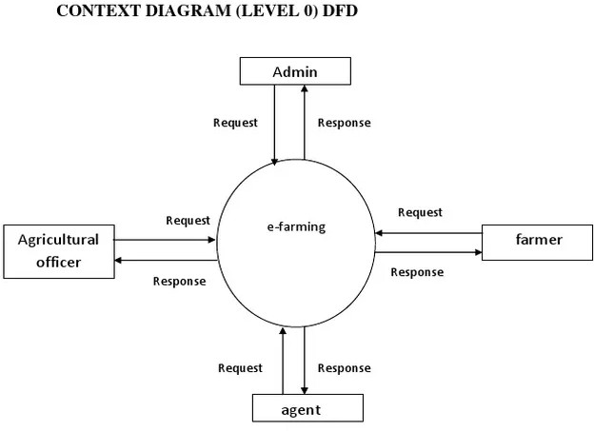

  - Entity Relationship Diagram

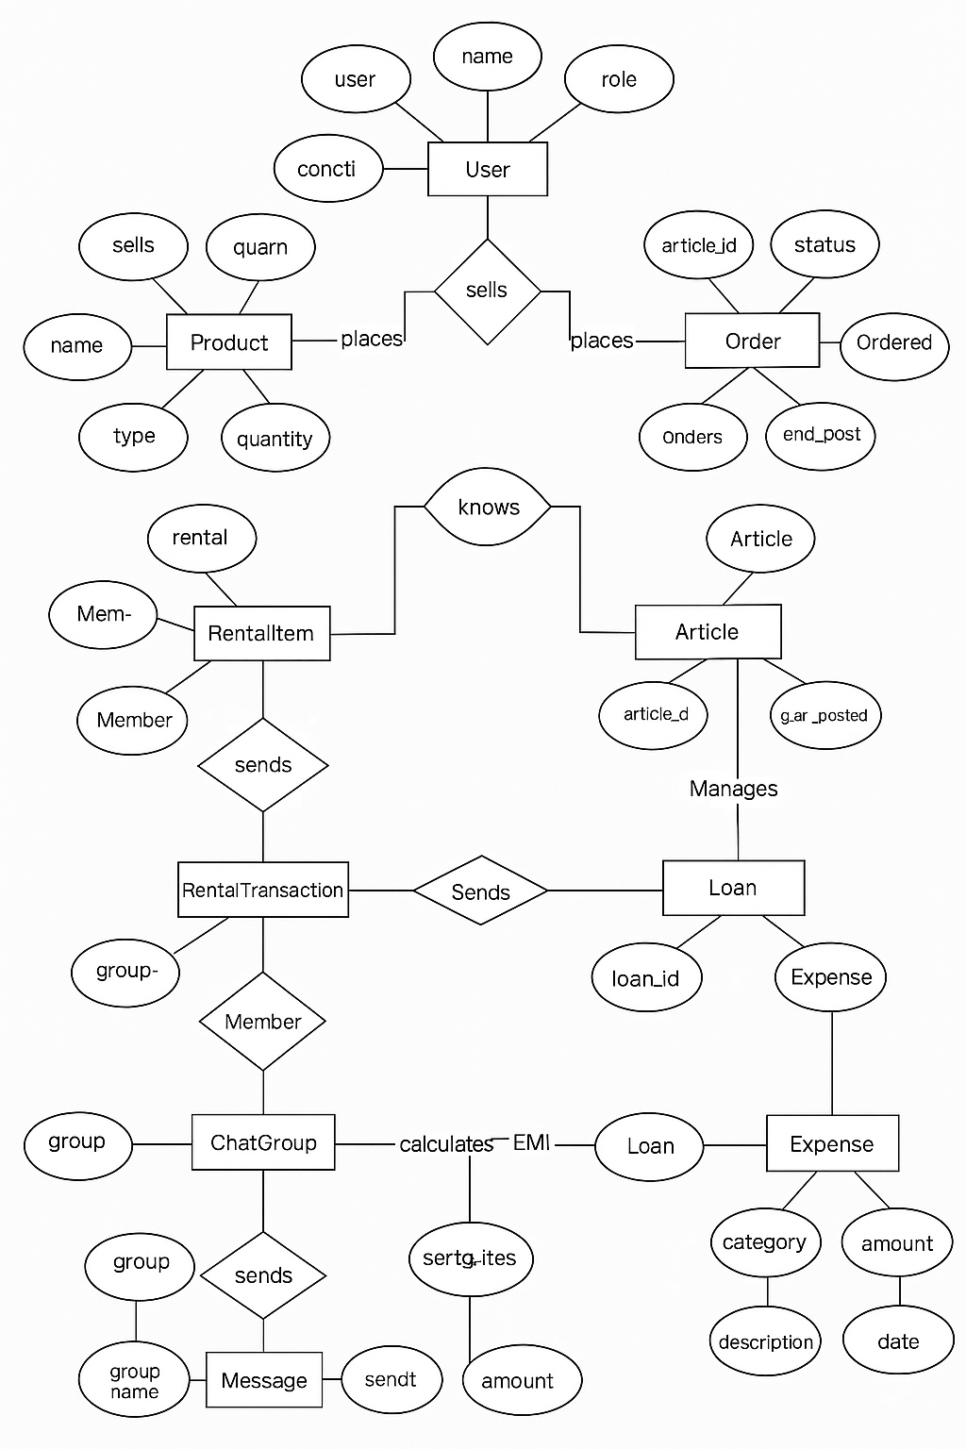

  - Physical and Behavioural Aspects of the System

Understanding a system involves analysing both its physical structure and behavioural characteristics. For the Krushi Manch platform, these two perspectives help define how the system looks, functions, and interacts with its users.

- Physical Aspects of the System
The physical aspect refers to the tangible components of the system, including the hardware, software, user interface design, and deployment environment.

  - User Interface (UI):
- Simple and clean design for ease of navigation.
- Multilingual support (e.g., English, Hindi, Marathi, etc.).
- Responsive layout suitable for desktops, tablets, and smartphones.
- Visual icons and minimal text to assist semi-literate users.

  - System Components:
- Frontend: HTML5, CSS3, JavaScript – used for creating user-facing pages.
- Backend: PHP – handles server-side operations and business logic.
- Database: MySQL – stores user data, crop information, weather, and market data.
- APIs: Integrated with third-party services to fetch live weather forecasts and market rates.

  - Physical Infrastructure:
- Cloud-based web hosting for easy access and scalability.
- Minimal hardware requirement on the user side (smartphone or PC with internet access).
- Compatible with low-speed internet connections.

- Behavioural Aspects of the System
The behavioural aspect focuses on how the system responds to user actions, system events, and data inputs.

  - User Behaviour and System Interaction:
- Users (farmers) can register, log in, and view personalized crop info and weather updates.
- System dynamically displays content based on user region and language.
- Expert users can respond to questions and upload agricultural tips.

  - System Responses:
- Displays error messages for incorrect inputs or system issues.
- Provides real-time updates from APIs (e.g., weather alerts).
- Stores and retrieves data based on user preferences and location.

  - Admin Activities:
- Admin can add, edit, or delete crop data, market price updates, and user profiles.
- System generates usage reports and manages content for quality control.

  - Notifications and Alerts:
- Behavioural logic includes sending notifications to users about:
  - Sudden weather changes
  - Market rate fluctuations
  - Pest/disease alerts for crops in their region

  - Security and Access Control:
- Login system ensures authorized access.
- Admin and expert functionalities are restricted by role-based access control.

User Interaction Flow

The User Interaction Flow illustrates how different users (Farmers, Experts, and Admins) interact with the Krushi Manch system from login to various functionalities. This flow helps visualize the steps a user follows while navigating the platform and accessing its features.

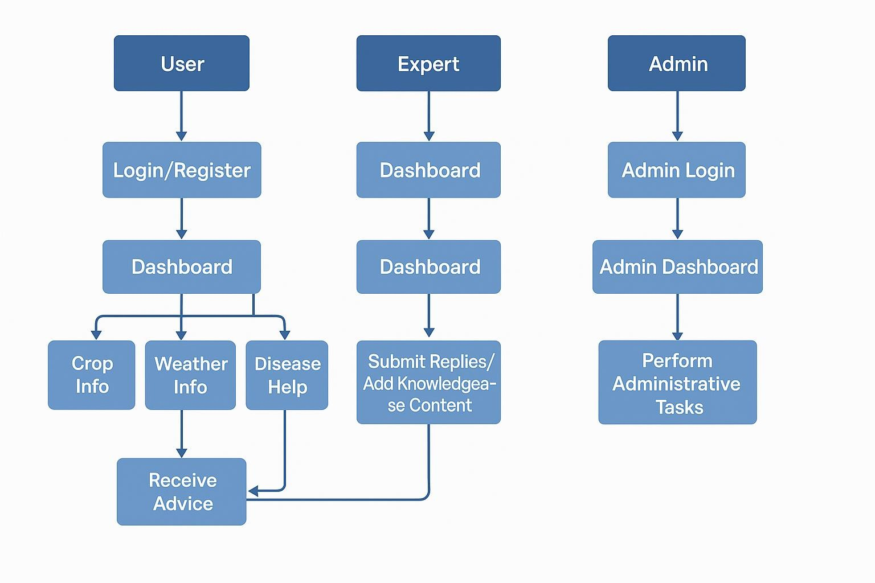

Admin Interaction Flow

The Admin Interaction Flow describes how the administrator interacts with the Krushi Manch system to manage content, users, and ensure the platform runs smoothly. The admin plays a vital role in maintaining data accuracy, controlling user access, and updating crop and market information.

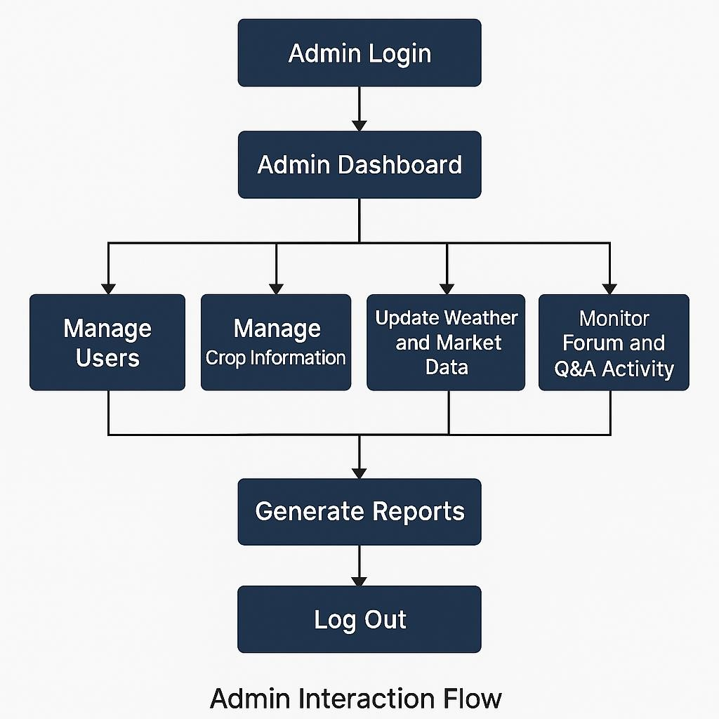

Chapter 5: Software Requirements Specifications

General Description

The Krushi Manch project is an agriculture-focused web platform designed to serve as a centralized knowledge-sharing and support system for farmers, agricultural officers, agronomists, and agricultural enthusiasts. The system aims to provide information, updates, and tools to help users make informed decisions about crop cultivation, soil management, pest control, weather patterns, government schemes, and other agricultural activities.
The platform will feature a user-friendly interface accessible via web browsers, allowing users to register, log in, and access content in multiple languages. It will also allow contributors to upload agricultural resources including crop information, disease control methods, soil and climate suitability data, and seasonal recommendations. Integration with a backend database will ensure secure and efficient data management, while multilingual support will increase accessibility for a wider rural user base.
The Krushi Manch system will include forums or discussion boards for community interaction, a Q&A section for expert advice, and possibly mobile support in the future. The goal is to enhance agricultural awareness, promote best practices, and bridge the information gap between agricultural experts and farmers through a scalable and extensible digital platform.

Product Perspective
The Krushi Manch platform is a standalone web-based information and communication system specifically developed for the agricultural sector. It is an original product, but it can be integrated in the future with other government portals, agricultural databases, weather forecasting APIs, or mobile applications to expand its functionality.
The system is designed to follow a modular architecture with distinct layers for user interface, business logic, and data storage. Each module (such as user management, crop information, discussion forums, language translation, etc.) is developed to ensure scalability, maintainability, and ease of future enhancement.
The product will be hosted on a secure web server and will interact with a backend database (e.g., MySQL or PostgreSQL) to manage user data, crop records, disease databases, and multilingual content. It will provide role-based access for different types of users including farmers, administrators, agricultural officers, and content contributors.

Product Functions

The Krushi Manch system provides a range of functions aimed at improving access to agricultural knowledge and fostering interaction among users. The primary functions of the platform include:
      - User Registration and Login
      - Crop Information Management
      - Multilingual Support
      - Discussion Forum / Q&A Section
      - Resource Upload and Sharing
      - Search and Filter Functionality
      - Admin Panel
      - Notifications and Announcements
      - Feedback System
These functions work together to ensure that Krushi Manch serves as a comprehensive platform for agricultural learning, discussion, and support tailored to the needs of the rural farming community.

User Characteristics

The users of Krushi Manch come from diverse backgrounds with varying levels of technical knowledge and agricultural expertise. The system is designed to be intuitive and accessible to accommodate all user types. Below is a summary of key user groups:

User Type | Description | Technical Expertise | Responsibilities / Access
Farmers | Primary users seeking information on crops, diseases, and best practices. | Low (basic smartphone/computer usage) | View content, participate in forums, ask questions, receive notifications.
Agricultural Experts | Subject matter experts contributing knowledge and answering questions. | Medium to High | Answer questions, upload resources, manage crop information, participate in discussions.
Administrators | Platform managers overseeing user accounts and content moderation. | High | Full system access: manage users, content, forums, announcements, and settings.
Contributors | Registered users (other than experts/admins) who can upload verified content. | Medium | Upload articles/resources, participate in forums (content approval needed).
General Visitors | Unregistered users visiting the site for general information. | Low | Can browse publicly available crop info and forum posts (read-only access).

General Constraints
- Platform Compatibility
The system must be accessible via modern web browsers (Chrome, Firefox, Edge, Safari) on both desktop and mobile devices.
- Language Support
The platform must support multilingual content, including English and at least two regional languages (e.g., Hindi and Kannada), with easy scalability for more
languages in the future.
- User Accessibility
The interface should be designed with accessibility in mind, adhering to WCAG 2.1 standards where possible, including readable fonts, contrast, and screen reader compatibility.
- Performance Requirements
Pages must load within 3 seconds on a standard 3G mobile connection. Crop data and images should be optimized to reduce load times without sacrificing clarity.
- Scalability
The backend and database must support up to 10,000 concurrent users and a database of at least 5,000 crop entries without significant performance degradation.
- Security
- User data must be securely stored using encryption.
- Input fields must be protected from SQL injection and XSS attacks.
- Role-based access control (admin vs. general users) must be enforced.
- Data Integrity
All crop-related information must be validated before being saved or displayed. Only authorized users can edit or delete data.
- Hosting and Deployment Constraints
The application will be hosted on a Linux-based server with support for PHP, MySQL, and Apache. All components must be compatible with this environment.
- Offline Support (Optional)
The system should provide a fallback or cached version of basic crop information in case of intermittent internet connectivity (for mobile users).
- Maintenance and Updates
The system must be designed with modular components to allow easy updates and maintenance without downtime.

Assumptions and Dependencies

Assumptions
      - Internet Connectivity
It is assumed that users (farmers, agricultural officers, etc.) have access to a stable internet connection to use the platform effectively.
      - User Familiarity with Basic Devices
Users are expected to have basic knowledge of using smartphones or computers to access the platform.
      - Timely Content Availability
All crop-related data (including text, images, and disease information) will be
provided by the agricultural department or reliable data sources in a timely manner.
      - Language Translations
Regional language translations will be provided or verified by linguistic experts or relevant authorities before being uploaded to the system.
      - Hosting Resources
The hosting environment will be provided with necessary resources such as PHP support, MySQL database access, sufficient bandwidth, and security configurations.
      - User Support
A basic helpdesk or support channel (email/chat/phone) will be available for users needing assistance with the platform.

Dependencies
- Third-Party Libraries and Frameworks
  - PHP for backend development
  - MySQL for database management
  - JavaScript libraries for frontend interactivity
  - Language translation APIs or tools (if automated translation is used)
- Web Hosting Provider
The performance and availability of the platform are dependent on the reliability of the hosting provider.
- Data Accuracy from Contributors
Accuracy and consistency of crop information depend on the data provided by agricultural experts or government agencies.
- Browser Compatibility
The application’s performance and UI/UX are dependent on the compliance of browsers with modern web standards.
- Future Integration Needs
Any integration with external systems such as weather APIs, government portals, or SMS gateways will depend on the availability and stability of those services.

Functional Requirements

The Krushi Manch platform aims to deliver agricultural information and support to farmers and other stakeholders. The following functional requirements outline the core system behaviours and interactions:
- User Management
  - FR1.1: The system shall allow users to register with basic details (name, contact, language preference, etc.).
  - FR1.2: The system shall provide login functionality for registered users using a username and password.
  - FR1.3: The system shall allow password recovery via email or SMS verification.
  - FR1.4: The system shall differentiate between user roles (admin and general user) with appropriate permissions.
- Crop Information Module
  - FR2.1: The system shall display a list of crop varieties with key details (name, type, season, duration).
  - FR2.2: The system shall allow users to search for crops by name, type, season, or language.
  - FR2.3: The system shall allow users to view detailed crop information, including:
    - Ideal soil and climate
    - Common diseases and treatments
    - Images of crops at various stages
  - FR2.4: The system shall allow admin users to add, edit, or delete crop records.
- Multilingual Support
  - FR3.1: The system shall support dynamic content display in multiple languages.
  - FR3.2: The system shall allow users to select their preferred language from the interface.

- Notifications and Alerts
  - FR4.1: The system shall send alerts or notifications about seasonal tips, pest outbreaks, or important updates via email or SMS (if integrated).
  - FR4.2: The system shall allow admin users to publish announcements visible to all users.
- Offline Accessibility (Optional)
  - FR5.1: The system shall store a limited cache of crop information for offline access on mobile browsers (if implemented via PWA or similar).
- Feedback and Support
  - FR6.1: The system shall allow users to submit feedback or report issues through a contact form.
  - FR6.2: The system shall store user feedback for review by the admin.
- Content Management
  - FR7.1: The system shall provide an admin dashboard to manage:
    - Crop data
    - Language content
    - User feedback
    - News or tips section

Non-Functional Requirements

Non-functional requirements define the quality attributes and constraints of the Krushi Manch
system that ensure its reliability, usability, and performance.
- Performance Requirements
  - NFR1.1: The system shall respond to user actions within 2–3 seconds under normal load.
  - NFR1.2: The platform must support at least 10,000 concurrent users without performance degradation.
- Usability Requirements
  - NFR2.1: The interface shall be simple, intuitive, and accessible to users with minimal digital literacy.
  - NFR2.2: The design shall follow consistent layouts and language-appropriate icons to help users navigate easily.
  - NFR2.3: The system shall provide tooltips and brief instructions for form fields and major sections.
- Reliability & Availability
  - NFR3.1: The system shall be available 99.5% of the time annually (excluding scheduled maintenance).
  - NFR3.2: The system shall provide appropriate error messages and fallback behavior in case of temporary failures.
- Scalability
  - NFR4.1: The system shall be scalable to handle future additions like weather data integration, crop price tracking, etc.
  - NFR4.2: The backend architecture must allow horizontal scaling when hosted on cloud or VPS environments.

- Security Requirements
  - NFR5.1: All user passwords shall be stored using salted hashing algorithms.
  - NFR5.2: Input validation and sanitization shall be enforced to prevent SQL injection, XSS, and CSRF attacks.
  - NFR5.3: Role-based access control shall restrict admin features to authorized users only.
- Maintainability
  - NFR6.1: The codebase shall be modular and documented to ease maintenance and future upgrades.
  - NFR6.2: The system should support logging and monitoring features to detect and resolve issues promptly.
- Localization
  - NFR7.1: The system shall support dynamic switching between at least three languages (English and two regional languages).
  - NFR7.2: Date formats, units, and terminologies shall be localized appropriately for each language.
- Backup & Recovery
  - NFR8.1: The system shall perform daily automated backups of all critical data.
  - NFR8.2: In the event of system failure, the system shall be recoverable within 24 hours.

External Interface Requirements

This section outlines how the Krushi Manch system will interact with external users, systems, and hardware components. These interfaces ensure smooth data exchange, usability, and integration.

    - User Interfaces
- UI1: The system shall provide a responsive web interface accessible via desktop, tablet, and smartphone browsers.
- UI2: The user interface shall support multilingual display, with a language switch option at the top of every page.
- UI3: The homepage shall offer:
  - A search bar for crops
  - Language selection
  - Seasonal tips or news highlights
- UI4: Admin users shall have access to a dashboard with modules for:
  - Managing crop data
  - Managing users and permissions
  - Publishing announcements and seasonal tips
- UI5: All form fields shall include labels, hints/tooltips, and error messages for validation feedback.

    - Hardware Interfaces
- HW1: The system is expected to run on standard web servers and does not require any specialized hardware.
- HW2: Client devices (desktop, mobile, tablet) must support modern web browsers and internet connectivity.

    - Software Interfaces
- SW1: The backend system shall use:
  - PHP for server-side scripting
  - MySQL for database management
- SW2: The frontend shall use:
  - HTML, CSS, JavaScript (optionally with frameworks like Bootstrap or Vue/Angular for responsiveness)
- SW3: The system may optionally use:
  - Language translation APIs (e.g., Google Translate API) if dynamic translation is supported
  - Weather APIs or government agriculture APIs in the future
- SW4: A mail server or SMS gateway may be integrated for sending notifications and alerts.

    - Communication Interfaces
- COM1: The system shall communicate with users over HTTPS to ensure encrypted data transmission.
- COM2: Admin-uploaded data or updates shall be reflected in real-time or with minimal delay (within 1 minute).
- COM3: Integration with external systems (if any) shall use RESTful APIs with JSON data format.
- COM4: The system shall log failed communication attempts and retry mechanisms where applicable (e.g., failed SMS/email delivery).

Performance Requirements
The performance requirements specify the expected speed, scalability, and responsiveness of the Krushi Manch system to ensure a smooth and efficient user experience.

    - Response Time
- PR1: The system shall load the homepage within 3 seconds on a standard 3G mobile network.
- PR2: Crop search results shall be displayed within 2 seconds of a user query.
- PR3: Form submissions (registration, feedback, crop info updates) shall complete within 2–3 seconds.

    - Concurrent Users
- PR4: The system shall support a minimum of 10,000 concurrent users without noticeable performance degradation.
- PR5: The backend shall be designed to scale horizontally to support future user growth.

    - Data Throughput
- PR6: The system shall be capable of handling at least 100 read/write operations per second under peak load conditions.
- PR7: The system shall support simultaneous image loading for multiple crop entries without lag.

    - Availability
- PR8: The platform shall maintain 99.5% uptime per year (excluding scheduled maintenance).
- PR9: The system shall notify the admin in case of critical service failures or downtimes via email/SMS.

    - Scalability
- PR10: The system shall allow the addition of new modules (e.g., weather info, crop price updates) without affecting existing performance.
- PR11: Database indexing and caching mechanisms shall be used to ensure fast data retrieval even as the crop database grows.

Design Constraints
Design constraints define the limitations and standards that must be considered during the development of the Krushi Manch platform. These constraints ensure consistency,
compatibility, and alignment with project goals and technical environments.

Technology Constraints
- DC1: The system must be developed using PHP for backend development and
MySQL for database management.
- DC2: The frontend shall be developed using HTML, CSS, and JavaScript, with optional use of frontend frameworks like Bootstrap or Angular for responsiveness and scalability.
- DC3: The platform must be hosted on a Linux-based server with support for

Apache, PHP, and MySQL.

    - Browser Compatibility
- DC4: The application must be compatible with the latest versions of all major browsers:
  - Google Chrome
  - Mozilla Firefox
  - Microsoft Edge
  - Safari (iOS and macOS)

Device Compatibility
- DC5: The system must be responsive and accessible on a wide range of devices, including:
  - Smartphones (Android/iOS)
  - Tablets
  - Desktop and laptop computers

Language Support
- DC6: The system must support multilingual content and allow seamless switching between at least three languages (e.g., English, Hindi, and Kannada).
- DC7: All static and dynamic content must be designed to accommodate language- specific formatting, alignment (e.g., RTL if needed), and special characters.

Security Standards
- DC8: The system must use HTTPS for all communications to ensure data encryption.
- DC9: Passwords must be stored securely using hashed and salted encryption techniques.
- DC10: Input validation and output encoding must be applied consistently to prevent
SQL injection, XSS, and CSRF attacks.

UI/UX Standards
- DC11: The user interface must follow simple, minimalistic design principles with accessibility in mind.
- DC12: Font sizes, colour contrast, and navigation structures must be compliant with
WCAG 2.1 guidelines for accessibility where possible.

Chapter 6: System Design

Introduction
The System Design chapter outlines the architectural and component-level planning for the Krushi Manch platform. This design phase translates the system requirements into a structured solution that guides the development and deployment of the application.
The primary goal of the Krushi Manch design is to create a scalable, modular, and user-friendly agricultural information system that supports multilingual access and provides reliable data on crop varieties, cultivation methods, and plant health. The design approach follows a layered architecture that separates concerns such as presentation, business logic, and data storage, allowing for easy maintenance and future enhancements.

  - System Architecture
    - User Interface

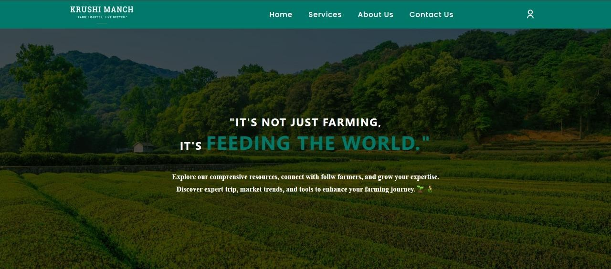

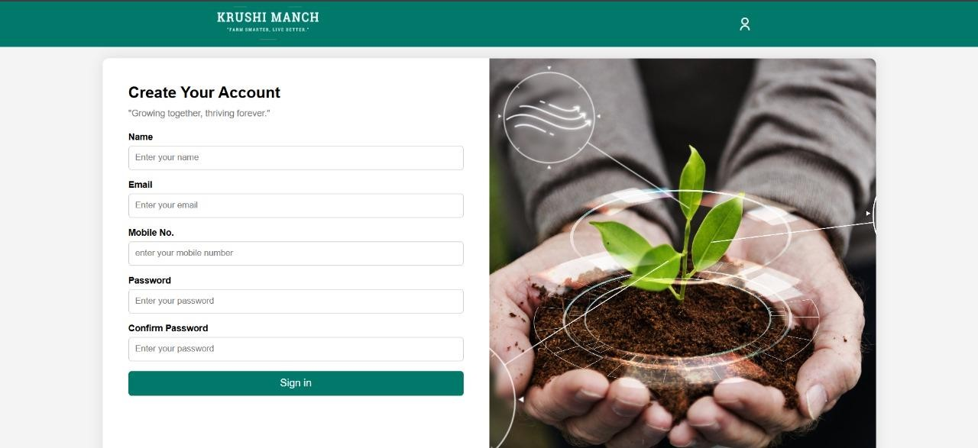
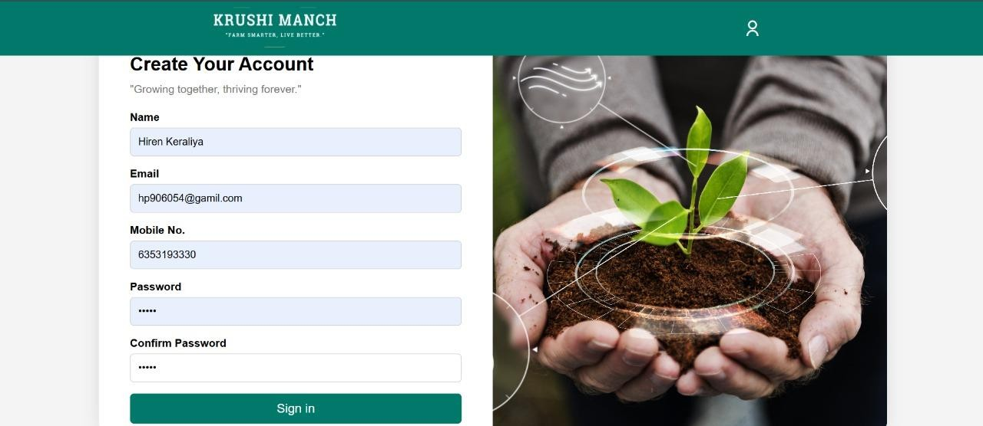

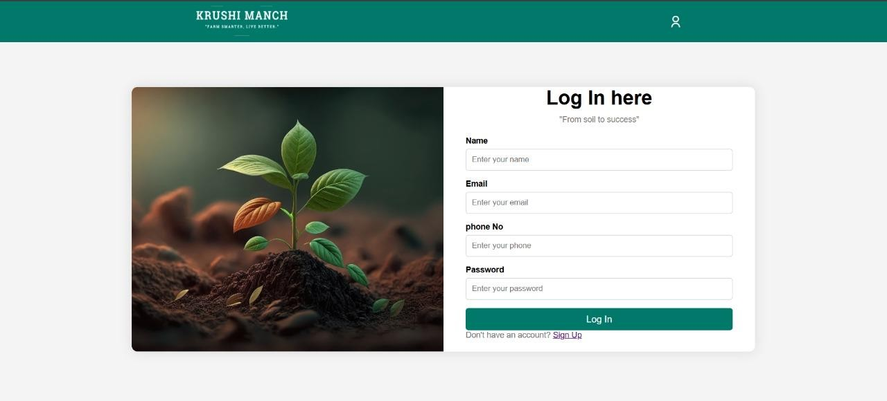
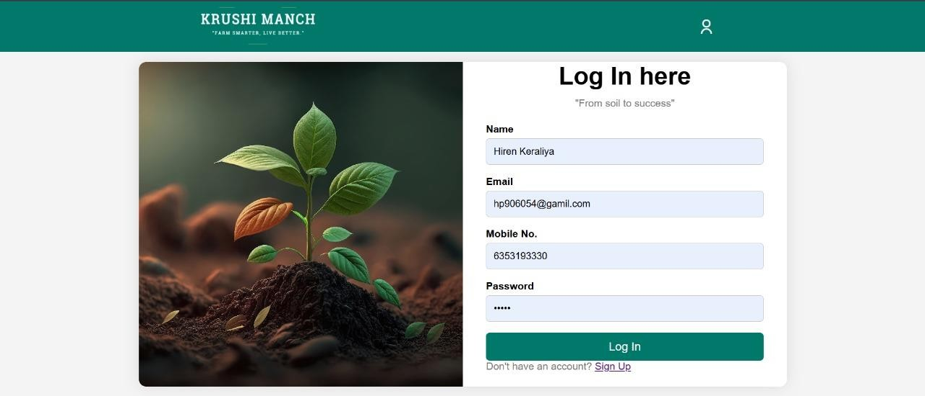

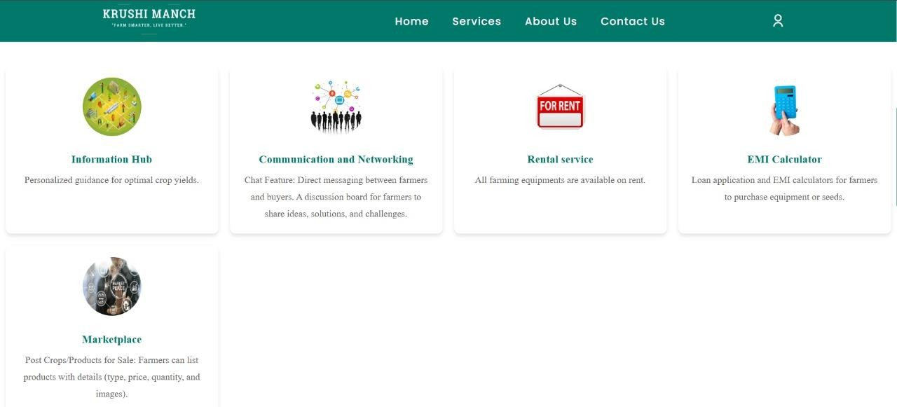

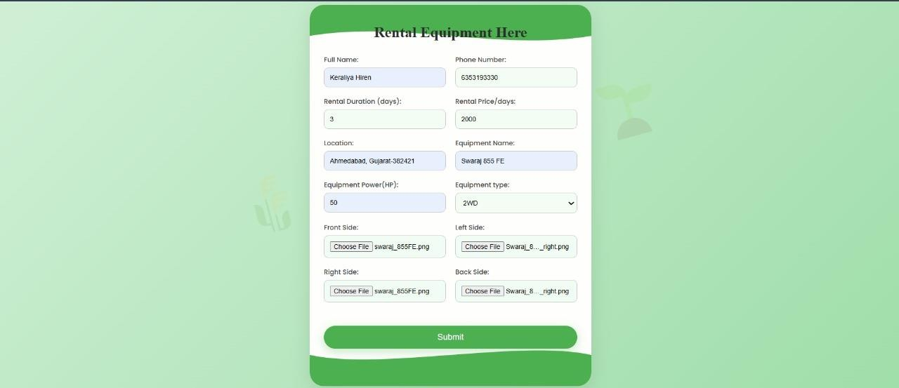

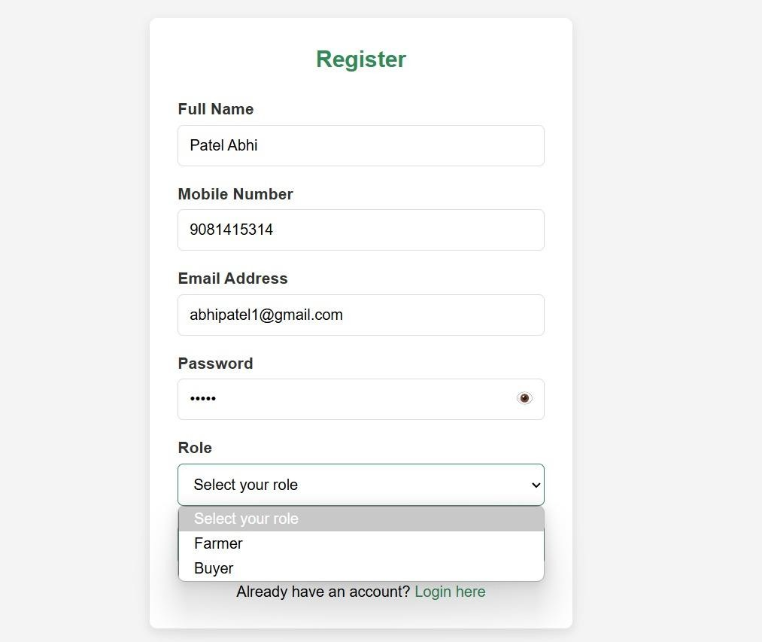

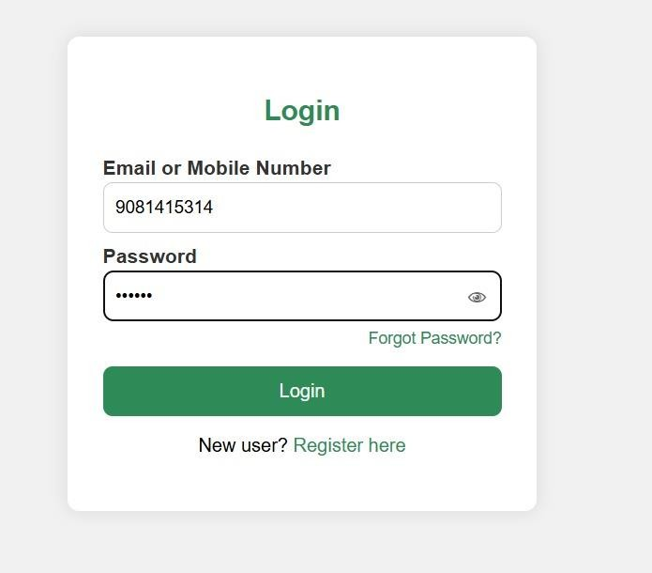

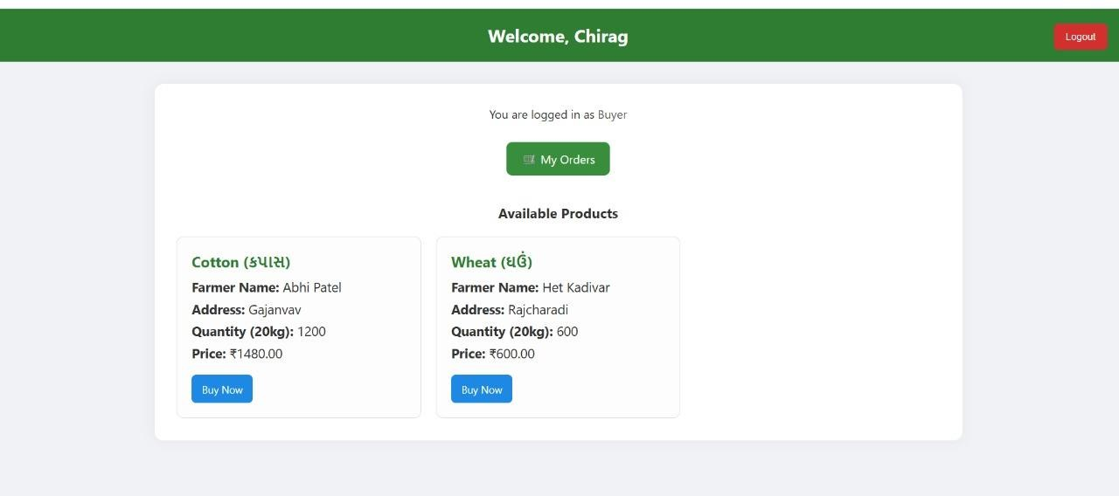

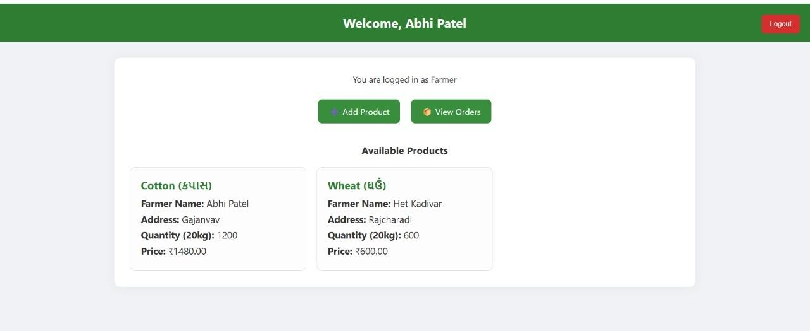

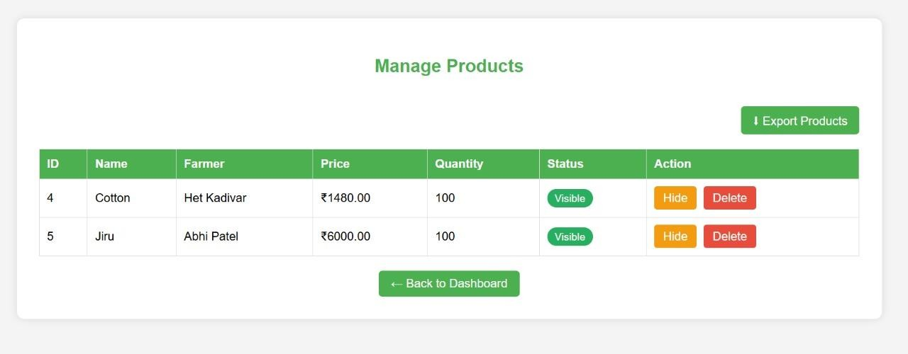

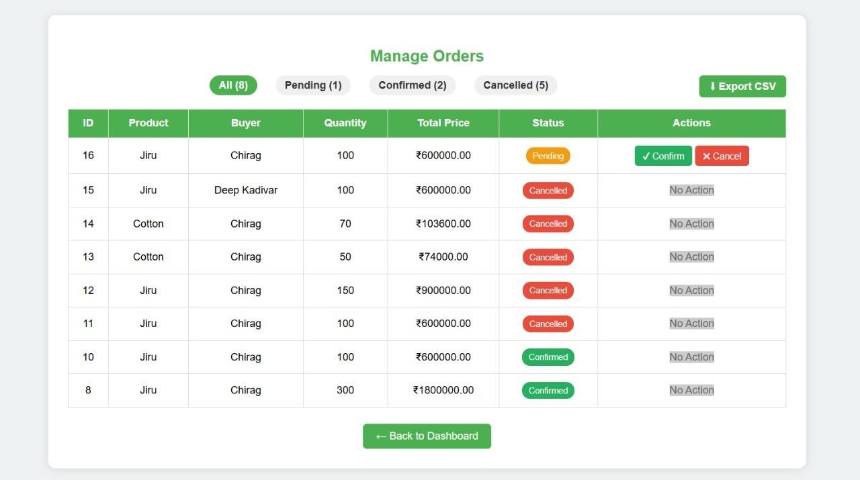

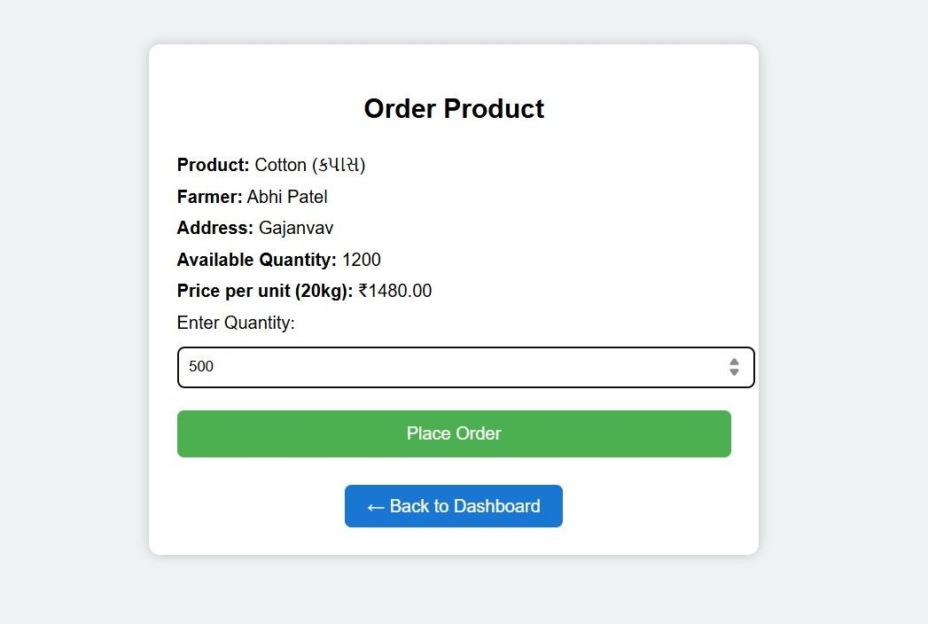

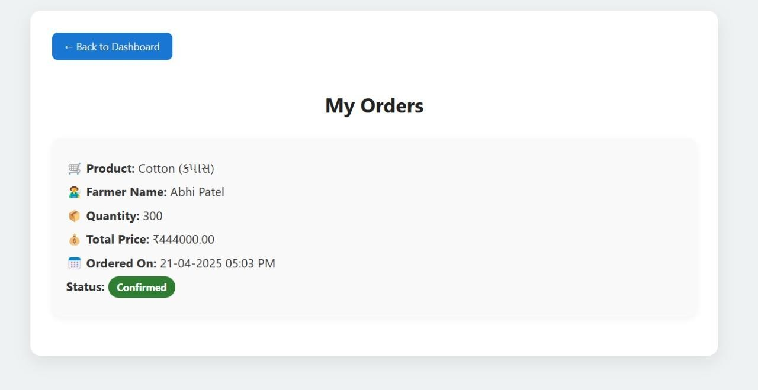

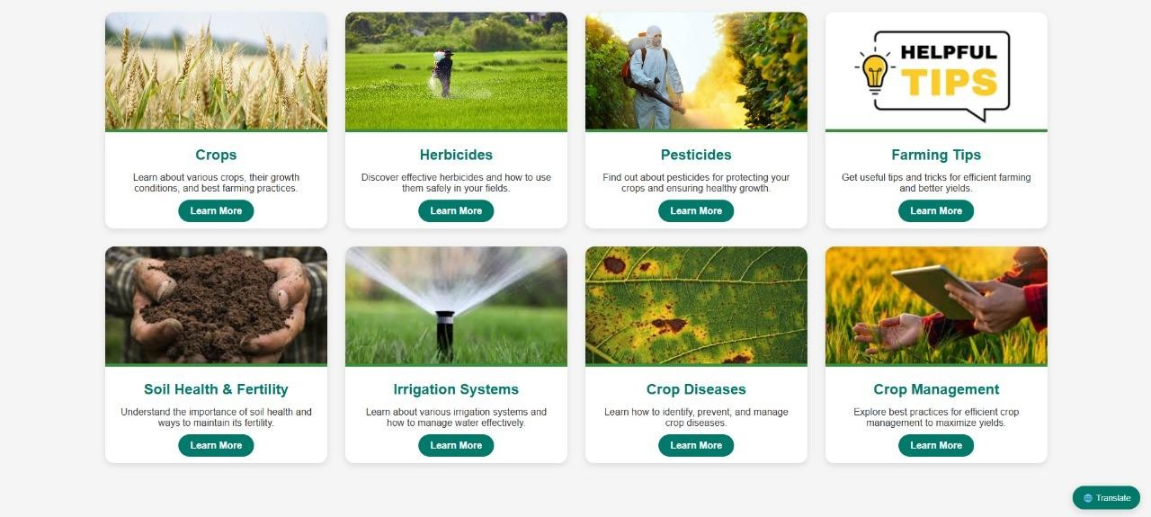

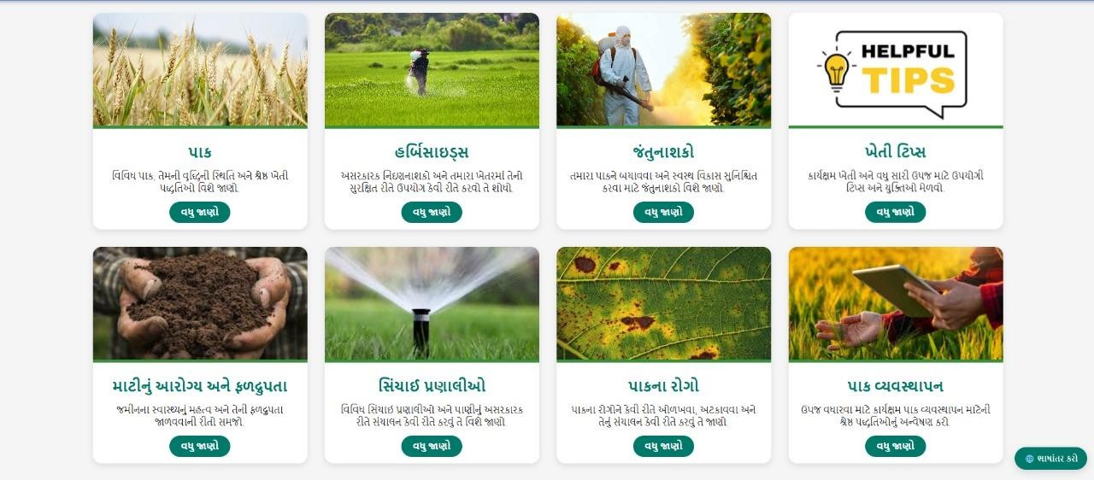

  - Module Design
    - Admin Interface
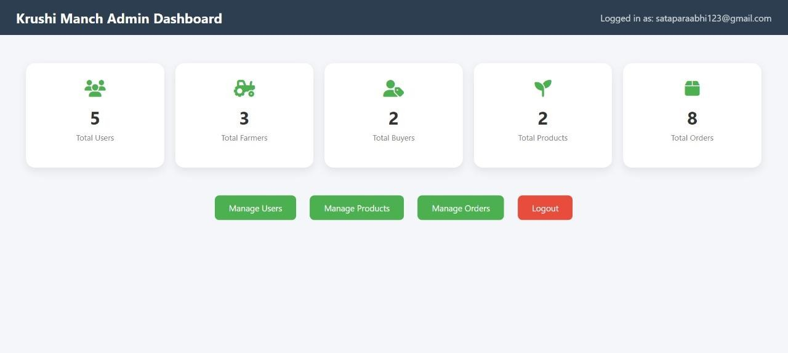
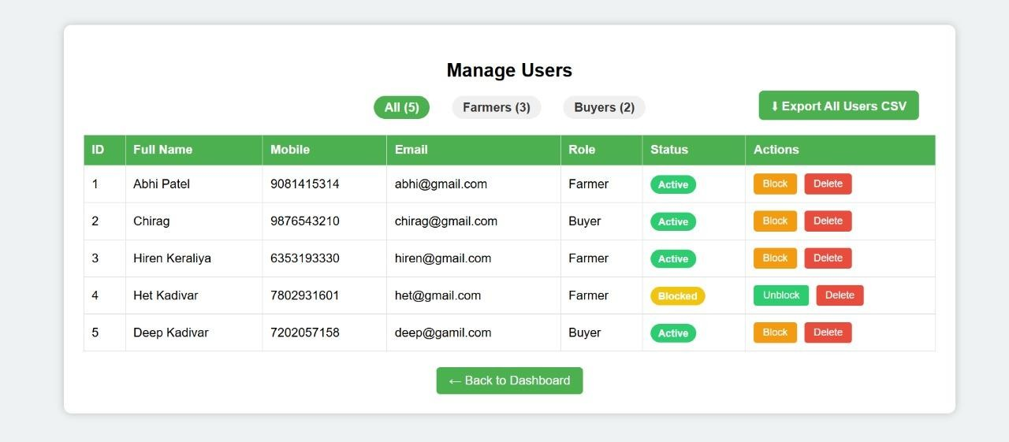

  - Database Design
- Key Table
  - Users
  - Products
  - Orders

Users

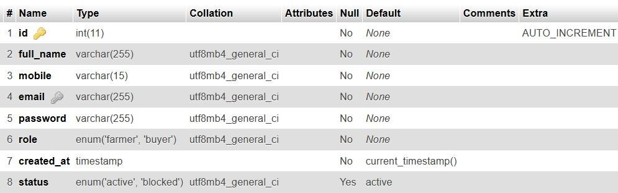

Products

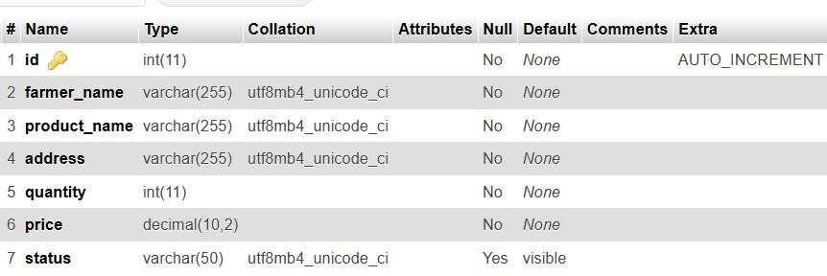

Orders

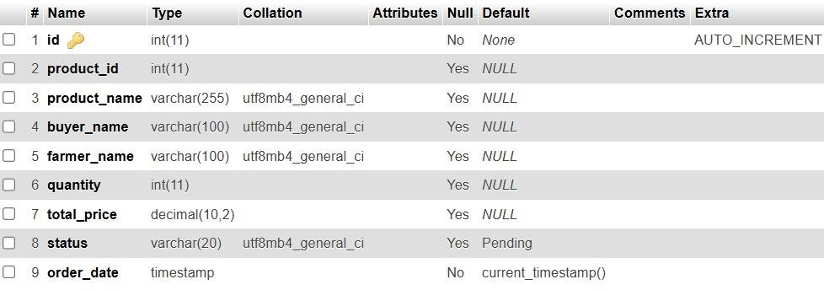

Input Output Design
The Input/Output (I/O) Design focuses on how users interact with the Krushi Manch system, detailing the structure, format, and flow of data entered into and generated by the application. The goal is to ensure usability, clarity, and data accuracy in all interactions.

    - Input Design
Input design defines how data is captured from users and administrators. The design prioritizes ease of use, validation, and consistency.

Key Input Interfaces:

Input Form | Fields | Validation Rules
User Registration | Name, Email/Phone, Password, Language Preference | Required fields, valid email/phone format
Login | Username, Password | Required fields, password masking, error handling
Crop Information Entry | Crop Name, Type, Season, Duration, Diseases, Image Upload | All fields required, image type & size validation
Feedback Form | Name, Email, Message | Basic validation, message length limit
Language Translation Form | Crop ID, Language, Translated Content | Input must match target language character set

    - Output Design
Output design ensures that data presented to users is meaningful, readable, and well-formatted across devices and languages.

Key Output Interfaces:

Output Type | Details Displayed
Crop List View | Crop Name, Season, Image Thumbnail
Crop Detail Page | Full crop information: description, soil/climate, diseases, images, in selected language
Admin Dashboard | User statistics, crop management tools, content upload history
Notifications/Alerts | Upcoming seasonal alerts, pest warnings, general announcements
Reports (optional) | CSV or printable reports of crop database entries or user activity

Algorithm Design
Algorithm design in Krushi Manch focuses on creating efficient, reliable, and user-friendly logic to handle key functionalities such as searching, filtering, language switching, user authentication, and data validation. The algorithms ensure that the system operates smoothly while delivering accurate results and a good user experience.

    - User Authentication Algorithm
Purpose: Validate login credentials and establish user sessions. Algorithm:
      - Input: username, password
      - Sanitize inputs to prevent SQL injection.
      - Query database for user record matching the username.
      - If record exists:
        - Hash the input password using the same hash algorithm used for storage.
        - Compare hashed password with stored password hash.
        - If match:
          - Start session and redirect to user dashboard.
        - Else:
          - Show “Invalid credentials” error.
      - Else:
        - Show “User not found” error.

    - Crop Search Algorithm
Purpose: Search crops by name, type, or season. Algorithm:
      - Input: search query (e.g., crop name/season/type)
      - Normalize input (e.g., lowercase, trim spaces)
      - Return result set to frontend for display.

    - Language Switching Algorithm
Purpose: Display content in the user’s selected language. Algorithm:
      - Input: language selected (e.g., English, Kannada, Hindi)
      - Store language preference in session or cookie.
      - On each page load:
        - Fetch crop content based on selected language from translation table.
        - If translation is not available, fallback to default language.
      - Render page content accordingly.

    - Crop Addition (Admin Only)
Purpose: Allow admin to add new crop data. Algorithm:
      - Input: Crop details (name, type, season, image, etc.)
      - Validate all required fields.
      - Sanitize inputs and check for duplicates.
      - Upload and store image with proper naming.
      - Insert crop record into the crops table.
      - Redirect to crop list with success message.

    - Feedback Submission Algorithm Purpose: Collect user feedback for review. Algorithm:
      - Input: Name, Email, Feedback Message
      - Validate required fields and message length.
      - Sanitize input.
      - Store in feedback table.

Electronic Data Communication Design

The Electronic Data Communication Design outlines how the Krushi Manch system transmits, receives, and manages data over digital communication channels. This includes internal communication between system components, user-device communication, and integration with external services.

    - Communication Objectives
- Ensure secure, reliable, and efficient transmission of data between client devices, servers, and any third-party APIs.
- Support real-time updates where applicable (e.g., crop additions, feedback submission).
- Enable multilingual content delivery based on user preferences.

    - Data Communication Channels
- Client ↔ Web Server: HTTP/HTTPS requests for content loading, form submissions, and user authentication.
- Admin Panel ↔ Database: Secure server-side operations for CRUD (Create, Read, Update, Delete) operations on crop and user data.
- User ↔ Server: Form-based interactions (login, registration, feedback, crop search) via secured connections.
- Optional (Future Scope): Integration with external APIs (e.g., SMS notifications, weather updates) over RESTful interfaces.

System Maintenance

Activity | Frequency | Responsibility
Database backup | Daily / Weekly | Server Admin
Security patches & plugin updates | Monthly / As needed | Developer/IT Team
Bug fix and code updates | As issues are reported | Development Team
User feedback review | Monthly | Project Coordinator/Admin
Content update (crops/tips) | Seasonal / As needed | Admin or Agriculture Expert
Server monitoring & uptime checks | 24/7 | Hosting Provider / IT Team

  - Other Alternative Considered

    - Alternative Backend Technologies

Option | Pros | Cons | Reason Not Chosen
Node.js | High performance, non- blocking I/O, scalable | Requires more advanced server setup | More complex for simple CRUD-based operations
Python (Django/Flask) | Clean syntax, rapid development, good ORM support | Fewer shared hosting options, heavier for small apps | PHP is more  compatible with existing hosting setup
PHP (Chosen) | Wide support, easy to deploy, ideal for LAMP stack | Slightly outdated in design pattern (if not using frameworks) | Best fit for existing infrastructure

    - Alternative Database Options

Option | Pros | Cons | Reason Not Chosen
PostgreSQL | Advanced features, robust transactions | Slightly steeper learning curve | MySQL is more common in shared  hosting environments
MongoDB | Schema-less, flexible for  unstructured data | Not ideal for relational crop data | Relational structure suits crop records  better
MySQL  (Chosen) | Reliable, widely used, supported by PHP | Requires indexing for performance with large data | Best fit with LAMP stack and relational structure

    - Frontend Alternatives

Option | Pros | Cons | Reason Not Chosen
React | Component-based, great for dynamic UIs | Requires build tools, less  intuitive for beginners | Too heavy for  basic display and form interactions
Angular | Rich features,  powerful for large applications | Steeper learning curve, heavy  initial setup | Overkill for  small-to-medium web project
Plain  HTML/CSS/JS with Bootstrap (Chosen) | Simple, fast  loading, responsive UI with minimal setup | Limited  interactivity compared to SPA frameworks

Chapter 7: System Implementation

Software Environment
The software environment defines the platforms, tools, and technologies required to develop, deploy, and maintain the Krushi Manch system. These selections were made based on factors such as compatibility, ease of use, scalability, and support for multilingual content and agricultural data handling.

    - Development Environment

Component | Technology / Tool | Purpose
Frontend Development | HTML5, CSS3, JavaScript, Bootstrap | Designing responsive, user-friendly interfaces
Backend  Development | PHP (Core PHP or Laravel – if used) | Server-side scripting and handling user logic
Database Management | MySQL | Storing and retrieving crop and user data
Language Support | UTF-8 Encoding | Displaying multilingual content (e.g., Hindi, Kannada)
Text Editor / IDE | VS Code / Sublime Text | Code writing and editing
Version Control | Git (optional) | Source code management and version tracking

System Development Platform
The Krushi Manch system was developed using a combination of open-source and widely supported tools that ensure accessibility, cost-effectiveness, and ease of deployment. The chosen development platform supports PHP-based web applications with a MySQL backend, optimized for both shared hosting and local development environments.

    - Development Platform Overview

Component | Platform / Tool | Purpose
Operating System | Windows 10 / 11  (Development) | Local development and testing
Local Server Stack | XAMPP / WAMP / LAMP | Bundle of Apache, MySQL, and PHP for development
Server-Side Language | PHP 7.x / 8.x | Backend scripting for processing logic
Database System | MySQL | Storing crop data, user data, translations
Frontend Technologies | HTML5, CSS3, JavaScript, Bootstrap | Interface design and responsiveness
Text Editor / IDE | Visual Studio Code, Sublime Text | Writing and managing source code
Browser for Testing | Google Chrome, Mozilla Firefox | Testing and debugging frontend design
Database Tool | phpMyAdmin | GUI for database creation and query execution

Project Accomplishment Status

- Implementation Phase: 90% Complete
- Testing & Finalization: In Progress
- Expected Readiness for Deployment: ✅ Ready after final testing
- Deployment Environment: Localhost tested, ready for shared hosting or server deployment

Guidelines for Continuation

- Regularly update content via admin dashboard.
- Monitor system performance and collect user feedback.
- Add support for QR code scanning as a future enhancement.

Chapter 8: System Testing

Test Plan

The test plan outlines the overall strategy, objectives, scope, and activities for testing the Krushi Manch system. The goal is to ensure that the application is functional, reliable, user-friendly, and free from critical defects before final deployment.

    - Objectives of Testing
      - Verify that all system functionalities work as intended.
      - Identify and fix defects in both frontend and backend modules.
      - Ensure compatibility across browsers and devices.
      - Validate the user experience in all supported languages.
      - Ensure database integrity and secure user interactions.

    - Scope of Testing
The following components of Krushi Manch are covered under testing:
      - Crop data display and search
      - Language switching mechanism
      - User login/logout and admin access
      - Feedback submission and retrieval
      - Image upload and crop content management
      - Responsive design across devices

  - Test Case

Test Case ID | Test Case Description | Preconditions | Test Steps | Expected Result | Actual Result | Pass/Fail | Remarks
TC_001 | Verify user login functionality | User is  registered | - Navigate to the login page  - Enter valid credentials  - Click "Login" | User is logged in and redirected to the homepage
TC_002 | Verify invalid login attempt | User is  registered | - Navigate to the login page  - Enter invalid credentials  - Click "Login" | Error message is displayed: "Invalid username or password."
TC_003 | Verify crop  information search functionality | Crop data exists in DB | - Navigate to the search bar  - Enter a crop name  - Click "Search" | Search results display matching crop details
TC_004 | Verify language switch functionality  (Hindi/English) | Language options available | - Select "Hindi" from the language menu  - Check the text on the page | The page content is displayed in Hindi
TC_005 | Verify image upload functionality in Admin Panel | Admin login credentials | - Login as Admin  - Navigate to the crop management section  - Upload an image | - Login as Admin  - Navigate to the crop management section  - Upload an image

Chapter 9: Conclusion & Future Direction of Work

Conclusion

The Krushi Manch project successfully achieves its primary goal of providing a comprehensive, user-friendly platform for sharing agricultural knowledge. With the integration of multilingual support, the system caters to a diverse user base, ensuring that information about various crop varieties is easily accessible. The project has demonstrated the power of technology in bridging gaps in agricultural knowledge dissemination, empowering farmers, agricultural students, and enthusiasts with the information they need to make informed decisions.
Key highlights of the project include:
- A responsive and intuitive interface that supports multiple languages.
- Easy-to-use features such as crop information search, feedback submission, and crop management for admins.
- Robust backend using PHP and MySQL for seamless data management and retrieval.
- Implementation of basic security features for user authentication and data privacy.
Throughout the development, emphasis was placed on ensuring that the platform is simple, efficient, and scalable, keeping the needs of rural users and agricultural professionals in mind. User feedback was actively incorporated to improve the system’s features and ensure that it truly addresses the challenges faced by the target audience.

Future Direction of Work
While the Krushi Manch project has successfully addressed its primary objectives, there are several areas where future enhancements can further elevate the platform’s functionality, accessibility, and user engagement. The following directions outline the next steps for developing and expanding the system.

Enhanced Features and Functionality
      - Mobile Application Development:
        - Develop a dedicated mobile application for both Android and iOS to provide offline access to crop information, weather updates, and farming tips. The app could feature push notifications for new content, pest alerts, and seasonal tips.

Weather Integration:
        - Integrate real-time weather data and forecasts to help farmers plan agricultural activities. By connecting the platform with external weather APIs, the system can offer localized weather reports for different regions, aiding decision-making regarding planting and harvesting.

Advanced Search and Filtering:
        - Implement more advanced search features, such as filtering by soil types, climate zones, or agricultural practices. This would help users find specific crop details tailored to their local conditions.

E-Commerce Integration:
        - Enable an e-commerce section where users can purchase farming equipment, seeds, and fertilizers. Partnering with local agricultural suppliers can make this feature a one-stop solution for farmers' needs.

Community Forum and Knowledge Sharing:
        - Create a community-driven forum where users can discuss best practices, share experiences, and collaborate on solving common agricultural problems. This could help build a more engaged user base and encourage peer-to-peer learning.

Reference

The following references have been used throughout the Krushi Manch project for technical guidance, research, and resource materials. These sources provide valuable insights into the technologies used, agricultural practices, and web development standards.

Books
- Welling, L., & Thomson, L. (2013). PHP and MySQL Web Development (5th ed.). Sams Publishing.
  - A comprehensive guide to web development with PHP and MySQL, providing in-depth understanding of backend functionality.
- Duckett, J. (2011). HTML and CSS: Design and Build Websites. Wiley.
  - An essential resource for web developers, focusing on the best practices in HTML and CSS design.
- Sharma, S. (2018). Agricultural Practices in India: A Modern Approach. AgriTech Publications.
  - A resourceful book detailing modern agricultural techniques and practices, particularly in the Indian context.

Journals & Research Papers
- Kumar, R., & Yadav, P. (2019). "A Comprehensive Review of Digital Agriculture Platforms in India." Journal of Agricultural Technology and Innovations, 15(4), 45-59.
  - Explores the role of digital platforms in transforming the agriculture sector, particularly in India.
- Verma, P. (2020). "Role of Technology in Modernizing Indian Agriculture."
International Journal of Agricultural Science, 28(3), 112-118.
  - Discusses the impact of technological advancements on improving farming efficiency and sustainability in India.

Websites & Online Resources
- W3Schools. (2024). PHP Tutorial. Retrieved from https://www.w3schools.com/php/
  - A go-to resource for learning PHP, providing tutorials and references on PHP syntax, forms, and database connectivity.
- MDN Web Docs. (2024). HTML5 and CSS3 Guide. Retrieved from https://developer.mozilla.org/en-US/docs/Web/HTML
  - Provides comprehensive documentation on HTML5 and CSS3, ensuring adherence to web standards.
- Google Cloud. (2024). Firebase Realtime Database Documentation. Retrieved from https://firebase.google.com/docs/database
  - Resource for integrating Firebase and cloud storage into web applications, including user authentication and data management.

Technical Documentation
- PHP Manual. (2024). PHP: Hypertext Preprocessor - Official Manual. Retrieved from https://www.php.net/manual/
  - The official PHP documentation, providing detailed information on PHP functions, syntax, and best practices.
- MySQL Documentation. (2024). MySQL 8.0 Reference Manual. Retrieved from https://dev.mysql.com/doc/
  - Official MySQL documentation outlining database management, queries, and optimization techniques.

