Model Binding

Mapping from User Interface name to Object property Name.



Form name = “txtCustomerName” and name = “txtCostumerCode”

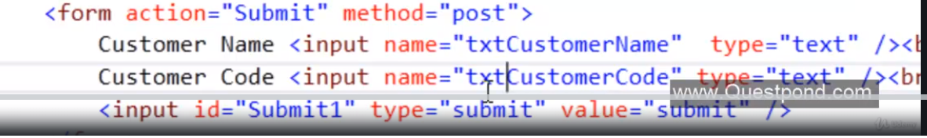

To bind above name with Customer class properties custCode and custName If it is not same names.

Need Customer Binder class

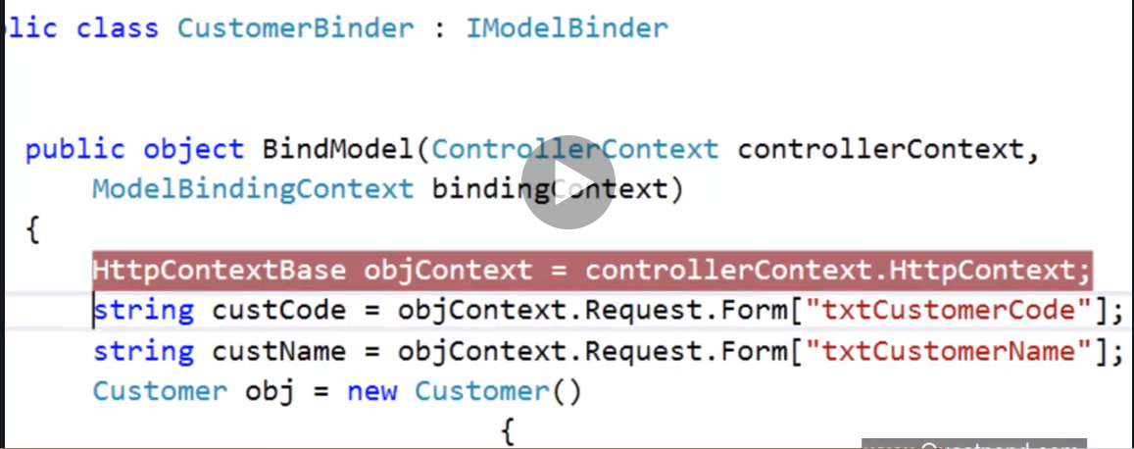

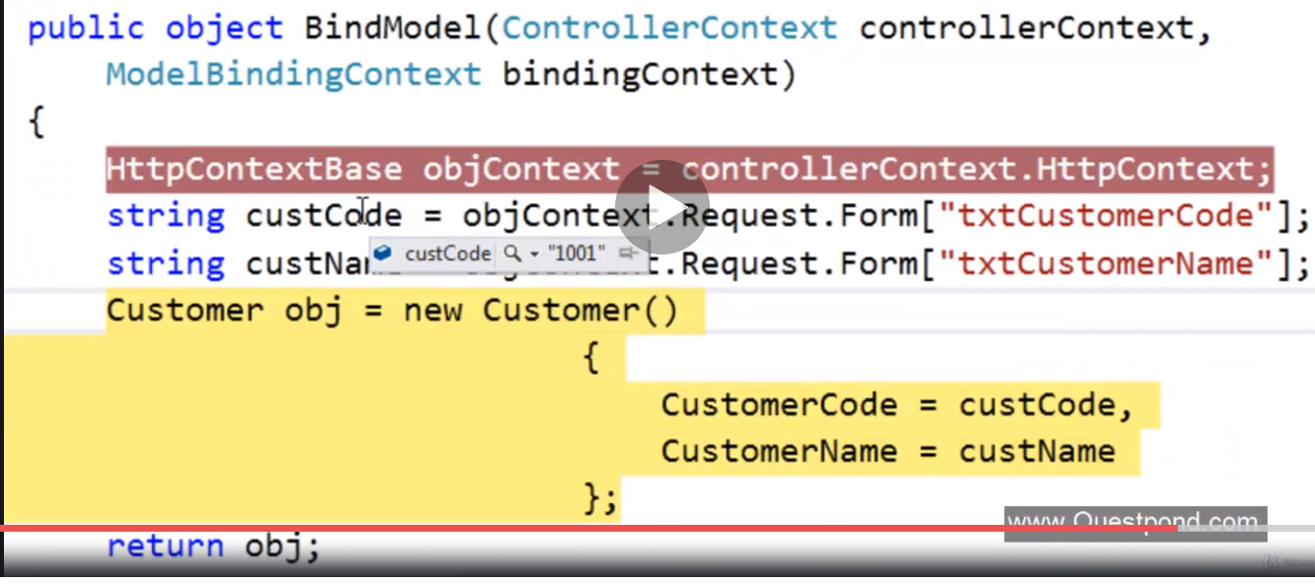

Full code for class

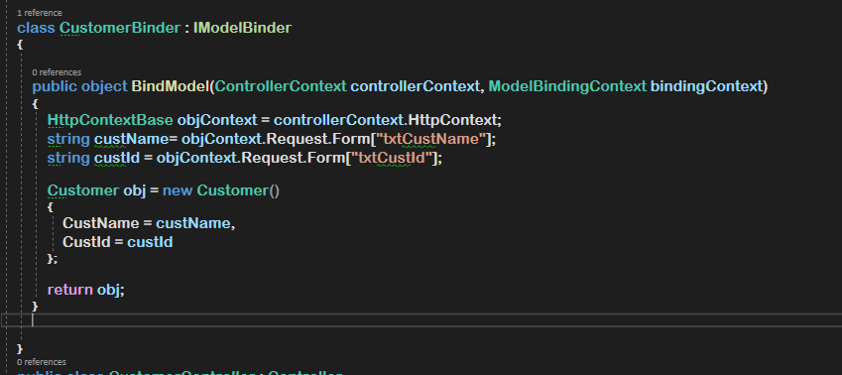

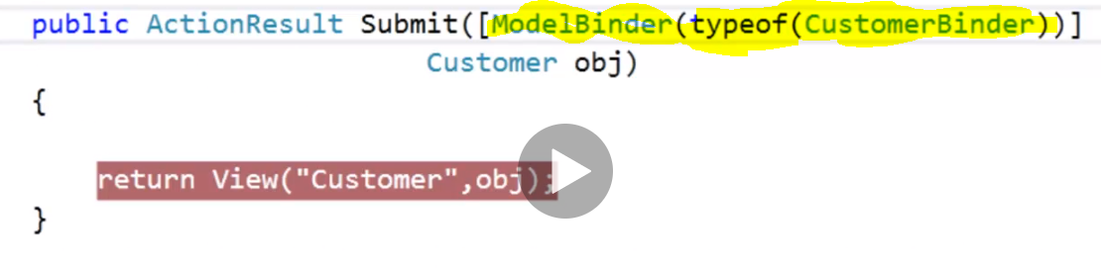

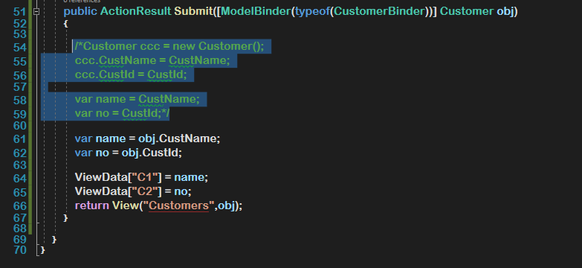

View model customer code

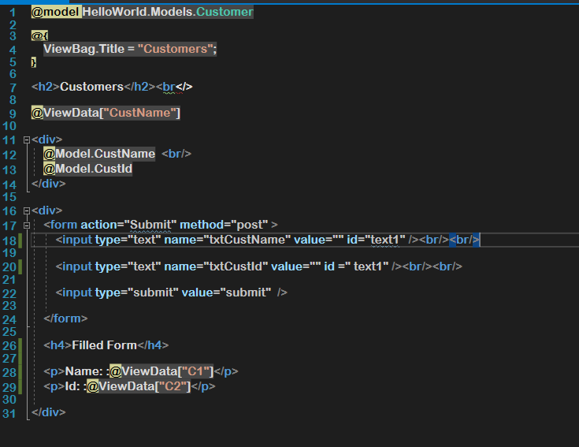

Customer Solution Explorer

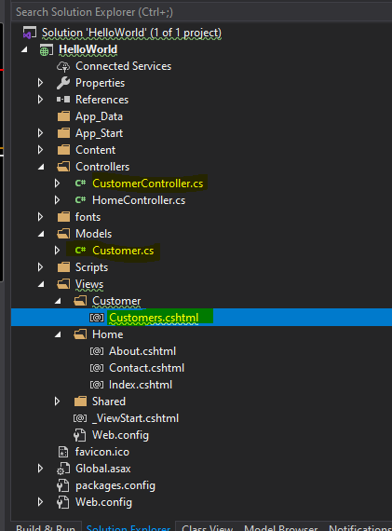

Full code of CustomerController

using System;

using System.Collections.Generic;

using System.Linq;

using System.Web;

using System.Web.Mvc;

using HelloWorld.Models;

using Microsoft.Ajax.Utilities;

namespace HelloWorld.Controllers

{

    class CustomerBinder : IModelBinder

    {

        public object **BindModel**(ControllerContext **controllerContext**, ModelBindingContext **bindingContext**)

        {

            HttpContextBase **objContext** = **controllerContext**.HttpContext;

            string **custName**= **objContext**.Request.Form["txtCustName"];

            string **custId** = **objContext**.Request.Form["txtCustId"];

            Customer **obj** = new Customer()

            {

                CustName = **custName**,

                CustId = **custId**

            };

**return** **obj**;

        }

    }

    public class CustomerController : Controller

    {

        // GET: Customer

        public ActionResult **Index**()

        {

**return** View();

        }

        public ActionResult **Load**()

        {

            Customer **customer** = new Customer();

**customer**.CustName = "Hirenkumar";

**customer**.CustId = "ABC1200";

            ViewData["CustName"] = **customer**.CustName;

**return** **View**("Customers",**customer**);

        }

        public ActionResult **Submit**([ModelBinder(typeof(CustomerBinder))] Customer **obj**)

        {

            /*Customer ccc = new Customer();

            ccc.CustName = CustName;

            ccc.CustId = CustId;

            var name = CustName;

            var no = CustId;*/

            var **name** = **obj**.CustName;

            var **no** = **obj**.CustId;

            ViewData["C1"] = **name**;

            ViewData["C2"] = **no**;

**return** **View**("Customers",**obj**);

        }

    }

}