CSV → Shopify Product Import System
Step-by-Step User Guide
A complete walkthrough of how to use the application — with real screenshots
Laravel 12 · Vue 3 + Inertia · PrimeVue · Shopify Admin GraphQL API
Every screenshot in this document is a real capture of the running application (captured 18 June 2026 against the live Shopify sandbox).

1. What this application does
You upload a Shopify-style product CSV. The application validates the file (in the browser and again on the server), stores it, and creates a database record for every row. A background queue then imports each product into a Shopify store through the Admin GraphQL API — creating the product, its variant (price, SKU, weight, inventory policy), setting inventory at a location, attaching the image, and adding it to the target collection.
Throughout the import, a live dashboard shows each product moving through pending → processing → successful / failed, with full logging, an in-app log viewer, and failure notifications. Re-uploading the same file updates the existing products instead of creating duplicates.

How the system is put together
The flow from a click in the browser to a product in Shopify:
Browser (Vue 3 + Inertia + PrimeVue)
│ upload CSV
▼
UploadController → validate type, size, required headers
▼
CsvImportService → parse + per-row validation + duplicate detection
→ 1 Upload record + N Product records
▼
Database queue → ProcessCsvImport → one job per product
▼
ShopifyService (GraphQL)
create | update → variant → inventory → image → collection
▼
status + Shopify IDs + logs + notifications → live dashboard

2. Step-by-step walkthrough

Step 1 — The upload page
Open the application at http://localhost:8000. You land on the import page.
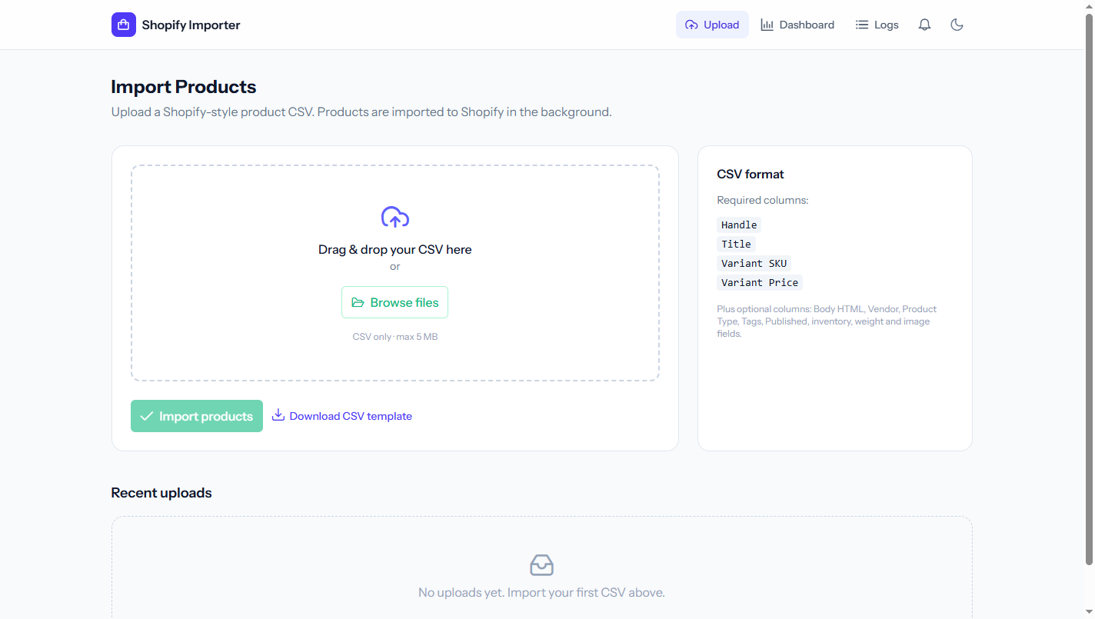
The import page — drag-and-drop upload with a format guide.
- A drag-and-drop dropzone (or the Browse files button).
- A format guide on the right listing the required columns (Handle, Title, Variant SKU, Variant Price) and the optional ones.
- A Download CSV template link so you always start from a correctly-formatted file.
- Top navigation — Upload · Dashboard · Logs, plus a notification bell and a dark-mode toggle.

Step 2 — Select a CSV
Drop in (or browse to) your product file. The app shows the file name and size, and the Import products button becomes active.
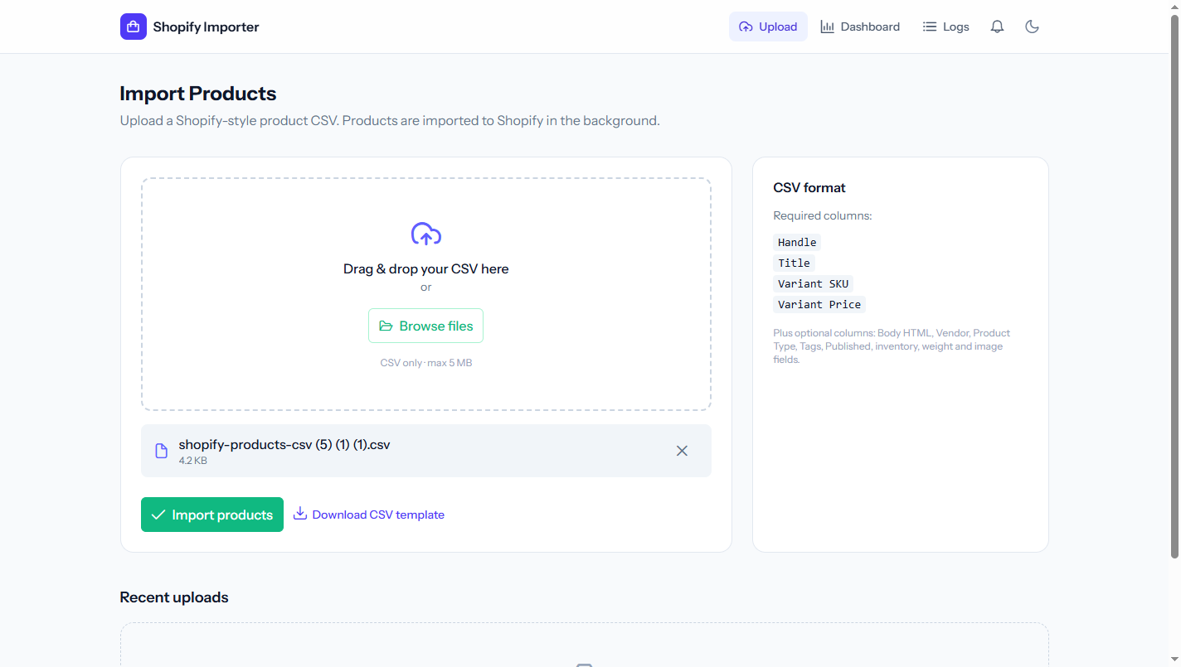
A file is selected — name and size are shown, the button is enabled.
The sample file used here contains 10 valid products.

Step 3 — Client-side validation
If you pick the wrong kind of file (or one that is too big or empty), the app rejects it instantly in the browser, before anything is uploaded.
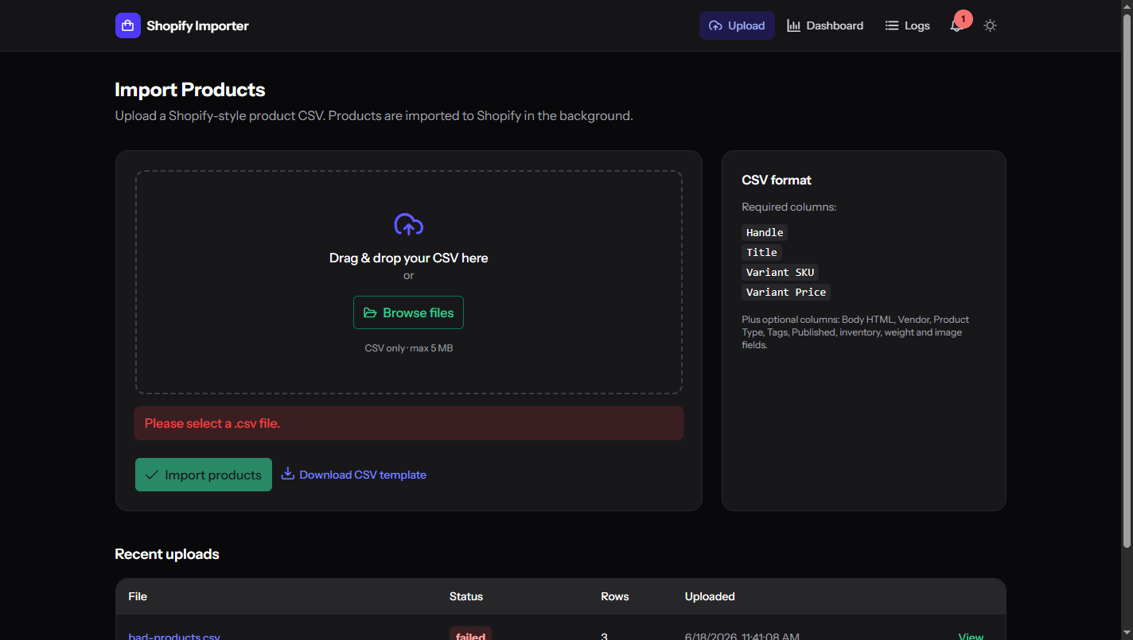
Client-side validation rejects a non-CSV file immediately.
Client-side validation checks the file type (.csv only) and size (≤ 5 MB) and rejects empty files. The server then re-validates everything independently and additionally confirms that the required column headers exist — so the rules can never be bypassed.

Step 4 — Upload & live processing
Click Import products. You get a success message — “Upload received — 10 rows queued for import” — and land on the detail page, which immediately starts tracking progress.
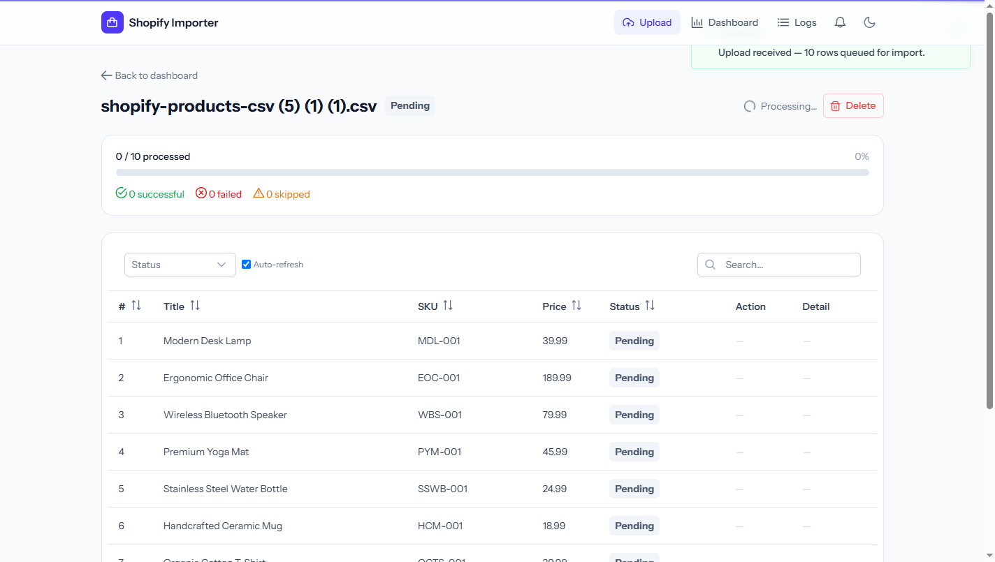
The detail page tracks each product live as it is imported.
- A progress bar (0 / 10 processed) and live counters: successful / failed / skipped.
- A per-product table — row #, Title, SKU, Price, Status, Action, Detail.
- Auto-refresh is on — the page updates every few seconds without a manual refresh.

Step 5 — Completion
Within a few seconds every product reaches a final state and the upload is marked Completed.
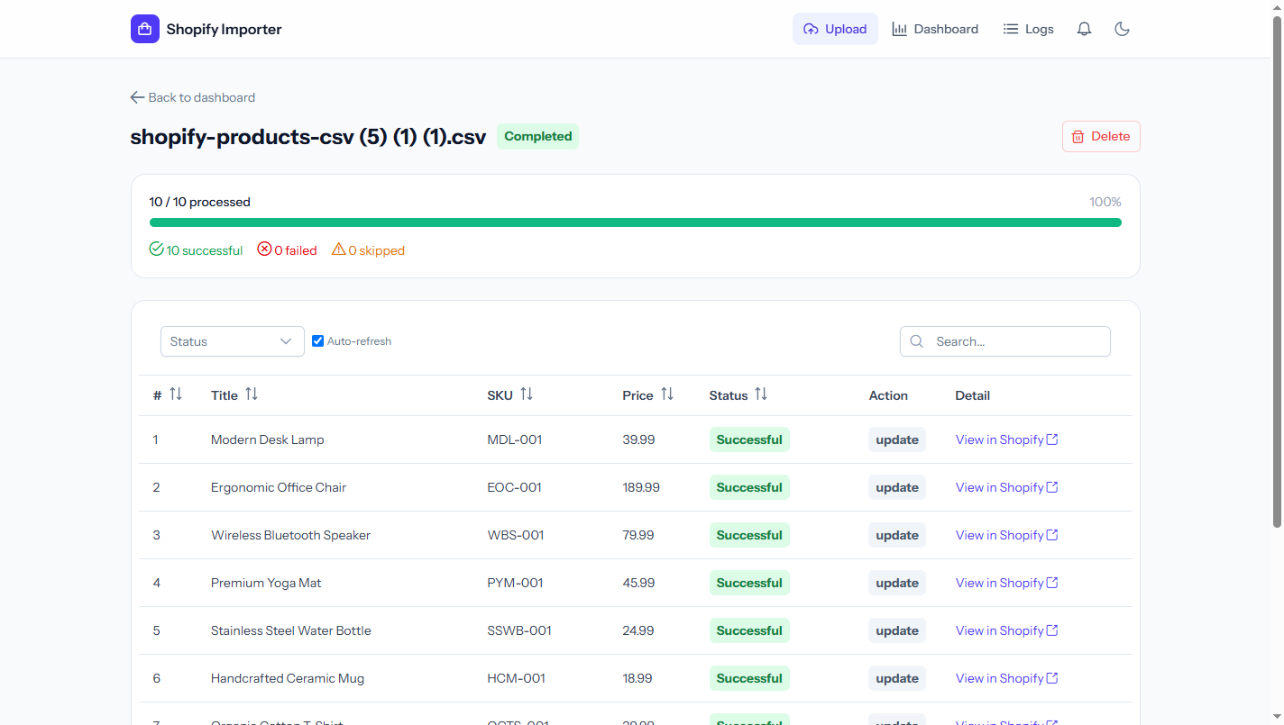
All 10 products imported successfully — 100% complete.
- 10 / 10 processed · 100% — 10 successful, 0 failed, 0 skipped.
- The Action column shows “update” here because these products already existed in the Shopify sandbox from earlier runs — the system matched and updated them instead of creating duplicates (the update-existing / upsert feature). On a brand-new store these would read “create”.
- View in Shopify links open each product directly in the Shopify admin.

Step 6 — The dashboard
The Dashboard gives the high-level overview of every import.
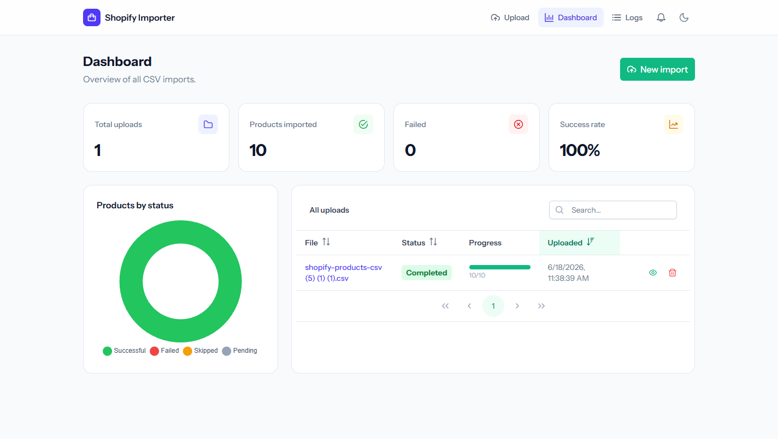
The dashboard — stat cards, a status chart, and the uploads table.
- Stat cards — Total uploads, Products imported, Failed, Success rate.
- A “Products by status” donut chart.
- An All uploads table with search, sortable columns, pagination, a per-upload progress bar, and view / delete actions.

Step 7 — The log viewer
Every import event is recorded. The Logs page is an in-app viewer over those records — you can filter by level and search messages.
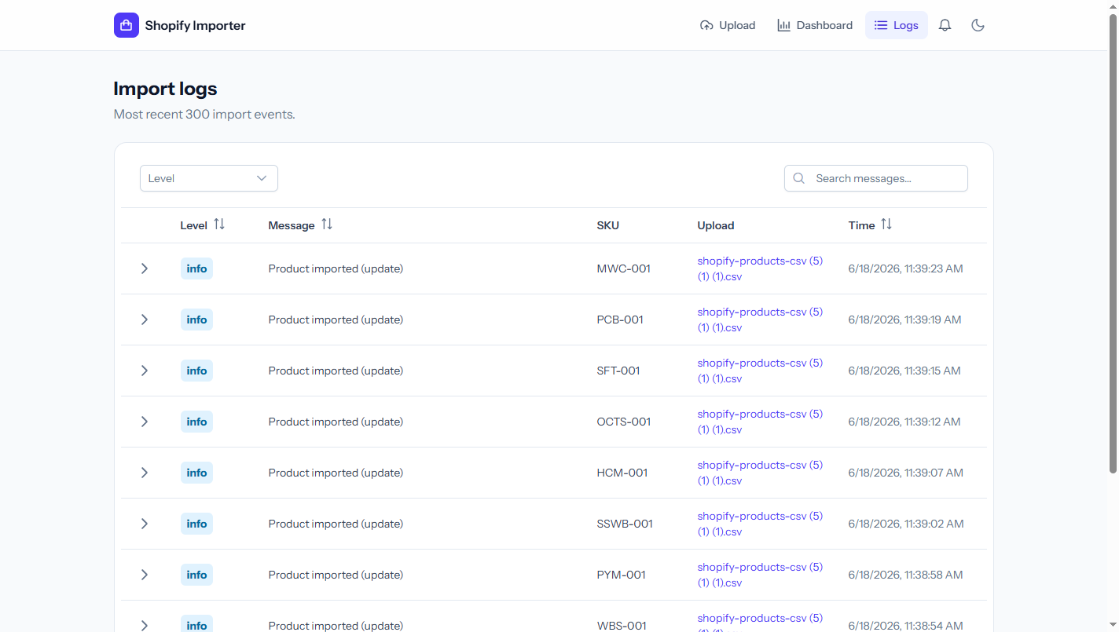
The log viewer — every import event, filterable and searchable.
Each row expands to reveal the full JSON context captured for that event:
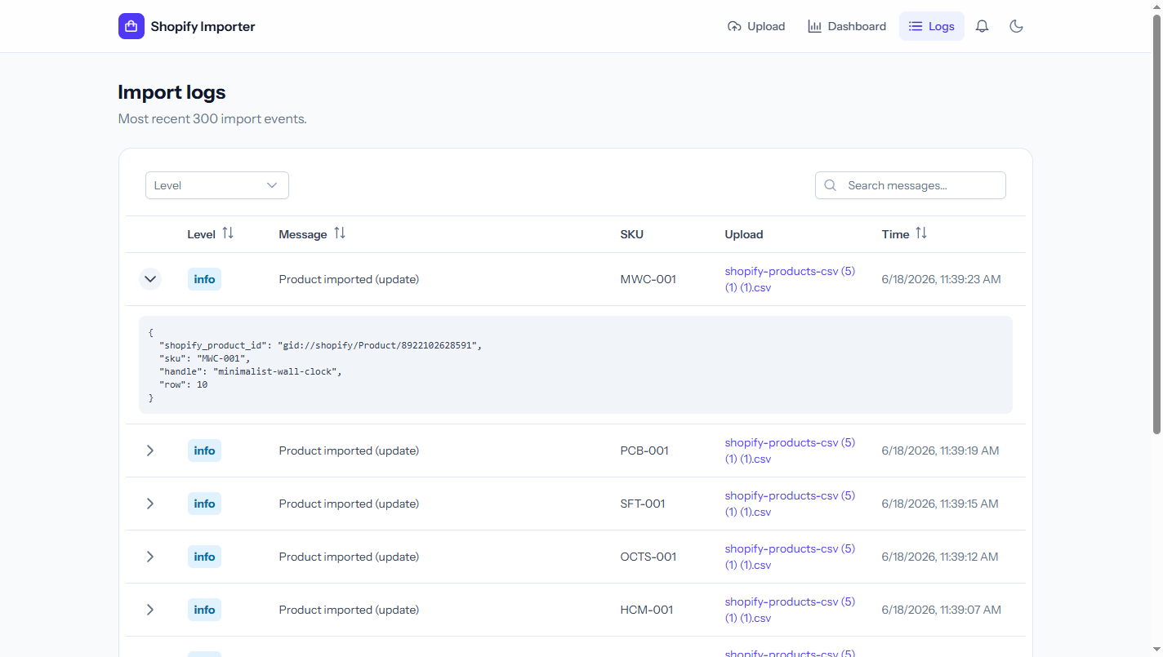
An expanded log row showing the Shopify product ID, SKU, handle, and row number.

Step 8 — Validation & failure handling
Now upload a deliberately bad CSV — a row with a non-numeric price, a row with a missing handle, and a row with a missing title.
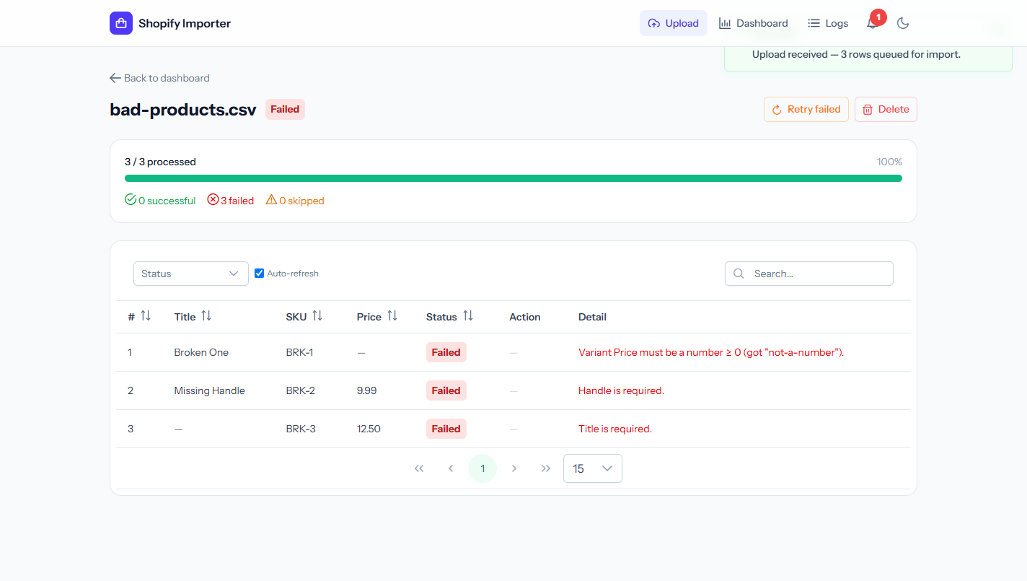
Each invalid row is marked Failed with a precise, readable error.
- The upload is marked Failed; the counters read 0 successful, 3 failed.
- Each row carries a precise error — e.g. “Variant Price must be a number ≥ 0 (got “not-a-number”).”, “Handle is required.”, “Title is required.”
- Validation is per-row — one bad row never aborts the whole file.
- The notification bell now shows a red unread badge, and Retry failed / Delete actions appear.

Step 9 — Failure notifications
Click the bell. An in-app, database-backed notification summarises the failure.
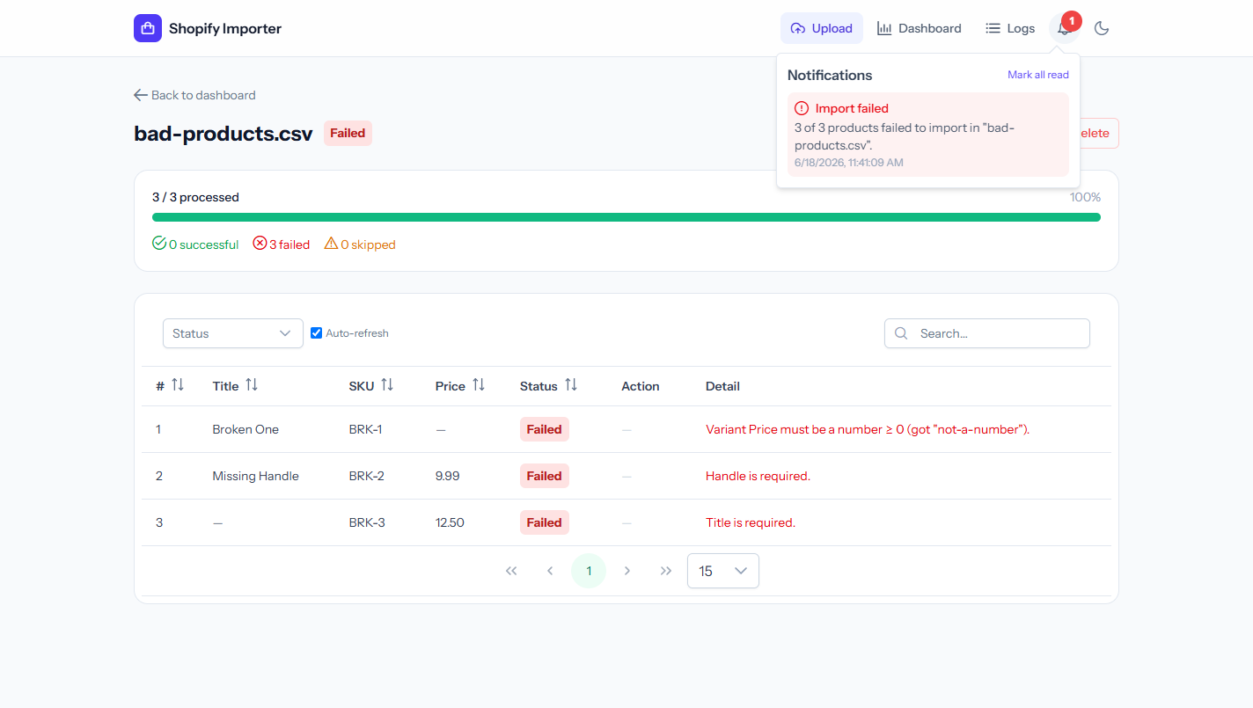
An in-app notification summarises the failed import.
“Import failed — 3 of 3 products failed to import in ‘bad-products.csv’.” with a timestamp and a Mark all read action.

Step 10 — Dark mode
The whole application has a polished dark theme, toggled from the top-right and remembered between visits. Here is the dashboard after both imports — the success rate has dropped to 77% and the chart now shows the failed slice in red.
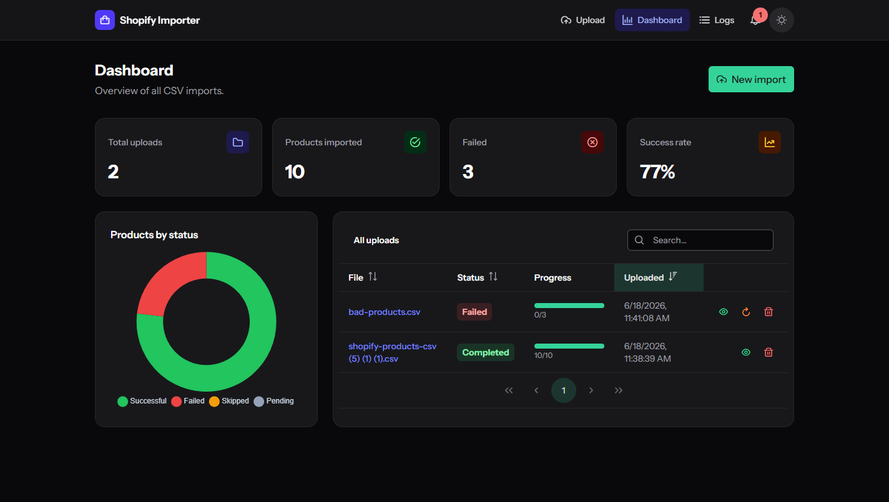
The dashboard in dark mode after a successful and a failed import.

3. How each requirement is demonstrated
Requirement | Shown in
CSV upload form, clean responsive UI | Steps 1–2
Client-side validation (type & size) | Step 3
Server-side validation + required headers | Steps 3–4, 8
Asynchronous (queued) processing | Steps 4–5
Per-product status (pending→processing→successful/failed) | Steps 4–5
Shopify integration via GraphQL (create/variant/inventory/image) | Step 5
Add to required collection 464337174767 | Step 5
Update existing product (upsert) | Step 5 (update action)
Dashboard: all imports, stats, chart, search/sort/paginate | Step 6
Error messages for failed rows | Step 8
Logging + in-app log viewer | Step 7
Error notification system | Steps 8–9
Retry & delete | Steps 6, 8
Dark mode / world-class UI polish | Step 10 (and all)

4. How to run it yourself
Two processes are needed — the web server and the queue worker. Run each command in its own terminal from the project folder.
# 1. Install dependencies and build the front-end
composer install
npm install
npm run build
# 2. Configure .env (database + Shopify keys), then migrate
php artisan migrate
# 3. Verify the Shopify connection (token, location, collection)
php artisan shopify:check
# 4. Start the app (two terminals)
php artisan serve # → http://localhost:8000
php artisan queue:work # processes the imports
Sample files:
- Valid CSV (10 products): plan/shopify-products-csv (5) (1) (1).csv
- Invalid CSV (for the failure demo): docs/sample-csv/bad-products.csv
For a full requirement-by-requirement mapping to the source files, see docs/CLIENT_REQUIREMENTS.md. For a narrated video version of this flow, see docs/DEMO_VIDEO.md.

