Spring Boot + JPA Rest API

1. Create a **stores** table in mySQL

Table Name: stores

id BIGINT(20) not null primary key,

store_name VARCHAR(45) not null,

coffee_name VARCHAR(45) not null

1. Application name **springboot-jpa**
2. Model class name **Store**
3. Repository class name **StoreRepository**
4. Rest Controller class **StoreController**
5. Custom Exception classes
6. **Application.java** is a main class
7. Execute 3 Junit test case in **StoreControllerIntegrationTest.Java**
8. Test case 1: contextLoads () : Simple context loads
9. Test case 2: testGetAllStores () : List of All the Stores
10. Test case 3: testGetStoreDetailsByStoreName () : Store details with the list of coffees for store
11. Image of successful executed 3 test cases and build

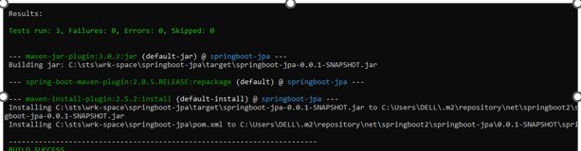

1. Logging used **log4j**

**Docker Image**

1. Dockerfile and source file.
2. Build docker image path: **docker build --tag springjpa:1.0 .**
3. Run image as a container, publish and ports: **docker run --publish 8080 --detach --name bb springjpa:1.0**

**OR**

Run a container in the background: **docker container run -d springjpa:1.0**

