**SOCIETY MANAGEMENT SYSTEM**

Assignment 2-Convert above ER model to relational model, semi_structured data model. List functional dependencies. Normalize these relations up to 3NF/BCNF.

-Relational Model

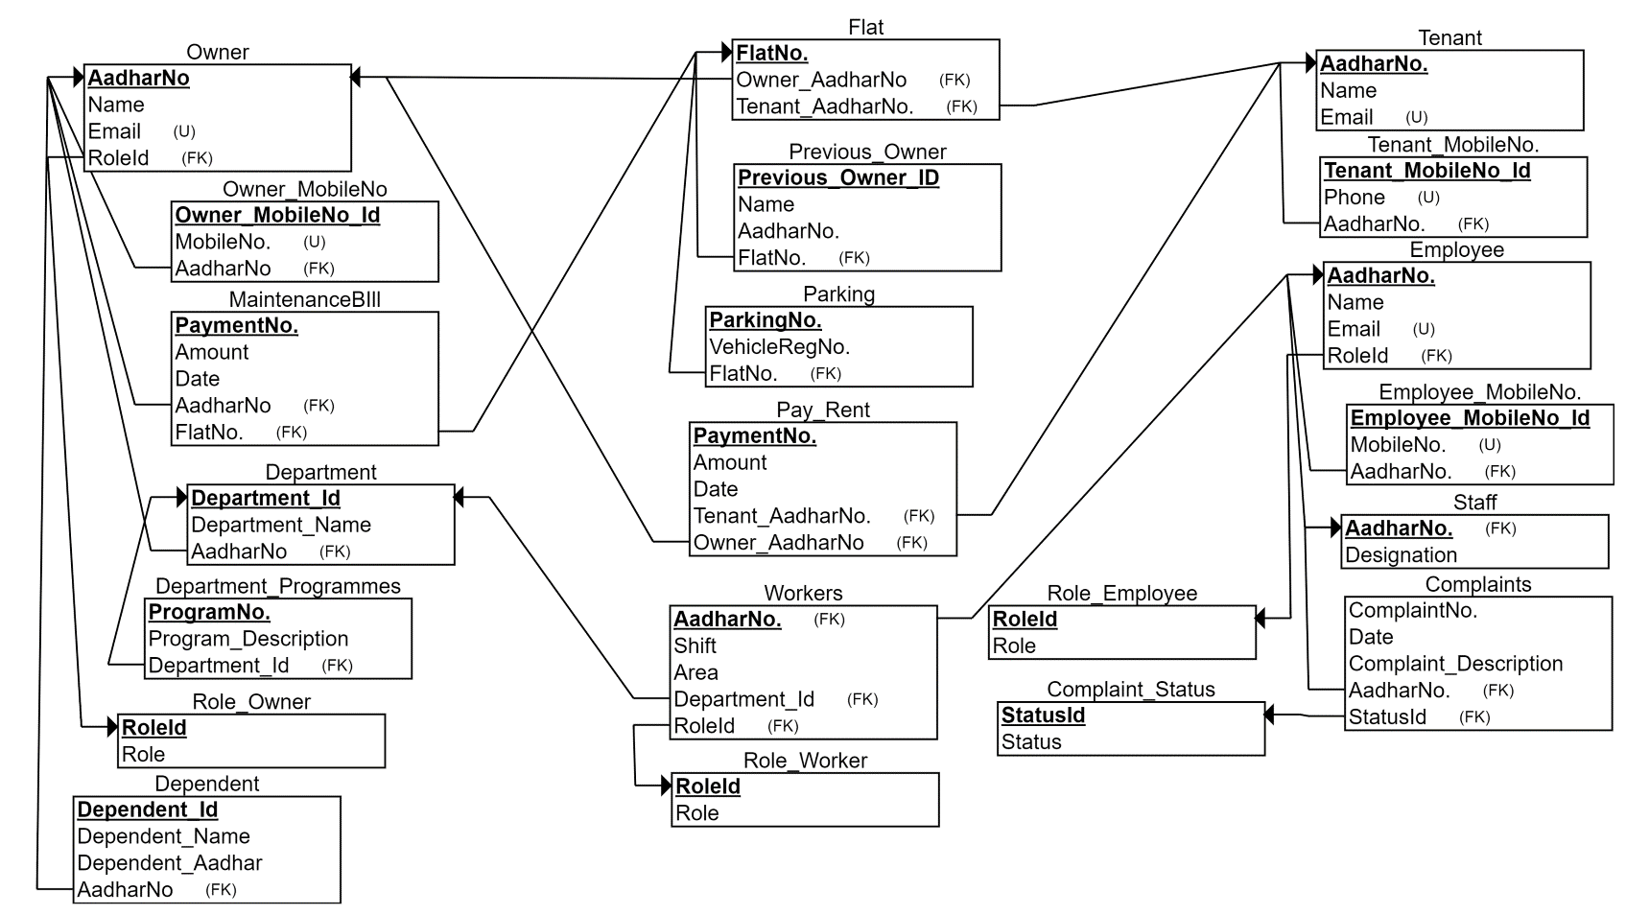

-Semi-structured data model

* Flat.xml

<Flat_info>

<Flat>

<FlatNo.>G404</FlatNo.>

<Previous_Owners>

<P1>

<Name>ABC</Name>

<AadharNo.>214125</AadharNo.>

</P1>

<P2>

<Name>XYZ</Name>

<AadharNo.>212413</AadharNo.>

</P2>

</Previous_Owners>

<Owner_AadharNo.>121242</Owner_AadharNo.>

<Tenant_AadharNo.>124125</Tenant_AadharNo.>

</Flat>

</Flat_info>

* Parking.xml

<Parking_info>

<Parking>

<ParkingNo.>1</ParkingNo.>

<VehicleRegNo.>MH43X212</VehicleRegNo.>

<FlatNo.>G404</FlatNo.>

</Parking>

</Parking_info>

* Tenant.xml

<Tenant_info>

<Tenant>

<Name>XYZ</Name>

<MobileNo.>

<M1>2145</M1>

<M2>3252</M2>

</MobileNo.>

<AadharNo.>31687</AadharNo.>

<Lease_date>

<Start_date>2016-01-31</Start_date>

<End_date>2016-12-31</End_date>

</Lease_date>

<Email>[abc@gmail.com</Email](mailto:abc@gmail.com%3c/Email)>

</Tenant>

</Tenant_info>

* Owners.xml

<Owner_info>

<Owner>

<Name>ABC</Name>

<MobileNo.>

<M1>12424</M1>

<M2>21513</M2>

</MobileNo.>

<AadharNo.>142552</AadharNo.>

<Email>[abcd@gmail.com</Email](mailto:abcd@gmail.com%3c/Email)>

<RoleId>1</RoleId>

</Owner>

<Owner_info>

* Role_Owner.xml

<Role_Owner>

<Role>

<RoleId>1</RoleId>

<Role_type>Resident</Role_type>

</Role>

<Role>

<RoleId>2</RoleId>

<Role_type>Department Head</Role_type>

</Role>

</Role_Owner>

* Dependents.xml

<Dependent_info>

<Dependent>

<Owner_AadharNo.>241511</Owner_AadharNo.>

<Name>

<D1>ACS</D1>

<D2>ZCV</D2>

</Name>

<AadharNo.>

<A1>215153</A1>

<A2>315135</A2>

</AadharNo.>

</Dependent>

</Depeendent_info>

* Employees.xml

<Employee_info>

<Employee>

<Name>ABC</Name>

<Email>[axa@gmail.com</Email](mailto:axa@gmail.com%3c/Email)>

<MobileNo.>

<M1>21412</M1>

<M2>24154</M2>

</MobileNo.>

<AadharNo.>141255</AadharNo.>

<RoleId>2</RoleId>

</Employee>

</Employee_info>

* Role_Employee.xml

<Role_Employee>

<Role>

<RoleId>1</RoleId>

<Role_type>worker<Role_type>

</Role>

<Role>

<RoleId>2</RoleId>

<Role_type>staff<Role_type>

</Role>

</Role_Employee>

* Staff.xml

<Staff_info>

<Staff>

<AadharNo.>13412</AadharNo.>

<Designation>Receptionist</Designation>

</Staff>

<Staff_info>

* Workers.xml

<Worker_info>

<Worker>

<AadharNo>241251</AadharNo>

<Shift>2</Shift>

<Area>G</Area>

<RoleId>2</RoleId>

<DepartmentId>1</DepartmentId>

</Worker>

</Worker_info>

* Role_Worker.xml

<Role_Worker>

<Role>

<RoleId>1</RoleId>

<Role_type>gardener<Role_type>

</Role>

<Role>

<RoleId>2</RoleId>

<Role_type>electrician<Role_type>

</Role>

</Role_Worker>

* Department.xml

<Department_info>

<Department>

<DepartmentId>1</DepartmentId>

<Department_Programmes>

<DP1>

<DPNo.>15125</DPNo.>

<DPDesc>abvcm…</DPDesc>

</DP1>

<DHead_AadharNo.>21451</DHead_AadharNo.>

</Department>

</Department_info>

* Complaints.xml

<Complaint_info>

<Complaint>

<ComplaintNo.>2151</ComplaintNo.>

<Date>2016-08-12</Date>

<Status>2</Status>

<AadharNo.>214113</AadharNo>

</Complaint>

</Complaint_info>

* Maintenance.xml

<Maintenance_info>

<MaintenanceBill>

<PaymentNo.>14125</PaymentNo.>

<Amount>2144</Amount>

<Owner_Aadhar>21415</Owner_Aadhar>

<FlatNo.>G404</FlatNo.>

</MaintenanceBill>

</Maintenance_info>

* PayRent.xml

<Rent_info>

<Rent>

<PaymentNo.>214214</PaymentNo.>

<Date>2016-09-09</Date>

<Amount>12411</Amount>

<Tenant_AadharNo.>21412</Tenant_AadharNo.>

<Owner_AadharNo.>25111</Owner_AadharNo.>

</Rent>

</Rent_info>

-Functional Dependency

1. Owner

|  |  |  |  |
| --- | --- | --- | --- |
| AadharNo | Name | Email | RoleID |
| 4641315664 | ABC | [abc@xyz.com](mailto:abc@xyz.com) | 1 |
| 5465468465 | XYZ | [def@xyz.com](mailto:def@xyz.com) | 2 |

AadharNo 🡪 Name, Email, RoleID

* Owner is in 1NF because domains of all the attributes are atomic.
* It is in 2NF as there is no partial dependency.
* It is in 3NF because there is no transitive dependency between the attributes.
* Hence, Owner is in BCNF because there are no multivalued dependencies.

1. Tenant

|  |  |  |  |  |
| --- | --- | --- | --- | --- |
| AadharNo | Name | Email | Start_date | End_date |
| 6464664678 | XYZ | [defj@xyz.com](mailto:defj@xyz.com) | 2016-01-01 | 2016-12-01 |
| 4456121687 | ABC | [nsa@xyz.com](mailto:nsa@xyz.com) | 2016-01-01 | 2016-12-01 |

AadharNo 🡪 Name,Email,Start_date,End_date

* Tenant is in 1NF because domains of all the attributes are atomic.
* It is in 2NF as there is no partial dependency.
* It is in 3NF because there is no transitive dependency between the attributes.
* Hence, Tenant is in BCNF because there are no multivalued dependencies.

1. Flat

|  |  |  |
| --- | --- | --- |
| FlatNo. | Owner_AadharNo | Tenant_AadharNo |
| G404 | 3520958059 | 2536465789 |
| G405 | 2158904266 | null |

FlatNo. 🡪 Owner_AadharNo, Tenant_AadharNo

* Flat is in 1NF because domains of all the attributes are atomic.
* It is in 2NF as there is no partial dependency.
* It is in 3NF because there is no transitive dependency between the attributes.
* Hence, Flat is in BCNF because there are no multivalued dependencies.

1. Previous_Owner

|  |  |  |  |
| --- | --- | --- | --- |
| Previous_Owner_ID | AadharNo. | FlatNo. | Name |
| 1 | 3829048909 | G404 | ACB |
| 2 | 1564564865 | G405 | BCD |

Previous_Owner_ID 🡪 AadharNo. , FlatNo. , Name

* Previous_Owner is in 1NF because domains of all the attributes are atomic.
* It is in 2NF as there is no partial dependency.
* It is in 3NF because there is no transitive dependency between the attributes.
* Hence, Previous_Owner is in BCNF because there are no multivalued dependencies.

1. Parking

|  |  |  |
| --- | --- | --- |
| ParkingNo. | VehicleRegNo. | FlatNo. |
| 1 | MH43X7678 | G404 |
| 2 | MH43Y3456 | G405 |

ParkingNo. 🡪 VehicleRegNo. , FlatNo.

* Parking is in 1NF because domains of all the attributes are atomic.
* It is in 2NF as there is no partial dependency.
* It is in 3NF because there is no transitive dependency between the attributes.
* Hence, Parking is in BCNF because there are no multivalued dependencies.

1. Owner_MobileNo

|  |  |  |
| --- | --- | --- |
| Owner_MobileNo_ID | AadharNo | MobileNo. |
| 1 | 9456651684 | 4946511987 |
| 2 | 4564187551 | 4846512308 |

Owner_MobileNo_ID 🡪 AadharNo, MobileNo.

* Owner_MobileNo is in 1NF because domains of all the attributes are atomic.
* It is in 2NF as there is no partial dependency.
* It is in 3NF because there is no transitive dependency between the attributes.
* Hence, Owner_MobileNo is in BCNF because there are no multivalued dependencies.

1. Tenant_MobileNo

|  |  |  |
| --- | --- | --- |
| Tenant_MobileNo_ID | AadharNo | MobileNo. |
| 1 | 9456651684 | 4946511987 |
| 2 | 4564187551 | 4846512308 |

Tenant_MobileNo_ID 🡪 AadharNo, MobileNo.

* Tenant_MobileNo is in 1NF because domains of all the attributes are atomic.
* It is in 2NF as there is no partial dependency.
* It is in 3NF because there is no transitive dependency between the attributes.
* Hence, Tenant_MobileNo is in BCNF because there are no multivalued dependencies.

1. Pay_Rent

|  |  |  |  |  |
| --- | --- | --- | --- | --- |
| Payment_No | Amount | Date | Owner_AadharNo | Tenant_AadharNo |
| 7845 | 10000 | 2016-09-12 | 4865431547 | 4865431540 |
| 9846 | 7845 | 2016-02-11 | 4865431544 | 4865431541 |

Payment_No 🡪 Amount, Date, Owner_AadharNo, Tenant_AadharNo

* Pay_Rent is in 1NF because domains of all the attributes are atomic.
* It is in 2NF as there is no partial dependency.
* It is in 3NF because there is no transitive dependency between the attributes.
* Hence, Pay_Rent is in BCNF because there are no multivalued dependencies.

1. Maintenance_Bill

|  |  |  |  |  |
| --- | --- | --- | --- | --- |
| PaymentNo. | FlatNo. | Amount | Date | AadharNo. |
| 1 | G404 | 3000 | 2016-01-01 | 2891429078 |
| 2 | G404 | 3000 | 2016-02-01 | 2891429078 |

PaymentNo. 🡪 FlatNo. , Amount, Date, AadharNo.

* MaintenanceBill is in 1NF because domains of all the attributes are atomic.
* It is in 2NF as there is no partial dependency.
* It is in 3NF because there is no transitive dependency between the attributes.
* Hence, MaintenanceBill is in BCNF because there are no multivalued dependencies.

1. Department

|  |  |  |
| --- | --- | --- |
| Department_Id | Department_Name | Department_Head_Aadhar |
| 1 | Water | 4465168885 |
| 2 | Electricity | 4864846158 |

Department_Id 🡪 Department_Name , Department_Head_Aadhar

* Department is in 1NF because domains of all the attributes are atomic.
* It is in 2NF as there is no partial dependency.
* It is in 3NF because there is no transitive dependency between the attributes.
* Hence, Department is in BCNF because there are no multivalued dependencies.

1. Department_Programmes

|  |  |  |
| --- | --- | --- |
| ProgramNo. | Department_Id | Program_Description |
| 1 | 1 | Abc |
| 2 | 1 | Def |

ProgramNo. 🡪 Department_Id, Program_Description

* Department_Programmes is in 1NF because domains of all the attributes are atomic.
* It is in 2NF as there is no partial dependency.
* It is in 3NF because there is no transitive dependency between the attributes.
* Hence, Department_Programmes is in BCNF because there are no multivalued dependencies.

1. Dependent

|  |  |  |  |
| --- | --- | --- | --- |
| Dependent_Id | Owner_AadharNo | Dependent_Name | Dependent_Aadhar |
| 1 | 6545135842 | ABC | 7856425682 |
| 2 | 6545135842 | XYZ | 8668423584 |

Dependent_Id 🡪 Owner_AadharNo ,Dependent_Name, Dependent_Aadhar

* Dependent is in 1NF because domains of all the attributes are atomic.
* It is in 2NF as there is no partial dependency.
* It is in 3NF because there is no transitive dependency between the attributes.
* Hence, Dependent is in BCNF because there are no multivalued dependencies.

1. Employee

|  |  |  |  |
| --- | --- | --- | --- |
| AadharNo. | Name | Email | RoleId |
| 8448785262 | DEF | [def@xyz.com](mailto:def@xyz.com) | 2 |
| 8465315785 | ABC | abc1@xyz.com | 1 |

AadharNo. 🡪 Name, Email, RoleId

* Employee is in 1NF because domains of all the attributes are atomic.
* It is in 2NF as there is no partial dependency.
* It is in 3NF because there is no transitive dependency between the attributes.
* Hence, Employee is in BCNF because there are no multivalued dependencies.

1. Employee_MobileNo.

|  |  |  |
| --- | --- | --- |
| Employee_MobileNo._Id | AadharNo. | MobileNo. |
| 1 | 8484562875 | 8464387652 |
| 2 | 8465533875 | 1235475624 |

Employee_MobileNo._Id 🡪 AadharNo. , MobileNo.

* Employee_MobileNo is in 1NF because domains of all the attributes are atomic.
* It is in 2NF as there is no partial dependency.
* It is in 3NF because there is no transitive dependency between the attributes.
* Hence, Employee_MobileNo is in BCNF because there are no multivalued dependencies.

1. Workers

|  |  |  |  |  |
| --- | --- | --- | --- | --- |
| AadharNo. | Shift | Area | Department_Id | Role_Id |
| 8455786575 | 1 | G | 2 | 1 |
| 8426875267 | 1 | H | 2 | 1 |

AadharNo. 🡪 Shift, Area , Department_Id , RoleId

* Workers is in 1NF because domains of all the attributes are atomic.
* It is in 2NF as there is no partial dependency.
* It is in 3NF because there is no transitive dependency between the attributes.
* Hence, Workers is in BCNF because there are no multivalued dependencies.

1. Staff

|  |  |
| --- | --- |
| AadharNo. | Designation |
| 8456227862 | Manager |
| 8526785862 | Clerk |

AadharNo. 🡪 Designation

* Staff is in 1NF because domains of all the attributes are atomic.
* It is in 2NF as there is no partial dependency.
* It is in 3NF because there is no transitive dependency between the attributes.
* Hence, Staff is in BCNF because there are no multivalued dependencies.

1. Complaints

|  |  |  |  |  |
| --- | --- | --- | --- | --- |
| ComplaintNo. | Status | Date | Complaint_Description | Staff_AadharNo. |
| 1 | 2 | 2016-09-08 | ABC | 2194891268 |
| 2 | 2 | 2016-09-17 | DEF | 2908148923 |

Complaint_No 🡪 Status, Date, Complaint_Description, Staff_AadharNo.

* Complaints is in 1NF because domains of all the attributes are atomic.
* It is in 2NF as there is no partial dependency.
* It is in 3NF because there is no transitive dependency between the attributes.
* Hence, Complaints is in BCNF because there are no multivalued dependencies.

1. Role_Employee

|  |  |
| --- | --- |
| Role_Id | Role |
| 1 | Staff |
| 2 | Worker |

Role_Id 🡪 Role

* Role_Employee is in 1NF because domains of all the attributes are atomic.
* It is in 2NF as there is no partial dependency.
* It is in 3NF because there is no transitive dependency between the attributes.
* Hence, Role_Employee is in BCNF because there are no multivalued dependencies.

1. Role_Worker

|  |  |
| --- | --- |
| Role_Id | Role |
| 1 | Sweeper |
| 2 | Electrician |

Role_Id 🡪 Role

* Role_Worker is in 1NF because domains of all the attributes are atomic.
* It is in 2NF as there is no partial dependency.
* It is in 3NF because there is no transitive dependency between the attributes.
* Hence, Role_Worker is in BCNF because there are no multivalued dependenscies.

1. Role_Owner

|  |  |
| --- | --- |
| Role_Id | Role |
| 1 | Chairman |
| 2 | Department Head |

Role_Id 🡪 Role

* Role_Owner is in 1NF because domains of all the attributes are atomic.
* It is in 2NF as there is no partial dependency.
* It is in 3NF because there is no transitive dependency between the attributes.
* Hence, Role_Owner is in BCNF because there are no multivalued dependencies.