# **CSS ASSIGNMENT**

**Q1: What are the benefits of using CSS?**

**Ans**: CSS has many benefits that enable developers to design a website.

-> Some of these benefits are:

1. **Better Website Speed:** For a website to function efficiently, it should have a faster load time.
2. **Easier to Maintain:** CSS is easy to maintain due to less maintenance time. This is because a single line code change affects the entire web page.
3. **Consistent Design:** CSS enables developers to ensure the style elements are applied consistently across several web pages.
4. **Time-Saving:** Due to faster speed and easier maintenance, CSS saves a lot of time and effort in the web development process due to faster loading time.
5. **Better Device Compatibility:** CSS ensures the task is done smoothly by providing better compatibility. It can be a smartphone, PC or laptop.
6. **Positioning of Design Elements:** We can change the position of an HTML tag with the help of CSS. We can place the elements like an image on any part of the webpage as and when required.

**Q2: What are the disadvantages of CSS?**

**Ans:** CSS has some disadvantages that make difficult developers to design a website.

-> Some of these benefits are:

1. **Confusion due to many CSS levels:** They might get confused while opting to learn CSS as there are many levels of CSS such as CSS2, CSS3, etc.
2. **Cross-Browser Issues:** Different browsers work differently. So, we have to check that changes implemented in the website via CSS codes are reflected properly among all browsers.
3. **Security Issues:** Security is important in today’s world driven by technology and data. One of the major disadvantages of CSS is that it has limited security.
4. **Extra Work for Developers:** Design services are required to consider and test all CSS codes across different browsers for compatibility. Due to developers testing compatibility for different browsers, their workload increases.

**Q3: What is the difference between CSS2 and CSS3?**

**Ans:**

|  |  |
| --- | --- |
| **CSS 2** | **CSS 3** |
| 1. Older version with basic styling Capabilities. | 1. Newer version with advanced features like animations, transitions, and rounded corners. |
| 1. Limited support for responsive design. | 1. Extensive support for responsive and flexible layouts. |
| 1. Less support for complex selectors and effects. | 1. Offers more powerful selectors and a wide range of styling options. |
| 1. Limited browser compatibility. | 1. Widely adopted with better browser support. |
| 1. Basic text and font styling. | 1. Allows for custom fonts, text shadows, and more. |

**Q4: Name a few CSS style components**

**Ans:**

1. **Color:** CSS allows you to set text and background colors using properties like color and background-color.

Ex.

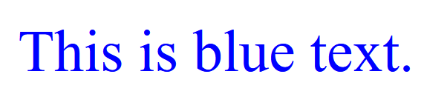

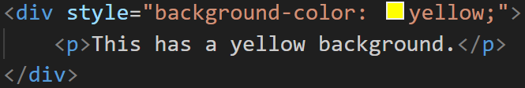



1. **Typography:** We can control fonts, font sizes, line heights, and text alignment with properties like font-family, font-size, line-height, and text-align.

Ex.







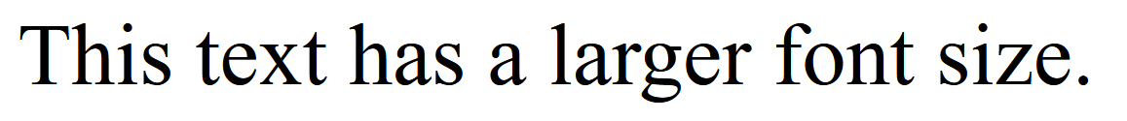





1. **Spacing and Layout:** CSS provides properties like margin, padding, width, height, display, and position to control spacing and layout of elements on a web page.

Ex.

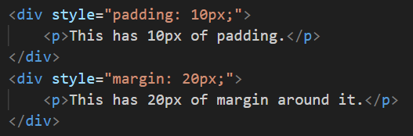

1. **Borders:** You can add borders to elements using properties like border, border-width, border-color, and border-radius for rounded corners.

Ex.

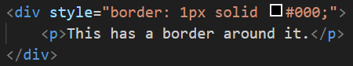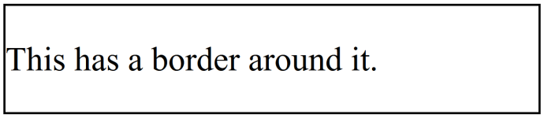

1. **Box Shadow:** Create shadows around elements using the box-shadow property.
2. **Backgrounds:** Customize element backgrounds with properties like background-image, background-repeat, and background-size.
3. **Transitions and Animations:** CSS enables smooth transitions and animations using properties like transition and animation.
4. **Flexbox and Grid:** CSS provides layout models like Flexbox and Grid for advanced control over the arrangement of elements within containers.
5. **Transformations:** Use properties like transform to apply 2D or 3D transformations like scaling, rotating, and translating elements.
6. **Media Queries:** Implement responsive design with media queries to apply different styles based on the screen size and device.

**Q5: What do you understand by CSS opacity?**

**Ans**: CSS opacity refers to the level of transparency or how "see-through" an element on a web page is.

-> It's a property that allows us to control how much an element, such as an image or a div, is visible.

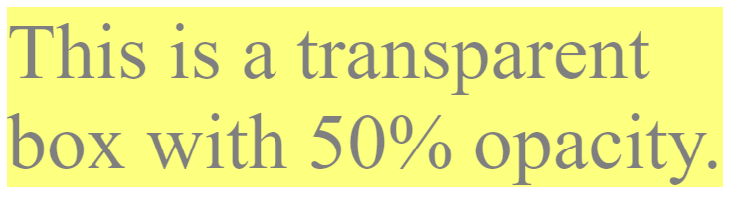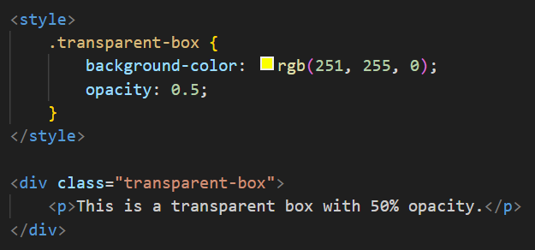-> An opacity value of 1 means the element is fully opaque (not transparent at all), while a value of 0 means completely transparent (invisible).

->

**Q6: How can the background color of an element be changed?**

**Ans:** You can change the background color of an element in HTML and CSS using the background-color property.

-> Here's how you can do it:





**Q7: How can image repetition of the backup be controlled?**

**Ans:**

1. **Repeat:** The background image is repeated both vertically and horizontally.

**Ex.**

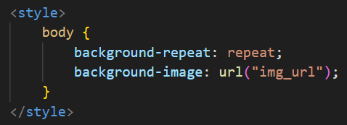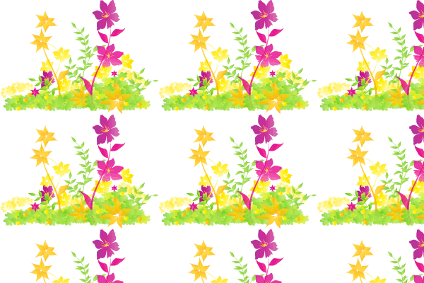

1. **repeat-x:** The background image is repeated only horizontally.

**Ex.**

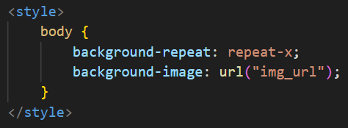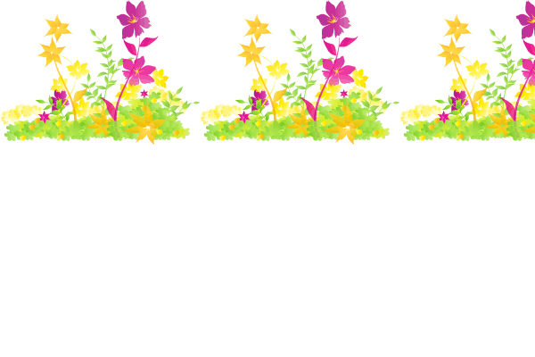

1. **repeat-y:** The background image is repeated only vertically.

**Ex.**

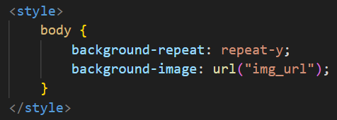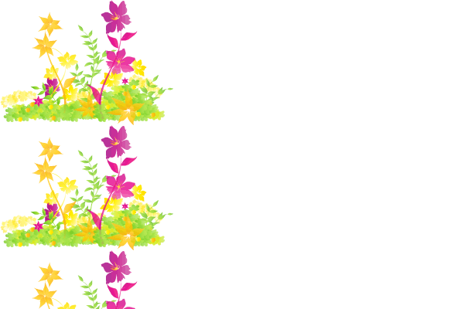

1. **no-repeat:** The background-image is not repeated. The image will only be shown once.

**Ex.**

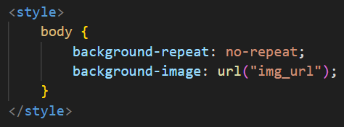

1. **space:** The background-image is repeated as much as possible without clipping. The first and last image is pinned to either side of the element, and whitespace is distributed evenly between the images.

**Ex.**

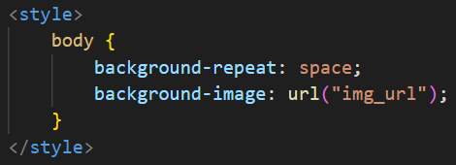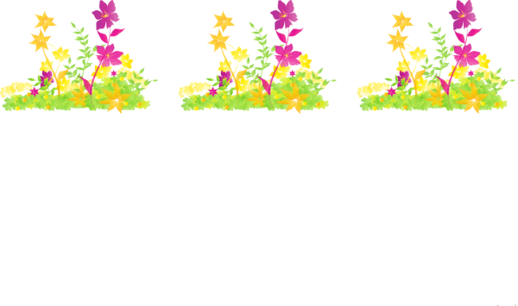

1. **round:** The background-image is repeated and squished or stretched to fill the space (no gaps).

**Ex.**

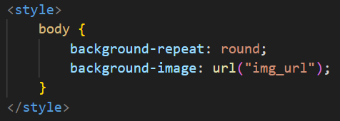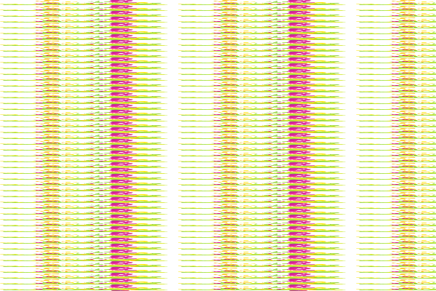

**Q8: What is the use of the background-position property?**

**Ans**: The background-position property in CSS is used to control where a background image is placed within an HTML element. It determines the starting position of the background image relative to the element's top-left corner. we can specify both horizontal and vertical positions.

Ex.

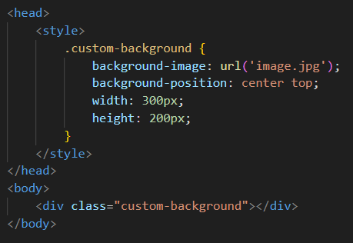

**In this code:**

* The background-image property is used to set the background image for the .custom-background div.
* The background-position property is set to center top, which means the image is centered horizontally and aligned with the top of the element vertically.
* The width and height properties specify the dimensions of the .custom-background div.

You can adjust the background-position values (e.g., center center, left top, right bottom) to control where the background image appears within the element. This allows you to achieve different visual effects and alignments.

**Q9: Which property controls the image scroll in the background?**

**Ans:**

1. **scroll (default):** The background image scrolls along with the content as the user scrolls down the webpage. This is the default behavior.

**Ex.**

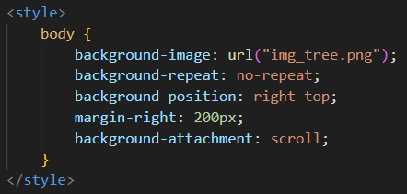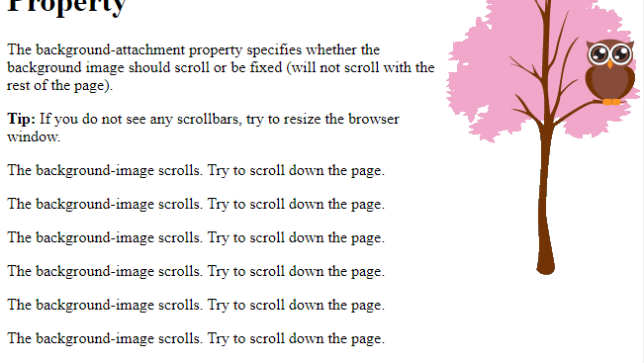

1. **fixed:** The background image remains fixed in place, so it doesn't move as the user scrolls. It stays positioned relative to the viewport.

**Ex.**

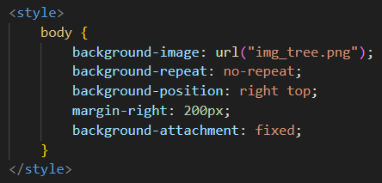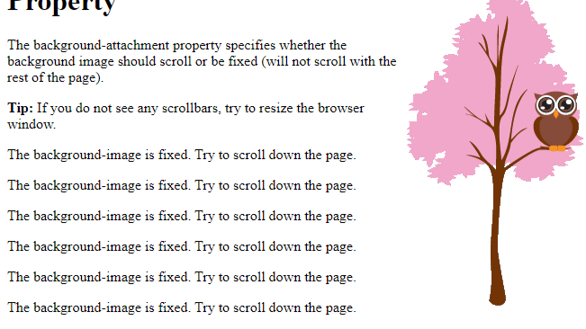

**Q10: Why should background and color be used as separate properties?**

**Ans**: Using background and color as separate properties in CSS allows for better control and flexibility in styling web elements.

1. **Layered Styling:** Separating background and color properties allows you to apply multiple background layers to an element, each with its own background color, image, and other properties. This makes it easier to create complex visual effects and layering, such as gradients, patterns, and textures.
2. **Background Image:** The background property includes settings for background images, repeat behavior, position, and more. Keeping these settings separate from the text or foreground color allows for precise control over the background appearance without affecting the text.
3. **Transparency:** Background colors and background images often require different levels of transparency (opacity). By separating them, you can control the transparency of the background independently of the text color and content.
4. **Efficiency:** Separating background and color properties can lead to more efficient CSS. If you need to change only the text color, you don't have to override or reset background properties, and vice versa, reducing the risk of unintended side effects.
5. **Clarity and Readability:** It improves the clarity and readability of your code. When someone reads your CSS, they can quickly identify which part of the styling is related to the background and which is related to the text color, making it easier to understand and maintain the code.

**Ex.**

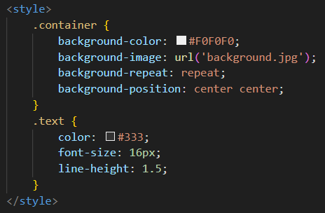

**Q11: How to center block elements using CSS1?**

Ans:

1. **Using Margin Auto:** Set the left and right margins of the block-level element to "auto." This technique relies on the automatic distribution of the margins to center the element horizontally within its containing parent element.

**Ex.**

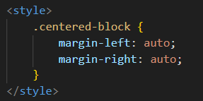

1. **Using position:**
2. **position:** absolute; positions the element absolutely within its nearest positioned ancestor.
3. **top: 50%;** and **left: 50%;** move the element's top-left corner to the center of its containing element.
4. **transform: translate(-50%, -50%);** translates the element back by 50% of its own width and height, effectively centering it both horizontally and vertically.

**Ex.**

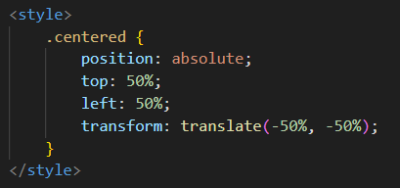

**12: How to maintain the CSS specifications?**

**Ans:** To maintain CSS specifications effectively, you can follow these simple guidelines with HTML and CSS code examples:

1. **Use Clear and Descriptive Class Names:**

* Use meaningful class names that describe the purpose of the styles.
* Keep class names consistent and organized.



1. **Separate Styles into External CSS Files:**

* Create an external CSS file for your styles (e.g., styles.css) to keep them organized.



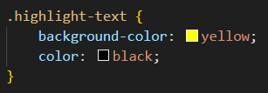

1. **Group Related Styles:**

* Group styles together for elements with similar properties.

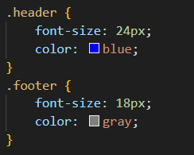

1. **Use Comments for Clarity:**

* Add comments to your CSS code to explain the purpose of specific styles.

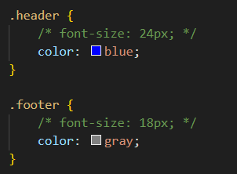

1. **Create a Style Guide:**

* Develop a style guide or documentation that documents your CSS specifications and usage guidelines.

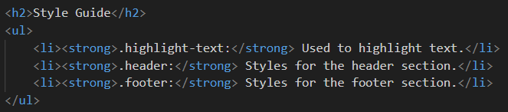

1. **Regularly Review and Refactor:**

* Periodically review your CSS code to identify redundant or unused styles.
* Refactor your code to remove unnecessary styles and improve readability.

1. **Use Version Control:**

* Use version control systems like Git to track changes to your CSS files. This helps with collaboration and version history.

-> By following these practices, we can maintain our CSS specifications in a clear and organized manner, making it easier to manage and update our styles as our web project evolves.

**Q13: What are the ways to integrate CSS as a web page?**

**Ans:** There are three main ways to integrate CSS into a web page:

1. **Inline CSS:** You can include CSS directly within an HTML element using the style attribute. This CSS will apply only to that specific element.



This method is suitable for applying unique styles to individual elements but can become messy for larger projects.

1. **Internal CSS:** You can include CSS styles within a <style> block in the HTML document's <head> section. These styles apply to all elements on the page.

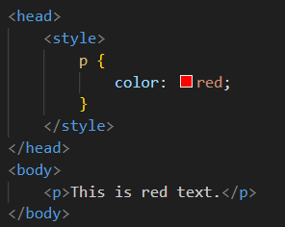

Internal CSS is useful for small to medium-sized projects where styles need to be applied to multiple elements on the same page.

1. **External CSS:** You can create a separate CSS file (e.g., styles.css) and link it to your HTML document using the <link> element in the <head> section. This allows you to maintain all your styles in one place and reuse them across multiple pages.

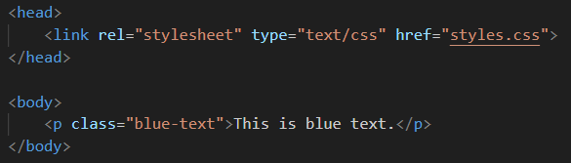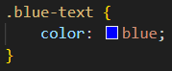

External CSS is the most common method for maintaining and applying styles in larger web projects because it promotes separation of concerns and reusability.

**Q14: What is embedded style sheets?**

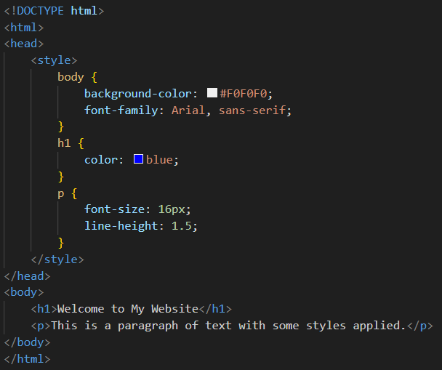**Ans:** **Embedded** style sheets, also known as **internal style sheets**, are a way to include CSS rules directly within an HTML document.

-> an embedded style sheet:

**Q15: What are the external style sheets?**

**Ans:**

**External CSS:** You can create a separate CSS file (e.g., styles.css) and link it to your HTML document using the <link> element in the <head> section. This allows you to maintain all your styles in one place and reuse them across multiple pages.



External CSS is the most common method for maintaining and applying styles in larger web projects because it promotes separation of concerns and reusability.

**Q16: What are the advantages and disadvantages of using external style sheets?**

**Ans:** **Advantages:**

1. **Modularity:** External style sheets promote a modular approach to web design. You can create a single CSS file or multiple CSS files for different components of your website, making it easier to manage and organize your styles.
2. **Reusability:** Styles defined in an external CSS file can be reused across multiple web pages. This saves time and effort in maintaining a consistent look and feel throughout your site.
3. **Consistency:** External stylesheets ensure a consistent design across your website because they apply the same styles to all pages linked to the stylesheet.
4. **Maintenance:** If you need to update your website's styling, you can do so in one place—the external CSS file. This simplifies maintenance and reduces the risk of errors.
5. **Caching:** External stylesheets are often cached by web browsers. Once a user visits a page on your site, the stylesheet is stored locally, improving page load times on subsequent visits.
6. **Collaboration:** When working on a web project with multiple team members, external CSS files facilitate collaboration and version control using tools like Git.

**Disadvantages:**

1. **HTTP Requests:** Each external stylesheet requires an additional HTTP request, which can slightly increase page load times, especially if you have multiple stylesheets. This can be mitigated by using techniques like CSS minification and bundling.
2. **Render-Blocking:** External stylesheets can block the rendering of the webpage until the stylesheet is fully loaded. This can lead to a delay in rendering the content, negatively impacting the user experience.
3. **Increased Complexity:** Managing multiple external CSS files for larger projects can become complex. Careful organization and naming conventions are necessary to maintain clarity and avoid conflicts.
4. **Potential for Unused Code:** If you have a large external stylesheet, there's a risk of including styles that are not used on a particular webpage, leading to unnecessary overhead.
5. **Limited Control in Certain Cases:** In some situations, you may need to apply inline styles (using the style attribute) or internal styles (using the <style> tag) for specific dynamic or one-off styling needs. External stylesheets may not provide the necessary control in these cases.

**Q17: What is the meaning of the CSS selector?**

**Ans:** In CSS, a selector is a pattern or criteria that defines which HTML elements in a web page should be targeted and styled by a set of CSS rules. Selectors allow you to pinpoint specific elements or groups of elements to apply styling to. Selectors are a fundamental part of CSS and play a crucial role in styling web pages.

-> Here are some common CSS selector types and what they mean:

1. **Element Selector:** Selects all instances of a particular HTML element. For example, the selector p targets all <p> elements in the document.

**Ex.**

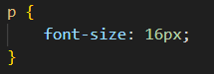

1. **Class Selector:** Selects elements with a specific class attribute value. For example, the selector .my-class targets all elements with class="my-class".

**Ex.**

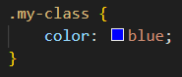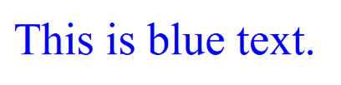

1. **ID Selector:** Selects a single element with a specific ID attribute value. For example, the selector #my-id targets the element with id="my-id".

**Ex.**

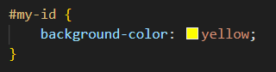

1. **Descendant Selector:** Selects elements that are descendants of a specific element. For example, the selector ul li targets all <li> elements within a <ul> element.

**Ex.**

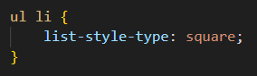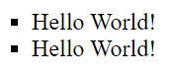

1. **Child Selector:** Selects elements that are direct children of a specific element. For example, the selector ul > li targets all <li> elements that are direct children of a <ul> element.
2. **Attribute Selector:** Selects elements based on their attributes and attribute values. For example, the selector [type="text"] targets all elements with type="text".
3. **Pseudo-class Selector:** Selects elements based on their state or position, such as :hover for elements when the mouse pointer is over them or :first-child for the first child element of a parent.

**Ex.**

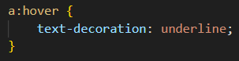

1. **Pseudo-element Selector:** Selects a specific part of an element's content or layout, such as ::before to style content before an element or ::after to style content after an element.

**Ex.**

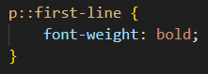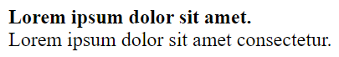

**Q18: What are the media types allowed by CSS?**

**Ans:** CSS allows you to apply styles to different media types or devices to create responsive designs. Media types in CSS are specified using the @media rule, and they help you target specific output devices or conditions.

-> Here are some common media types allowed by CSS:

1. **all (Default):** This is the default media type, and it applies to all devices.
2. **print:** Used for styles that are intended for printed pages. These styles control how a webpage should appear when printed.
3. **screen:** Used for styles that are intended for screens, such as computer monitors, smartphones, and tablets. This is the default media type for most styles.
4. **speech:** Used for styles that are intended for screen readers or speech synthesizers to improve accessibility for users with visual impairments.
5. **aural (Deprecated):** This media type was used for audio-based user agents, but it is deprecated and no longer widely supported.
6. **braille (Deprecated):** Used for braille tactile feedback devices. Like aural, it is deprecated.
7. **handheld:** Intended for small, handheld devices like mobile phones and PDAs. However, support for this media type is limited in modern web development.
8. **tv:** Used for television-like devices. Styles for large screens and televisions can be specified using this media type.
9. **grid (Deprecated):** This media type was intended for grid-based devices and is deprecated.

Each media type allows you to define styles tailored to specific output devices or conditions, enabling you to create responsive designs that adapt to different contexts and user needs. It's important to note that some media types, like aural, braille, and grid, are deprecated and not commonly used in modern web development.

**Q19: What is the rule set?**

**Ans:** In CSS, a "rule set" is a collection of CSS rules that define how a specific group of HTML elements should be styled. It's like a set of instructions that tells the web browser how to display those elements on a web page.

-> A rule set consists of two main parts:

1. **Selector:** This part specifies which HTML elements the rules should apply to. For example, you can use a selector like h1 to target all <h1> elements on the page, or you can use a class selector like .highlight to target elements with a specific class.
2. **Declaration Block:** This part contains one or more CSS declarations enclosed in curly braces {}. Each declaration consists of a property (e.g., color, font-size) and a value (e.g., red, 16px). These declarations define the styling rules for the selected elements.

**Ex.**

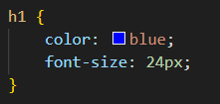

**In this rule set:**

* The selector is h1, which means it applies to all <h1> elements.
* The declaration block contains two declarations: one for the text color and another for the font size.

-> Rule sets are the building blocks of CSS, and they allow you to control the appearance and layout of HTML elements on a web page. By combining selectors and declaration blocks, you can create complex styles for your website.