HireTrack
Sprint 1 Documentation
Scenario 1 - Recruitment & Hiring Tracker
COMP50074 - Professional Practice and Project Management
Name | Project role | Main responsibility
Isuru | Developer | React front end, Express API, SQLite schema
Fazl | Scrum Master | Sprint board, stand-ups, burndown, sprint ceremonies
Thariq | Business Analyst | Requirements, user stories, acceptance criteria, UML
Ahmed | QA Engineer | Test cases, automated API tests, bug reports, verification

Item | Detail
Sprint | Sprint 1 of 2
Sprint dates | [start date] to [end date]
Sprint length | 10 working days
Committed story points | 63
Completed story points | 63
Technology | React 18 (Vite) front end, Node.js + Express REST API, SQLite database
Repository | git repository in the project folder - 4 commits in Sprint 1

Before you submit this document
Everything in this document comes from the system we actually built and tested, except for the items below. They depend on your own calendar, board and screen, so they are left as clearly marked placeholders. Work through this list, then delete this page.

Fill these in before submitting
- Cover page and section 3.1 - the sprint start and end dates, and the date of each stand-up.
- Section 3.1 - read through the draft stand-up entries and correct anything that did not happen that way.
- Section 3.2 - confirm the daily remaining points against your board; the chart is drawn from that table.
- Section 2.3 - take the six screenshots listed and paste them under the captions provided.
- Section 4.3 - paste screenshots of your GitHub repository and your Trello or Jira board.
- Section 3.3 - add any feedback your tutor gives during the sprint review.

Contents
1. Sprint Planning and Backlog Management
1.1 Sprint goal
1.2 Product backlog overview
1.3 Sprint backlog
1.4 Rationale for selection (MoSCoW)
1.5 Backlog refinement evidence
2. Sprint Execution and Implementation
2.1 Story implementation table
2.2 Design artifacts
2.3 Code snippets and screenshots
2.4 Testing
3. Sprint Review and Monitoring
3.1 Daily scrum records
3.2 Burndown chart
3.3 Sprint review summary
3.4 User story specifications
3.5 Risk registry
4. Enhancements
4.1 Sprint retrospective
4.2 Team contribution table
4.3 Tools used
Appendix A - Running the system for the demo
Appendix B - Sprint 2 backlog

1. Sprint Planning and Backlog Management

1.1 Sprint goal
To deliver a working end-to-end recruitment flow: the hiring team can open a vacancy with its own configurable interview stages, a client can apply and upload a CV, and the team can review that CV, move the candidate through the pipeline, leave interview feedback and record an outcome - with each user only able to see and do what their access level allows.

1.2 Product backlog overview
Every story considered for the project, prioritised with MoSCoW and estimated in story points by the whole group. The last column shows which sprint the story was pulled into.
ID | MoSCoW | User story | Pts | Owner | Sprint
AUTH-01 | Must | As a visitor, I want to create an account with my email and password so that I can use the system. | 3 | Isuru | 1
AUTH-02 | Must | As a user, I want to sign in and sign out so that my session is mine alone. | 3 | Isuru | 1
AUTH-03 | Must | As a user who forgot my password, I want a reset link so that I can get back into my account. | 5 | Isuru | 1
AUTH-04 | Could | As a user, I want to sign in with my Google (Gmail) account so that I do not need another password. | 3 | Isuru | 1
SEC-01 | Must | As the hiring team, we want clients to see only their own application so that candidate data stays private. | 5 | Thariq / Isuru | 1
JOB-01 | Must | As the hiring team, I want to open a vacancy with a job description so that candidates know what the role is. | 5 | Isuru | 1
JOB-02 | Must | As the hiring team, I want to set the interview stages for each vacancy separately so that different roles can follow different processes. | 5 | Isuru | 1
JOB-03 | Should | As the hiring team, I want to close and reopen a vacancy so that it stops taking applications when we are done. | 2 | Fazl | 1
JOB-04 | Must | As a client, I want to browse the open vacancies so that I can find a job to apply for. | 3 | Isuru | 1
APP-01 | Must | As a client, I want to apply for a vacancy so that I can be considered for the role. | 5 | Isuru | 1
APP-02 | Must | As a client, I want to upload and replace my CV so that the team can assess me. | 5 | Isuru | 1
APP-03 | Must | As a client, I want to see whether my CV was accepted or rejected so that I know where I stand. | 3 | Thariq | 1
CAN-01 | Must | As the hiring team, I want to see everyone who applied for a vacancy so that I can work through them. | 3 | Fazl | 1
CAN-02 | Must | As the hiring team, I want to accept or reject a CV so that the candidate gets an answer. | 3 | Ahmed | 1
CAN-03 | Must | As the hiring team, I want to move a candidate to the next stage so that the pipeline reflects reality. | 3 | Isuru | 1
CAN-04 | Should | As the hiring team, I want to record an outcome (active / on hold / hired / rejected) separately from the stage. | 2 | Fazl | 1
INT-01 | Should | As the hiring team, I want to schedule an interview against a candidate so that everyone knows when it is. | 3 | Ahmed | 1
FB-01 | Should | As an interviewer, I want to leave feedback at my stage so that the decision is based on evidence. | 5 | Ahmed | 1
FB-02 | Should | As the hiring team, I want to compare candidates side by side so that we choose fairly. | 5 | Thariq / Isuru | 1
COM-01 | Won't (Sprint 2) | As a candidate, I want an email when my interview is scheduled so that I do not miss it. | 5 | - | 2
WF-02 | Won't (Sprint 2) | As the hiring team, we want to block advancing a candidate until the current stage's feedback is in. | 3 | - | 2
RPT-01 | Won't (Sprint 2) | As management, I want to export a hiring report to CSV/PDF so that I can share progress. | 5 | - | 2
FB-03 | Won't (Sprint 2) | As an interviewer, I want my feedback to be anonymous to other interviewers so that scores are not influenced. | 3 | - | 2
AUD-01 | Won't (Sprint 2) | As an administrator, I want an audit log of who changed what so that decisions can be traced. | 5 | - | 2
Sprint 1 total: 63 story points across 19 stories. A further 21 points across 5 stories were deliberately left for Sprint 2.

1.3 Sprint backlog
The stories selected for Sprint 1, grouped where they share acceptance criteria, with their estimates and dependencies.
User story | Acceptance criteria | Estimate | Dependencies
AUTH-01 / AUTH-02  Sign up, sign in, sign out | - A new user can register with name, email and password.  - The password must be at least 8 characters and contain a letter and a number.  - A duplicate email is refused with a clear message.  - Signing in sets an httpOnly session cookie; signing out clears it.  - The same message is shown for a wrong email and a wrong password. | 6 points | users table
AUTH-03  Forgot / reset password | - Requesting a reset always returns the same message, whether or not the email exists.  - The reset link expires after one hour.  - A token can only be used once.  - Only a SHA-256 hash of the token is stored in the database. | 5 points | AUTH-01
SEC-01  Staff and client access levels | - The four team roles have identical permissions.  - A client cannot create, edit or delete a vacancy.  - A client cannot list other candidates or download another CV.  - Asking for someone else's application returns 404, not 403.  - The API enforces this independently of the user interface. | 5 points | AUTH-02
JOB-01 / JOB-02 / JOB-03  Vacancies and their interview stages | - A vacancy stores title, department, location, type, salary range, closing date and description.  - Each vacancy has its own ordered list of interview stages that can be added, removed and reordered.  - A stage that candidates are currently sitting on cannot be deleted.  - A vacancy can be closed and reopened; a closed vacancy takes no new applications. | 12 points | jobs and job_stages tables
JOB-04 / APP-01  Browse vacancies and apply | - A client sees only open vacancies.  - Applying records the candidate against that vacancy at the first stage of its pipeline.  - A client always applies as themselves - the name and email come from their account.  - The same email cannot apply twice for the same vacancy. | 8 points | JOB-01, JOB-02
APP-02 / APP-03 / CAN-02  CV upload, review and status | - A CV can be uploaded and replaced (PDF, DOC or DOCX, maximum 5 MB).  - Any other file type is refused with a clear message.  - A new CV starts as PENDING and the client sees 'Under review'.  - The team can accept or reject the CV; the client's page then shows 'CV accepted' or 'Not successful'.  - Replacing the CV puts it back to 'Under review'. | 11 points | APP-01
CAN-01 / CAN-03 / CAN-04  Pipeline and outcome | - The vacancy page lists every applicant with stage, outcome and CV status.  - 'Move to next stage' advances one step through that vacancy's own pipeline.  - A candidate at the last stage cannot be advanced again.  - The outcome is stored separately from the stage. | 8 points | JOB-02, APP-01
INT-01 / FB-01 / FB-02  Interviews, feedback and comparison | - An interview can be scheduled against a candidate with stage, date/time and interviewer.  - An interviewer can score a candidate 1-5 at a stage with an advance / hold / reject recommendation.  - One person can only leave one score per stage; saving again updates it.  - The comparison table ranks every candidate for a vacancy by average score. | 13 points | CAN-03

1.4 Rationale for selection (MoSCoW)
Why each group of stories was or was not pulled into Sprint 1.
Priority | Stories | Justification
Must | AUTH-01, AUTH-02, AUTH-03, SEC-01, JOB-01, JOB-02, JOB-04, APP-01, APP-02, APP-03, CAN-01, CAN-02, CAN-03 | These form the shortest complete path through the product: open a vacancy, apply to it, upload a CV, get the CV reviewed, and move the candidate on. Nothing in the scenario can be demonstrated without all of them, and each one is a dependency of the next.
Should | JOB-03, CAN-04, INT-01, FB-01, FB-02 | Not needed to prove the flow works, but they are what Scenario 1 asks for by name - interviewer feedback at each stage and a fair side-by-side comparison. We pulled them into Sprint 1 because the pipeline was already in place and adding them late would have meant reworking the candidate page twice.
Could | AUTH-04 (Google sign-in) | Nice to have and quick, because it reuses the same session cookie. It is disabled unless Google credentials are supplied in the environment file, so it cannot break the demo.
Won't (this sprint) | COM-01, WF-02, RPT-01, FB-03, AUD-01 | Email notifications need a mail server we do not have; blocking advancement depends on FB-01 existing first and would slow down testing; reports, anonymous feedback and the audit log add no value until there is real data in the system. All five are carried into the Sprint 2 backlog.

1.5 Backlog refinement evidence
The backlog did not stay still. These are the refinements made during the sprint:
- The backlog was written first as one large story per area ('manage vacancies', 'manage candidates'). During refinement these were split so that no single story was larger than 5 points - for example 'manage candidates' became CAN-01 (see applicants), CAN-02 (review the CV), CAN-03 (move stage) and CAN-04 (record outcome).
- APP-02 originally read 'as a client I want to upload my CV'. Testing the acceptance criteria showed there was no way for the candidate to learn the result, so APP-03 ('see whether my CV was accepted or rejected') was added and a cv_status column was introduced to the database.
- SEC-01 was not in the first version of the backlog at all. It was added after a walkthrough showed that a client account could list every other candidate. It was given 5 points and treated as a Must, because it changes the API for every endpoint.
- WF-02 ('block advancing without feedback') was moved out of Sprint 1 once we agreed it depends on FB-01 being finished and tested first.
- Estimates were agreed by the whole group using planning poker; where two people disagreed by more than one card we discussed the story until we converged.

SCREENSHOT: Sprint board showing refinement
Your Trello or Jira board with the backlog, in-progress and done columns. If your board shows the split stories (CAN-01 to CAN-04) that is the clearest evidence of refinement.
Paste your screenshot here, then delete this box.

2. Sprint Execution and Implementation

2.1 Story implementation table
ID | Title | Description | Design approach | Tasks | Responsibility | Status
AUTH-01 to AUTH-04 | Accounts and sessions | Sign up, sign in, sign out, forgot / reset password and optional Google sign-in. | bcrypt hashes the password; a JSON Web Token is stored in an httpOnly cookie so page JavaScript cannot read it. Reset tokens are stored as a SHA-256 hash with a one hour expiry. | users and password_resets tables; /api/auth routes; React sign-in, sign-up, forgot and reset pages; AuthContext to hold the session. | Isuru (build), Ahmed (tests) | Done
SEC-01 | Staff and client access levels | Two access levels: the four of us (identical permissions) and clients from outside. | A requireStaff middleware guards every team-only route. Client requests are filtered to their own user_id in SQL rather than in JavaScript, so nothing else can leak. | role column with a CHECK constraint; requireStaff middleware; loadFor ownership check; separate React navigation and route guards. | Thariq (rules), Isuru (build), Ahmed (tests) | Done
JOB-01 to JOB-04 | Vacancies with configurable stages | Create, edit, close, reopen and delete a vacancy, each with its own ordered interview pipeline. | Stages are a separate job_stages table (one row per stage with a position) rather than a text column, so the order is a database concern and each stage can be referenced. | jobs and job_stages tables; /api/jobs routes; JobEditor with add / remove / reorder stage chips; client card list and team table. | Isuru (build), Fazl (review) | Done
APP-01 to APP-03 | Applying and the CV | A client applies, uploads a CV, and follows its status. | The CV is written to disk under a generated random filename; only its metadata is stored in the database. cv_status drives a plain-English status shown to the client. | applications table with cv_status; multer upload with type and size checks; /api/applications routes; My applications pages. | Isuru (build), Thariq (wording), Ahmed (tests) | Done
CAN-01 to CAN-04 | Pipeline and outcomes | See all applicants, accept or reject the CV, move a candidate along, record an outcome. | 'Move to next stage' looks the candidate up in that vacancy's own stage list and advances by one, so it can never step outside the configured pipeline. | /api/applications/:id/advance and /cv-review; candidate detail page; outcome selector; applicant table on the vacancy page. | Isuru, Fazl (build), Ahmed (tests) | Done
INT-01, FB-01, FB-02 | Interviews, feedback and comparison | Schedule interviews; score a candidate at a stage; rank candidates side by side. | One row per interviewer per stage, enforced by a UNIQUE constraint, so nobody can weight the result by writing twice. The comparison is a single grouped SQL query. | interviews and feedback tables; /api/interviews and /api/feedback routes; feedback form on the candidate page; Compare page. | Ahmed (rules), Isuru (build) | Done

2.2 Design artifacts

2.2.1 Wireframes
The six screens designed before implementation. The client and the hiring team see different versions of the same vacancy list, which is the design decision that drove the whole access model.
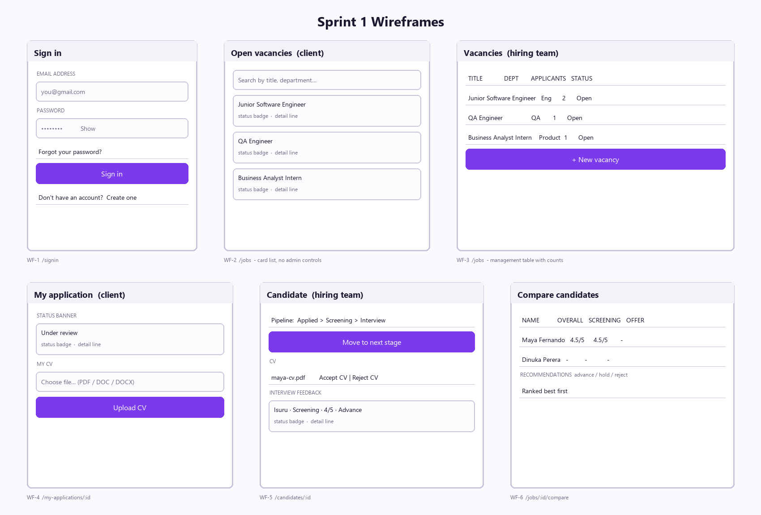
Figure 1 - Sprint 1 wireframes

2.2.2 Use case diagram
Two actors. The role a team member holds (Developer, Scrum Master, Business Analyst, QA) is a label for the coursework, not an access level - all four share one permission set.
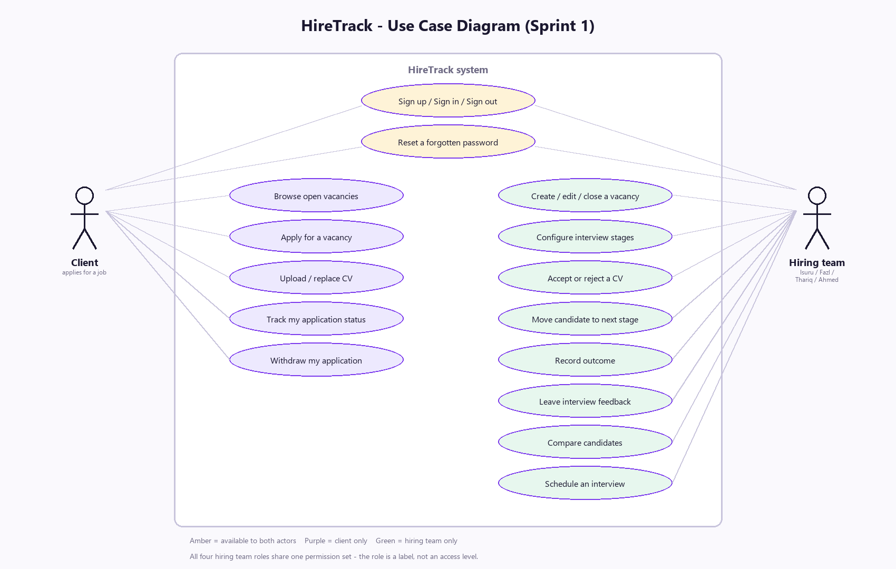
Figure 2 - Use case diagram

2.2.3 Activity diagram
The core flow: a client applies and uploads a CV, the hiring team reviews it, and the decision flows back to the client's own screen.
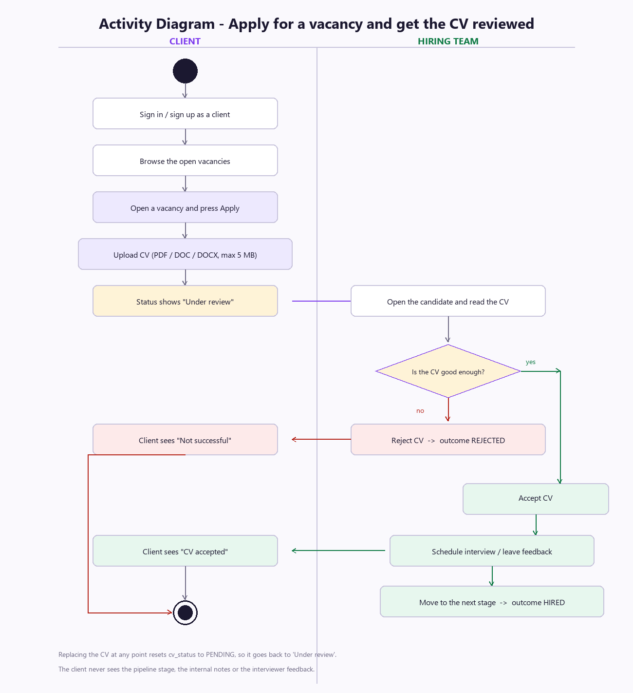
Figure 3 - Activity diagram: apply and CV review

2.2.4 Entity relationship diagram
Seven tables. Foreign keys are enforced by the database (PRAGMA foreign_keys = ON), and CHECK constraints keep status, outcome, role and rating values valid at the database level rather than only in the code.
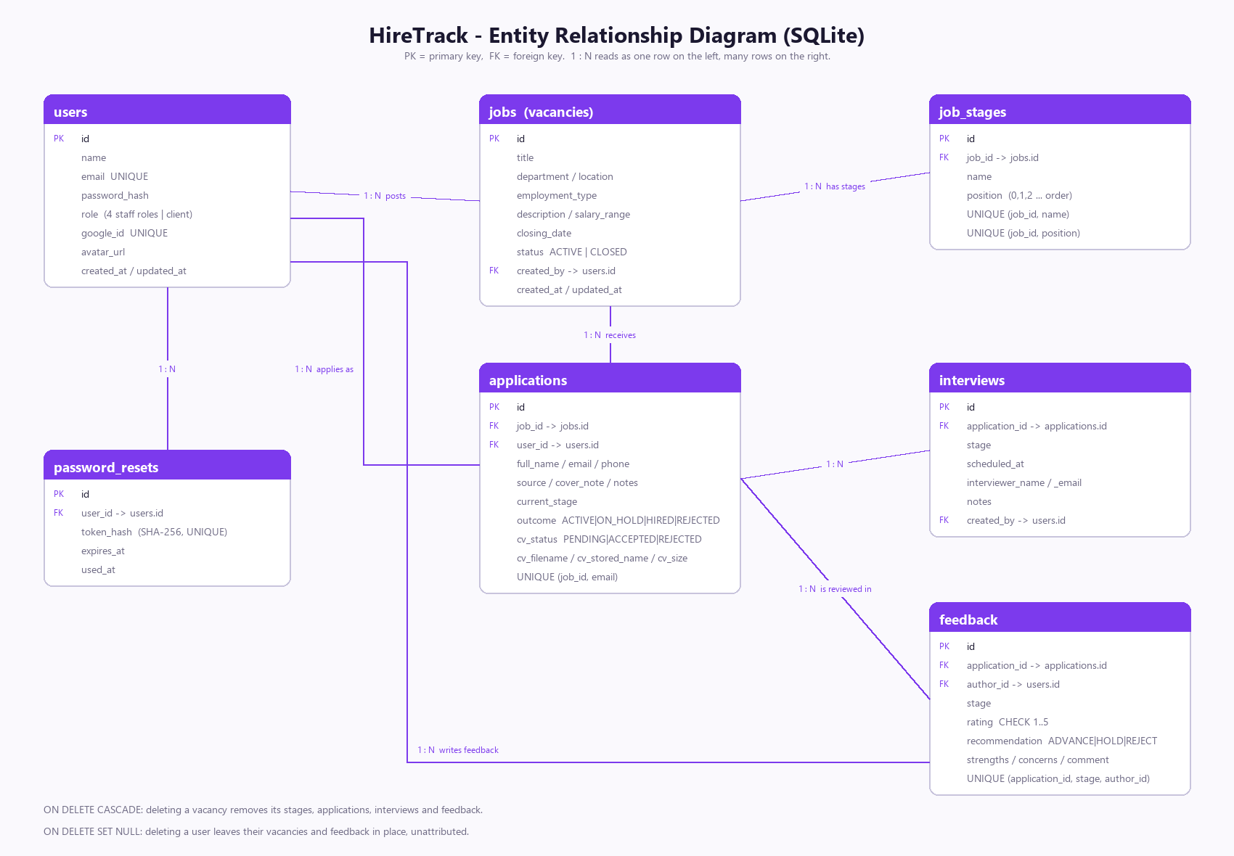
Figure 4 - Entity relationship diagram

2.3 Code snippets and screenshots
Sprint 1 delivers a running system, not a prototype. These four snippets are taken directly from the submitted code and cover the decisions that were hardest to get right.
Snippet 1 - interview stages are a table, not a text column, so the order is a database concern server/db/schema.sql (lines 64-75)
64 -- -------------------------------------------------------------------
65 -- job_stages - the pipeline, ordered by position (0,1,2,...)
66 -- Deleting a vacancy deletes its stages.
67 -- -------------------------------------------------------------------
68 CREATE TABLE IF NOT EXISTS job_stages (
69 id INTEGER PRIMARY KEY AUTOINCREMENT,
70 job_id INTEGER NOT NULL REFERENCES jobs (id) ON DELETE CASCADE,
71 name TEXT NOT NULL,
72 position INTEGER NOT NULL,
73 UNIQUE (job_id, name),
74 UNIQUE (job_id, position)
75 );

Snippet 2 - the single check that separates the hiring team from a client server/middleware.js (lines 26-34)
26 export function requireStaff(req, res, next) {
27 if (!req.user) {
28 return res.status(401).json({ error: "You need to sign in to do that." });
29 }
30 if (!req.user.isStaff) {
31 return res.status(403).json({ error: "Only the hiring team can do that." });
32 }
33 next();
34 }

Snippet 3 - ownership check; a client gets 404, not 403, so a record cannot be confirmed to exist server/routes/applications.routes.js (lines 88-101)
88
89 /**
90 * A client may only ever touch their own application. Staff may touch
91 * any of them. Returns the row or throws.
92 */
93 function loadFor(req, id) {
94 const row = selectOne.get(id);
95 if (!row) throw httpError(404, "That application does not exist.");
96 if (!req.user.isStaff && row.user_id !== req.user.id) {
97 // 404 rather than 403 so a client cannot even confirm it exists.
98 throw httpError(404, "That application does not exist.");
99 }
100 return row;
101 }

Snippet 4 - moving a candidate along that vacancy's own pipeline server/routes/applications.routes.js (lines 369-390)
369 // --- Move to the next stage in the pipeline ---------------------------
370 router.post(
371 "/:id/advance",
372 requireStaff,
373 asyncHandler(async (req, res) => {
374 const id = v.id(req.params.id, { field: "application id" });
375 const existing = loadFor(req, id);
376
377 const stages = stagesFor(existing.job_id);
378 const index = stages.indexOf(existing.current_stage);
379 if (index === -1) throw httpError(400, "This candidate's stage is no longer in the pipeline.");
380 if (index >= stages.length - 1) {
381 throw httpError(400, "This candidate is already at the final stage.");
382 }
383
384 db.prepare(
385 "UPDATE applications SET current_stage = ?, updated_at = datetime('now') WHERE id = ?"
386 ).run(stages[index + 1], id);
387
388 res.json({ application: toJson(selectOne.get(id)), stages });
389 })
390 );

Screenshots of the running system
Start the app with npm run dev, sign in with the accounts in Appendix A, and capture these six screens.
SCREENSHOT: Sign in page
The sign-in screen at http://localhost:5173/signin, showing the demo account box.
Paste your screenshot here, then delete this box.

SCREENSHOT: Vacancies - hiring team view
Signed in as isuru@gmail.com: /jobs, showing the management table with applicant counts.
Paste your screenshot here, then delete this box.

SCREENSHOT: Open vacancies - client view
Signed in as maya.fernando@gmail.com: /jobs, showing the job cards with no admin controls. Put this next to the previous screenshot - the contrast is the evidence for SEC-01.
Paste your screenshot here, then delete this box.

SCREENSHOT: Candidate page with CV review and feedback
Signed in as the team: /candidates/1, showing the pipeline, the Accept CV / Reject CV buttons and the interview feedback list.
Paste your screenshot here, then delete this box.

SCREENSHOT: My application - client view
Signed in as the client: /my-applications, showing the status banner ('Under review' or 'CV accepted').
Paste your screenshot here, then delete this box.

SCREENSHOT: Compare candidates
Signed in as the team: /jobs/1/compare, showing candidates ranked by average score.
Paste your screenshot here, then delete this box.

2.4 Testing

2.4.1 Automated test results
41 automated API tests run against a temporary throw-away database with the command npm test. All 41 passed on the final run of the sprint.
Test suite | Tests | What it covers
Health | 1 | The API starts and answers.
Authentication | 7 | Sign up, duplicate email, wrong password, /me, password rules, reset token used once, forgot-password does not reveal accounts.
Vacancies | 4 | Creating with stages, title required, applicant counts, signed-out visitor refused.
Applications | 10 | Apply, duplicate refused, pipeline advance, invalid stage, outcome separate from stage, CV upload and download, wrong file type refused, stage in use protected, invalid ids.
Interviews | 2 | Scheduling and invalid dates.
Feedback and comparison | 4 | Score recorded, rating limits, one score per person per stage, comparison ranking.
Client isolation | 11 | A client cannot create vacancies, see the team, open another application, download another CV, advance themselves or accept their own CV; applies as themselves; sees the correct status.
Team access level | 2 | A QA account can do everything a Developer account can; dashboard counts are correct.

SCREENSHOT: npm test output
Run npm test in the project folder and screenshot the summary lines showing 'tests 41 / pass 41 / fail 0'.
Paste your screenshot here, then delete this box.

2.4.2 Manual test results
Manual test cases written from the acceptance criteria and executed by hand in the browser before the sprint review.
ID | Story | Steps | Expected result | Actual result | Status
TC-01 | AUTH-02 | Sign in as ahmed@gmail.com with the correct password. | Signed in and taken to the dashboard. | As expected. | Pass
TC-02 | AUTH-02 | Sign in with a deliberately wrong password. | 'Invalid email or password.' and no session created. | As expected. | Pass
TC-03 | AUTH-03 | Request a reset link, use it, then use the same link a second time. | First use succeeds; second use is refused as already used. | As expected. | Pass
TC-04 | JOB-02 | Create a vacancy, add a stage, reorder it, then save. | The pipeline is stored in the new order. | As expected. | Pass
TC-05 | JOB-02 | Try to delete a stage that a candidate is currently on. | Refused, naming the stage. | As expected. | Pass
TC-06 | APP-01 | Apply for the same vacancy twice with the same account. | Second attempt refused as a duplicate. | As expected. | Pass
TC-07 | APP-02 | Upload a .txt file as a CV. | Refused: only PDF, DOC or DOCX accepted. | As expected. | Pass
TC-08 | APP-02 | Upload a valid PDF, then download it again. | File downloads with its original name. | As expected. | Pass
TC-09 | APP-03 / CAN-02 | As the team, accept the CV; then sign in as that client. | Client's page changes from 'Under review' to 'CV accepted'. | As expected. | Pass
TC-10 | CAN-03 | Press 'Move to next stage' until the last stage is reached. | Advances one stage each time; refused at the final stage. | As expected. | Pass
TC-11 | SEC-01 | Signed in as a client, type /candidates into the address bar. | Redirected to My applications; the API also refuses the request. | As expected. | Pass
TC-12 | SEC-01 | Signed in as a client, request another candidate's record directly. | 404 returned, so the record cannot even be confirmed to exist. | As expected. | Pass
TC-13 | FB-01 | Leave feedback at a stage, then leave it again for the same stage. | The first score is replaced, not duplicated. | As expected. | Pass
TC-14 | FB-02 | Open the comparison table for a vacancy with feedback recorded. | Candidates ranked by average score, per stage columns filled. | As expected. | Pass

2.4.3 Bug report summary
Three defects were raised during Sprint 1. All three were fixed inside the sprint and none are outstanding.
ID | Story | Description | Severity | How it was found | Fix | Status
BUG-01 | AUTH-02 | The sign-in form refused the team's password. The shared password box applied the 'at least 8 characters' rule to every screen, including sign-in, so the browser blocked the form before it reached the server. | High - nobody could sign in with the seeded accounts | Manual test TC-01 | minLength is now opt-in: it applies where a password is chosen (sign up, reset, change) but not where an existing one is typed. | Fixed - commit 2c2023f
BUG-02 | SEC-01 | A client account could list every other candidate, download their CVs, read the team list and create vacancies, because the API only checked that the user was signed in, not who they were. | Critical - candidate personal data exposed | Walkthrough as a client account | Added the requireStaff middleware and per-owner filtering; 11 automated tests now cover it. | Fixed - commit b0fab26
BUG-03 | APP-02 | A CV upload that failed validation after the file had been written left the file on disk with no database row pointing at it. | Low - wasted disk space only | Code review | The upload route now deletes the stored file when the application cannot be found. | Fixed - commit b0fab26

BUG-02 is the one worth discussing at the review. It was a design mistake rather than a coding mistake: we built every endpoint to check that the user was signed in, but never which user they were. It took most of a day to correct and is the main input into our retrospective.

3. Sprint Review and Monitoring

3.1 Daily scrum records
Stand-ups were held at the start of each working day. Each entry records what each person did the previous day and what they picked up, plus any blocker raised.
Day | Date | Isuru (Dev) | Fazl (SM) | Thariq (BA) | Ahmed (QA) | Blockers
Day 1 | [date] | Set up the repository, Express server and SQLite schema. | Set up the board, moved the sprint backlog onto it. | Wrote the user stories and acceptance criteria. | Drafted the manual test cases from the acceptance criteria. | None
Day 2 | [date] | Built sign up / sign in / sign out with hashed passwords. | Ran the stand-up, chased the estimates. | Reviewed AUTH acceptance criteria against the build. | Wrote the first automated API tests for authentication. | None
Day 3 | [date] | Forgot / reset password with one-time tokens. | Updated the burndown. | Wireframes for the vacancy screens. | Tested the reset flow, raised the token reuse case. | No mail server - agreed to show the link on screen in development
Day 4 | [date] | Vacancies plus the job_stages table. | Reviewed the vacancy screens. | Use case and activity diagrams. | Tested stage reordering and deletion. | None
Day 5 | [date] | Apply flow and CV upload. | Board tidy-up before the weekend. | Checked the apply wording. | Tested file type and size limits. | None
Day 6 | [date] | Candidate pipeline: advance stage, record outcome. | Ran the stand-up. | ERD finalised. | Tested the pipeline boundaries. | None
Day 7 | [date] | CV review (accept / reject) and the client status wording. | Updated the burndown. | Wrote the client-facing status messages. | Tested the client's view of each status. | None
Day 8 | [date] | Reworked every route for the staff / client split. | Re-planned the remaining work after the access bug. | Re-checked SEC-01 acceptance criteria. | Found BUG-02 - a client could see every candidate. | BUG-02 pulled the rest of the sprint back by roughly half a day
Day 9 | [date] | Interview feedback and the comparison table. | Prepared the review agenda. | Checked the comparison against 'compare fairly'. | Wrote the feedback and isolation tests (41 in total). | None
Day 10 | [date] | Fixed BUG-01, rebuilt, wrote the README. | Burndown closed out, retrospective prepared. | Compiled this document. | Full regression run - 41 of 41 passing. | None

3.2 Burndown chart
Day | 0 | 1 | 2 | 3 | 4 | 5 | 6 | 7 | 8 | 9 | 10
Ideal remaining | 63 | 57 | 50 | 44 | 38 | 32 | 25 | 19 | 13 | 6 | 0
Actual remaining | 63 | 63 | 57 | 50 | 44 | 44 | 35 | 27 | 20 | 9 | 0

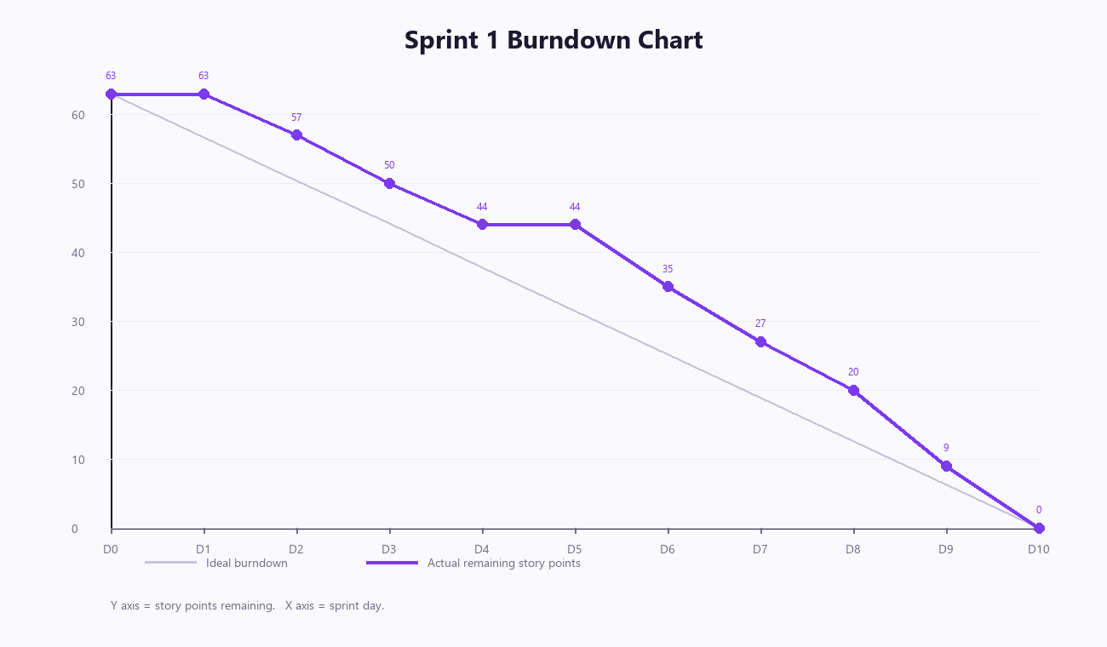
Figure 5 - Sprint 1 burndown

Commentary on progress and deviations
- The actual line sits above the ideal line for most of the sprint. Two things caused that.
- Days 1 and 2: nothing was closed on day 1 because the repository, database schema and project scaffolding had to exist before any story could be finished. This is normal for the first sprint and we expect day 1 to be flat again only if we start a new codebase.
- Day 5: no points were closed. Day 5 fell on a weekend day where only two of us were available.
- Day 8: the line is still above ideal because BUG-02 (a client could see every candidate) forced us to rework every API route. We chose to fix it inside the sprint rather than carry it, because it is a data privacy defect.
- The sprint still finished on zero because the Should stories were smaller in practice than estimated and the last two days were mostly testing rather than new code.

3.3 Sprint review summary

Planned versus completed
Measure | Result
Committed story points | 63
Completed story points | 63
Stories committed | 19
Stories completed | 19
Stories carried to Sprint 2 | 0 (5 stories were never committed - see the Won't rows in the product backlog)
Automated tests at the end of the sprint | 41, all passing
Defects found | 3 (all fixed inside the sprint)
Defects still open | 0

Demo feedback
- The end-to-end demo ran without a failure: create a vacancy, apply as a client, upload a CV, accept it as the team, leave feedback, compare candidates.
- The clearest feedback was that a client should get an email when their CV is accepted rather than having to sign in and check. That is COM-01 and it is already at the top of the Sprint 2 backlog.
- A second comment was that the hiring team cannot yet see, at a glance, which candidates still have no feedback. We have noted this as a small Sprint 2 story.
- [Add any comments your tutor or the other group gives you during the review here.]

3.4 User story specifications
Final status of every story committed to Sprint 1. 'Accepted' means the acceptance criteria were demonstrated and the matching automated or manual test passed.
ID | User story | Pts | Owner | Status
AUTH-01 | As a visitor, I want to create an account with my email and password so that I can use the system. | 3 | Isuru | Done - accepted
AUTH-02 | As a user, I want to sign in and sign out so that my session is mine alone. | 3 | Isuru | Done - accepted
AUTH-03 | As a user who forgot my password, I want a reset link so that I can get back into my account. | 5 | Isuru | Done - accepted
AUTH-04 | As a user, I want to sign in with my Google (Gmail) account so that I do not need another password. | 3 | Isuru | Done - accepted
SEC-01 | As the hiring team, we want clients to see only their own application so that candidate data stays private. | 5 | Thariq / Isuru | Done - accepted
JOB-01 | As the hiring team, I want to open a vacancy with a job description so that candidates know what the role is. | 5 | Isuru | Done - accepted
JOB-02 | As the hiring team, I want to set the interview stages for each vacancy separately so that different roles can follow different processes. | 5 | Isuru | Done - accepted
JOB-03 | As the hiring team, I want to close and reopen a vacancy so that it stops taking applications when we are done. | 2 | Fazl | Done - accepted
JOB-04 | As a client, I want to browse the open vacancies so that I can find a job to apply for. | 3 | Isuru | Done - accepted
APP-01 | As a client, I want to apply for a vacancy so that I can be considered for the role. | 5 | Isuru | Done - accepted
APP-02 | As a client, I want to upload and replace my CV so that the team can assess me. | 5 | Isuru | Done - accepted
APP-03 | As a client, I want to see whether my CV was accepted or rejected so that I know where I stand. | 3 | Thariq | Done - accepted
CAN-01 | As the hiring team, I want to see everyone who applied for a vacancy so that I can work through them. | 3 | Fazl | Done - accepted
CAN-02 | As the hiring team, I want to accept or reject a CV so that the candidate gets an answer. | 3 | Ahmed | Done - accepted
CAN-03 | As the hiring team, I want to move a candidate to the next stage so that the pipeline reflects reality. | 3 | Isuru | Done - accepted
CAN-04 | As the hiring team, I want to record an outcome (active / on hold / hired / rejected) separately from the stage. | 2 | Fazl | Done - accepted
INT-01 | As the hiring team, I want to schedule an interview against a candidate so that everyone knows when it is. | 3 | Ahmed | Done - accepted
FB-01 | As an interviewer, I want to leave feedback at my stage so that the decision is based on evidence. | 5 | Ahmed | Done - accepted
FB-02 | As the hiring team, I want to compare candidates side by side so that we choose fairly. | 5 | Thariq / Isuru | Done - accepted

3.5 Risk registry
ID | Risk | Impact | Likelihood | Mitigation | Status
R-01 | Candidate personal data (names, emails, CVs) is exposed to the wrong user. | High | Medium | Two access levels enforced in the API, not only in the interface; 11 automated tests specifically cover client isolation. | Closed - fixed as BUG-02
R-02 | The team cannot demonstrate the system because the environment will not start on the day. | High | Low | One command setup (npm run setup), SQLite file database with no server to install, seed script that recreates the demo data, and a written run guide in the README. | Open - monitored
R-03 | Uploaded CV files fill the disk or contain malware. | Medium | Low | 5 MB limit, type checked, stored under generated filenames outside the web root. Virus scanning is listed as out of scope. | Open - accepted
R-04 | Only one member understands the codebase, so work stops if they are away. | Medium | Medium | Code is commented, the README documents every endpoint, and the whole group walked through the code in the day 6 stand-up. | Open - monitored
R-05 | Scope creep from Scenario 1's 'things to think about' list. | Medium | High | MoSCoW applied at planning; the five Won't stories are written down with reasons so they are not argued again mid-sprint. | Open - controlled

4. Enhancements

4.1 Sprint retrospective

What went well
- The end-to-end flow was working by the middle of the sprint, so every later story could be tested against something real rather than in isolation.
- Writing the acceptance criteria before the code meant the automated tests were mostly a translation job, not a design job.
- Splitting stories to a maximum of 5 points kept the board moving; nothing sat 'in progress' for more than two days.
- Choosing SQLite meant nobody lost time installing or configuring a database server.

Challenges faced
- We designed the permissions as an afterthought. A client account could see every candidate until day 8, and fixing it touched every route. It should have been a design decision on day 1.
- We had no mail server, which left the forgot-password and interview-notification stories half-answerable. We worked around it by showing the reset link on screen in development, but it is not a real solution.
- Estimating was inconsistent early on - AUTH-03 was estimated at 5 and took closer to 2, while SEC-01 at 5 took nearly twice that.
- Day 1 produced no closed points, which made the burndown look worse than the actual progress felt.

Improvements for Sprint 2
- Decide the access model in Sprint 2 planning, before any endpoint is written, and add a permission line to every story's acceptance criteria.
- Add a 'setup' story worth points at the start of a sprint so day 1 is not artificially flat.
- Re-estimate at the mid-sprint stand-up instead of waiting for the retrospective.
- Configure a test mail service early in Sprint 2 so COM-01 can actually be finished and demonstrated.

4.2 Team contribution table
Name | Role | Contribution in Sprint 1 | Stories owned
Isuru | Developer | React front end (14 screens), Express API (7 route modules), SQLite schema and seed data. | AUTH-01 to 04, JOB-01 to 04, APP-01 to 02, CAN-03, FB-02
Fazl | Scrum Master | Sprint board, daily stand-ups, burndown, sprint planning and review facilitation, vacancy close/reopen story. | JOB-03, CAN-01, CAN-04
Thariq | Business Analyst | User stories and acceptance criteria, MoSCoW prioritisation, use case / activity diagrams and the ERD, client-facing wording, this document. | APP-03, SEC-01 (rules), FB-02 (rules)
Ahmed | QA Engineer | 14 manual test cases, 41 automated API tests, 3 defect reports, regression run before the review. | CAN-02, INT-01, FB-01, all testing

4.3 Tools used
Tool | How we used it
Git | Version control. Four commits in Sprint 1, each one a complete piece of work with a written message.
GitHub | Remote repository for the group. [Paste a screenshot of your repository page.]
Trello / Jira | Sprint board with the backlog, in-progress and done columns. [Paste a screenshot of the board.]
Visual Studio Code | Editor used by the whole group.
Node.js test runner | Automated API tests, run with npm test.
WhatsApp / Discord | Daily stand-ups when we could not meet in person. [Paste a screenshot if your module asks for communication evidence.]

SCREENSHOT: GitHub repository
Your repository page showing the commit history for Sprint 1.
Paste your screenshot here, then delete this box.

SCREENSHOT: Sprint board
Your Trello or Jira board at the end of the sprint, with everything in the Done column.
Paste your screenshot here, then delete this box.

Appendix A - Running the system for the demo
The examiner or tutor needs three commands. Node.js 18.18 or newer must be installed.
npm run setup (first time only - installs everything and creates the demo data)
npm run dev (starts the API on port 4000 and the React app on port 5173)
npm test (runs the 41 automated tests)
Then open http://localhost:5173 and sign in.

Demo accounts (password 123 for all of them)
Email | Who they are | What they can do
isuru@gmail.com | Isuru - Developer | Everything (hiring team)
fazl@gmail.com | Fazl - Scrum Master | Everything (hiring team)
thariq@gmail.com | Thariq - Business Analyst | Everything (hiring team)
ahmed@gmail.com | Ahmed - QA Engineer | Everything (hiring team)
maya.fernando@gmail.com | Maya Fernando - client | Browse open vacancies, apply, upload a CV, follow her own application
dinuka.perera@gmail.com | Dinuka Perera - client | As above, for his own application only

Note for the report: 123 is a demo password written straight into the database by the seed script so it is quick to type during the presentation. The sign-up form still enforces the real rule - at least 8 characters with a letter and a number - so an account created through the interface cannot use it.

A five minute demo script
- Sign in as maya.fernando@gmail.com (a client). Point out that the menu has only two items.
- Open a vacancy, press Apply for this job, then upload a PDF as the CV. The status shows 'Under review'.
- Sign out and sign in as isuru@gmail.com (the hiring team). Point out the full menu and the dashboard.
- Open Vacancies, open the same vacancy, and show Maya in the applicants list.
- Open her candidate page. Press Accept CV, leave interview feedback with a score, and move her to the next stage.
- Open Compare candidates to show the ranking.
- Sign back in as Maya. Her page now reads 'CV accepted' - this is the loop the scenario asks for.
- Finish by running npm test to show the 41 automated tests passing.

Appendix B - Sprint 2 backlog
These stories were written and estimated during Sprint 1 planning but deliberately not committed. They are ready to be pulled into Sprint 2 planning.
ID | MoSCoW for Sprint 2 | User story | Pts | Why it was not in Sprint 1
COM-01 | Must | As a candidate, I want an email when my interview is scheduled so that I do not miss it. | 5 | Needs a mail server, which we did not have in Sprint 1. Raised again as the main piece of demo feedback.
WF-02 | Must | As the hiring team, we want to block advancing a candidate until the current stage's feedback is in. | 3 | Depends on FB-01 existing and being tested first.
RPT-01 | Should | As management, I want to export a hiring report to CSV or PDF. | 5 | No value until there is real data in the system.
FB-03 | Could | As an interviewer, I want my feedback hidden from other interviewers until I submit mine. | 3 | Low value for a four person team; worth doing if the system is used for real.
AUD-01 | Could | As an administrator, I want an audit log of who changed what. | 5 | Larger change; better once the data model has stopped moving.
NEW-01 | Should | As the hiring team, I want to see which candidates still have no feedback so that nobody is forgotten. | 2 | Raised as feedback during the Sprint 1 review.

Total Sprint 2 candidate backlog: 23 story points.

