SOC Investigation Report #1

Case Information
Field | Value
Case ID | SOC-001
Alert | Sysmon Process Creation
Event ID | 1
Host | windows
Severity | Low
Status | Closed - Benign

Scenario
This investigation validates that Sysmon Event ID 1 process creation events are successfully forwarded to Splunk Enterprise and analyzes whether observed processes are malicious or expected.

Investigation Steps
- Generated activity (cmd.exe, notepad.exe, calc.exe, whoami, hostname, ipconfig).
- Collected Sysmon Event ID 1 in Splunk.
- Reviewed Image, ParentImage, CommandLine and User.
- Determined legitimacy of processes.

Screenshot 1 - Windows activity
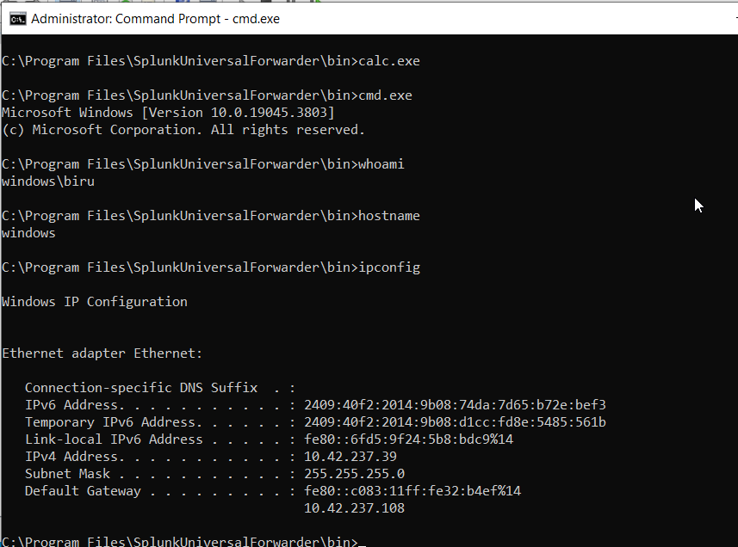

Screenshot 2 - Splunk investigation
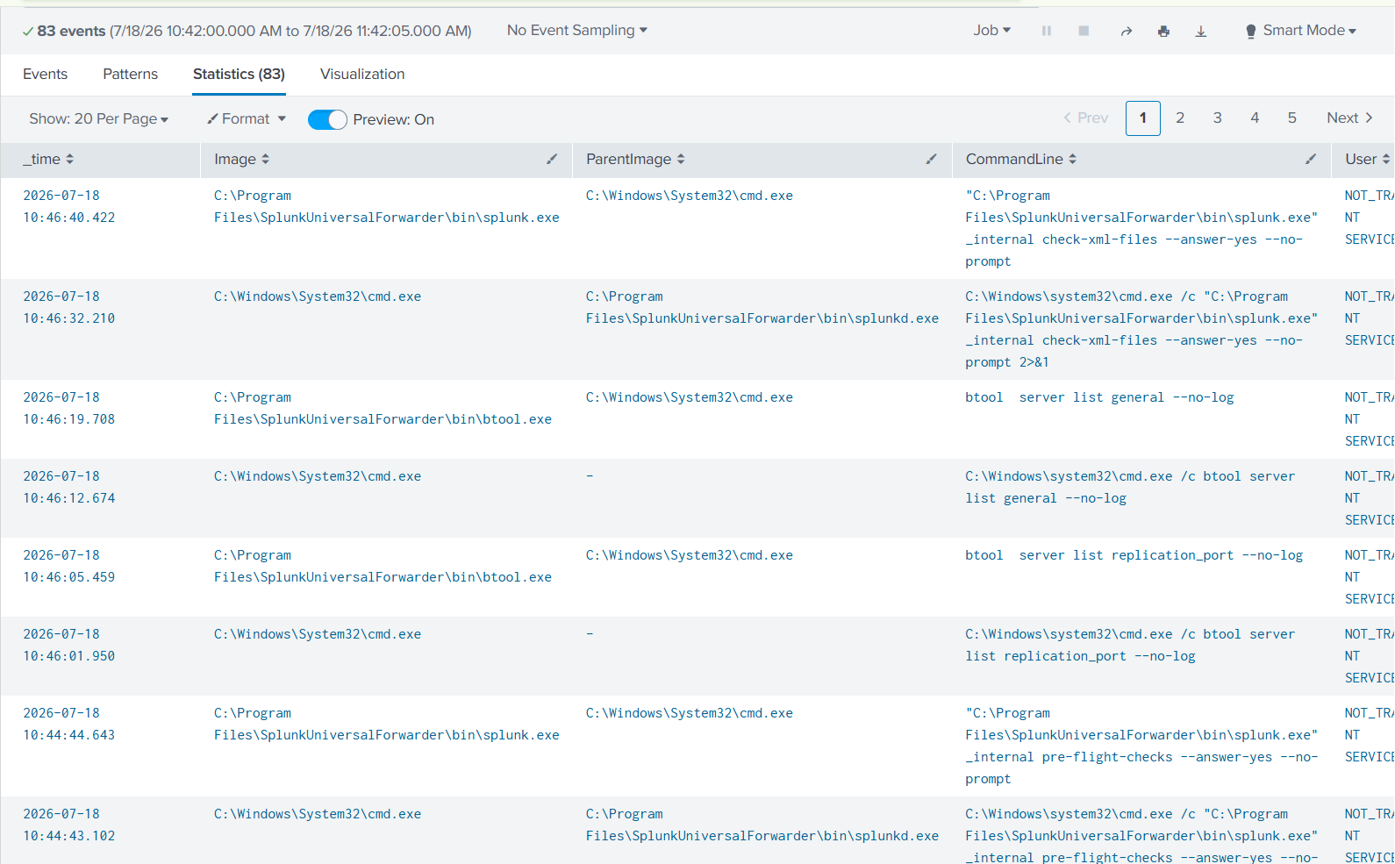

Findings
- Sysmon telemetry successfully reached Splunk.
- Observed cmd.exe, splunk.exe and btool.exe.
- Execution chain matched expected administrative activity.
- No indicators of compromise identified.

MITRE ATT&CK
T1059 - Command and Scripting Interpreter
T1059.003 - Windows Command Shell

Conclusion
This alert represents expected administrative activity while validating the SOC lab. No malicious behavior was detected.

